***Gladiator: Dewey Gram***

***Setting:***

*The story takes place in Italy. It takes place in Rome and other countries of Rome. The story takes place in the time of Julius Caesar.*

*This book is a historic thriller.*

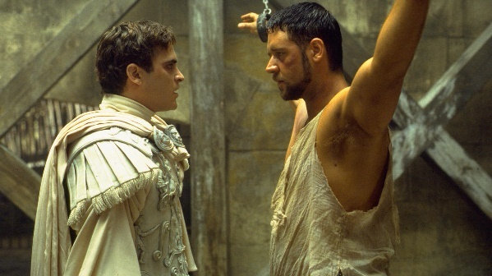***Characters:***

**Commodus Maximus**

***Maximus*** *is the main character. Maximus is a soldier in the army of Marcus Aurelius. It’s a very strong man in his mind and in his body. He’s a man of honor. When he promises something, he will do it.*

***Commodus*** *is the enemy of Maximus. He’s a very meen man. You can’t trust him. He is also a very jalous man.*

***Problem/Main Events/Conclusion.***

*Maximus is a commander of the army of emperor Marcus Aurilius. He’s also a friend of him. Caesar is a very old man and he will die soon. He says to Maximus that he will be the protector of Rome. The emperor’s son Commodus is very angry and kills his father. He makes himself the emperor and orders to kill Maximus. But Maximus escaped. He goes to his family in Spain. When he arrives, his wife and son are killed by the men of Commodus. He is very angry. He falls asleep.*

*As he waked up he is a slave on a boat the boat goes to marok. In marok he will be a gladiator. He’s a very good one and kill every other gladiator easily. He is so good that he may fight in Rome. The new emperor Commodus cames also and he then Maximus have a chance to kill him. He kills every gladiator and then he must fight with the emperor. The emperor had kill him almost but maximus pushes his knife in his chest. The emperor dies. But Maximus also because Commodus had pushed a little knife in his side before the game. Maximus has kill his enemy but he was also self died.*

***Own opinion:***

*The book has a lot of action and I love that. The story is sad but that makes it interested. I think it’s a good story.*