What are the consequences of Brexit in Scotland
Scotland’s independency from brexit

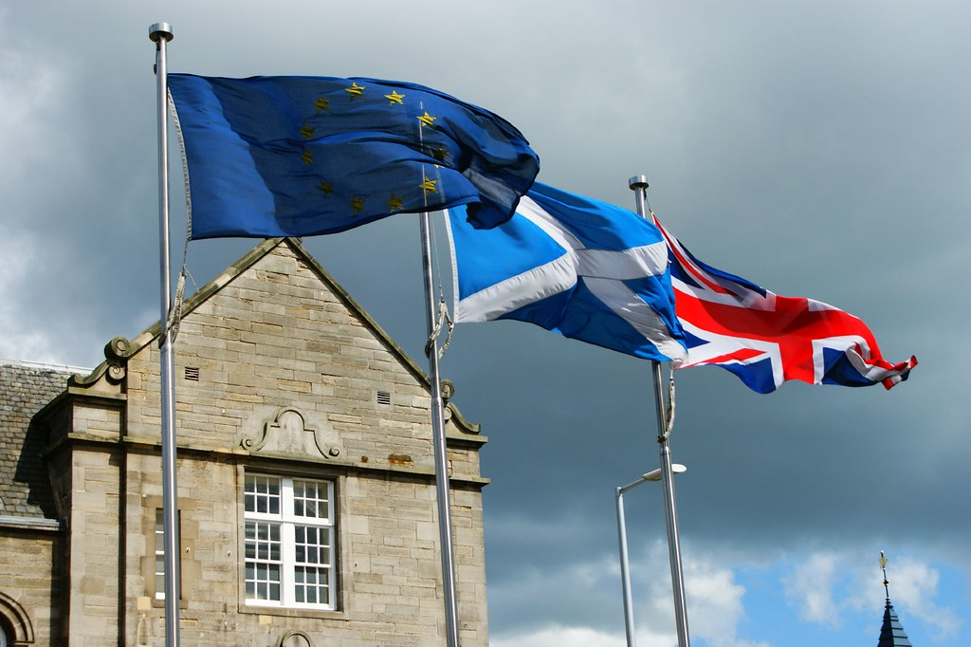
Table of contents
Identity 2
Leaving and staying 2
Financial 3
With the EU 3
Reliance 3
Borders all around 4
Traffic jams 4
Hadrian’s wall reversed 5
Today or tomorrow 5
Sources 6
Picture sources 6

Scotland’s independence from Brexit
The Scottish people have been wanting and waiting for their independence ever since 1707. Now, they are a part of the United Kingdom, like Wales, Northern Ireland and England. Together they stood as a united front towards the world, but that might change. With Brexit coming closer, Scotland needs to make up her mind.

Scotland has a lot to offer, but to whom is the question. Both staying and leaving means they will have a hard time economically; this is to be expected. Most certainly they will also suffer from having a hard border with England. There is a lot that goes into both of these. The difference is made in the determination of the people. For both possibilities are going to be hard, it is only the question if Scotland wants to stay with the UK or become independent.

Identity
Scotland is a part of the United Kingdom of Britain and Northern Ireland, the UK. But while the English consider themselves as English as British, the Scots do not. Being Scottish is one thing and British is just another box they find themselves in. And the while English, Welsh or Irish would unlikely consider themselves as European, that is just another box for Scotland. Which is the reason why Brexit is ongoing despite Scotland having voted to remain during the referendum of 2016. Independence would be the next step for Scotland. But although the choice would be to become independent. This would not be an actual choice but a carefully asked question without any actual action, the choice has already been made by the rest. (Ramsay, 2016)

Leaving and staying
Regaining your independence is a fickle thing. This is not because people do not want it, it is because people either do not know what it will involve or that their independence is not being granted. Now that the majority, 52 to 48%, of the UK wants Brexit, it leaves Scotland little choice to do anything about that. Given that England (and Wales) in itself consists of more people and thereby voters than the collective of Northern-Ireland and Scotland, who both voted remain, 56 to 44% and 62 to 38%. Historically, none of the countries in the UK besides England has had much say in politics. Even the decision of leaving is almost unavailable. (BBC, n.d.)

Financial

With the EU
After joining the EU in 1973, the UK has been able to profit from the common laws between countries and leisure in commerce to the other members. In 2016 the UK decided to leave, but as the majority of countries in Europe are in the EU, it is going to be a hard time economically, no matter the deal the UK will get. Following a report (de Vos, 2019) the economy of Scotland will most likely fall with 8% after a joined Brexit.

This is one of the reasons for why the UK has not left yet. The cabinets have cast out all deals they have been presented, not wanting a hard Brexit despite bringing it on to themselves.

There will be complications in the finances. Although remaining in the EU, there is a certainty of financial support. Still, Scotland would be in need of having a greater and bigger city to sustain the rest of rural Scotland’s spending. Both the cities Glasgow and Edinburgh are to this day too small to sustain that. Whereas Scotland could suffer from this, because of their partisanship with the EU, there is an opportunity to grow as a whole. (Spence, 2019)

Reliance
After Brexit, it is most likely that Scotland’s GDP will fall by 8%. Given that Westminster does not want to grant Scotland their independence, it has been speculated that this is one of the reasons that Scotland’s GDP has been going down since the 2014 referendum. So not only because of the oil-crisis, but also because Westminster has been refusing to invest in Scotland. Thus, making them dependent on the rest of the UK, mainly London, England. It is estimated that Scotland has a capacity for renewables worth 6 billion pounds. This green energy combined with the petroleum business could become an important source of jobs and income. (Maxwell, 2019) (Spence, 2019)

One of the other financial reasons for Scotland to stay with the EU is the promise of free healthcare with their National Healthcare System. If Scotland stays with the UK, who eventually will leave the EU, then they won’t have any security of having this free healthcare, in case of a no-deal Brexit. Not only that, but according to a report, shortages of medicines and medical supplies could last up to 6 months. (Mason, 2019)

As mentioned before Scotland partially does rely on England. However, contrary to popular belief they do not rely on England as much as one might think. “Scotland is about as fiscally independent as Yorkshire” (Spence, 2019). Scotland’s financial independence has grown and developed to being almost entirely independent today. With a continued membership with the EU, Scotland should not have to be facing trouble on the financial part. This means that Scotland has no indefinite ties to England; they can be severed easily. (Spence, 2019)

Borders all around
Beside the financial consequences there are also those of a border between the countries in question. Staying with the UK means a border over the Canal, and gaining independency means a border with England. Either way there will be quite some time lost at border controls. Although it is most likely not going to cause a big a rift as there is and was between Ireland and North-Ireland, there are going to be consequences. (Mason, 2019)

A border would come either way; be it in the Canal or between England and Scotland. It is very fortunate that these countries only border to each other and the seas around them. Had it been a more centralized country within the mainland of Europe, there would have been more dire consequences.

Traffic jams
But this also does not make it any easier. Sharing a border with the EU will not be easy to maintain. Without a good and efficient deal, the wares will take longer to cross and more expensive for the UK. For instance, will it take more time, up to days, for food to be delivered. This has caused a dilemma, as much of the food in the UK is being imported from France, Belgium, the Netherlands and others. With the current flow of traffic, even a 2-minute delay can cause a 27 km traffic jam. A shortage of food will incur either way for the UK, at least to some length, whether Scotland is a part or not. (Chibber, 2018)

A shortage would of course happen in a lesser degree in some places. There are even positive sides to this problem. Local businesses that do not require importing could thrive and thus the economy could be stabilised. Although experts and the NFU (National Farmers Union) have concluded that a quarter of farms will go bankrupt since the UK will become more reliant on imports. Medicines, food and other goods will have to be imported, ergo become more expensive. The main reason for why people across the UK are stocking up on imported goods. (Abboud, 2019)

Hadrian’s wall reversed
Should Scotland take to drawing up a border between them and England, then there are sure to be restrictions and consequences to follow. While they could still be ensured of a free marked and crossing of borders with the EU, not everything can be transported directly to Scotland. An example of a solution is to enlarge the current harbours. That way the problem of national income and jobs could also be solved. (Lydgate et al., 2019)

A border would cause the businesses near this border and transport across to vacate. The trade barrier between England and Scotland also undermines the agriculture and food distribution with different health restrictions. If the UK could make an exclusive deal with Scotland, even though they would be a part of the EU, there are many solutions to be made. Different roads to go can land them in either a rift reopened after centuries or with a good business partner.
(Lydgate et al., 2019)

Today or tomorrow
However, if you look at Scotland’s wish for independence and what would happen afterwards, there are a lot of different outcomes. There are although a lot of hurdles to get over first. Cooperation is the answer, even if there are tons of arguments and unanswered letters to be gone through. Scotland has to choose who they want to stay with in this divorce between the EU and the UK, and either way is easier and either way is harder. Just as in any fair divorce, the kid should get to choose in which house they play and should not have their hand forced by a forced relationship not wanting to let go. The difference lies in the determination of the people.

Sources
Abboud, L. (2019, September 25). British farmers face uncertainty despite ‘green Brexit’ promises. Retrieved 17 December 2019, from https://www.ft.com/content/6e159a24-be7d-11e9-9381-78bab8a70848

BBC. (n.d.). EU Referendum Results. Retrieved 18 December 2019, from https://www.bbc.com/news/politics/eu_referendum/results

Chibber, K. (2018, September 12). Brexit Britain is quietly preparing for the world’s largest traffic nightmare. Retrieved 17 December 2019, from https://qz.com/1386499/brexit-britain-is-quietly-preparing-for-the-worlds-largest-traffic-nightmare/

de Vos, V. (2019, October 5). Schotland komt op straat: "Steeds meer mensen willen liever onafhankelijk land in EU dan deel van "Brexit Britain"" Retrieved 13 November 2019, from https://www.vrt.be/vrtnws/nl/2019/10/05/schotland-na-de-brexit-meer-en-meer-schotten-zijn-ervan-overtu/

Lydgate, E., Anthony, C., & Millstone, E. (2019, November). Brexit food safety legislation and potential implications for UK trade: The devil in the details « UK Trade Policy Observatory. Retrieved 18 December 2019, from https://blogs.sussex.ac.uk/uktpo/publications/brexit-food-safety-legislation-and-potential-implications-for-uk-trade-the-devil-in-the-details/

Mason, R. (2019, December 18). No-deal Brexit: key points of Operation Yellowhammer report. Retrieved 18 December 2019, from https://www.theguardian.com/politics/2019/aug/18/no-deal-brexit-key-points-of-operation-yellowhammer-report

Maxwell, J. (2019, October 14). Scotland Could Leave the United Kingdom Over Brexit—and Green Energy. Retrieved 13 November 2019, from https://foreignpolicy.com/2019/10/14/scotland-could-leave-the-united-kingdom-over-brexit-and-green-energy/

Ramsay, A. (2016, June 14). Nine reasons Scotland is more Remain, (and what will happen if it’s dragged out). Retrieved 6 December 2019, from https://www.opendemocracy.net/en/opendemocracyuk/eight-reasons-scotland-is-more-remain-and-what-will-happen-if-its-dragged-out/

Spence, E. (2019, September 1). Scottish Independence Is Back, and So Are the Financial Hurdles. Retrieved 10 December 2019, from https://www.bloomberg.com/news/articles/2019-09-01/scottish-independence-is-back-and-so-are-the-financial-hurdles

Picture sources
Goldstein, S. (2009). Edinburgh, Holyrood House [Photograph]. Retrieved from https://www.flickr.com/photos/33278177@N00/3645306226/in/photostream/

