[Datum]
Anna Nijssen
Schoter, 2TVa
The Ferryman
Essay
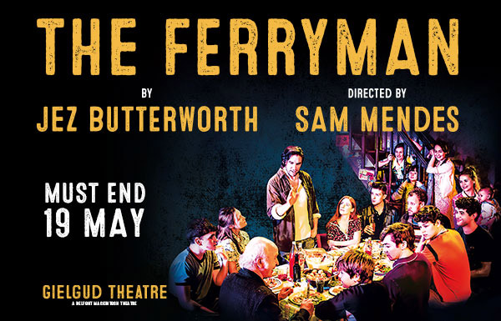

The combination of Jez Butterworth as writer and Sam Medes as director turned the play The Ferryman into a hot ticket. Jeremy Butterworth (also called Jez Butterworth) is the writer from the play The Ferryman. He is an English playwright, screenwriter and film director. He has written screenplays in collaboration with his brothers, John-Henry and Tom. He was born in March 1969, in London. Butterworth’s most recent play, The Ferryman, opened at the Royal Court Theatre in April 2017. Directed by Sam Mendes. It became the fastest selling play in the Royal Court Theatre’s history. Set in rural County Armagh in 1981 and focussing on the events surrounding the deaths of the IRA hunger strikers, it received 15 five-star reviews, including all the major UK papers. The ferryman won the 2017 Evening Standard Award for Best Play, the 2018 Critics’ Circle Award for Best Play, The 2018 Whatsonstage Award for Best Play and the 2018 Olivier Award for Best Play.
- You have to understand what the IRA (Irish republic army) is, and the troubles between Ireland and the UK. During the period in which the novel takes place, there were lots of hunger strikes of captured IRA prisoners. Northern Ireland was part of the UK, but the IRA wanted a united Ireland. In which Northern Ireland was no longer part of the UK. The IRA were mainly Catholics. The IRA was bombing police stations and other governmental institutions in London to get their way.
- In the prologue father Horrigan meats three people (from the IRA) who are trying to blackmail him to give information about the family Carney, of which Horrigan in the family priest of. The IRA wanted to know where Quinn Carney lived at that moment. Father Horrigan refused to help, but they showed him a picture of his sister and threatened to hurt her. So he had no choice and gave the address of Quinn Carney.
- Starting in act one it is harvest time for the family Carney. They have to bring in the yearly harvest of oat, wheat and barley. Three brothers of the Corcoran family came to help as they do every year. After bringing in the harvest, they have a feast called the harvest feast.
- The story is told by the characters themselves, because it is a play and not a novel. But the main character is Quinn Carney.
- Set in rural County Armagh in 1981 and focussing on the events surrounding the deaths of the IRA hunger strikers. It could not happen somewhere else, because the Irish situation between England and Ireland has a crucial role in the play.
- So Quinn Carney is the main character in the story. He faces his first problem when he gets visited by father Horrigan and told that the body of his missing brother Seamus Carney has been found. He was murdered, possibly by the IRA.
- Quinn told Caitlin that her husband Seamus has been found dead, Caitlin decided not to tell her son immediately. But her son Oisin heard the conversation. Quinn wants to know how father Horrigan knew that Seamus was found in the bog. But father Horrigan refused to tell Quinn, and that is why Quinn told father Horrigan to leave and not come back to his house anymore.
- After that they have their harvest feast. At the end of the evening Muldoon arrives with his two companions (Frank Magennis and Lawrence Malone).

Two themes:

Two motives

Two metaphors:

Conclusion:

Opinion:

Recommend:

