Bookreport
The Escape
– C.L. Taylor
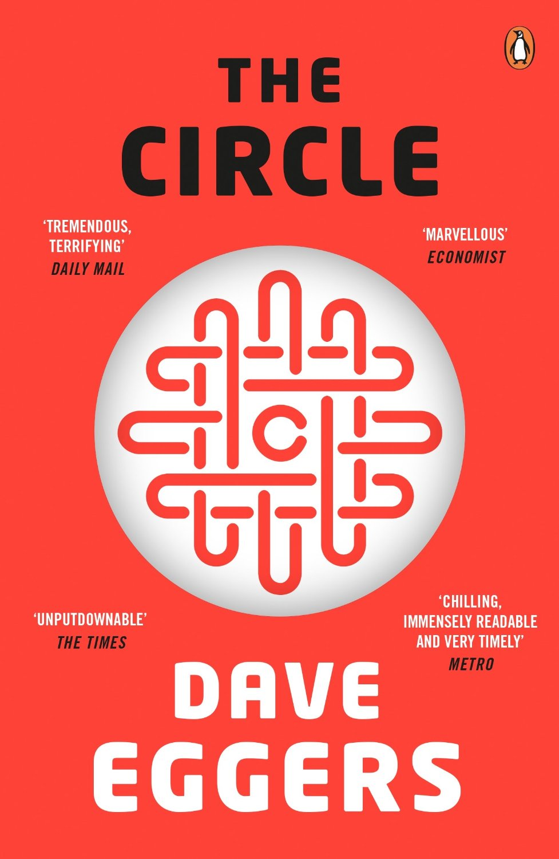
XXXX
6V2
12 January 2018
Summary
This story is about Mae Holland who is hired by the most powerful internet company in the world which is called “The Circle”. It contains a lot of details and information to serve it’s customers, which is collected from almost every electronic device you could think of.
The Circle has an awesome campus with a lot of activities for the employees to do while on their break. All seems very exciting for Mae, but when she meets Ty, the creator of TrueYou, she discovers that there are some secret’s she doesn’t know about.
Later on Mae get’s more important in the company but this hurts her family and friendships. She continues to rise as a remarkable sign in the company and she presents her ambitions to make the company even more powerful.
This all happens until a Friend of hers, Mercer, dies during a during chase where the followers of the Circle are chasing down Mercer who didn’t want to be found.
Eventually, Mae puts the bosses of the Circle, Eamon Bailey and Tom Stenton, into their own trap.

Characters
Mae Holland
Mae Holland is a girl who is the leading character in the story. She is insecure about her new job and is hurt by seeing her father having to do deal with the consequences of MS. She is naïve and does everything what the Circle wants and thinks everything the Circle does is for the greater good.

Eamon Bailey
Eamon Bailey is the CEO of the Circle, and he is kind of slippery. He is all smiles and laughs, but behind that smile hides a less friendly mastermind, which tries to convince everyone around him that his ideas need to be spread, but he keeps silent about the fact that is ideas will make him a very powerful man

Mercer
Mercer is a friendly character for Mae, who lives on countryside and he likes to craft stuff. When he meets Mae in the Circle, he starts to say what is actually wrong with the Circle. He received death threats just because Mae posted a picture of one of his craftworks with deer horns, people think he is a deer-killer now, just because of the picture.

Explanation of the title

The story is called “The Circle” because of the company name The Circle, where Mae eventually gets a job. The Circle tries to obtain power by knowing everything about everyone. The Circle tries to “complete” itself, by entering a phase “completion”. I have read a part of a bookreport on Scholieren.com (Pol, 2013), trying to compare my view, with the author, but the author missed a part I think could have a meaning in this story. I’m referring to the saying “everything comes full circle”, which means that everything is complete and which in this case means, all the information is now present and everything is known about everyone.

Opinion

I think this is a good story, it reflects on current developments about the internet and online profiles, and it let’s you think about your own activities on the internet. The story ends with a “sad” ending, instead of a happy-end, but I think this is done to show that this situation is current and isn’t yet (to be) closed, so to speak, to finish the story, but still I like to read about happy endings, but I also got to realize that not everything is a happy ending.

Tension
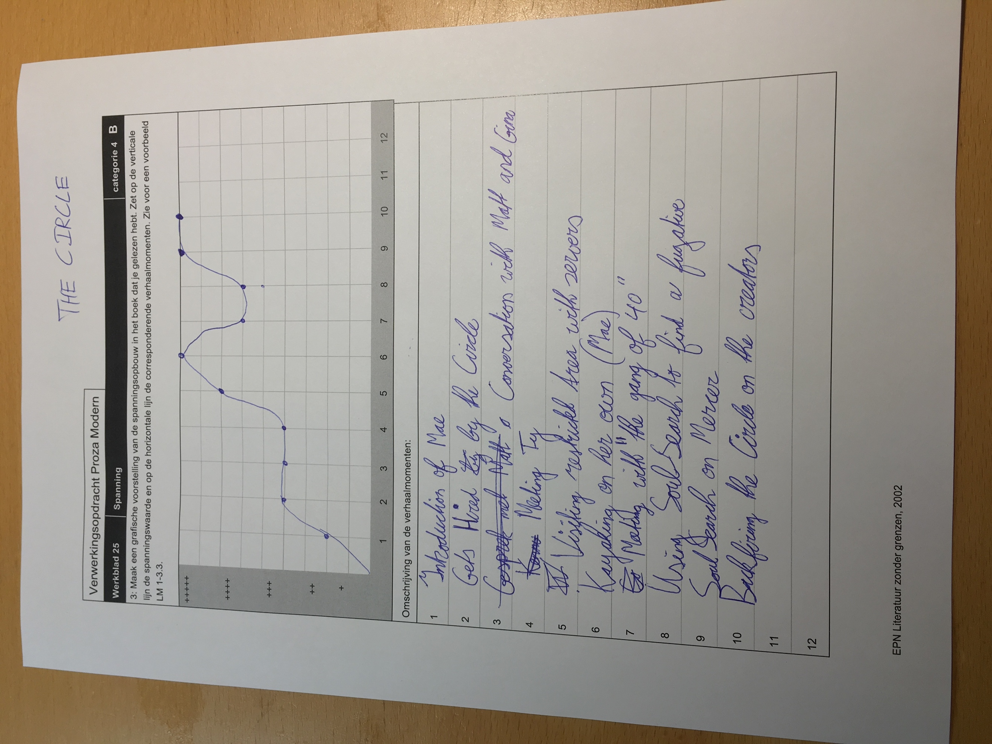
Other ending
The Circle wants to know me, but I don’t want them to know me. Nor my family. The Circle is one big database where every person starts to become nothing more than bits and bytes.
I exited the college room where the DreamFriday’s are held and made my way to the park, because I really could use a walk of fresh air.
But instead of walking, I stopped and destroyed my phone and my bracelet and started running towards the exit, the exit of the Circle. The end of the hallway, the end of this all. The end on knowing everything about everyone. I saw that Ty was there to pick me up.
Ty: “Mae!, guess what?”
“What is it Ty?”
“You know you just let me crack open the accounts of Eamon and Bailey? Yeah, this allowed me to crack the servers with the information and install a worm, which will eat all that from the inside out, until nothing is left.”
We drove away in Ty’s SUV.
Ty pressed a button on his phone.
Something exploded in the far end.
But I already know what it was that exploded.
I didn’t look back but I looked forward instead.

