Bookreport
Me before you
– Jojo moyes
XXXX
6V2
6 january 2018

Summary
The book Me before you is about Louisa and Will. Louisa is a 27 year old female who lives in a poor family which can’t afford a lot of things. Her father has lost his job at a furniture factory, so Louisa becomes the earner of the family. When she has lost her job at a café where she has worked for the last seven years, she goes to the job center to apply for a job. She has tried working in a chicken meat processing factory, but after 2 weeks Louisa resigned because the job was hard to do compared to the salary received, and the working hours where mostly during the night.
After a job interview, she is hired as carer for a 35 year old quadriplegic man named William, who is all alone and is barely able to move his arms. At first, Louisa thinks this will be a dead-end job, but this job will make her face a challenge. Will has tried to commit suicide after the accident which made him quadriplegic. William doesn’t see a bright future for him anymore and has given up hope on recovery. Louisa doesn’t want to let William commit suicide.

Characters
There are a two main characters in the book and some side characters involved in the story
Louisa Clark and William Traynor are the two main characters. There is a third character named Nathan, but I classify him as a secondary character.

Louisa is a woman from a poor family. She is sweet, caring and she seems happy. In the storyline Louisa is on one side of the battle, the side which tries to prevent committing suicide.
William Traynor is a man from a rich family. He is on the other side of the battle, since he seems distant and cold. William became injured after an accident where he was hit by a motorcycle.
Nathan is a professional caretaker from New-Zealand and is hired by William’s mother to take care him. He joins the two on multiple trips but isn’t much of a factor in this battle.

Explanation of the title
At first I wasn’t really sure what the title is about. It could be that while Louisa is trying to prevent William from committing suicide, William starts trying to make Louisa’s life a better life, so he puts the wellbeing of Louisa before his own.
But then the title would be “you before me”, but that isn’t the case. So my genius suddenly had an insight; William is so convinced of committing suicide, because he says he can’t live in a wheelchair for the rest of his life because of how good his life was before the accident. And after Louisa comes in after all this time, he tells her stories about how amazing his life was before he needed so much caretaking. So William wants to make clear of how he was before Louisa came into his life.

Opinion
It was hard for me to continue reading in the beginning of the story as it described everyday house life of Louisa, I have enough everyday house life of my own, which caused me to put the book on a shelf which was doomed to collect dust. But after a while, I started again in the story, and I read non-stop for the following six hours until I finished the book.
I find this book rather long but the story contains some moments where I zoned out and started to lock myself in my mind, thinking and comparing what I just read to my life and the lifes around me.
All the opinions on the books cover mentioned they needed tissues, but I find this rather exaggerated.

Tension
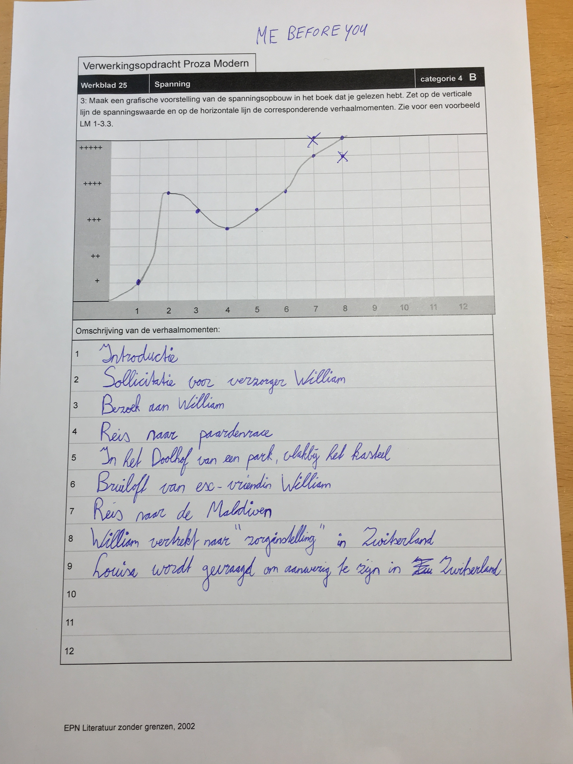

Other ending
After I finally landed in Zurich, it has already been midnight. I suddenly felt really tired, but my adrenaline caused me to feel under pressure at the same time.
The car Mrs Traynor sent to pick me up was there already. As soon as I jumped in, we drove off like we were an Ambulance responding to heart attack. We were speeding well above the speed limit, but the driver told me that we otherwise would be too late.
After the most intense carride I have ever experienced, we arrived at what seemed a big millionaire house, with multiple stories and enough space in the driveway for at least six vehicles, but my mind was racing so I couldn’t dedicate more time to my observation. I started running towards the entrance which was already open, as someone is already waiting for me. I stopped running when I was in the hallway, with these big, astonishing and symmetrical staircases, making it harder for me to catch my breath.
I screamed “Will? Will?”, but immediately after that I stopped as no one was reacting. After a couple of seconds of despair, I heard the familiar sound, of William Traynor moving happily in his chair, towards me.
While I was still in shock, he drove closer to me, until he was just as close as he could safely get, without hitting me, and he opened his mouth: “Will you be with me for the rest of my life?”

