Writing letters

VWO 5 Engels 2016-2017

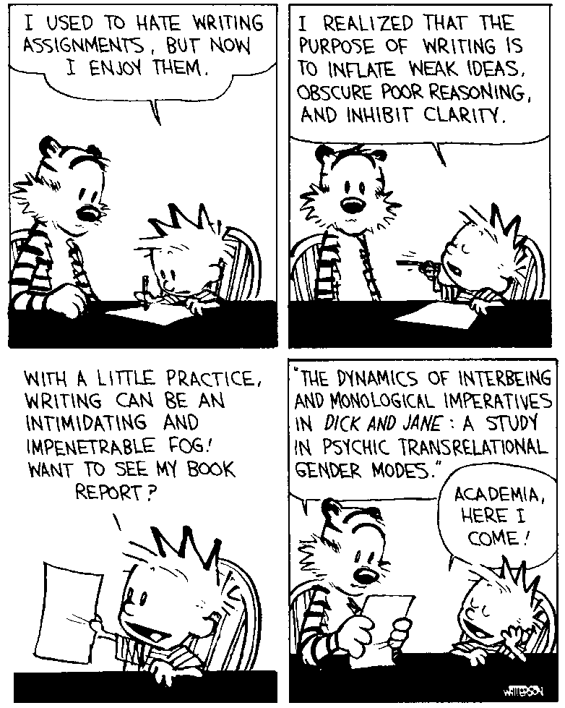

Content:

Lay-out formal letter p 2-3-4

Lay-out informal letter p 5-6

Tips and tricks p 7

Tenses p 8-9

Irregular Verbs p 10-11-12-13

Useful phrases p 14-15-16

Assignments p 17- 20

Practise Letter p 21 **Example: formal letter:**

Griftdijk 9a

6663 AA Lent

The Netherlands

3 September 2012

Mr William Jones

The Eclipse Organisation

13 Maddox Street

W1R 9LE

London

England

Dear Mr Jones,

Your advertisement in the Holiday & Travel columns of The Observer of Sunday 11 March 2001 strongly appealed to me for two reasons.

The first is that I have always wanted to spend a few weeks with an English family in order to improve the English that I have learnt at school. Your description of all the activities that can be undertaken in and around your farmstead sounded very attractive. I myself am very keen on windsurfing and swimming, and Cornwall, I am told, is ideal for that.

However, the second reason why I am writing to you is this: it occurred to me that you might need someone to help you look after the young boys and girls in your care during the summer. Since I have been a senior scout for several years, I am used to working with children aged 7 to 14.

In other words, I would like to apply for a holiday job as assistant or group leader at your farmstead in the months of July and August. I realize that there may be no such vacancy at all, but I thought it might be worth trying my luck.

I am eighteen years old and about to take my final exams. After my exams I intend to study English at a university in the Netherlands.

I would be very grateful if you could let me know whether you think you can offer me such a job. All I ask for, apart from free board and lodging, would be a small amount of pocket money. I suggest ten pounds a week. Obviously I shall pay my own traveling expenses. I enclose a photograph of myself and an addressed envelope with an international reply coupon.

I look forward to hearing from you at your earliest convenience,

Yours Sincerely,

## Karel de Vries

Karel de Vries

1:Adressering

2:Datum

3:Geadresseerde

4:Aanhef

5:Inhoud

6:Afsluiting

7:Ondertekening

Formal letter:

Start **all parts of the letter** on the **left** of the page

Leave **one blank line** between all separate parts of the letter!

1. Address: write your own address without your name. If you send the letter abroad, you also write the name of your country (‘The Netherlands’ or ‘Holland’)
2. Dates can be written in various ways:

12th January, 2013

12 January, 2013

January 12th, 2013

January 12, 2013

Avoid using too many numbers in dates because it is not always clear which number refers to the month:

12/01/2013 = 12 January in Europe

12/01/2013 = 1 December in America

All months must be written with a capital letter!!

1. Below the date write the name and address of the person or firm that you are writing to.
2. There are various options you can use here. Pay attention to the information you get from the task!

If you know the person, you can write:

* Dear Jeroen,
* Dear Mr de Groot, (if he is married or unmarried)
* Dear Mrs de Groot, (if she is married or a widow)
* Dear Miss de Groot, (if she is unmarried)
* Dear Ms de Groot, (if you don’t know whether she is married or

not)

**No full stop (.)** after Mr, Mrs, Miss or Ms

If you **do not know** the person, you can write:

* Dear Sir, (you know you are writing to a man, but you don’t know

his name)

* Dear Sir/Madam, (you don’t know whether you are writing to a man or a

woman)

* Dear Madam, (you know you are writing to a woman, but you don’t

know her name)

* Dear Sirs, (plural)

1. Your letter always consists of paragraphs.
   * Use the first paragraph to refer to something, e.g. a previous letter or a job advertisement.
   * Each paragraph should deal with one aspect of the topic you are writing about. For each new aspect you should start a new paragraph.
   * Use the last paragraph to finish the letter. You can refer to the next letter or to a meeting, for example.

Divide the body of the letter into paragraphs by skipping a line.

Do not use contracted forms in a formal letter. Instead of ***I’m, you’re, they’ve*** you should use ***I am, you are, they have***.

1. Finish your letter as follows:
   * Yours faithfully – if you begin your letter with ‘Dear Sir(s)’ of ‘Dear Madam’
   * Yours Sincerely – if you begin your letter with ‘Dear Mr Jones’ or ‘Dear Mrs Jones’ (when you know the name of the person you are writing to)

Below this, write your signature and below your signature your full name.

**Example: informal letter:**

25 Oxford Road

London, NE6 3FR

United Kingdom

5th October 2012

Dear Paula,

Oh, how I missed being with you during the holidays this year! Everything in London is so different from Spain that I don't know if I'll ever get used to living here. I'm so glad that my father's job at the Spanish Embassy will only last until June. Then we will come home, and you and I can spend the summer on the beach. (I hope you'll spend your holiday in Spain, as usual.)

I've already made some very nice friends, but don't worry - no one could ever replace you as my best friend! After school, I sometimes go to my friend Fiona's house. She enjoys listening to the same music and watching the same clips that you and I like. In fact, Fiona and I have tickets for One Direction’s concert next month. I wish you were coming with us!

Life is very different here. Would you believe that we have to wear a uniform to go to school? It's awful! A blue skirt and blazer, a white blouse and a ridiculous checked tie, not to mention a pair of horrible, long, white socks. Besides, there is nothing to do in the evening. All the shops close by 4.30 p. m. and pubs are only open till 11 p. m.

That's all for now. I must start my homework for my English class tomorrow. The teacher wants us to write an informal letter to a friend and I don't even know where to begin!

Please write soon and tell me all the news. I miss you.

Love,

Sandra

1: Adressering

2: Datum

3: Aanhef

4: Inhoud

6: Ondertekening

5: Afsluiting

Informal letter:

Start **all parts of the letter** on the **left** of the page

Leave **one blank line** between all separate parts of the letter!

1. Address: write your own address without your name. If you send the letter abroad, you also write the name of your country (‘The Netherlands’ or ‘Holland’)
2. Dates can be written in various ways:

12th January, 2013

12 January, 2013

January 12th, 2013

January 12, 2013

Avoid using too many numbers in dates because it is not always clear which number refers to the month:

12/01/2013 = 12 January in Europe

12/01/2013 = 1 December in America

All months must be written with a capital letter!!

1. There are various options you can use here. Pay attention to the information you get from the task!

If you know the person, you can write:

* Dear Jeroen,
* Dear Mr de Groot, (if he is married or unmarried)
* Dear Mrs de Groot, (if she is married or a widow)
* Dear Miss de Groot, (if she is unmarried)
* Dear Ms de Groot, (if you don’t know whether she is married or

not)

**No full stop (.)** after Mr, Mrs, Miss or Ms

1. Your letter always consists of paragraphs.
   * Use the first paragraph to refer to something, e.g. a previous letter or a job advertisement.
   * Each paragraph should deal with one aspect of the topic you are writing about. For each new aspect you should start a new paragraph.
   * Use the last paragraph to finish the letter. You can refer to the next letter or to a meeting, for example.

Divide the body of the letter into paragraphs by skipping a line.

You are allowed to use contracted forms in an informal letter, e.g. ***I’m, you’re, they’ve***

1. Finish your letter as follows:
   * Yours,
   * Best wishes,
   * All the best,
   * Kind regards,
   * Regards,
   * Love,

Below this, write your name.

# Tips voor het schrijven van een brief

**Tip 1:**

Je schrijft je brief altijd in het blokmodel. Na elke alinea **sla je 1 regel over** en begin je je nieuwe alinea **links**.

**Tip 2:**

Je behandelt **één onderwerp** per alinea. Dus: als je drie onderwerpen wilt behandelen, behandel je die in drie alinea’s. **Tip:** Begin elke alinea dan met **In the first place, in the second place** etcetera, of iets dergelijks. (zie link naar verbindings- en signaalwoorden)

**Tip 3:**

Zorg dat je de **werkwoordstijden** goed kent.

* **Onvoltooid verleden tijd** wordt gebruikt als een handeling in het verleden plaatsvond en **is afgelopen**. Bijvoorbeeld: Yesterday I wrote this letter
* **Voltooid tegenwoordige tijd** wordt gebruikt als een handeling in het verleden begon en **nog steeds voortduurt**. Bijvoorbeeld: I have worked here as a teacher for 2 months
* **Toekomende tijd** wordt gebruikt als iets nog moet gebeuren. In het Engels moet je dit altijd aangeven met **shall, will, to be going to, - ing vorm, to be to, onvoltooid tegenwoordige tijd**

**Tip 4:**

Lees de opdracht van een toets of tentamen altijd goed. Behandel ze stap voor stap en ga niet onnodig andere dingen verzinnen. Hoewel originaliteit altijd erg gewaardeerd wordt, maak je hierdoor ook kans op extra fouten.

**Tip 5:**

Bij de toets mag je een woordenboek gebruiken. Kijk altijd verder dan je neus lang is als je een woord hebt gevonden: veel woorden hebben meer dan 1 betekenis…. Zorg dat je de goede eruit pikt.

**Werkwoordtijden**

Om een Engelse zin correct te kunnen vertalen is het belangrijk om te weten wanneer je welke werkwoordtijd gebruikt. In de volgende schema’s staat wanneer je welke tijd krijgt in het Engels. De signaalwoorden worden ook vermeld. Deze verraden welke tijd je in het Engels gebruikt.

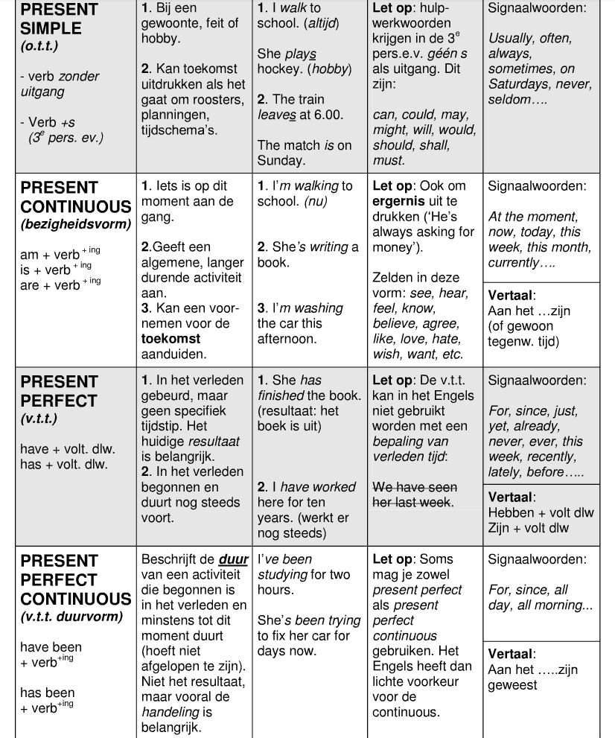

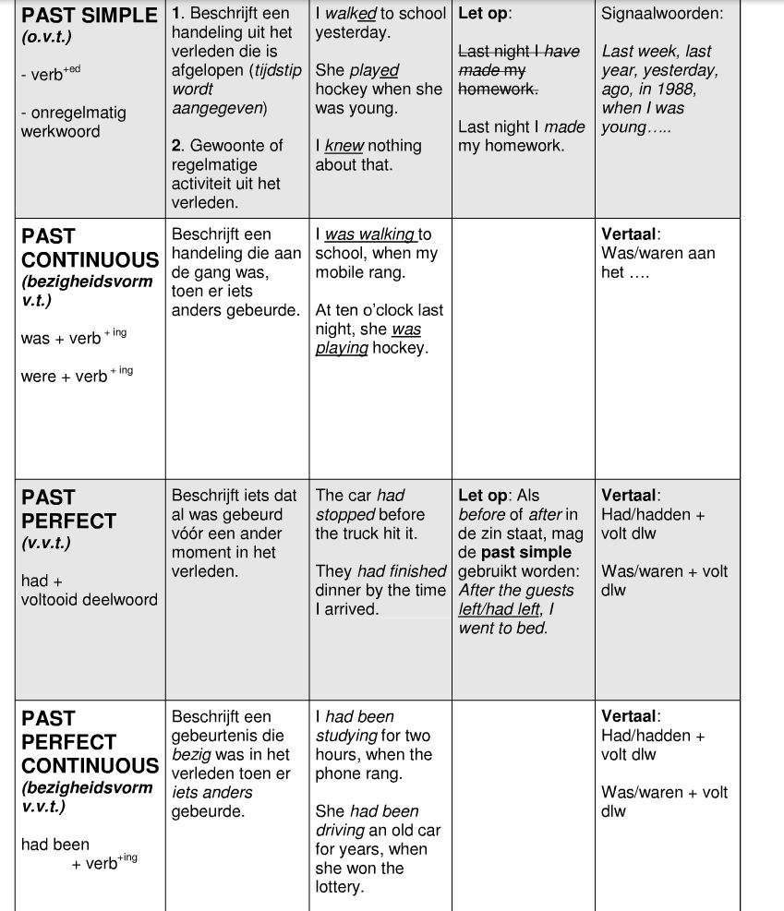

**Irregular Verbs English**

|  |  |  |  |
| --- | --- | --- | --- |
| **a** | | | |
| abide | abode / abided | abode / abided | **blijven / dulden** |
| alight | alighted | alighted | **afstappen** |
| arise | arose | arisen | **ontstaan** |
| awake | awoke | awoken / awaked | **ontwaken** |
| **b** | | | |
| be | was/were | been | **zijn, worden** |
| bear | bore | borne | **verdragen** |
| beat | beat | beaten | **verslaan** |
| become | became | become | **worden** |
| begin | began | begun | **beginnen** |
| bend | bent | bent | **buigen** |
| bet | bet | bet | **wedden** |
| bind | bound | bound | **binden** |
| bite | bit | bitten | **bijten** |
| bleed | bled | bled | **bloeden** |
| blow | blew | blown | **blazen** |
| break | broke | broken | **breken** |
| breed | bred | bred | **opvoeden, fokken** |
| bring | brought | brought | **brengen** |
| broadcast | broadcast | broadcast | **uitzenden** |
| build | built | built | **bouwen** |
| burn | burned / burnt | burned / burnt | **branden** |
| burst | burst | burst | **barsten** |
| buy | bought | bought | **kopen** |
| **d** | | | |
| deal | dealt | dealt | **handelen** |
| dig | dug | dug | **graven** |
| do | did | done | **doen** |
| draw | drew | drawn | **tekenen, trekken** |
| dream | dreamed / dreamt | dreamed / dreamt | **dromen** |
| drink | drank | drunk | **drinken** |
| drive | drove | driven | **rijden** |
| dwell | dwelt | dwelt | **verblijven, wonen** |
| **e** | | | |
| eat | ate | eaten | **eten** |
| **f** | | | |
| fall | fell | fallen | **vallen** |
| feed | fed | fed | **voeden** |
| feel | felt | felt | **voelen** |
| fight | fought | fought | **vechten** |
| find | found | found | **vinden** |
| flee | fled | fled | **vluchten** |
| fly | flew | flown | **vliegen** |
| forbid | forbade | forbidden | **verbieden** |
| forecast | forecast | forecast | **voorspellen** |
| forget | forgot | forgotten | **vergeten** |
| freeze | froze | frozen | **vriezen** |
| **g** | | | |
| get | got | got (US: gotten) | **krijgen** |
| give | gave | given | **geven** |
| go | went | gone | **gaan** |
| grow | grew | grown | **groeien** |
| **h** | | | |
| hang | hanged | hanged | **ophangen (mens)** |
| hang | hung | hung | **ophangen (voorwerp)** |
| have | had | had | **hebben** |
| hear | heard | heard | **horen** |
| hide | hid | hidden | **verbergen** |
| hit | hit | hit | **slaan** |
| hold | held | held | **houden** |
| hurt | hurt | hurt | **bezeren** |
| **k** | | | |
| keep | kept | kept | **bewaren** |
| kneel | knelt | knelt | **knielen** |
| know | knew | known | **kennen, weten** |
| **l** | | | |
| lay | laid | laid | **leggen** |
| lead | led | led | **leiden** |
| lean | leaned | leaned | **leunen** |
| lean | leant | leant | **leunen** |
| leap | leapt | leapt | **springen** |
| learn | leaned / learnt | learned / learnt | **leren** |
| leave | left | left | **(ver)laten** |
| lend | lent | lent | **(uit)lenen** |
| let | let | let | **laten, verhuren** |
| lie | lay | lain | **liggen** |
| light | lit | lit | **aansteken** |
| lose | lost | lost | **verliezen** |
| **m** | | | |
| make | made | made | **maken** |
| mean | meant | meant | **bedoelen** |
| meet | met | met | **ontmoeten** |
| mow | mowed | mown | **maaien** |
| **p** | | | |
| pay | paid | paid | **betalen** |
| put | put | put | **leggen, zetten** |
| **r** | | | |
| read | read | read | **lezen** |
| ride | rode | ridden | **rijden** |
| ring | rang | rung | **klinken** |
| rise | rose | risen | **stijgen** |
| run | ran | run | **hardlopen, runnen** |
| **t** | | | |
| take | took | taken | **nemen** |
| teach | taught | taught | **leren** |
| tear | tore | torn | **scheuren** |
| tell | told | told | **vertellen** |
| think | thought | thought | **denken** |
| throw | threw | thrown | **werpen, gooien** |
| thrust | thrust | thrust | **stoten** |
| tread | trod | trodden | **betreden** |
| **u** | | | |
| understand | understood | understood | **Begrijpen** |
| **w** | | | |
| wake | woke | woken | **wekken** |
| wake | waked / woke | waked / woke(n) | **wekken, wakker worden** |
| wear | wore | worn | **dragen** |
| weep | wept | wept | **wenen, huilen** |
| win | won | won | **winnen** |
| wind | wound | wound | **opwinden** |
| withdraw | withdrew | withdrawn | **terugtrekken** |
| withhold | withheld | withheld | **weerhouden** |
| wring | wrung | wrung | **(uit)wringen** |
| write | wrote | written | **schrijven** |

**Useful Phrases / standaardzinnen**

* I am writing this letter in response to your advert in The Observer of 25 April.
* I am a sixteen year old girl from the Netherlands.
* I am eighteen years old and I live in Leiden, The Netherlands.
* I am doing my exams at a small school in Leiden called St Augustine.
* I would like to invite you to spend your holiday in The Netherlands with me.
* I would like to apply for the position of student assistant at your organization.
* Could you please inform me about the options in your program?
* I think your organization is doing some excellent work.
* In my opinion, more people should take an interest in animal welfare.
* If it is possible I would love to receive some information about the conditions
* I could meet you on 7 July at six o’clock.
* My hobbies are sailing, shopping and playing hockey.
* Please accept my apologies for…
* It is very important for me to know if…
* Something else that I would really like to ask you, is…
* Moreover, I was also wondering whether you could tell me something about…
* Could you please tell me something about…
* Please do not hesitate to contact me if you want to know…
* Finally, I would be grateful if you could…
* I am looking forward to your response
* I look forward to hearing from you.
* I look forward to meeting you.
* If you have any further questions, please do not hesitate to contact me.

**Op deze zinnen kun je eindeloos variëren. Leer ze en zet ze in!**

**Enkele veel voorkomende standaarduitdrukkingen in een Engelse brief**

**Beleefdheidsuitdrukkingen die aangeven dat je iets wilt of leuk vindt:**

* It would be nice if…
* I would be delighted if…
* It would be wonderful if…
* I would be very glad if…
* Would you be able to…
* I would be very pleased if…
* I wonder if you could…
* How about …ing …

**Aannemen of afslaan van en uitnodiging, aanbod etc:**

* It was very kind of you to …
* I gladly accept…
* I would be delighted to…
* I would love to …
* I am sorry that I cannot…
* I very much regret that I …
* I cannot accept…
* I am afraid I cannot…

**Vragen om inlichtingen:**

* I would be very grateful if you could answer a few questions.
* I was wondering if you could tell me if…
* Could you let me know if…
* I would like to know if…

**Klagen en / of protesteren:**

* I wish to complain about…
* I feel quite disappointed about…
* I am shocked by what you…
* I insist that this should be set right.
* I want to object to…

**Aanbieden van excuses:**

* I sincerely apologize for …
* I am very sorry that…
* I regret …
* I am afraid I must …

**Feliciteren of condoleren:**

* Please accept my congratulations on…
* Many happy returns!
* Please accept my best wishes
* Please accept my condolences
* We were sorry to hear that your … has passed away
* I condole you on your loss.

**Hoe druk je een mening uit:**

* I am of the opinion that…
* In my opinion…
* I think / feel that …
* According to me…

**Solliciteren:**

* Your advertisement in the [krant] of [datum] strongly appealed to me
* With reference to your advertisement in the [krant] of [datum] I would like to apply for the post of…
* I am sending you my curriculum vitae as well as two references
* I enclose a photograph of myself…
* I would be grateful if you could let me know if…

**Afsluiten:**

* I look forward to hearing from you.
* I would be grateful for an early reply
* I thank you in advance and hope to hear from you soon.
* Please reply as soon as possible.
* Please write soon. (informal use only!)

**Enige belangrijke verbindingswoorden en voegwoorden:**

* Consequently - daarom
* However - echter
* On the one hand / on the other hand - enerzijds/anderzijds
* Unfortunately - helaas
* Moreover - bovendien
* If - als, indien
* Even if - zelfs als
* Although - hoewel
* Because - omdat, aangezien
* As - omdat, aangezien
* Since - omdat, aangezien

**Structuur**

Om je brief een goede structuur te geven, kun je gebruik maken van *linking words*.

Bijvoorbeeld: *First, second, third, finally*

*To start with, furthermore, moreover, in addition, to conclude*

Ieder nieuw onderwerp kun je beginnen met één van die woorden zodat je brief beter gestructureerd overkomt.

Als je een **tegenstelling** aangeeft kun je gebruik maken van de volgende woorden:

*However, nevertheless, yet, still, on the other hand*

Als je meer **uitleg** geeft over een onderwerp gebruik je woorden als:

*What is more, thereby, for example*

Als je een **conclusie** trekt uit iets wat je eerder gezegd hebt:

*Therefore, that is why*

Als je twee dingen **vergelijkt**:

*Similarly, also, moreover, besides*

**Assignment 1: The importance of Punctuation**

Dear Jack,

I want a man who knows what love is all about. You are generous, kind, thoughtful. People who are not like you admit to being useless and inferior. You have ruined me for other men. I yearn for you. I have no feelings whatsoever when we're apart. I can be forever happy - will you let me be yours? Jill

Dear Jack,

I want a man who knows what love is. All about you are generous, kind, thoughtful people, who are not like you. Admit to being useless and inferior. You have ruined me. For other men I yearn! For you I have no feelings whatsoever. When we're apart I can be forever happy. Will you let me be? Yours, Jill

**Assignment 2: Spelling: find and mark the mistakes in the following short biography.**

Jack Friedhamm was born to New York in October 25, 1965. He began school at the age of six and continued until he was 18 years. He then went to New York University to learn Medicine. He decided on Medicine because he liked biology when he was at school. While he was to University he met his wife Cindy. Cindy was a beautiful woman with hair long black. They went along for yeers before they decided getting married. Jack began to work like a doctor as soon as he graduated to Medical School. They had two children named Jackie and Peter, and have lived in Queens since the past two years. Jack is very interested painting and likes to paint portraits of his sun Peter.

**Assignment 3: Language in Letters**

*Which phrase or type of language would you find in a formal letter? Which phrase or type of language would you find in an informal letter? Put the letter 'F' next to those phrases or language types that are used in formal letters and 'I' next to those used in informal letters.*

|  |  |
| --- | --- |
| * I am sorry to inform you that... * I am very grateful for... * Why don't we... * I will not be able to attend the... * idioms and slang * contracted verb forms like *we've, I'm, etc.* * Give my regards to... * I look forward to hearing from you... * Let me know as soon as... * short sentences | * Dear Tom, * Dear Ms Smithers, * Best wishes, * Yours faithfully, * I'm really sorry I... * Unfortunately, we will have to postpone... * We had a little bit of luck... * Our computers are used for a variety... * I use my pencil sharper for... * polite phrases |

*Look at the phrases 1-11 and match them with a purpose A-K*

|  |  |
| --- | --- |
| 1. That reminds me,... 2. Why don't we... 3. I'd better get going... 4. Thanks for your letter... 5. Please let me know... 6. I'm really sorry... 7. Love, 8. Could you do something for me? 9. Write soon... 10. Did you know that.. 11. I'm happy to hear that... | 1. to finish the letter 2. to apologize 3. to thank the person for writing 4. to begin the letter 5. to change the subject 6. to ask a favor 7. before signing the letter 8. to suggest or invite 9. to ask for a reply 10. to ask for a response 11. to share some information |

**Assignment 4: translate the sentences**

**Mind you, do not automatically use the first meaning you see!**

1. Hoe *kom* ik bij het station?
2. Ik heb *te doen* met hem
3. Ze *halen* heel goede resultaten
4. Jouw oom was een rare vent, maar ik *mocht* hem wel
5. Het aantal *loopt* in de duizenden
6. Ik moet meer aandacht *schenken* aan de cursus die ik volg
7. Je hebt het verkeerde nummer *gedraaid*
8. De auto *ging* op dat moment veel te hard

**Translate the sentences. Mind the tenses!!!!!!**

1. Ik heb de afwas gisteren gedaan.
2. Wij zijn sinds 1978 vrienden.
3. De brieven zijn aangekomen, maar ze zijn nog niet beantwoord.
4. Twee minuten geleden heb ik haar nog gezien.
5. Ik woon al 2 jaar in Ridderkerk
6. Toen ik 2 was, ben ik verhuisd.
7. Kijk, ik heb een prijs gewonnen.
8. Toen ik drie jaar piano had gespeeld, was ik het beu.
9. Zij heeft hem nog nooit geloofd.
10. Hij heeft zijn verjaardag gisteren gevierd.
11. Vorig jaar zijn we naar Frankrijk geweest.
12. Mijn vriend John spijbelt regelmatig.
13. Hoe lang speel jij al voetbal?
14. Mijn opa is vorige maand gestorven.
15. Woon jij al lang in Kopenhagen?
16. Ik was gisteren niet thuis, dus ik heb televisie geen gekeken.
17. Ik heb twee jaar geleden het boek van die film gelezen
18. Waarom heeft de BBC vorige week besloten dat interview niet uit te zenden?
19. Toen Bob en ik door de stad wandelden, kwamen we een bekende Nederlandse soapster tegen.
20. Tijdens de vakantie hebben we om de andere dag een film gezien.
21. Toen wij naar die aangrijpende film zaten te kijken, moesten we bijna huilen
22. Waarom zijn de kijkcijfers tussen de achtste en de twaalfde aflevering naar beneden gegaan?
23. Geeft jouw lerares Engels ook altijd zoveel huiswerk op?
24. Ik heb meestal niet zo’n goed lesrooster.
25. Is jou echt beloofd dat je opslag zult krijgen?

**Assignment 5: Spelling**

**Correct the mistakes in spelling. Punctuation marks may be wrong as well!**

1. The aquaintance, who told the commitee that he was eligible, was desperate and embarrassed that his tennant had been compelled to boycott the production of bycicles.

2. Psychology, mathematics and car maintenence are compulsary college-subjects if you want to take the correspondance and literature course.

3. He could hardly distinguish the ommission the academic scolar had chosen to give an intepretation of his opponents innocence.

4. Monotenous messengers are responsible for not quitely recommending sufficient rhythm and air-resistance in diciplined and colloquial bussiness language.

5. Have angles got an appetite for awkward deserts when they are hungry

or do they only excel in exaggerated airoplane imitations.

6. If you have not been inocculated against nuckle diseace, it's absolutely neccesary to wear wooden shoes or woolen socks.

7. There's no necessity to apologise for having made fourty errors in that pronounciation excercise, except for the fact that you couldn't say the word thourogh.

8. The librarian had to seperate all similar vehicles simultaneousely.

9. Knowledge of the succesfull principle of lightning is a asset when you want to compete with others in conscientious espionage.

10. He had hid his head, and especially his forehead which he had covered with a hat, was bleeding severly?

**Assignment 6:**

Read the English letter below. Correct all the mistakes you can find. Then use the correction model to ‘grade’ the letter.

----------------------------------------------------------------------------------------------------------------

Peter Janssen  
Dorpstraat 15  
4123 AB Utrecht  
The Netherlands  
  
Peter Janssen  
Calle del pueblo 15  
4123 AB Girona  
Spain  
  
december 30, 2012  
  
Dear Sir janssen.  
  
I am writing this voorbeeldbrief to you, because I need a example to explain the way a English letter is written. Further explaination of this matter will follow in the second share of this letter.  
  
As U might know write a English letter don’t come easy to everyone, because they are not using to writing a letter in this language. However, everything that is difficult at first can improve and make easy. Last year i have created a website on wich i help the visitors by giving tips and exampels.  
  
I hope you don’t mind me to send you this letter and adding it for the website. I hope to hearing from you soon!  
  
Yours sincerely,  
  
[Handtekening]

Peter Janssen

Schrijfvaardigheid Oefenbrief 1

Je gaat een brief schrijven aan je penfriend Robin (M/V) die je al jaren kent. Afgelopen zomervakantie is hij/zij nog bij jou op visite geweest en hij/zij had je inmiddels alweer een lange brief geschreven die je nog steeds niet beantwoordt hebt. Je gaat dat nu dus doen (eindelijk!).

Verwerk de volgende punten in je brief (en let op dat je je goed aan de opdracht houdt):

* Bedank voor Robin’s brief die je al vorige maand ontvangen hebt en bied je **excuses** aan dat je nu pas terug schrijft. Geef 2 goede redenen waarom het terugschrijven zo lang duurde.
* Vertel dat je in je **eindexamen** jaar zit en geef aan of je denkt wel of niet te zullen **slagen**, geef ook 2 redenen voor die mening. Noem 2 vakken die je makkelijk af zullen gaan en noem 2 vakken die wat moeilijker voor je zijn. Vraag welke **vakken** Robin lastig vindt en of hij/zij denkt te gaan slagen.
* Zeg dat je dit jaar 8 boeken voor Nederlands moet lezen en ook 2 voor Engels. Vertel hoeveel je al gelezen hebt en geef aan of je lezen belangrijk vindt en vertel ook waarom (niet). Voor Engels moet je **trouwens** ook 5 teksten uit WASP magazine lezen en er opdrachten bij maken. Vertel of je dit zinnig vindt of niet en vertel ook waarom.
* Verander van onderwerp. Volgende week zijn er **verkiezingen** in Nederland en het is deze keer **opvallend** hoe veel lijsttrekkers met een **zelfgeschreven boek** komen. Vertel of jij een van die boeken wilt of gaat lezen en vertel ook waarom. Geef je mening over die politieke boeken: zijn ze zinvol en helpen ze in de **verkiezingsstrijd** of niet? Hoe moet een **politieke partij** volgens jou reclame maken voor zichzelf?
* vertel of je **interesse hebt in** politiek en geef ook aan waarom (niet). Zeg of je zou gaan stemmen als je 18 bent en zo ja, vertel dan ook op welke partij je zou willen stemmen. [als je als 18 bent: ga je stemmen en zo ja, op wie]
* genoeg over politiek, zeg dat je de week dat Robin bij jou was super leuk hebt gevonden. Haal 2 leuke/opvallende herinneringen op aan iets wat jullie meegemaakt hebben. Zeg dat je je **verheugt** om in de kerstvakantie naar Robin te gaan en dan samen Londen in te gaan. Noem minstens 2 dingen die je zou willen doen of zien in Londen.
* zorg voor een passend slot

**Instructies:**

* Gebruik 210 woorden
* Maak eerst een kladbrief en daarna een nette brief, lever beide versies in!
* Schrijf duidelijk en leesbaar
* Noteer het aantal woorden linksboven in de kantlijn van je nette versie
* Laat na iedere alinea een regel open
* Zorg dat je alle elementen uit de opdracht in je brief verwerkt
* Gebruik de juiste Engelse vertaling van de dikgedrukte woorden uit de opdracht
* Houd je aan de conventies voor het schrijven van een brief
* Bij de beoordeling wordt er niet alleen op gelet of je taalfouten hebt gemaakt, maar ook of je brief een goedlopend geheel is. Verder wordt beoordeeld of je je aan de opdracht hebt gehouden
* Het gebruik van een woordenboek is toegestaan!

**Succes!!**