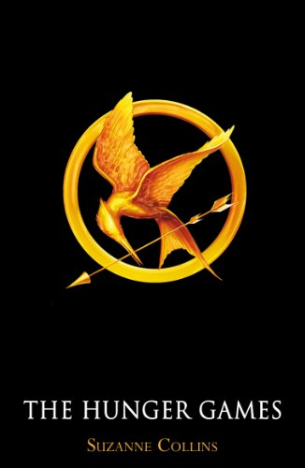
The Hunger Games - Suzanne Collins

1.Titel:
- The Hunger Games
- x
- x
- The titel is chosen because the book is about the hunger games, she is a tribute in the hunger games.

2.Writer:
- Suzanne Collins
- Real name
- x
- x

3.Publication:
- It was released on 14 September, 2008.
- No, it isn’t.

4.Genre:
- The genre is dystopian, that means that it’s set in a time and place where everything is wrong and horrible.
- Young adult.

5.Setting in place:
It’s set in a place that was created after the government of the USA collapsed, that country is Panem. Panem has 12 districts and the Capitol.

6.Setting in time:
- It’s set in an indefinite time more than one hundred years in the future. It’s important to know when it’s set because it’s about something that has never happened on this earth before, but it could happen in the future.
- A couple of weeks/ months.
- Yes.
- No, there are flashbacks in the story.
- Yes there are flashbacks. for example: about her dad (he died in a mine explosion), how she met Gale and how she met Peeta.

7.Narrator:
- The main character (Katniss Everdeen) narrates the story, so it’s first person.
- No, the only narrator is Katniss.

8.Style:
- Her writing tone is a little bit stoic but sometimes it is very emotional. It is easy to read but her style can be very melancholy. The way that she describes things is very detailed and very plausible.
- The story is written for young adults so I think that her writing style is very suitable for the target-group.

9.Organisation:
- The book is divided in three parts with nine chapters each.
- The tree parts divide the story in different parts but it is not really important to understand the book.

10.Theme:
- The first theme is: the inequality between the rich and the poor people
The second theme is: the way you look/ your appearance is very important.
The third theme is: that some people have to suffer to entertain the rest.
- I have read the book a few years ago in Dutch, so I don’t know if the book has changed my opinion because I can’t remember it.

11.Characters:
Main characters:
Katniss Everdeen:
She is the female tribute of district 12, she tells the story in her perspective, she is a hunter and is very good with a bow. Her dad died when she and her sister were very young, her mom got ill so she had to take care of her family. They were starving but a boy gave them some bread, from that moment on she was a bit stronger and went into the woods to hunt. There she met her best friend Gale. Before the games she doesn’t really change but during the games she finds out that she had feelings for Gale but is also developing feelings for Peeta.
Peeta Mellark:
He is the male tribute of district 12, he is the son of the baker who gave Katniss the bread that kept her and her family alive. He was in love with Katniss for almost his entire life, but Katniss never knew. He is very good in painting and is very helpful.
Haymitch Abernathy:
He is the trainer of Peeta and Katniss. Most of the time he is drunk. He really supports the love act between Katniss and Peeta because if people would like them, they would give them food and supplies that they need. His way of communication is very limited but Katniss understands what he means, Peeta doesn’t. At first he seemed like a person who couldn’t help them but he proved himself to be a really good trainer at the end.
Effie Trinket:
She only cares for her own career but in the end she did care about her tributes.
Gale:
Back in district 12 he was Katniss’s best friend and her hunting partner. When Katniss was around him she was able to fully be herself.
Prim Everdeen:
She is the sister of Katniss, she was picked to be the tribute but Katniss volunteered to go in her place.

12.Fiction:
The story is fiction because Suzanne Collins made up the story, it isn’t realistic in this time.

Source:
http://www.sparknotes.com/lit/the-hunger-games/

