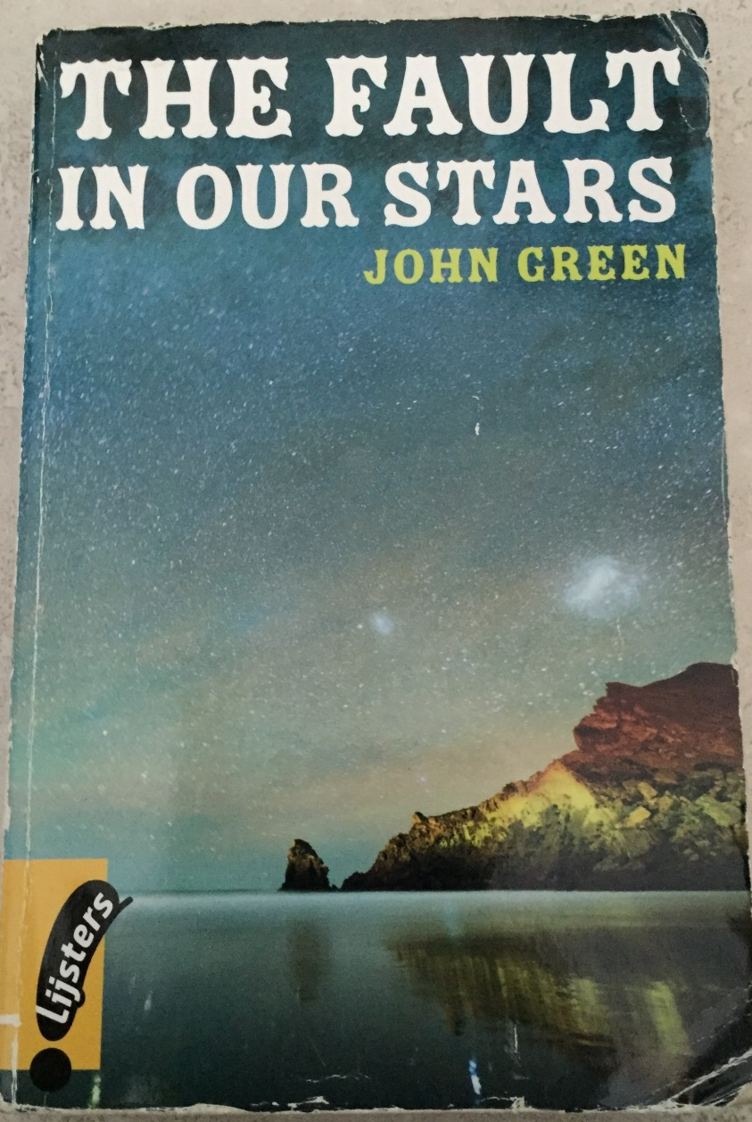
The Fault in Our Stars - John Green

1.Titel:
- The Fault in Our Stars
- x
- “As the tide washed in, the Dutch Tulip Man faced the ocean: ‘Conjoiner rejoinder poisoner concealer revelator. Look at it, Rising up and rising down, taking everything with it.’ ‘What’s that?’ Anna asked. ‘Water,’ the Dutchman said. ‘Well, and time.’ — Peter Van Houten, An Imperial Affliction.
- In a letter Augustus had received from Van Houten he used a quote from Shakespeare: "The fault, dear Brutus, is not in our stars, but in ourselves, that we are underlings." Van Houten says that Shakespeare was wrong; they have cancer because of a fault in their stars.

2.Writer:
- John Michael Green
- Real name
- x
- x

3.Publication:
- The book was published in 2012.
- No, it isn’t.

4.Genre:
- Young adult
- Young adult

5.Setting in place:
She lives in Indianapolis and she went to Amsterdam with Gus. Yes it’s important to know because she had to fly from America to Amsterdam, they didn’t have money so they used Gus’s wish.

6.Setting in time:
- It was never really mentioned when the story happened but based on the setting in place and the physical setting it must have taken place in the period between 2008 and 2012.
- It all happened in a couple of months.
- Yes, it is.
- No, there are some flashbacks.
- Yes there are.

7.Narrator:
- The story was told in first person by the main character Hazel Grace Lancaster.
- The only narrator is Hazel Grace except in the letter from Gus it is in his perspective.
It shows how Gus felt the whole time.

8.Style:
- It’s very straightforward but also very thoughtful, Hazel is thinking a lot about existential questions. She uses a lot of adjectives.
- It’s not really hard to understand so it fits the target-group.

9.Organisation:
- It’s divided in chapters.
- It is not important to understand the book.

10.Theme:
- 1) The Necessity of Suffering.
2) Fear of Oblivion.
3) The Insensitivity of the Universe.
- No, it hasn’t.

11.Character
Hazel Grace Lancaster:
Her physical development is that she grows weaker, you can notice that in the fact that she used the stairs to her Support Group in the beginning of the story and in the end she used the elevator. Her mental development is that in the beginning of the story she doesn’t want people to get close to her, because her death will hurt the people close to her, she called herself a ‘grenade’. This fear is mostly for her mom, when everyone thought that she was dying she overheard her mom saying if she dies she won’t be a mom anymore. And this fear really makes her want to know what happened to the characters at the end of her favorite book An imperial Affliction. She needs to know how it ends to make sure everything turns alright for Anna’s mom and she can convince herself that her parents will be okay too.
When she is in her relationship with Gus she changes her perspective. When Gus’s cancer comes back she knows that he is the grenade of the two of them. After his death, she was in a lot of pain but she thinks that the pain was worth it and still is.
Augustus “Gus” Waters:
In the beginning he is ‘Augustus’ he is a strong and confident boy, he loves using metaphors of his own health and death, like jumping on grenades in video games to save other people.
But when his cancer came back, he dropped the performance an he became ‘Gus’. Gus is the side of him that his parent knew. Hazel learned his nickname from his parents. She starts calling him Gus instead of Augustus. She discovers that Gus is actually a really sweet and loving boy, where Augustus, the boy she first met, is more self-confident and tough.
Isaac:
He is a friend of Augustus and Hazel, he attends the support group too. In the beginning he still had one eye left, but he had to have surgery to remove his second eye. His girlfriend broke up with him after he told her he was going to be blind. His name is the same as Isaac from the bible who was blind as well.
Mrs. Lancaster:
She is Hazel’s mom. She is a strong and kind mom who cares for Hazel. Hazel is very scared that she will hurt her mother when she dies, at the end she is really happy that her mom is becoming a social worker. Hazel said that she would be a great Patrick.
Mr. Lancaster:
Hazel’s father. He cries a lot, in contrast to her mom. He spends a lot of time at work.
Peter Van Houten:
He is the writer of An Imperial Affliction. They went to Amsterdam to meet him but found out that he was a drunk and a rude person. He is a huge disappointment for Hazel because she waited for this moment a long time.
Patrick:
He is the leader of the support group, he suffered of cancer when he was young as well.
Augustus’s parents:
They are kind and smart people, at the end of the book Augustus’s father told Hazel about how great it is that she has been a part of his son’s life.
12.Fiction
It is fiction but some parts of the story could be true.

Source
http://www.sparknotes.com/lit/the-fault-in-our-stars/summary/

