Into the wild

John Krakauer

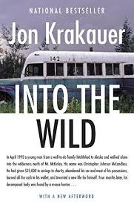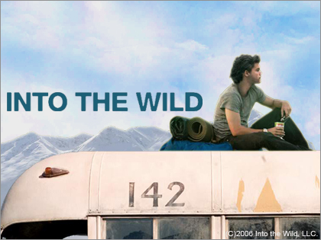

Into the wild. A book, a movie, but most of all, a real happened story.

A story where the 22 years old Chris McCandless choses to let everything he has behind. He wants to go *into the wild!* So with a little bit of resources, he decides to go to Alaska. Not America Alaska, no, Alaska Alaska as he says. After a beautiful journey, he arrives at his final destination. Lives there and dies there on one of the most terrible ways.

The setting of the book mostly is in the western portion of the United States. But also in Alaska, Mexico, and Virginia. All the things that are happening in the book span various years but all the most important events take place in the 80s and 90s.

The type of narrator what this book has is the third-person: the story is being told by John Krakauer. Who made the whole trip himself to get the story. Each chapter there is a text that is written or said by someone who Chris met at his journey ore by someone who wanted to write something about it in form of a poem. Actually, I am not that great fan of a third person-book because it is harder to be in/with the story and the characters. But this book is just too beautiful to not be in the story. To not feel what is going on.

I think one of the important themes is the ultimate freedom. Chris McCandless describes what he is looking for on his odyssey, “ultimate freedom.” Chris McCandless is looking for himself while being free. He leaves everything behind because he doesn’t want to live that life anymore. He just wants to do whatever he can do and live. Not to be a prisoner of his ‘normal’ life. to be alone in the nature itself. The second one might be to live in the nature itself. Chris McCandless loves the nature, the wild, books about the nature, discovering the nature and the wild. Just to find out who he is. But the only problem is that he spends a little too much time to find food and other resources that he doesn’t get all of his questions answered.

For me this is the most inspiring book I have ever read! And I am really looking forward to do the same as Chris McCandless, except for dying of course. This story wants you to read the story without quitting. And that is what I did. I would really recommend this book. There is no better reason than everything above this text to read it. It tells you a story about money that you just don’t need, about finding answers for yourself while being alone in the wild. 10 out of 10 for me.