[Datum]
Anna Nijssen
2TVa
The outsiders
Essay
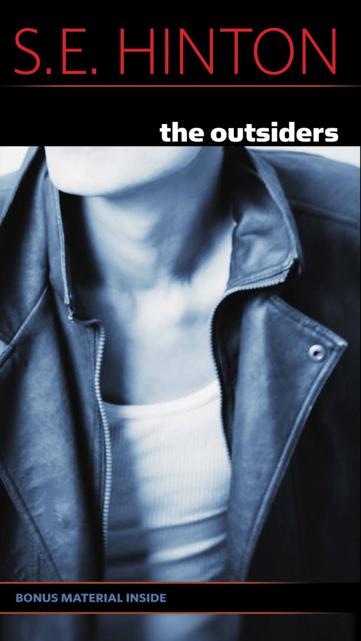
Essay The Outsiders
This book shows the struggle between rich and poor. The two main groups of the story were the Socs and the Greasers. The name Socs is short for ‘’socials’’. The Socs are the upper class while the Greasers are the poor ones that dislike the Socs because they have more money, better cars, and act like they are better than the Greasers. Ponyboy Curtis, a 14-year-old Greaser, tells the story. Other characters include Sodapop and Darry (Ponyboy's brothers), Johnny, Dallas, and Two- Bit, that were also gang members and Ponyboy's friends.
This book is great, but if someone had told me about the topic of this book before I read it, I don’t really know if I would chose to read it. Because it wasn’t really a topic what I find interesting. At the beginning of the book I thought that it would be a really boring book. But the more I read, the more I liked the book. First I couldn’t identify myself with the main character Ponyboy, but after a few chapters I could.
The writer of the book The Outsiders is Susan Eloise Hinton. She was born on July 22, 1948. She is an American writer, best known for her young-adult novels. Especially the book The outsiders, which she wrote during high school. The Outsiders was inspired on two rival gangs at her school.
The main character is Ponyboy Curtis who is the one who tells the who the story. Then there is Johnny who has a small role in the beginning but becomes more important at the end. The two brothers, Sodapop & Darry are also very important for the main character. Dally plays an important role when Johnnie and Ponyboy were fleeing for the police, because Dally gave them two guns and some money.
The title of the Outsiders is about the Greasers, because the Greasers are a kind of outsiders of the civilisation. Greasers are people to look up on, to look down to, to not trust. The police would take Dally into questioning regularly, just because he was a Greaser.
I think theme one is loyalty. Loyalty, according to Ponyboy, it the thing that holds the gang together. He doesn’t like some of the people in his gang, especially dangerous Dallas Winston, but he would still do anything for Dallas, because he is loyal to the gang. The gang is loyal to each other because they know each other well. They grow up together and faced all the hard times together. Ponyboy doesn’t trust his oldest brother that well. Other people said to him that that is not true. In the end of the book, he got to see that his oldest brother does love him, and that he gave up a lot for Ponyboy. The loyalty between Ponyboy and his oldest brother Darry grew a lot in the book.
One day, the main person of the book, Ponyboy, went to a movie. He met two girls (Socs), and he and johnnie walked back home together with the girls. They met some other Socs. They were not happy that Ponyboy and Johnny picked up their girls. When Ponyboy came home, Darry wasn’t happy that he was too late. So Darry hit Ponyboy, Ponyboy walked away, in the park he and Johnny met again with the Socs. When one Soc tried to drown Ponyboy, Johnny killed the boy to save Ponyboy.
I think theme two is misunderstanding. There is a lot of misunderstanding in the book. For example, Sodapop tries to explain to Ponyboy that Darry really does love him, but he just doesn’t know how to show it. Ponyboy didn’t believe it at first. But in the end of the book Ponyboy saw that Darry does love him. Second example, Ponyboy and Cherry (a Soc), try to piece together an understanding of the Socs and the Greasers. It’s hard for them because all their lives they’ve been taught to hate the gang they don’t belong to. They begin to realize that the two groups aren’t nearly as different as they thought they were. There are a lot of misunderstandings
The climax in this story is when Johnny kills the Soc. After that everything changes. Ponyboy and Johnny were searched by the police now. Dally helped Ponyboy and Johnny by giving them guns and money. Ponyboy and Johnnie went to a church, that is where they slept for five days. Then on one day, Ponyboy and Johnnie saved a few children. The people said that they were heroes. When they told the whole story to the people, they couldn’t imagine that it was the case. The Socs change their way of fighting and they want revenge. One of them (Randy) doesn’t want to fight and he makes peace with Ponyboy at the end.
This book takes place in an American village. I think this novel can’t happen everywhere, because you need a village with a lot division between rich and poor. I don’t think there are places in countries in Europe, with this kind of division and problems. Maybe there are, but I can’t imagine that.
I think this was a really nice book to read because it tells a story about two groups which could really happen. It also describes every situation very well, so you can understand very well what the main character feels.
But this book was also very hard to read, because it was written down in the way how people really say it. So the English is hard to read, but after a little while I got used to the street language they used in the story. So I definitely recommend reading this book to people from twelve years old or older.

