6-3-2017
Percy Jackson
Essay
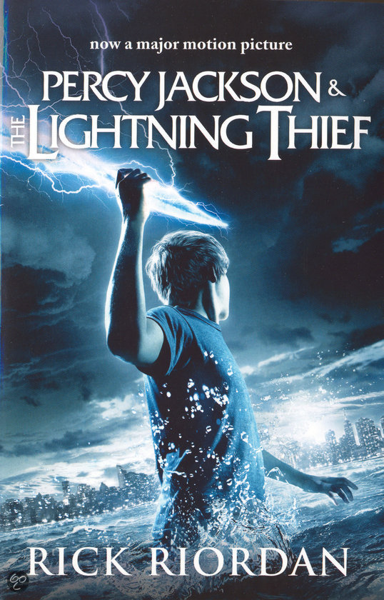
Anna Nijssen
klas 1TvA
6-3-2017
Essay Percy Jackson
The writer from the book Percy Jackson is Rick Riordan. Rick Riordan was born on the fifth of June 1964. He wrote a lot of books. He wrote also the award winning Tres Navarre series, intended for adults. First he was a history teacher, for 15 years, at different schools. I think that that is the reason, that he writes books about history (for example the Greeks). Now he lives with his wife and two sons in Boston. The books of Percy Jackson are one of the best series that he wrote. For example, the fourth book from Percy Jackson sold more than 1 million books! He created the idea for the Percy Jackson series as bedtime stories about ancient Greek heroes for his son Harley. Harley has ADHD and dyslexia and this has the main character also.

In the beginning Percy (the character) is at school, he went on a school trip. He doesn’t have good experiences with school trips. He is also a lot of times suspended from school. When he went to the school trip he defeats his mathematics teacher, because she changed in a monster. He discovered who he was. The son from Poseidon, the sea-god. He went to camp half blood. That is a camp for children that are half god and half man. His friend is called Grover, he was first also on the same school as Percy and tried to guard him. When Percy knows who he is and went to camp half-blood Grover also goes to camp half-blood.

For me the climax of the novel is when Percy went to camp half-blood. Before the climax I thought: ‘what is this a strange story’. That is the reason that I didn’t want to read further, but after the climax I knew the line of the story and why the strange things were happening. Than I thought: ‘let’s read further, because it is a great book’.

One of the themes is the identity. In the story there is a lot to do about identity. At the beginning of the story Percy doesn’t know who his father is or which special powers he has. So identity is very important in the story. There was also said that Percy is going to be betrayed by a friend. So he doesn’t know who he can trust.

This novel can happen everywhere, because the only thing that is important is that there is a camp half-blood, but the camp can be everywhere. The people are also travelling, and the entrance from the underworld can also be everywhere. In a fantasy book it is difficult to know if it the story can happen on another place.

Suddenly the Lightning bolt from Zeus is stolen. The gods thinks that Percy stole it, but that isn’t true. So he went on a quest to prove his innocence. He hopes that he can find the lightning bolt and bring it to Zeus, because when he doesn’t do that he gets the blame and there will be a war between a few gods. Percy thinks that Hades has stolen the bolt, so he went to the underworld. In the underworld are a lot of monsters and it is very dangerous there. But Hades didn’t steal the bolt and his helmet is also stolen, he thinks that Percy did that, but that isn’t true. So he must go back to the normal world. But his mother is also in the underworld and Percy wants to have his mother back, but he has only three pearls. One for Percy, one for Grover and one for Annabeth, so zero for his mother otherwise someone must remain in the underworld. There is no other option, he goes without his mother to the normal world.

When he is again in the normal world he see Ares (the god of the war). He finds out that Ares has stolen the bolt and the helmet. Than Percy fights with Ares and Percy win. Than he gives the bolt to Zeus and the Helmet to Hades, and goes to home. But suddenly his mother is there. Hades had freed his mother, because he was happy that he has his helmet again.

The second theme is loyalty. For example, the god of the war seemed to trust, but he wasn’t, because Ares (the god of war) said that Percy must do something and Percy did that. But then Ares did another thing then Percy hoped, and they goes fighting. Fortunately Percy won.

The story is wrote in the I form. You see the story all the time through the eyes from Percy. You don’t see the story from the side of Annabeth and Grover. You don’t know the opinions from Annabeth and Grover.

The age group is 12, because in (I think) the book Percy Jackson is around the 12, and his friends also. But I think that you can also read it when you are 10, because the book is exiting, but not too much exiting. So for that reason, I think the age group is 10 and older. The book is also easy to read, there aren’t very difficult words in the story, so it is easy enough for younger persons than I. But I think it is also a great book for people with an age of 14.-

My opinion is that it is a very great book, because it is exciting and I love exiting books. I like it also because it can’t be real, a book with a real story is often boring! So I love fantasy books. I like it also because the book is always exiting, there is never a dull moment in the book.
I recommend the book to everyone, because you learn a lot of the Greek gods and it is a very great book. But I can imagine that there are people who don’t like this book, they probably thinks ‘What is this for a strange story, a boy who is a half-god and his mother came back out the dead and the boy jumps from a building and came into a water pool that is far away from the building! And as icing on the cake, he can breathe under water and under water came a messenger from his father! That is very realistic!’. But to my opinion that is exactly the funny thing in fantasy books!

