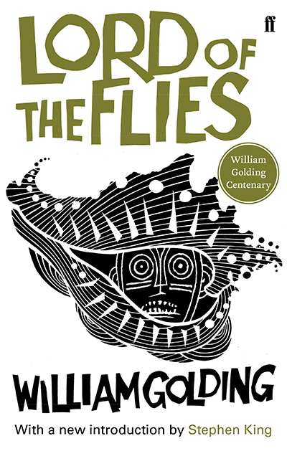

Title: Lord of the Flies
Author: William Golding
Name: Quinty Mastop
Class: 5Hc
Teacher: A.D. Oldeman
Subject: English
Assignment: Writing to an author
Date: 27-01-17

Introduction

This is my first media file this school year. The book I chose is called Lord of the Flies. It was first published in 1954 and the idea after the story (by William Golding) was,
‘’wouldn’t it be a good idea to write a story about some boys on an island, showing how they would really behave, being boys and not little saints as they usually are in children’s books.’’

I wanted to write a letter in which I could share my thoughts, compliments and questions over the book to William Golding. So that’s the reason why I chose to do this specific assignment.

On the next page you’ll find the letter, that’s all I can tell you for now.
Enjoy my media file!

Writing to an author

publisher, gapermissions@faber.co.uk

Dear William Golding,

At first I would like to introduce myself. My name is Quinty Mastop, I am sixteen years old and from The Netherlands. I live in a small village called Reeuwijk. I have two dogs and I love to take a walk with them in the forest, especially now that all the trees are losing their leaves. I also like listening to alternative music, hot chocolate, go shopping, watch a movie and most importantly, have fun with friends. I am a senior at High School and for the subject English we all made a media file and read a book from the list. I chose your book ‘Lord of the Flies’ because I heard it was a surprising best-seller. The extra assignment I wanted to do was to write a letter to the author of our book. I have a lot of unanswered questions and thoughts that I wanted to share with you. That is the reason why I am sending you this email today.

I read the Lord of the Flies because it was recommended by a friend. She told me that it was written in a fine way and easy to read in a short time. It took me 2 weeks to read it from the beginning to the end and that is fast for me, because English can sometime be a little hard for me to understand. At the beginning of the book I was annoyed, because the reason why they had end up on the island was obscure. But I also got sympathy for Ralph, Piggy and their camp. They tried to survive in an organized group, but there was this stupid selfish kid named Jack who wanted everything his way and was willing to kill people for it. Sometimes I had to read a page over, because I couldn’t believe events as, Roger who rolled a big stone that knocked piggy off the cliff onto a flat rock in the sea, then felt from a cliff and died bursting his head open. That part of the story was incredibly sad and I hoped a little that Ralph was maybe still able to save Piggy’s life but Ralph had to hide for Jack and his soldiers himself. I almost forgot that the story was about boys between 6-13 years old. I really didn’t expect these happenings in the beginning of the book. I really liked Piggy, because he came across as a smart, wise and loyal boy. Unfortunately, he died and I have to get over it, but he could’ve died more peaceful. If I were stuck on an island I would search for food, good water and materials to signal to the world out there to get of the island and try to make friends. The respectful last words about Piggy in the end were very beautiful. Great way to end the book.

What I have taken from the deeper meaning of the story is that every human being entered a certain depravity and badness in his nature. In this story the author shows the reader what will happen when a person is free of the rules. Primitive instinct that occurred in the time of farmers and hunters stand above compliance standards when there is no adult around. In our society rules and discipline ensures that everybody behaves, as soon as fail people can’t control themselves. Especially kids, they are always searching and challenging the boundaries. On the island the boys didn’t had any boundaries so they did where they were looking for. There might also have been a little war influences in the story, because the story seemed to take place during a nuclear world war and that is also why they ended up on the island in the first place. They had to evacuate for the war in Great-Britain , but sadly the plane crashed and that is how they got on the Island. There were also a few social problems going on between the boys. Besides all the low facilities, there was a lack of order and a rebellion was started by Jack and his followers.

What was an early experience where you learned that language had power? I saw that you wrote more books and every writer has of course his own way of writing, but are you trying to build a body of work with connections between you books, or do you want each book to stand on it’s own?
If you were able to do something differently as a teenager of child to become a better writer as an adult, what would you change? And last but not least, how many half written of unpublished story’s do you have?
I look forward to your answers and I hope to be hearing from you soon.
I wish you all the best and good luck with your upcoming stories.

Yours sincerely,

Quinty Mastop

