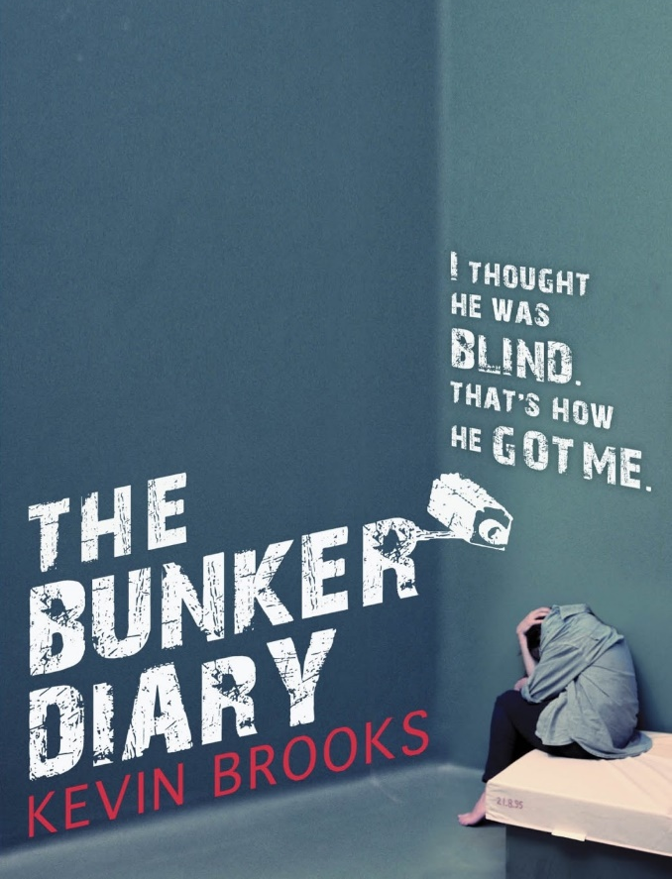
General Information

Title: The Bunker Diary
Author: Kevin Brooks
Illustrator: Kevin Brooks. There is only one picture ^{[2]}
Published: 2013
Pages: 272
Genre: Youth literature
Perspective: First Person (written in the form of a diary).
Location: The whole book is written from a bunker,
somewhere in Great Britain.

The Story
Linus Weems is a homeless boy of 16 years old. He earns money by begging and playing songs on his guitar. He ran away from home and he does not want to go back. On a day, he is helping a blind man in the city centre of London putting a heavy suitcase into a minivan. This was not a smart choice and the man uses a chemical called chloroform to intoxicate Linus. Time passes by. Linus wakes up in a room without any windows, the bunker. The bunker consists of 6 sleeping rooms; each having a bed, a nightstand containing a Bible and a notebook with a leather cover, there also was a kitchen which only had a cupboard with 6 mugs, 6 plates, 6 sets of cutleries and an empty fridge. There was a tap, only running cold water. The bathroom had a sink and a bathtub. Those only ran cold water as well. Then there was the big room. Housing a table, 6 chairs and a clock. The lift did not work and there was no form of controlling it. Linus’ money and cell phone were all stolen by the kidnapper.
1. Book Cover (Brooks, K. (2013) The Bunker Diary. Consulted on 27/01/2018)
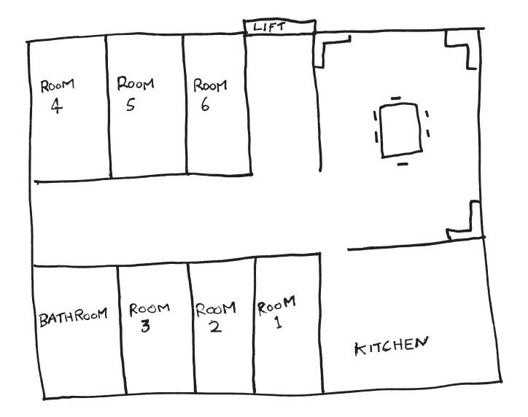
A few days later, there is a loud noise. Linus figures out it was the lift going up. After a while, the lift comes back again. In it was a 9-year-old girl, which had also been drugged by the chloroform. This girl, named Jenny Lane formes a good bond with Linus. In the period after, four more people come in. A management consultant, a heroin addict, a female estate agent and a incurably diseased, homosexual, black philosopher. The bunker is filled to the brim with cameras and food is limited. Will they escape?
2. Map of the Bunker (Brooks, K. (2013) The Bunker Diary. Consulted on 27/01/2018)
Language
The choice of the words is good and the style of writing really fits the feeling Kevin Brooks wanted to express. Most of the text is not hard to understand. If one of the words was hard, it would be explained in a way it fits the story. The only word I had to translate was ‘shrugging’. Furthermore; sometimes the words can be a bit specialistic. Such as when they talk about philosophy or diseases. Linus also had to explain a lot of things to Jenny because she could not understand everything yet.

Characters
- Linus Weems: Linus is the person of who’s point of view the book is written. He is a homeless boy. He walked away from home because of the situation there.
- Jenny Lane: She is very sweet, positive and balanced. she is very wise for her age.
- Fred: a big, strong man. He is also homeless (like Linus). In addition, he is addicted to drugs.
- Anya Mason: handsome, but cold woman in her late twenties. She is a real estate agent in London.
- William Bird: a wealthy consultant working in London. He is in his late 30’s, fat and arrogant.
- Russel Williams: a writer and philosopher. He is 71 y.o. and he is a homosexual. He has only one eye.
- The abductor: The person who kidnapped all these people (stays anonymous).

My opinion
The mark this book deserves:
‘The Bunker Diary’ by Kevin Brooks is a book that I would absolutely recommend to my friends. This book is great for people from around 12 to 14 years old. There is only one thing to consider when reading this book. The book is about a topic that might be not suitable for certain people. ‘Abduction’. The book will be to harsh for some readers. If I had to rate this book on a scale of one to ten I would give this book a definite 8.5.
8.5.

The Author
Kevin Brooks is a 59-year-old writer who has written quite a lot of books. He has written a total of 22 books and has studied at Harvard University. His books are always very well received. One of his books; Iboy, has even been filmed and is a very popular movie on Netflix.
3. Kevin Brooks Portrait (Lezad, K.L. (2012) Leestijger.nl – Consulted on 27/01/2018)

