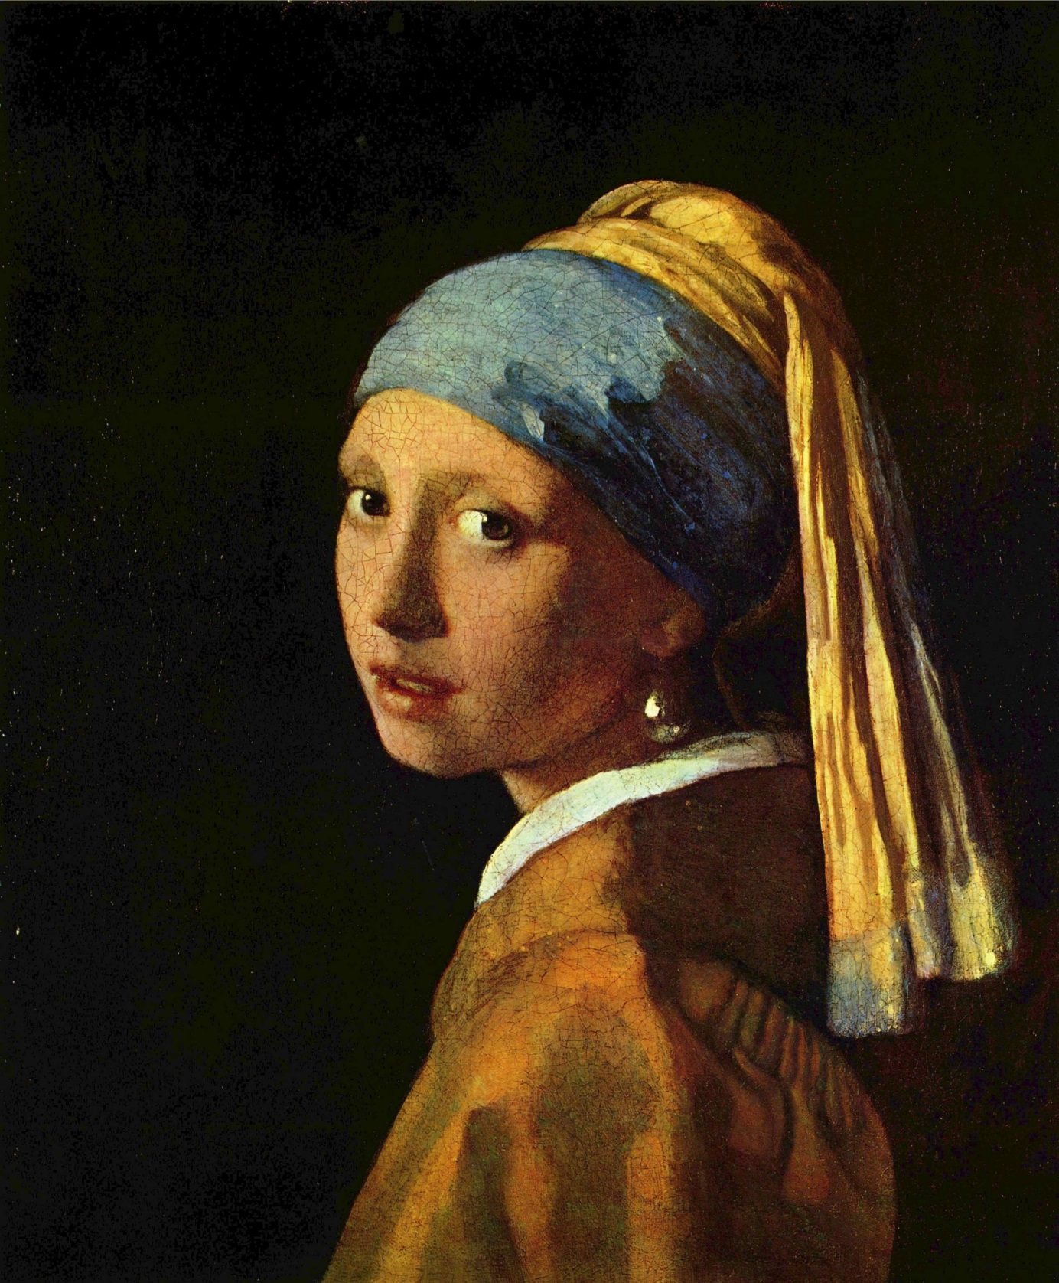
Book report ‘’ Girl with a pearl earring’’

A. Preliminary details
title = Girl with a pearl earring
author= Tracy Chevalier
(first) date of publication= September 30, 2003
number of pages = 233

B. Descriptive Part

-Main characters
Griet (round character)
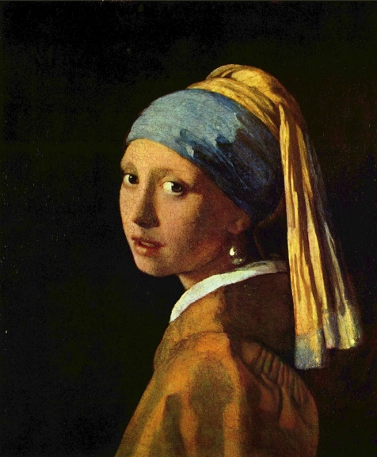
She has brown wavy hair and wide eyes. Her father used to work in a tile factory but an oven exploded taking both his eyes. Now that he is blind, the family consisting of him, his wife and three children ( Frans, Griet and Agnes) has a money shortage. So they had to send Frans to a factory and Griet became a maid of the family Vermeer. She was 16 at the time. At first it is a bit of a problem for her because she is a protestant and the family is catholic. Up the stairs is the painting studio, one of the places where she is to clean. Vermeer has settings there where the one he’s painting can take place, with objects like a powder brush, a cloth, a jewellery box, a map and a letter. Each thing may not be moved until the painting is complete but they need to be dusted. Because her father can’t see, it is nice that everything at home always is on the same place so that he can find things. Griet now uses this skill to put everything back at the exact same place after cleaning. She also falls in love with Vermeer but keeps it to herself.
Griet doesn’t want anyone to see her hair. That way, she feels like having a little secret. But Vermeer didn’t like her cap so he gave her pieces of cloth which she could wrap around her head. One clothe came loose and he liked it very much so he painted her that way.
The pearls have a whole story behind them; they are Catharinas, Vermeer’s wife. Vermeer wanted Griet to wear them because he thinks the painting is not finished without it. Griet knew it would ruin her if she wore it but she could not refuse to her master.

When Catharina found out about this she got so angry that she wanted to destroy the painting with a palette knife. Vermeer could stop her, but Griet was not allowed to work in the house anymore.

She got married to Pieter when she was 28 and they got two children. Now they work together as butchers.

Johannes Vermeer (flat character)
He is the painter. He likes Griet and is one of a limited amount of people who saw Griet’s hair. She was wrapping her head in the yellow and blue clothes when he entered the room. Because van Ruijven, a rich man who wants to take Griet to his house, is a sort of a threat to her Johannes becomes a bit protective.

Tanneke (flat character)
She is a very loyal maid and already served the Vermeers for fourteen years, she is twenty- eight when Griet became the second maid so she worked there for half her life so far. She is proud of that, and also of the painting Vermeer made for her.

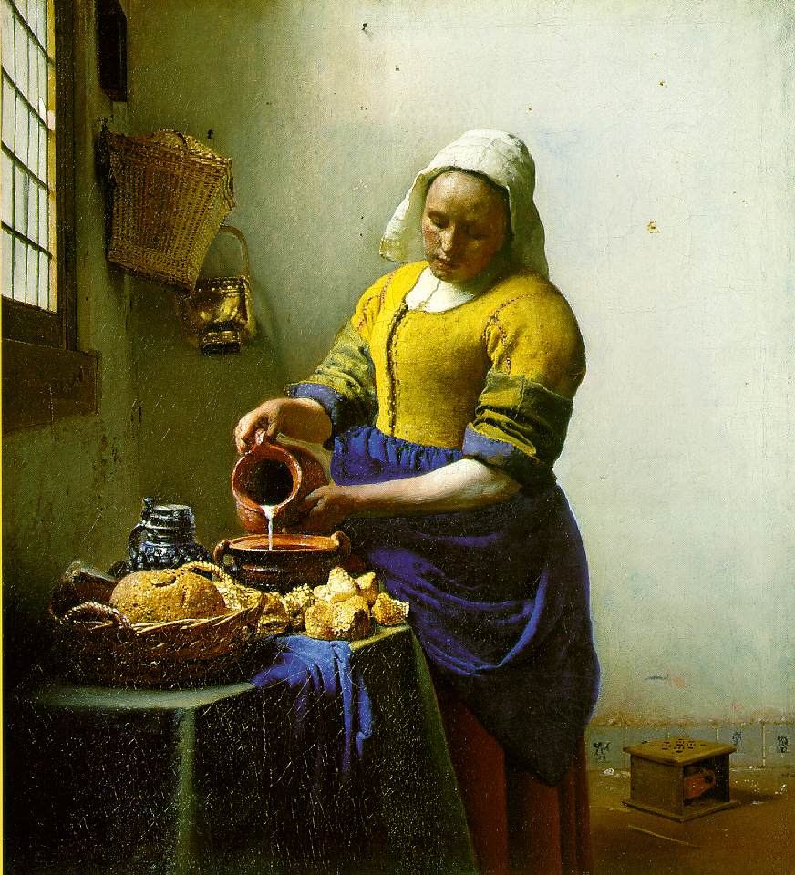
Catharina Vermeer (flat character)
This is the wife of Johannes, she gave birth to fifteen children of which 4 died very young. Because her brother had gone mad and attacked her in the past, she sometimes reacts anxious when, for example, a knife falls on the floor. She doesn’t trust Griet at all, but hasn’t got any clear reasons for that. She has a few possessions; an ivory comb, a yellow coat and a pearl necklace and pearl earring which she carefully keeps in her jewellery box . Johannes doesn’t allow her into the studio because she is too jumpy.

Tanneke is very proud of this painting. Van Ruijven has it now.

Pieter (flat character)
He is the son of the butcher where the family Vermeer buy their meat. Because Griet is the maid she is often sent to fetch meat there. It quickly turns out that Pieter likes Griet and he wants to marry her. Griet’s parents don’t like that very much, but because they are so poor and haven’t ate any meat for a long, long time, they approve the marriage.

-Minor characters:

Maertge Vermeer (flat character)
She is one of the daughters and a nice girl that likes to accompany Griet.

Cornelia Vermeer (flat character)
She is a mean kid that looks like her mother with her read curly hair. She breaks Griet’s stuff on purpose to hurt her and always brings her into difficult situations. Griet slapped her two times in the book.

Frans (flat character)
The older brother of Griet. He works in a Fabric and never comes home because it’s a long walk to get to Delft, where the story finds place. In the end he is kicked out of the fabric and becomes a sailor man, even further away from Griet. That’s the last time I heard of him.

Agnes (flat character)
The younger sister of Griet. She died due the plague and that’s why Griet’s parents became very sad. The last thing Griet did to her was turning her back on her because she didn’t want Maertge to know they were sisters. Griet feels very bad about this because Agnes was hurt and she never got to make it up to her.
Maria Thins (flat character)
This is the mother of Catharina. She is very wise and old. She does whatever is best for the family and takes care of Griet.

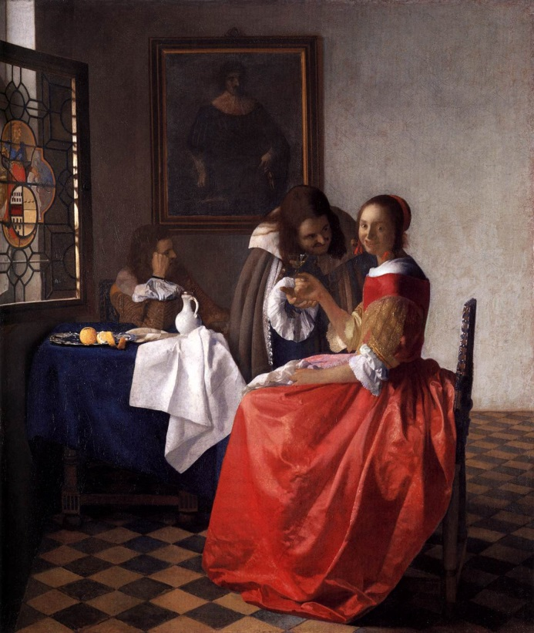
Van Ruijven (flat character)
A very wealthy man who has always been a good customer of Johannes. He calls Griet ‘ The wide eyed maid’ and always palpates her when he’s got the chance. Griet does not like him at all and is a bit nervous when he’s around. He wants Vermeer to paint a painting with him and Griet in it. But Vermeer doesn’t want to because the last maid that went on a painting with him got into a nasty situation. But he can’t refuse because van Ruijven is his best customer and the family has a shortage of money. So he decides to paint Griet alone, not with anybody near her. When it was done van Ruijven bought it.

This is the painting of van Ruijven and the other maid

Antoni van Leeuwenhoek (flat character)
He’s a great friend of Vermeer and is able to see the situation in which Griet is finding
herself. He always warns her for danger. He made a few camera obscuras and often takes one to Vermeer because he claims to be able to see the colours better through it. Catharina is afraid of him because she once ruined one with her clumsiness.

Setting
The story takes place in Delft. You can say that the centre of all places where Griet can go is the eight pointed star. I do not know where it is, but I can say it’s somewhere in the middle of Delft. Every point leads to a different destination:
- The market place
- van Ruijven
- van Leeuwenhoek
- Rotterdam (Frans when he becomes a sailor)
- Unclear
- Papist’s corner (the Vermeers)
- New church (protestant church)
- Griet’s parents

New church is where Griet and her family always pray on Sunday.
The market place is where Pieter and his father sell meat. It smells like fish, goats, cows, meat and other things they sell there. There are often children who play with kites.

Most of the story takes place in Papist’s corner. There the tiles crack when you walk on them, you can hear the children play and the adults talk. And there’s almost always a new baby, so you could also hear baby sounds. It would smell like laundry and dinner. The mood is a bit tense because Catharina stresses a lot. In the winter it is very cold due to bad isolation. The street smells like canal water. The story takes place in the past, from 1664 to 1665 to 1666 to 1676.

It’s a bit cooler in the studio than elsewhere. The light is also brighter. There are not much things in it and that is why it feels spatial there. This is the room Griet likes the most.

Conflict
There is a massive amount of problems and issues in the book;

Journey type problems:
Her family has almost nothing to eat while the Vermeers eat luxurious things.
Pieter wants to marry her and she has to for the meat but does not really want to.

Contest problems:
Catharina does not like her at all.
Cornelia tricks her all the time.
Van Ruijven threats her.

Other problems:
Griet likes Vermeer but is not allowed to.
Her Father is blind.
The sister of Griet dies and there was nothing she could do.
There are a lot of rumours and gossips about Griet.
She will probably never see Frans anymore.
Vermeer died and when she heard that she cut her hand badly.
Her earlobe became infected when she pierced it with a needle for the earring, which was very painful.
She has to work so hard that her hands became wounded.
Tanneke does not like her anymore after she finds out Griet is grinding colours.
Her most precious possession, the tile of her and Frans, is broken by Cornelia.
The great conflict that led to the event that Griet was fired was that Catharina did not like her at all and Vermeer made her wear the earring. When Catharina found out she freaked out and hated Griet even more, so she had to be fired.

There are little problems who were solved;
The parents of Griet have enough to eat now and Cornelia got punished for her setups.

C. Interactive Part
Poetry
1.

Because my father lost his trade,
I had to become a very young maid.

I wash and cook every day,
Everything they say I have to obey.

My hands are bloody, my back aches,
it won’t be long before my mind breaks.

It’s been a while since I began,
soon I will see my family again.

I won’t do this for the rest of my life,
Because I will be a butcher’s wife.

2. This is actually a very short summary of Griet’s life as described in the book. Everything in the poem is true.

Journal
Quote  number | Quote | Thoughts, questions, feelings | Page number
1 | As the woman turned to look at the man, a fold of her mantle caught the handle of the knife I had been using, knocking it off the table so that it spun across the floor. The woman cried out. | Why would she react like that? That’s weird. | 4
2 | ‘’Cornelia, are you going to help me carry the water? If not, go back up to your sisters.’’ She looked at me, and then she did the worst thing. If she had sulked or shouted, I would know I had mastered her. Instead she laughed. I reached over and slapped her. Her face turned red, but she did not cry. | This was in my opinion the strangest part of the book. Why would you slap someone just for laughing? | 22
3 | When I turned around Agnes had gone. I shall have to explain to her when I see her Sunday, I thought. I have two families now, and they must not mix. I was always ashamed afterwards that I had turned my back on my own sister. | The afterwards part made me a bit curious. It is like she never got to apologize to her sister. | 53
4 | When I opened it the tile came apart in two pieces. It had been broken so that the girl and boy were separated from each other, the boy now looked behind him at nothing, the girl all alone, her face hidden by her cap. I wept then. | I got mad at Cornelia when I read this. (she broke it) It is very mean to break Griet’s tile! | 97
5 | He held the earrings up to the light, bit them, took them outside to squint at them. ‘’Twenty guilders,’’ he said. I nodded, took the coins he held out, and left without looking back. | I thought this was a pity. She should not have sold those earrings. | 233
Writing a letter

2014,March 6

Hello Tanneke,

It must be very hard to have worked for the Vermeers for half of your life. Are you also paid four guldens a week, like Griet? The painting you are in is very famous now. Everybody knows it and they call you the milk girl. I think you are a very brave and wise woman.

For example when Willem, Catharina’s mad brother, came in the house and started to attack Catharina and beat Maria Thins, you jumped between them to protect your mistress. That was very brave and loyal of you. Not only because he could beat you as well, but he could also stab you with the knife he brought. Luckily, he didn’t stab you, but you did get beaten. It was a nasty situation.
I think that if I were you, and I’d seen the knife, call out for help on the street. Or maybe hit him on the head with a broom very hard so that he would be unconscious. Do you, by the way, think that Catharina due to this event got a phobia for knives? When she dropped a knife in Griet’s house, she screamed.

How did things go at Papist’s corner before Griet joined in? Did you have to work a lot harder? I can imagine that you would be very tired every day. I thought you were very nice towards Griet when she became the second maid. You showed her what to do and how in a kind way.

But you’re not always very kind;
When you discovered that Griet was grinding colours for Vermeer, I thought you overreacted a bit, why is it a big deal? I also didn’t like your behaviour towards Griet from that moment. She couldn’t help it, you know. If she refused to grind those colours, she would probably be fired. And if that happens her family will starve. If I were you, I would’ve support Griet because she already had a hard time working so hard and only seeing her family for only one day a week.

But you didn’t know all of this so maybe you just was jealous because Vermeer didn’t ask you to grind colours for all the years you worked there. I understand. The reason for that was by the way because she had a special gift for colours and paintings. She even changed the setting in the studio while Vermeer was painting it. Luckily for her, he agreed and made the change in the painting as well. Another example is when she made soup when Vermeer and Catharina came to her house to take a look at what was to be their new maid. Vermeer noticed immediately that Griet was sorting the vegetables on colour before they went in the soup.

I also would like to ask you a few things:
Do you have a husband and children? Why did you become a maid at a young age? Did you, while posing for your painting, talk to Vermeer or was it silent all the time? I would like to know more about you.

Greetings from Marieke van Diemen

Glossary
Number | Word + sentence | Meaning | Page number
1 | I knew already that it was best if no one knew I had run an errand for him. | To get or do something for someone on a short journey | 96
2 | ‘’Where will you sleep?’’ Maertge asked, wiping mushy fingers on her apron. | What you wear to prevent your clothes getting dirty. | 21
3 | Maria Thins Chuckled | When someone is smiling | 45
4 | I nodded respectfully to the man and woman. | To move your head up and down | 4
5 | He wore a black cloak over his shoulders, a white shirt and a fine lace collar. | The part of the neck in a shirt with a lace in it | 5
6+7 | Her cap was askew so that tiny blond curls escaped and hung above her forehead like bees which she swatted at impatiently several times. | Oblique + hit a bug in a way you’re crushing it | 4
8 | Her collar needed straightening and was not as crisp as it could be. | Stiff/ when your clothes aren’t flexible | 4
9 | One day the kiln exploded, taking his eyes and his trade. | A large oven for baking pottery, bricks or in this case tiles. | 7
10 | ‘’That’s enough prattle,’’ the woman declared. | Unclear talk (for outsiders) about unimportant stuff | 6
11 | Against the wall, behind the chair and easel, was a small cupboard, its drawers closed. | A closet with drawers | 33
12 | We crept downstairs again. | To slowly walk somewhere so that others can’t hear you | 20
13 | Maria Thins snorted. | To sniff/ to breathe in air through your nose | 37
14 | The joint was grey on the edges. | piece (in this case a piece of meat). | 40
15 | Catharina returned while I was taking down laundry in the courtyard. | A garden or square in the middle of a house without a roof. | 24
16+17 | He wore a smart black velvet jacket. | A classy jacket made from a thick type of cloth. | 83
18 | Catharina gazed up at her husband in surprise. | To stare at someone. | 105
19 | He rarely showed interest in domestic affairs. | Things going on at home. | 105
20 | ‘Oh yes, madam,’ Tanneke broke in eagerly. | To do something with desire and interest/ enthusiastic | 106
21 | He even thumped him soundly. | To hit someone in an unfriendly way. | 116
22 | Or at Mechelen, his mother’s inn. | A hotel or public house in a village | 116
23 | Maria Thins and Catharina managed to have Willem confined last year. | To imprison someone | 116
24 | ’Quiet, thief. They’ll throw you in prison,’ she hissed, ’ and you won’t see sunlight for years.’ | A way of speaking in which you make the sound of the letter s to show your anger. | 214
25 | She winced again | When someone makes him-/herself smaller | 214
26+27 | Catharina cried shrilly, jerking her head at me. | A high sound  In this case a movement to point at someone with your head. | 214

