Thirteen reasons why

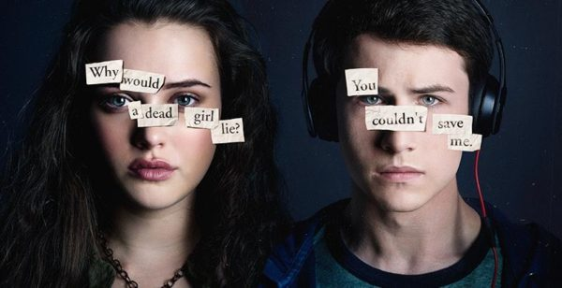

Name: Roy Holleman
Class: 4H2
Date: 6th of june 2017
Title book: Thirteen Reasons why
Writer: Jay Asher

Short Summary
The book is about a boy, Clay Jensen, who founds a package with 7 tapes in it. When hr starts listening, he figures out that the package is from Hannah Baker. A girl who killed herself a few weeks ago. The tapes are reasons why she killed herself. Thirteen reasons, thirteen tapes. Only the people who were a reason that she killed herself got the tapes. One by one. She tells at the first part of the first tape that there is a copy of the tapes and if someone doesn’t give the tapes to the next person, everyone could listen to the tapes. The first tape is about Justin Foley, Hannah’s first kiss. Followed by Alex, Jessica, Tyler, Courtney, Marcus and Zack. The 9th tape is about Clay. He is not the same as the last tapes. He didn’t do anything to her. They had a fun night on a party together what ended in a kiss. Hannah was thinking about some bad things that happened to her during the kiss. She decided to commit suicide after that. She told Clay that she felt sorry on his tape. Clay figures out that his best friend, Tony, has the copy of the tapes after listening his tape. Tony has to watch if the person that has the tapes, gives the tapes to the next person. Clay was really flabbergasted about this. After Clay’s tape are there some few new people who did something to Hannah. At the end knows Clay why Hannah, the person who Clay was in in love with, why she committed suicide. Clay past the tapes trough to the next person to complete Hannah’s wish.

Main characters.
Hannah Baker is a girl with, brown curly hair, who killed herself two weeks before Clay got the package. She came from a town where she had two friends at the beginning, but later in the story did they let her down. She had in first some thoughts about killing herself, but when later in the story more things happens to her she became more quit and killed herself on the end. She was in love with Clay Jensen. She has given the copies of the tapes to Tony.
Clay Jensen is a slim boy with short brown hair who has got the Hannah Bakers package as 9th. He didn’t know what he did to her and he finds out that he didn’t do anything to her at the end. He liked Hannah since she was in his school, but he was too shy to talk to her. Tony is Clay’s best friend.
Tony is a guy with a black haircut who likes cars and is Clay’s best friend. Tony did get Hannah’s bike if he explained to her how she could record tapes, he didn’t know that she would kill herself. He got the package what he must send if the other package didn’t all the persons who were a reason for Hannah’s death.

Verwerkingsopdracht 1.

Verwerkingsopdracht Proza Modern
Werkblad 25 |  |  | Spanning |  |  |  |  |  |  |  |  |  | categorie 4 B
3: Maak een grafische voorstelling van de spanningsopbouw in het boek dat je gelezen hebt. Zet op de verticale lijn de spanningswaarde en op de horizontale lijn de corresponderende verhaalmomenten. Zie voor een voorbeeld LM 1-3.3.

+++++

++++

+++

++

+
 | 1 2 3 4 5 6 7 8 9 10 11 12
Omschrijving van de verhaalmomenten:
1 De nieuws dat Hannah zelfmoord had gepleegd
2 Dat Clay het pakketje had gekregen met de tapes
3 Reason 1
4 Reason 2
5 Reason 3
6 Reason 4
7 Reason 5
8 Reason 6
9 Reason 8
10 Reason 9
11 Reason 10
12 Reason 14

Verwerkingsopdracht 2.

Dear Hannah Baker,
I am Roy Holleman, a 16 years old Student from The Netherlands. I have to write a letter to you for a English subject at school, but it’s pretty stupid to do this. You are dead, so you can never read this and you’re a fictional character. You are a dead, fictional character. So it’s kind of silly that a put time in this letter. This letter must have around the 200 words and at this moment I have 78 words. So here some random words. Have fun reading this. Grass, Balloon, Fridge, Computer, Laptop, Keyboard, Mouse, Mice, Headphones, Earpads, Time, Wi-Fi, Cap, Beer, Phone, Watch, Clothes, Bottle, Mouse pad, Pen, Lamp, Coach, Sugar, Pain, Suicide, Kill, Deo, Stone, Rock, In, The, Up, Under, Donald Trump, Michelle Obama, Ronald, Roy, James, Hank, Bob, The Simpsons, Blue, Red, Green, Purple, Orange, Collars, Hand, Legg, raise, Horizon, Tired, Deadline, School, Poop, Stupid, Timeless, Waste, Netflix, YouTube, Gaming Blank, Ed Sheeran, Switch, Spoon, Fork, Knife, Strips, Minus, Erik, Roy, Chrome, Google, Best friend, Secret, Dog, Cat, Submarine, Car, Bike and Random.
Best regards,
Roy Holleman

Dear Roy,

Ghosts Exists.

Best regards,
Hannah (Dead and fictional) Baker.

