Ries Schoot Uiterkamp

V5A

12-05-16

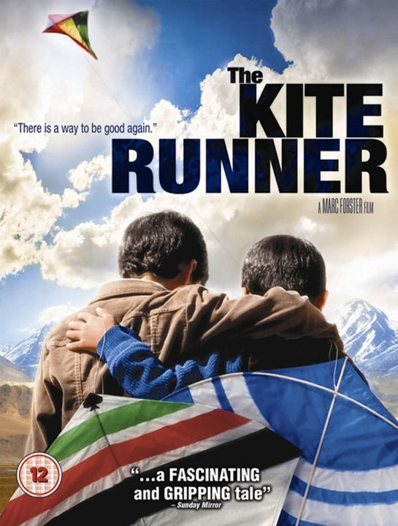

The Kite Runner

By Khaled Hosseini

**Expectation:**

I heard this was a good book, so I expect it to be enjoyable to read as well as bringing a message. I have already seen the movie so I know the red lines in this book but I hope there will be much more.

**Summary**

Amir recalls an event that happened twenty-six years before, when he was still a boy in Afghanistan, and says that that made him who he is. Before the event, he lives in a nice home in Kabul with Baba, his father. They have two servants, Ali and his son, Hassan, who are Hazaras, an ethnic minority. When Afghanistan’s king is overthrown, things begin to change. One day, Amir and Hassan are playing when they run into three boys, Assef, Wali, and Kamal. Assef threatens to beat up Amir for hanging around with a Hazara, but Hassan uses his slingshot to stop Assef and protect Amir.

When the kite fighting tournament take place,boys cover their kite strings in glass and battle to see who can cleave the strings of the opposing kites. When a kite loses, boys chase it to find the kite, this is called kite running. When Amir wins the tournament, Hassan sets off to run the losing kite. Amir looks for him and finds Hassan trapped at the end of an alley, pinned with his pants down. Wali and Kamal hold him, and Assef rapes him. Amir runs away and he pretends he doesn’t know what happened. After this they grow away from each other. Amir, who is filled with guilt, decides either he or Hassan must leave. He stuffs money and a watch under Hassan’s pillow and tells Baba that Hassan stole it. When Baba confronts them, Hassan admits that he has stolen it, even though he didn’t do it. Shortly after, Ali and Hassan move away.

March 1981. Baba and Amir are in the back of a truck as they escape from Kabul, invaded by the Soviets and a war zone now. After an awful journey, they make it to Pakistan. Two years later, Baba and Amir live in Fremont, California. While Baba works at a gas station, Amir finishes high school and goes to college. Baba and Amir sell things at a flea market on Sundays, and Baba sees an old friend, General Taheri. Amir notices General Taheri’s daughter, Soraya. When Amir finally speaks to her, General Taheri catches him and tells him there is a proper way to do things. Not long after, Baba is diagnosed with lung cancer. Amir asks Baba if he will get General Taheri’s consent for Amir to marry Soraya. General Taheri accepts the proposal. They hold the wedding quickly because of Baba’s health, and Baba dies a month later.

Amir gets a call from Rahim Khan, his best friend when he was young. Rahim Khan is sick and wants Amir to see him in Pakistan. Amir meets him a week later, and Rahim Khan tells Amir about the devastation in Kabul. He says things only got worse after the Soviets were driven out of the city. The Taliban rules with the power of fear. He has a favor to ask of Amir, but first he needs to tell him about Hassan. When Baba and Amir left Afghanistan, Rahim Khan watched their house. Out of loneliness and because he was getting older, he decided to find Hassan. He convinced Hassan and Hassan’s wife, Farzana, to come back to Kabul with him. Farzana and Hassan eventually had a little boy, Sohrab. A few years later Rahim Khan went to Pakistan for medical treatment, but he received a call from a neighbor in Kabul. The Taliban went to Baba’s house and shot Hassan and Farzana and sent Sohrab to an orphanage.

Rahim Khan wants Amir to go to Kabul and bring Sohrab back to Pakistan, where a couple lives that will take care of him. He tells Amir that Hassan was actually the bastard son of Baba, and Hassan and Amir are actually brothers. In Afghanistan, Amir finds the orphanage where Sohrab is supposed to be, but he is not there. The Taliban got him not long ago, if Amir wants to find the guy who took him, he will be at the soccer stadium during the game the next day. Amir goes to the game, and at half-time, the Taliban put a man and a woman in holes in the ground and they are stoned to death by the crowd. Through one of the Taliban guards, Amir sets up a meeting with the official.

When they meet, Amir tells the official he is looking for a boy, Sohrab, and the official tells the guards to bring the boy in. The official says something Amir recognizes, and suddenly Amir realizes the official is Assef. Assef says he wants to settle some unfinished business. He beats Amir with brass knuckles, breaking Amir’s ribs and splitting his lip. Sohrab threatens Assef with his slingshot, and when Assef lunges at him, Sohrab shoots him in the eye, allowing Amir and Sohrab to escape. As Amir recovers in the hospital, he finds out there never was a couple that could care for Sohrab. Amir asks Sohrab to live with him in America and Sohrab accepts.

One day, they go to a park with other Afghans. People are flying kites. Amir buys one and gets Sohrab to fly it with him. They spot another kite and battle it. Using one of Hassan’s favorite tricks, they win. Sohrab smiles, and as the losing kite flies loose, Amir sets off to run it for Sohrab.

**Book information**

The Kite Runner is written by Khaled Hosseini. Published on May 29, 2003 and consists of 372 pages.

**Biography and bibliography source:http://khaledhosseini.com/biography/**

Khaled Hosseini was born in Kabul, Afghanistan, in 1965. His father was a diplomat in the Afghan Foreign Ministry and his mother taught Farsi and history at a high school in Kabul. In 1976, the Foreign Ministry relocated the Hosseini family to Paris. They were ready to return to Kabul in 1980, but by then their homeland had witnessed a bloody communist coup and the invasion of the Soviet Army. The Hosseinis sought and were granted political asylum in the United States, and in September 1980 moved to San Jose, California. Hosseini graduated from high school in 1984 and enrolled at Santa Clara University, where he earned a bachelor’s degree in biology in 1988. The following year he entered the University of California, San Diego, School of Medicine, where he earned a medical degree in 1993. He completed his residency at Cedars-Sinai medical center in Los Angeles and was a practicing internist between 1996 and 2004.

In March 2001, while practicing medicine, Hosseini began writing his first novel, The Kite Runner. Published by Riverhead Books in 2003, that debut went on to become an international bestseller and beloved classic, sold in at least seventy countries and spending more than a hundred weeks on the New York Timesbestseller list. In May 2007, his second novel, A Thousand Splendid Suns, debuted at #1 on theNew York Times bestseller list, remaining in that spot for fifteen weeks and nearly an entire year on the bestseller list. Together, the two books have sold more than 10 million copies in the United States and more than 38 million copies worldwide. The Kite Runner was adapted into a graphic novel of the same name in 2011. Hosseini’s much-awaited third novel, And the Mountains Echoed, will be published on May 21, 2013.

**Books by Khaled Hosseini:**

* [The Kite Runner](https://en.wikipedia.org/wiki/The_Kite_Runner) (2003)
* [A Thousand Splendid Suns](https://en.wikipedia.org/wiki/A_Thousand_Splendid_Suns) (2007)
* [And the Mountains Echoed](https://en.wikipedia.org/wiki/And_the_Mountains_Echoed) (2013)

**Characters**

The main characters of The Kite Runner are:

* Amir was born in 1963, in Kabul, son of a rich father. Later he migrates to America following the downfall of Afghanistan. Amir is Hassan's half-brother; however, Amir does not learn of their relationship until much later in his life.
* Hassan is a childhood friend of Amir, although Amir never explicitly admitted to this. Hassan is first thought to be the son of Ali ,Baba's servant and childhood friend. Later in the story, Hassan is revealed to be the bastard son of Baba and Sanaubar. Hassan died without ever knowing about the truth of him being Amir’s halfbrother.
* Assef is a sadisticteenager from Amir's neighborhood in Kabul. As a teenager, he rapes Hassan. He hates the Hazaras, and he gives a book to Amir for his thirteenth birthday, which is about his idol, Hitler. As an adult he becomes an officer at the Taliban, where he executes people and lead the city.

**Title explanation**

The title refers to the yearly kite competitions and thus the boys who catch the kites that have been cut loose.

**Genre**

The genre of this book is historical fiction, because it is completely fictional and it is set in history with certain events popping up in the book that actually happened.

**Setting**

The story is set in Afghanistan, Kabul, and in America, California. Amir and Baba move to the states after the Soviet Union invaded Afghanistan. The story takes place from 1974 to 2002.

**Themes**

The themes in this book are; guilt and redemption.

Guilt. Guilt is what drives Amir to break up the friendship with Hassan, as the guilt is too hard to live with.

Redemption. Redemption is what is the factor for the second part of the book, where Amir goes back to Afghanistan to find Hassan’s son. He does this as redemption for what he did to Hassan.

**Quotation**

*‘’Your father, like you, was a tortured soul,* Rahim Khan had written. Maybe so. We had both sinned and betrayed. But Baba had found a way to create good out of his remorse. What had I done, other than take my guilt out on the very same people I had betrayed, and then try to forget it all?’’

This quote from Amir really shows how he feels about his actions to Hassan and the guilt he feels not doing anything while seeing Hassan being raped.

Chapter 23

**Verdict**

The Kite Runner is a very interesting book to read and also very beautiful. It is definitely recommendable to everyone, because it is a very beautiful book to read and it is a real pleasure doing it.

**Sources**

<http://khaledhosseini.com/biography/>

<https://en.wikipedia.org/wiki/The_Kite_Runner>