Paper Towns
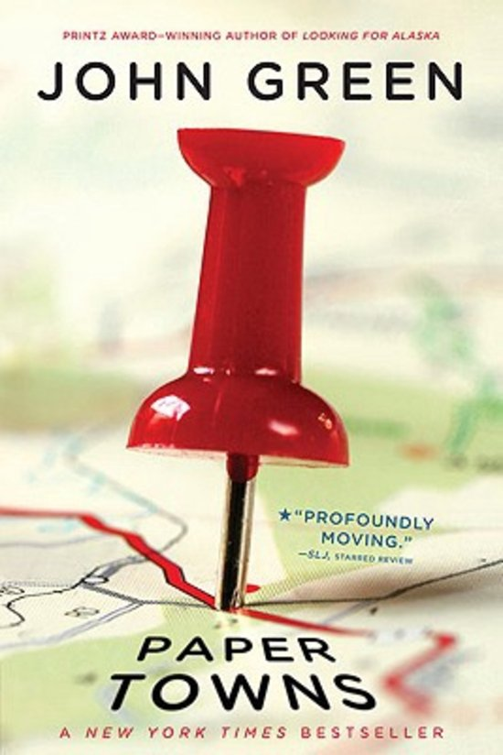
- General information
Paper towns is written by John Green, the novel was published on October 16, 2008 by Dutton Books in America.
John Green is an American writer. He was born in Indianapolis on August 24, 1977. His parents are Mike and Sydney Green. He graduated from Kenyon College in 2000 with a double major in English and Religious studies. His first novel, Looking for Alaska, was published in 2005. In 2008, debuted Paper Towns, as his third novel, at number five on The New York Times Best Seller list for children’s books.

- Summary
The Prologue:
On a lovely day in Florida, the nine years old Margo Roth Spiegelman and Quentin (Q) were cycling in the park. But then they saw a dead body. They go home to tell their parents. Quentin wants to forget the dead man, but the curious Margo finds out he committed suicide.
The Strings:
Nine years later in the middle of the night of May the 5th Margo Roth Spiegelman sneaked into Qs room. Since they found the dead body they haven’t really talk to each other, but Margo needs a favor from Q. She asks if she could borrow his car, and to drive her around. She found out that her boyfriend Jase Worthington cheated on her with her best friend, Becca. So she made a plan to take revenge on them. First they took revenge on Becca and her ‘ex’ boyfriend. Than they went to Lacey Pemberton, who is her other best friend. Because Margo thought Lacey knew that her boyfriend was cheating on her. Than they went to Chucks house and so they cleared the list. They vandalize houses and cars with spray paint and fish. After the plan succeeded Margo took Q to a building with an overview of Orlando. She told him that It’s a paper town. Nobody cares about anything there. At last they broke into SeaWorld, this was the last thing they did that evening and went home.
The Grass:
The next morning Margo wasn’t at school. It was not the first time she disappeared, but Q felt that this time was different. He tells Radar and Ben about it and together they find some clues they think Margo could have left. Those are things like: a poster on the back of a curtain, hidden notes in doors and marked words in poetry that leads them to an abandoned mini-mall. Q worries about Margo and thinks she may be committed suicide like the man they found nine years ago.
On may the 28th Q was searching on Omnictionary for information about paper towns. He found out Margo is still alive and that she will be in Agloe, New York till May the 29th. Q, Radar, Ben and Lacey skip their school graduation to go to Agloe, which is a “paper town” that doesn’t exist on the map, to find her.
The Vessel:
Q, Radar, Ben and Lacey went on a road trip of nearly 24 hours. When they arrive in Agloe, they found Margo in an old farmhouse, writing in her book. They are happy because they found her, but Margo is doesn’t reacts very friendly. Lacey, Ben and Radar went to a near Motel. Q and Margo have a deep and long conversation and at the end Margo tells she never wanted to be found and that she doesn’t want to go home. She is going on a road trip through the USA and he has to let her go.

The book is divided four parts. Each part has its own name. Part 1 is called the Prologue, this is the introduction of the book, in the introduction is told what you need to know before the beginning of the story. Part 2 is called The Strings that refers to Margo’s description in the book where she compared suicide to the man who commit suicide. She told Q that maybe all the strings snapped in his body, so this was the only option to him. Part 3 is called The Gras, this is a reference to Whitman’s poem, which Margo underlined. The idea of the grass is that Whitman believes that people are the same as grass. Grass consists out a lot of blades of grass, but none of them is individual. They are all part of the same origin. Whitman applies it to people, because people all have the same origin. He believes that if you analyze a person long enough, you are able to understand that person in process of time. Part 4 is called The Vessel, this is what indicated the car which they use for the road trip to find Margo.

- Characters
Quentin Jacobsen: Quentin is the main character and he is the narrator who tells the story from his own perspective. His nickname is Q. He is 17 years old and is a quiet and introvert boy. He loves to game with his best friends and is not the type of person who goes to parties. He has a crush on his neighbor Margo. When they were little, they sometimes played together. Now is Margo is popular on school and they don’t really talk anymore. In the beginning of the book Q dares not much, but in the end he is more confident about himself. He will not give up the mission to find Margo.
Margo Roth Spiegelman: Margo is a popular and mysterious girl. She is the neighbor of Q and the best friend of Lacey and Becca. She seems really happy and spontaneous, but it turns out that she feels very alone and depressed. She says she’s fake, like paper, so she must live in a paper town. A paper town for a paper girl.
Ben Starling: Ben and Quentin are best friends since the fifth grade. He is not very long and has an olive colored skin. Ben wants to get popular on school, so he goes to the parties where all the popular kids go to. He is often selfish and has no attention for Quentin. But in the end turns out, he is a true friend.
Marcus Lincoln: Marcus is the other best friend of Quentin and Ben. He is nicknamed after a guy on the TV show M*A*S*H, his name was Radar. Radar has an girlfriend and he is a big-time editor of Omnictionary. His parents own the world’s largest collection of black Santa’s.
Lacey Pemberton: Lacey is Margo’s friend since the kindergarten, but now Margo thinks she hates her. Lacey is very popular on school and goes to all the parties. Lacey has never talked to Q, Ben and Radar, but in the end she gets an relationship with Ben.
Margo attracts me the most. She is really mysterious and I like that. Behind the smile on her face, nobody knew she had an depression. That people never know other people their story and after a kind of happening, people are astonished and want to know more about it. This appeals to me.
Ben attracts me the least. That is because he is often really selfish. In the end he finally starts helping Q, but in the beginning Margo had not a meaning to him. His meaning was she only needed a lot of attention.

- Place and time
The story takes place in the state Orlando in Florida. Quentin and Margo live in Jefferson Park. Orlando is known of its many new neighborhoods of cheap material. In addition, there are many new construction projects in the city that never been finished. It is not necessary for the story that it takes place in Orlando, as long as it is in a city with such new neighborhoods like that. This is one of the references to the title: Margo believes that because the buildings are so badly put together, that they are actual fake, it is like a paper town.
The Prologue lasts one day in March. This takes place nine years ago from the day when he tells the whole story. The Strings, The Grass and The Vessel take place in 24 days. The story begins on may the 5th with Q who went to school, he made his daily routine and went home. In the evening Margo Roth Spiegelman stands in his room and the adventure begins. On May 29th Margo will leave Agloe and on that day Q and his friends found Margo. The story ends in Agloe. The story takes place in the present. They have a lot of things that we have now.
The story has an open and an closed ending. It is an closed ending because they found Margo and they know she is fine and they know the story behind everything. It is an open ending because I have questions like: will she return to Jefferson Park after her road trip? and how will Q live without her now he know where she is?
The story is written in chronological order, but it are two flashbacks. One to when they were nine years old and one with the rest of the story. Everything is written in the past tense.

- Point of view
The book is written in the perspective of Q. He writes in the past tense and first narratives point of view. So the book is actually a look back at the mystery of Margo which Q has solved. Q knows in the begin of the book more than you know, but the further the story takes, the more you come to know about everything. Besides that, Q tells also a lot about his thoughts and emotions he had during the story. The fact that the book is a look back at the things that happened, gives me the feeling that you can’t trust this point of view. He could have told things in the wrong way or lie about things that happened to make it more dramatically.

- Themes
The main themes of the story are love and friendship. The friendship between Q and Margo and the love that Q has for Margo. That Margo on her last night in Orlando Q ask to come with her and Q does everything to find Margo. The friendship between Q, Ben and Radar is really strong, you see that they are best friends. They help each other, game together and be there to find out where Margo is. Sometimes they don’t agree with things they say, but it always has an good end. The love between Ben and Lacey, and the love between Radar and Angela.
There are also other themes. Chasing after what you want in life, no matter what is left behind is one of them. This theme is shown through many of the characters. Margo left family and friends behind because she doesn’t want to be in Orlando anymore. Q leaves his family at his graduation to find Margo. Ben wants to get a date with Lacey and he is only focused on that. He did not give any attention to Q and Radar. Another theme is mystery, because Margo disappeared and nobody knows why that is and what they have to do, how long she stays away. There are a lot of questions that aren’t answered when she disappeared.
There are none themes related to the title. I think that the title Paper Towns, comes from the different meanings that the word paper holds.
John Green has used it to describe many things in the book, like paper people, paper life, and what he means by it, when he calls something or someone paper, it means that this person or this thing is only two dimensionally, it isn't real, it is only an illusion we created to give ourselves some comfort, there is nothing alive about a paper life, where you live is everything according to a plan you never made, a plan that was there in the first place, like what Margo Roth was trying to escape, to her the paper life is the career and husband and kids life, and the only real non-paper life is to her the life of adventure and travel.
So the word paper can hold many significances and you can never be really sure what meaning it has, but in my eyes it reflects to the opposite of real, the opposite of alive, and the image of illusions in life. A paper life, is a lifeless life.

- Reading experience
The book did lived up to my expectations. I thought it would be a book like The fault in our stars, when you start to read, you can’t stop reading, because you feel like you are in the book itself. The book let you thinking about some things in life. That is why I like John Green his books, so yes I would really read more books of this author. The part of the book where Q and Margo took revenge at Margo’s ex-boyfriend and best friends do I like the most. That is because of the tension and energy you feel when you read the book. The part where they are in the car for a 24 hour road trip to find Margo did I not like very much. That is because of the wordiness of the story in that part of the book. It was a really great and mysterious book to read!

