Summary chapter 2
2.1
The church of Rome
- New Saint Peter’s cathedral in 1506
- Indulgences (tickets that you can go to heaven for sure)
- Medieval peasants still had the memento mori (remember that you’ll die
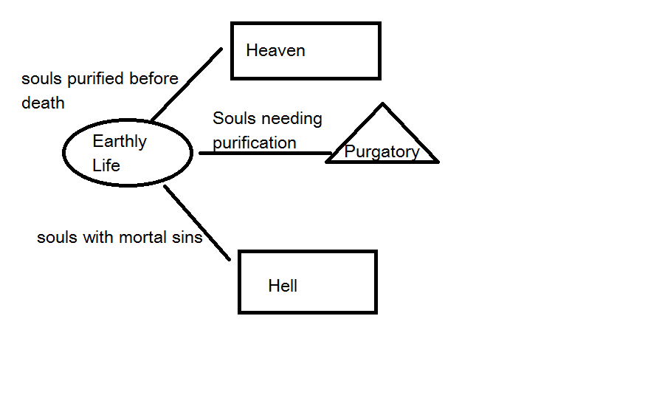
Martin Luther
- Martin Luther-> German monk-> outraged by indulgences
- October 1517-> 95 theses
- Pope has no authority on who goes and who doesn’t go to heaven
- Reading Bible by themselves
- Priests-> not needed to explain or forgive
- Saints and relics should not be worshipped.
The church splits
- The pope and German emperor Charles V demanded Luther to take back his words, which he refused
- Ideas spread-> printing press
- Luther-> outlaw in 1521
- Sheltered Luther-> Frederick III
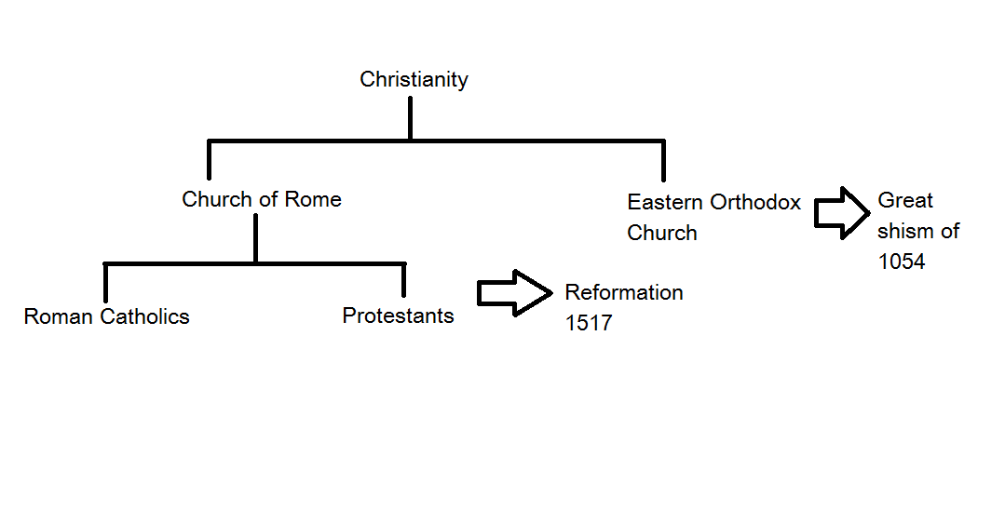
- German translation of the Bible
Split of the church

After Luther
- After Luther-> different Protestant churches
- John Calvin-> most influential France and the Netherlands
- Calvanism=Netherlands
-Lutherism=Germany
2.2
The Low Countries under Charles V
Whereas the Low Countries had still been a collection of wealthy, independent duchies, countries and dioceses in the Middle Ages, this changed in the fourteenth century. Through clever marriages and war, the dukes of Burgundy began to gain control over large parts of the Low Countries. By the sixteenth century the city of Antwerp in Brabant, had outstripped all the other towns of Flanders to become the leading commercial centre of Europe.
The government of the Low Countries
At the time of Charles V’s rule, the Low Countries were not a unified nation but a collection of 17 provinces, each with its own laws and customs. The States-Provincial was made up of the leading nobles, clergy and representatives of the towns in that province. The States-Provincial would only agree to pay taxes to a ruler if he confirmed their existing privileges or granted them new ones. Charles V was represented by a governor. He also appointed a deputy in each province, called a stadtholder. Who was always a member of the high-ranking nobility.
Centralization of government
The process of governing from a single place is called centralization. Whenever Charles needed money quickly he called together all provincial representatives in meetings of the States-General. People could be summoned to trial in Mechelen from as far away as Zeeland. To many people, this centralization flew in the face of their ancient customs and privileges. The provinces preferred to leave this the way we were. This desire to be as independent and preserve ancient privileges as much as possible is known as particularism.
Placards against heretics
By this time, the reformers had also gained followers in the Low Countries. Yet Charles V wanted his subjects to remain Catholic. He therefore issued a number of placards against the Protestants, who he regarded as heretics (misbeliever).
Philip II
In 1555 Charles V stepped down from the throne. His son Philip II became the king of Spain and ruler of the Low Countries. First he lived in the Low Countries but in 1559 he left and then he appointed his half-sister Magaret of Parma to govern the Low Countries. Philip refused to let the States-General meet, saying it obstructed his rule. As a strict Catholic, he also ordered the enforcement of the Blood Placard.
This led to more unrest, also among more moderate Catholics, who felt the Inquisition was to severe. On 5 April 1566 they handed over the Petition of the Nobles. In this document, they asked the governor to petition her brother the king to repeal the placards against heretics. Alarmed, Magaret promised in order the Inquistion to be more lenient for the time being.
The nobles celebrate
Afterwards the group of mostly young noblemen gathered at one of their palaces in Brussels to celebrate Magaret’s promise to pass on their petition to the king.
2.3
Iconoclastic outbreak
- More people in the Netherlands became protestant
- Effects: hedge services-> illegal sermons (mis) for protestants in open air
- 1566: iconoclastic outbreak (Beeldenstorm) destroying sculptures, statues, and other valuables. Bible says you can’t make images of god.
Effect of the Iconoclastic outbreak
- Philip II was furious
- Send Duke of Alba
- 1567: new governor of NL
- Task: put an end to the Calvanists
- The Council of Troubles (Blood Council)
- This Council starts to hunts the iconoclasts
- Effect 1: people became scared
- Effect 2: People lost faith (believing in someone) in their king
Tenth Penny
- Introduced fixed taxes -> Tenth Penny
- Nobles-> furious because feared losing their power to the Spanish king
The Revolt
- 1568: Orange attack the Spanish troups with his merchandaries (someone who’s payed to kill someone)
- Summer 1572: Orange is chosen by the States-General-> leader of the Revolt.

2.4
The Spanish Fury
In 1573, Alba got the permission to return home. Philip II ordered Don Luis de Requesens to go to the Low Countries to take Alba’s place as a governor. Requesens policies were more moderate than Alba’s and he offered amnesty to all rebels who would lay down their weapons. In 1576 Requesens died unexpectedly. During the Spanish Fury they sacked numerous towns.
From Pacification to division
The States-General decided to call a meeting and concluded a peace treaty with Holland and Zeeland. In the Pacification of Ghent, all of the provinces banded together to drive the Spanish forces out of the Low Countries. The only thing they could not agree on, was the religion. At William of Orange’s request, they pledged to not persecute each other any longer. A few Walloon provinces in the south therefore decided to ally themselves with the Union of Arras and make peace with Philip II in 1579. In the same year, the provinces that wanted to continue the Revolt joined in the Union of Utrecht.
William of Orange the outlaw
William had begun to take a stand against Philip’s policies. He and the other high-ranking nobles wanted more say in governance and also criticized Philip’s harsh treatment of Protestants. After the Council of Troubles seized his lands in the Low Countries, William became the leader of the Revolt. In 1580, Philip declared the prince an outlaw.
William of Orange takes a stand
For a long time, William maintained his allegiance to King Philip II. In Delft, the Catholic Balthazar Gerards shot William of Orange with a pistol and killed him.
2.5
In search of a new ruler
Meanwhile, a successful counterattack was launched by the new governor, Magaret’s son, the duke of Parma. In 1578 he began a series of attacks on towns in the southern Low Countries. The rebellious provinces realized they were no match for the powerful Spanish army and would be defeated if they did not find a strong ally to aid them. They thought of France. To make it official, the provinces renounced Philip II as their ruler in 1581. In 1588, the States-General finally decided to give up its search for a new ruler.
War, truce, more wars and peace at long last
In 1588, Spain suffered a crushing defeat. Philip II had built a huge fleet, called the Armada, to invade England and put down the rebellion in the Low Countries. By the time Philip II died in 1598, the Spanish treasury (schatkist) was empty. In 1609 a truce was agreed. It lasted until 1621. At the end of this Twelve Years’ Truce, the war resumed.

2.6
Timeline
1515; Charles V becomes sovereign ruler of the Low Countries
1517; Luther publishes his 95 theses against practices in the Roman-Catholic Church
Age of explorers and reformers (1500-1600)
1550; Charles V issues the Blood Placard
1555; Philip II succeeds Charles V as sovereign ruler
1566; Petition of the Nobles and the Iconoclasm
1567; Alba arrives in the Low countries
1568; William of Orange invades the Low Countries with a merchant army
1572; Brielle captured by the Sea Beggars
1576; Spanish Fury and the Pacification of Ghent
1579; Union of Arras and the Union of Utrecht
1580; Philip II exiles William of Orange
1581; Act of Abjuration
1584; William of Orange is assassinated
1588; Foundation of the Republic of the Seven United Netherlands
1609-1621; Twelve Year’s Truce
1619; Execution of Johan van Oldenbarnevelt
1648; Treaty of Münster
Terms
Amnesty: A promise not to prosecute of convict rebels who were prepared to lay down their arms.
Catholics: People belonging to the part of Christianity that obeys the bishop of Rome, the pope.
Centralization: Process in which an area or country is increasingly governed from one place, and according to the same fixed set of rules.
Council of Troubles: A court set up by the duke of Alba to punish the people who took part in the Iconoclasm.
Generality Lands: Those parts of the Low Countries that remained Catholic after being conquered by the Dutch Republic. They were directly controlled by the States-General: Zeelandic Flanders, North Brabant and South Limburg.
Governor: Deputy of the sovereign ruler, responsible for the administration of all the provinces in the Low Countries.
Hedge services: Protestant services held outdoors because at the time Protestants had no church buildings of their own. The services were often held in a sheltered place to ensure the safety of people who attended.
Heretics: People who do not obey the official doctrine and rules of the church.
Humanists: Scholars who studied and imitated classical culture and literature.
Iconoclasm: A Protestant campaign to remove statues and decorations from churches so that protestant church services could be held there. The Protestants hated what they saw as ‘statue worship’.
Indulgence: Proof that a person’s sins or some of their sins have been forgiven.
Inquisition: Organization within the Catholic Church with a mission to track down and prosecute heretics.
Land’s advocate (grand pensionary): Senior official within a province. He was the spokesman for his province at the States-General.
Letters of marque and reprisal: Letters from a ruler which gives the recipient permission to seize control of the enemy’s merchant vessels.
Pacification of Ghent: Treaty which united all the provinces of the Low Countries in order to drive Spanish troops out of the country.
Particularism: Campaign by provinces, nobles and cities to preserve their ancient privileges and to be as independent as possible.
Petition of the Nobles: Request from the nobles to the governor asking her to relax the persecution of heretics.
Placards: Laws (wetten)
Predestination: The idea that God has determined in advance who will go to heaven when they die and who will not.
Privileges: Special rights given to a person, city or province by the sovereign.
Protestant Church: People belonging to the part of Christianity that rejects the pope’s authority, following in the tradition of Luther, Calvin and other reformers.
Provinces: Areas of the Netherlands with their own governance, rules and privileges.
Reformation: Attempt to do something about the abuses within the Catholic Church, which led to the foundation of the Protestant Church.
Republic: In modern times, this term refers to a country with an elected head of state rather than a monarch who has inherited the title.
Republic of the Seven United Netherlands: A confederation of the seven provinces, in which the States-General determined matters of foreign policy and defence. The States-Provincial decided on matters of taxes, religion and law. The Republic had no head of state.
Sea Beggars: Protestant rebels who fought at sea and launched attacks from the sea.
Sovereign ruler: Ruler over an area which is not a kingdom. In the Low Countries, this title is used as a general term for all the titles of Charles V and Philip II.
Spanish Fury: Mutiny by Spanish soldiers stationed in the Low Countries, which led to the sacking of Antwerp and other towns.
Stadtholder: The governor who replaced the sovereign in the provinces of the Low Countries. In the days of the Dutch Republic, the States-Provincial appointed the stadtholder. At that time, he was also commander of the army.
States-General: The assembly of the delegates from all of the Low Countries’ provincial states.
States-Provincial: Meeting of the representatives of the clergy, nobility and towns in the province (at the time of the Dutch Republic the clergy was not included).
Tenth Penny: A tax imposed by the duke of Alba. Ten present had to be paid on each product sold.
Union of Arras: Pact between the Walloon provinces in the south of the Low Countries which made peace with Philip II after the Pacification of Ghent failed.
Union of Utrecht: Pact between the provinces which decided to continue the Revolt after the failure of the Pacification of Ghent.

