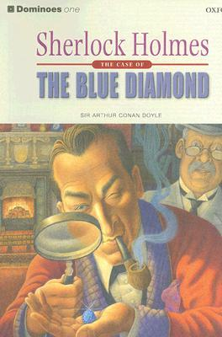
Book Report
Lex van den Brand
V1BT
Title of the book: Sherlock Holmes, The case of the blue Diamond
Author: Arthur Conan Doyle
Level: C
Setting: The story is in London, United Kingdom. The year number is not in the book but i think that it is in round 1900

Summary:
Sherlock Holmes has an old hood and a goose. The doorman of the Baker Street Hotel gives them on Sherlock Holmes. In the old hat their was an name. And in The goose there was a beautiful blue diamond. The name in the hat was Henry Baker. He goes to newspaper to place a advertisement to search Henry Baker. When he was found he saids that he not knows that a diamond is in the goose. Sherlock Holmes goes to mr. Breckinridge. He sells that goose. He saids that mrs Oakshott sells the goose to him. Sherlock Holmes See after that a weak little man. He has a discussion with mister Breckinridge. Then he walk away from mr. Breckinridge. Sherlock Holmes saids to hem if he comes to his house. Then Scherlock Holmes take a lot of questions tot the weak little man. His name was mr. Ryder. He was the diamond thief.

Review:
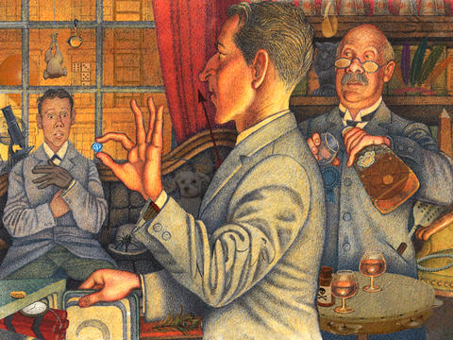
It was a nice book to read for me. The story line was good but in parts of the book it was not so good as in other parts. When i was read the book i was curious how the story ends and that means that it was exciting. The level of the book was good because it was not to difficult and not to easy and that is wat i prefer for books. I will recommend it to another people because it was a good book and not to difficult. I gives the book an 8 because it was good, but not super.

