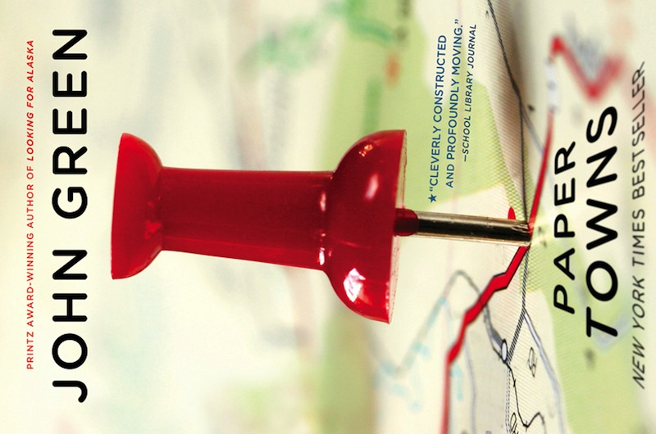
Book report
November 23, 2016
Lisa Kattenberg
Fioretti College, 3V2
Paper Towns by John Green

The author:
John Michael Green, also known as John Green, is an author, vlogger, writer, producer, actor and editor. He is born in August 24, 1977 and lives in The United states.

Setting:
Mostly the book takes place in Orlando, Florida. The characters live in a suburb named Jefferson Park. The paper town Agloe in New York is also an important location in the book. I think the time of the book is the almost the same time as now. The characters have smartphones and they act like modern teenagers.

Main characters:
Margo Roth Spiegelman:
Margo and Quentin know each other since they were 9 years old, because they are neighbors and their parents are friends. At first sight, Margo seems to be a very happy and spontaneous girl, but later in the story it turns out that she is actually a really different person.

Quentin (also named as Q):
Quentin is 17 years old. He is a very quiet person. He is kind of a ‘nerd’ and likes to play videogames with his friends Radar and Ben. He lives a quite normal life and is not looking for more than that. The only thing he wants, is attention from one of the most popular girls in high school: Margo Roth Spiegelman, the girl he has loved for almost his whole life.

Radar (Marcus):
His real name is Marcus, but his friends call him Radar, because he is very smart. He is one of the two best friends of Quentin. Just like Q, he is a very quiet person.

Ben (just Ben):
Ben is the other best friend of Quentin. Ben is actually very different relative to Q. He really wants to be popular and would do anything to have a girlfriend. He is a very weird boy with a strange sense of humor. He is very selfish. In the beginning, he didn't want to help Q to find Margo. But eventually, he does.

Other characters:
Lacey:
Before Margo disappeared, Lacey was Margo's best friend. Later Lacey becomes the girlfriend of Ben.

Jase:
Jase is/was Margo's boyfriend. In the beginning of the book, Margo has just find out that he is cheating with her best friend Becca.

Becca:
The other best friend of Margo.

Summary of the book:
Quentin is in love with Margo since they were neighbors. In the past they always played together and they used to be good friends. But now Margo is one of the most popular girls in high school and Quentin seems invisible to her.
On a night when Quentin was almost asleep, Margo comes climbing through the window in Quentin’s room. She told him that she needed his moms car and his help for the adventure that she has planned. Margo wants to take revenge on all her enemies. Her plans are to catch her boyfriend cheating with her best friend, hide some rotten fishes in her best friends houses, shave away the eyebrows of the biggest bully from high school and many more.
Margo and Quentin had very much fun that night, but the next day on school, Margo is gone. Everyone is searching for her, but she is nowhere to be found. Quentin hasn’t told anybody about the night before she disappeared. Quentin is very anxious about Margo and decides to look for her. He finds out that Margo left some clues so he could find her.
After a long time, Quentin finally knows where Margo is.
The school year is coming to an end and everyone is talking about prom. On the day of the graduations, Quentin takes Radar, Ben and Lacey with him on a road trip to Agloe, New York. After a long time of searching, the finally find Margo. But the Margo they had found, is a different Margo than the happy and spontaneous Margo in Orlando. Margo is very surprised that they came all the way to New York. But she is not going to go back to Orlando. She explains that she is actually very depressed and lonely. This is the reason why she went to Agloe, the smallest paper town in New York. ‘A paper town for a paper girl’ is what she said.

Assignment:
The person I like the most is the happy, spontaneous and adventurous Margo Roth Spiegelman from Orlando. Margo always comes with weird adventures and plans to revenge people she doesn’t like. The part I liked the most, was when Margo and Quentin shaved off the right eyebrow from Chuck Parson at midnight:
I was standing above Chuck with his right eyebrow in my hand when his eyes shot open. Lightning fast, Margo grabbed his comforter and threw it over him, and when I looked up, the little ninja was already out the window. I followed as quickly as I could, as Chuck screamed, ‘’MAMA! DAD! ROBBERY! ROBBERY!” I wanted to say, ‘The only thing we stole was your eyebrow’, but I swung myself feetfirst out the window. I damn near landed on Margo, who was spray-painting an M onto the vinyl siding of Chuck’s house, and then we both grabbed our shoes and hauled ass to the minivan. When I looked back at the house, lights were on but no one was outside yet. By the time Mr. Parson pulled open the living room curtains and looked outside, we were driving in reverse back toward Princeton Street and the interstate.
‘’Yes!’’ I shouted. ‘’God, that was brilliant.’’

The person I don’t like is the depressed and lonely Margo Roth Spiegelman from Algoe in New York. It is very unfortunate that a girl like the Margo in Orlando, could change so fast to a whole different person. In this part, Margo and Quentin are having a fight.
She tries to turn away me, but I grab her shoulders and hold her in front of me and say, "Did you ever even think about what your leaving meant? About me or Lacey or any of the other people who cared about you? No. Of course you didn't. Because if it doesn't happen to you, it doesn't happen at all. Isn't that it, Margo? Isn't it?' She doesn't fight me now. She just slumps her shoulders, turns, and walks back. She kicks down both of the Plexiglas walls, and they clamor against the desk and chair before sliding onto the ground. "SHUT UP SHUT UP YOU ASSHOLE.

