Don’t Tell Me What To Do.
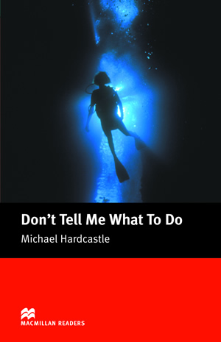

Name: Thom van Bakel.
Class: 3G1
Teacher: Ms Paulusma.
Date: 11-12-16

The author is Micheal Hardcastle, I cant find when the book was published.
The book got 58 pages withoud the information.
The main character are Shirley, Vincent Masters and Tom Doggett, but Tom is the biggest main character.
Tom is a guy he is very strong 18 years old and have short hair, he is smart he love swimming and have a eye on Shirley, he ran away from home, he goes work at Vincent Masters.
Vincent Masters:
The employer of Tom Doggett and father of Shirley. A nice man, who gives a lot of orders.
Shirley:
Shirley is the daughter of Vincent Masters and is in love with Tom. A mysterious person. She has short hair and is 18 years old.
A short summary:
Tom Doggett runs away from home to be a horse racer that was his dream, but meets Shirley he likes her end she like him and he meat Vincent Masters the dad of Shirley on the road. He gets offered a job and gets a lot of money. He has to emerge a bag with drugs from a ship wreck, but Vincent Masters says that it are diamonds. Tom likes Shirley very much. When he’s in the ship wreck, called the Kular, he notes that there had already someone been. He lost the bag of drugs and comes to the water surface because he doesn’t have much air left. There he sees Vincent Masters odd move. Because already a guy died with the job, Tom thinks Vincent Masters want to kill him. But Vincent Masters is stuck with his air hose. Tom tries to save him, but he’s death. He decides to proceed with Shirley and they live happily ever after.
Why should other pupils read this book:
It’s a very good not difficuld with few pages, it is very exciting and adventurous but also a bit romantic, it’s a cool book.
normal I don’t like this book but also this book I like him, I want more book at this.

