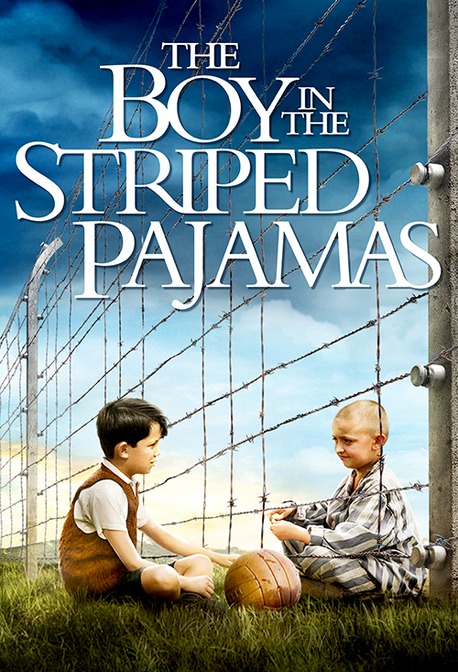
THE BOY IN THE STRIPED PAJAMAS

Aybike Imelda Aydogan
Class 14
Teacher: Angela Kemper-Galo
Table of contest

General information ………........3

Introduction …………………... 4

Assignment 1 ……………….... 5
- Sumarry

Assignment 2 ……………….....9
3 topics

Sources ..................................... 13

General information
Published in 2006, this book by John Boyne is told from the point of view of nine-year-old Bruno, the German son of a Nazi soldier who moves with his family from Berlin to Poland. And when he arrives, it turns out that their new house is just a stone's throw away from the Auschwitz concentration camp. Uh-oh… But while plenty of terribleness ensues, something really incredible happens, too: Bruno befriends a kid on the other side of the fence, Shmuel. And these two become the truest of friends.

Introduction

I read the book and watched the movie. I have to say that I liked the book more and that the movie is not really copmarable with the details in the book. It’s a very good novel, you see war trough the eyes of a Nazi son. I would recommend this novel, because of it’s sweeping story.
The theme of this story is friendship in war. Bruno becomes best friends with Shmuel, despite the big difference between them: Shmuel is a Jew and lives in Poland. He’s used to live with almost ten people in one house, you can call him poor. Bruno is a not-Jew and used to live in a five floor-counting villa.

Summary
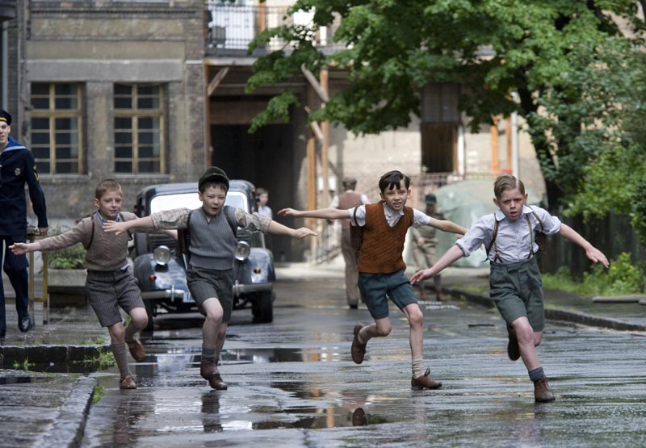
When Bruno came home he saw the maid putting his belongings into boxes. Bruno’s mother explained that they had to move because father’s new job.
Bruno’s new house was in the middle of nowhere. He saw no houses or other boys or children to play with. Bruno tried to explore the house, but there was nothing to explore in their new house.
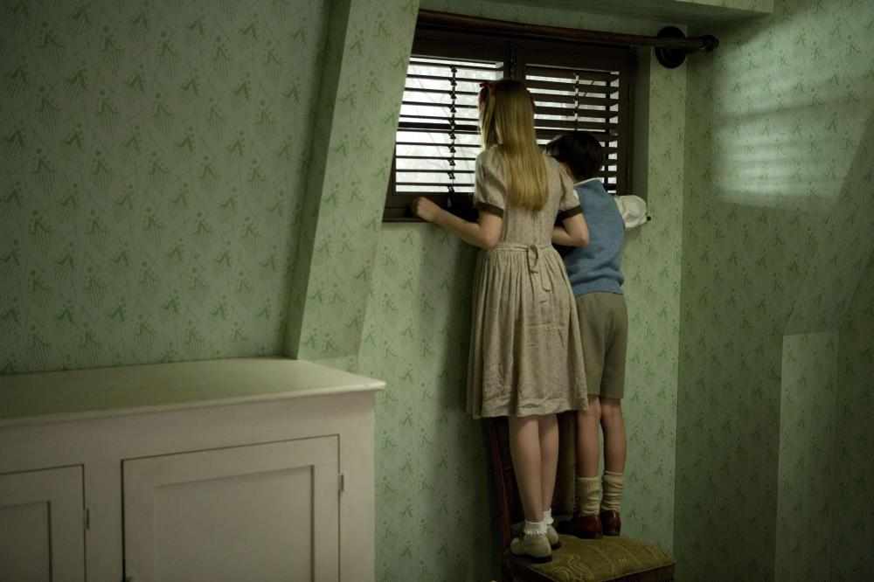
Gretel explained Bruno the name of the new house, called Out-With. Bruno missed their old house and friends very much. Bruno showed Gretel also the people he could see from his bedroom.
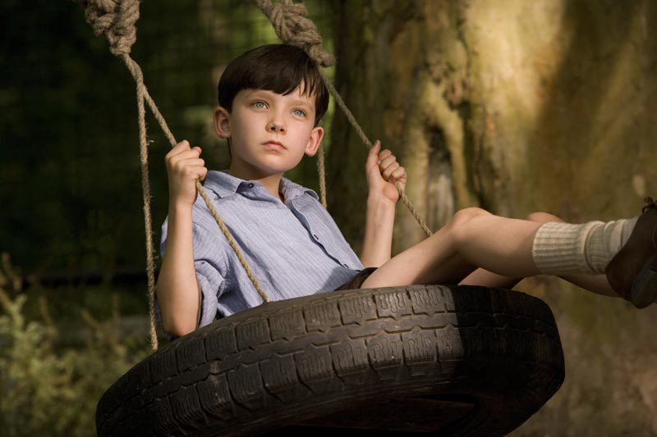
They were wondering what people they saw. Bruno thought it were people from another town.
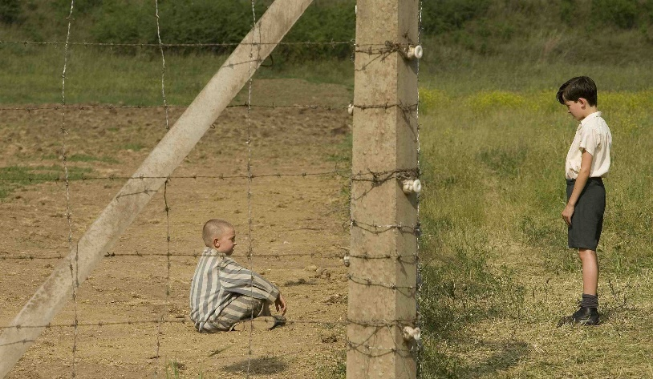
Bruno remembered that he used to joy exploration. He found a fence.
Behind the fence Bruno’d discovered, he saw a dot that became a speck that became a blob that became a figure that became a boy. When he met shmuel he didn’t quit understand why he was always wearing pajamas. They got talking and discovered they were born on the same day.
Since that day Bruno went everyday to the fence to play with Shmuel. Sometimes he would bring food or some chocolate for Shmuel.
Mother thought Out-With wasn’t a good place for children to grow up, so they were leaving Out-With and went back to their old home in Berlin. Bruno was very sad about this, because he had to miss Shmuel.
Bruno told Shmuel he had to leave. Shmuel were very sad because he lost his father. Bruno and Shmuel made a plan that Shmuel would bring striped pyjamas the other day, so Bruno could search for Shmuel’s father.
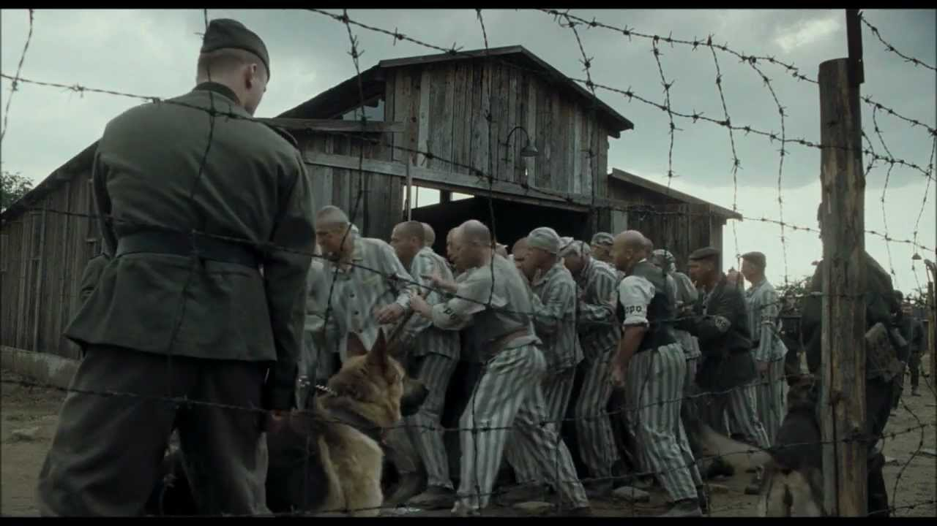
Bruno pulled the pyjamas and went to Shmuel’s side of the fence. Bruno didn’t like it there at all, but when he wanted to go back, they had to go on a march and they had to go in a room. Bruno said Shmuel was his best friend. At the time Shmuel opened his mouth, Bruno didn’t heard it because there was a loud noise from the door, which was closed. Bruno held Shmuel’s hand while there was the chaos on the dark room.
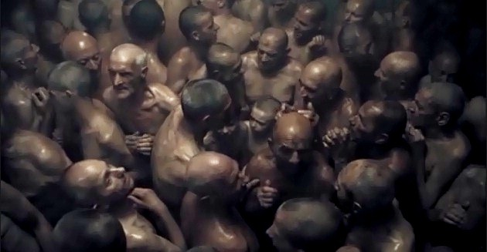
Bruno was missed. Father looked for him trough the whole house. A villager found Bruno’s clothes near the fence Bruno used to meet Shmuel. Gretel and mother returned to Berlin, but either there wasn’t Bruno. After a year father went back to the fence and discovered Bruno climbed to the other side. He immediatly understood what happened to Bruno.
3 Topics
- It is easier to be brave if you don’t know how dangerous a situation is. Discuss whether Bruno is a brave boy or a coward. Use 100 words.
Bruno is a really brave character who loves adventure. When he met Shmuel he didn’t quit understand why he wore pyjamas all the time and why he was dirty. When Bruno found out that Shmuel was a jew and that they actually should have been enemies, and not be friends. But Bruno says that Shmuel a good and nice jew, that is why Bruno keeps going to see him and bring him food. One day when Shmuel’s dad is missing he askes Bruno to help and find him. Because Bruno is a brave boy and wants to help his friend, they start to make a plan. Shmuel finds some pyjamas that Bruno can wear so he can sneak into the camp.
- Describe the development of at least two characters, use 70 words per character.
Gretel:Gretel is Bruno's twelve­year­old sister who loves to play with dolls and rearrange them on her shelf.When Gretel met Lieutenant Kotler and learned more about the history of jews she changed her habits, throw her dolls away, and acted more maturely. She became a big Hitler supporter. Her mom was not happy about how Gretel developted. Gretel tought Bruno how bad jews were and that they were awful people.

Bruno: Bruno was a adventure lover, spoiled boy who had alot of friends in Berlin. He acctually never know what the job of his father was. When they moved he had nobody and felt lonely. One day he goes to the backyard where he is not supposed to be. He wants to explore the ‘farm’. He meets Shmuel and becomes friends. He becomes a really nice and giving boy who want to help his friend out.

- “And that’s the end of the story about Bruno and his family. Of course this happened a long time ago and nothing like that could ever happen again. Not in this day and age.” Give your opinion on these ﬁnal sentences of the book. Do you agree or disagree? Why do you think the author ﬁnishes the book with these words? Use 150 words.
My opinion on those last sentences is that the author meant is what happened in the story can not happen, neither be real in this time of age beccause there is no war and something terrible like that will never happen again. I do agree with those last sentences. Because I think that there will never come a war again, and even if it would happen it will not be as bad as WWII. I think that the author of this novel finished his book with these sentences because he wanted to convince the readers that such a horrible thing will not happen ever again. I personally didn´t liked it that the author finished this novel with that sentence because I would rather had something more dramatic, like ´Father couldn´t live anymore with the thought of that he was the reason why his son died and killed hung hisself.´ But either way I really liked the story.

Sources

- http://www.scholieren.com/boek/9255/the-boy-in-the-striped-pyjamas
- https://nl.wikipedia.org/wiki/The_Boy_in_the_Striped_Pyjamas

