ENGLISCH BOOKREPORT.
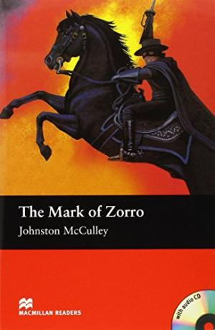

Name: Thom van Bakel.
Section: Enlisch.
Teacher: M Paulusma.
Dates: 7-10-16

1.A The title of the book is: The mark of Zorro.
B
2.A The autor of the book is Johnston McCulley.
B Johnston McCully was born on 2 Febuary 1883 in Los Angeles and is deceased on November 23, 1958.
3.A it is a avondture book because there is a lot of action and it's exciting.

4.A How does Zorro looks like? Zorro is a man his real name don don diego vega his age is 24, his name is in Spanish fox. What does he look like? He has a black shirt and black pants with a long black cape he has a black mask with two round holes for his eyes, he has a black mustache and a long silver sword it looks like a long silver rod he often has a gun.

5.A When he seess how the villagers are oppressed by the rich landowners and the government, takes Don Diego (outside everyone to know is a master screens) the identity of Zorro. Zorro as he dives regularly from nowhere to the villagers at the stand. He especially has to deal with the corrupt Governor Alvarado, his henchman Captain Juan Ramon and the brutal Sergeant Pedro Gonzales.

6.A The solution is: Don Diego Vega sees rich people's army and the church the money demands of poor people and poor farmers then will don diego vegas action he takes the identity of Zorro and goes to the rich people of the municipality and the army a lesson by their fight and steal money from the rich and give that to the poor farmers and poor people.

7.A During a dark night in February, a group of soldiers in a tavern on the side of Los Angeles. When one of the soldiers Zorro start talking Sergeant Gonzales begins to laugh. He says he's waiting for Zorro and will murder him. moments later the door opens and everyone thinks Zorro arrives, but it was Don Diego Vega. Zorro come later that day to the inn to discuss Gonzales about what he did. then they fight Gonzales against Zorro, Gonzales wants to murder him alone that fails it is sword to sword says Zorro, Zorro put the sword of Gonzales hands and Gonzales says killed me, but Zorro doesn’t do that and runs out of the window and disappears
in the fog. Don Diego is falls in love with Lolita and Lolita also Don Diego but Lolita sees Zorro comes along she is really falls in love with Zorro. Then goes to Captain Ramon and he want to kiss her and marry with her she does not want that, Lolita refers him, and Zorro walks in there and asks what he is doing Captain Ramon goes away and Zorro kis Lolita on her lips. then they come to the house of the Frey Felipe soldiers think Frey Felipe Zorro has constipated in the house and search the house, but the Don Diego tells the soldiers' why are you here? some soldiers take Frey Felipe to the courtroom soldiers pull the shirt von Frey Felipe out and hit him 15 times with a whip because the dealer says Frey Felipe stole his money but than Zorro walks in and says to the dealer you told lies you give someone 15 hits with a whip, but now I'm going to hit you 15 times with a whip. Gonzales will find Zorro and he is going to search every house. a little while later, Zorro goes fight with Captain Ramon and Zorro makes three quick movements and makes a bloody z on his face. some time later, everyone gathered in the square Don Alejandro says Senor Zorro you're safe down here, put your mask and show who you are, Zorro does the mask of, Lolita says but with witch men im gone to marry whit Zorro of Don Diego Vega, Don Diego Vega laughs and Lolita marry with Don Diego Vega.

8.A I think the book really recommendable I could read me very alive in the book Self is my English is not super good and I thought I had so first a lot of trouble with the book, but reading was easy. I was completely engrossed in the book and could read it almost without problems, it's also fun to read because it is not a thick book, it is also great for people who love reading but need to do it then I would this book really recommend and platelets are also and I also like.

