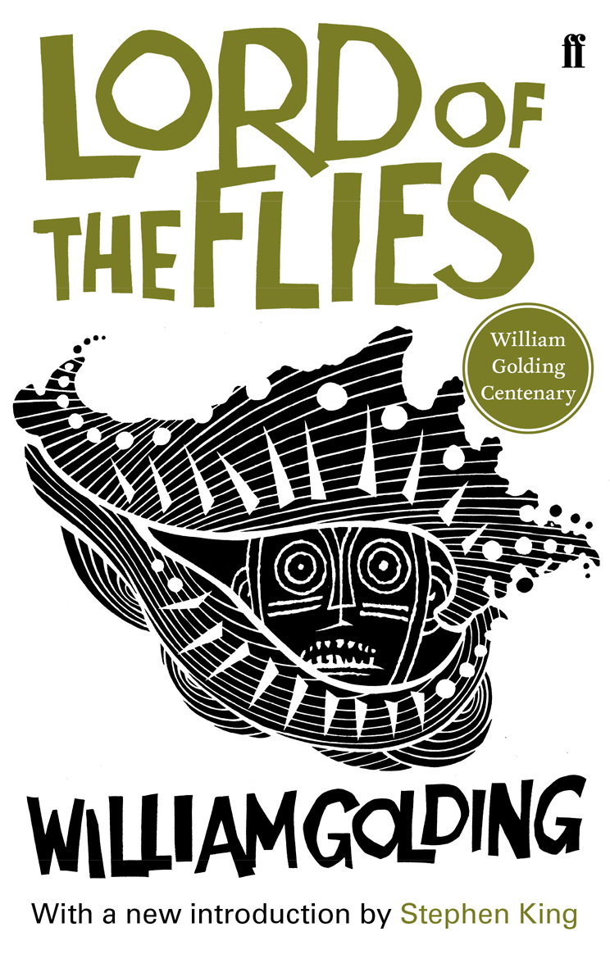

Book report V5 by Marieke van Diemen

Table of contents

Preliminary details………………………………………………………………………………………………..page 3
Characters…………………………………………………………………………………………………………….page 3
Setting………………………………………………………………………………………………………………….page 4
Conflict…………………………………………………………………………………………………………………page 4
Journal………………………………………………………………………………………………………………… page 5
Poem…………………………………………………………………………………………………………………… page 6
Letter………………………………………………………………………………………………………………….. page 7
Glossary………………………………………………………………………………………………………………. page 8

Preliminary details
Title: Lord of the flies
Author: William Golding
Date of publication: 1954
Number of pages: 288
Noteworthy: Lord of the flies is William Golding’s first novel and by writing it he won the Nobel Prize for Literature.

Characters
All characters in the book are boys aged from as young as 6 a.k.a. the littluns, up to the age of 12 a.k.a. the biguns. The reader does not know how many boys are present on the island because they never counted how many there were. The reader does get a lot of names throughout the story: Johnny, Bill, Jack, Piggy, Ralph, Sam, Eric, Percival, Simon, Maurice, Walter, Robert, Roger, Harold and Henry.
Ralph is the main character. He is tall compared to the others, he has fair hair and he is handsome. Ralph is the leader of all boys. His father works in the navy. Ralph is a round character. His strength is to speech and to keep thinking ahead and be sensible. He is the first boy to be introduced in the book. At first Ralph doesn’t seem to care too much about what’s happening. But when things start to go wrong he feels terribly miserable and he starts to blame himself for the happened events, such as the murder of Simon.
Piggy is next in line: he is shorter than Ralph and quite fat. Piggy’s best friend during the book is Ralph. His real name is not piggy but because of his body mass everybody refers to him as piggy, and before that as fatty. He does not like the other boys to call him names, it hurts his feelings. The reader doesn’t get to know his real name. Piggy wears glasses and has asthma. He talks with a funny accent. This is something Piggy said to give you an idea: ‘There isn’t more than a ha’porth of meat in a crab.’ The other boys do not take him seriously, despite that he is the smartest of them all. When piggy feels threatened, he turns to Ralph for help.
The Boy who is most disrespectful towards him is named Jack Merridew. He has red hair, and a crumpled, freckled ugly face. His eyes are light blue and his body is bony. He is the leader of some other boys such as Simon, Maurice and Robert. Together they are the choir boys and Jack is the chapter chorister. Of all the boys Jack is the most savage of them all. Because of this characteristic he and Ralph sometimes clash, as Ralph always tries to remain sensible. At first Jack couldn’t bear to murder a pig but after a while he can’t think of anything else. He also became much more rude and insurgent. Because this change in personality Jack is a round character.
Simon is a good friend of Ralph. He is skinny and had black hair that reaches till his eyes. It’s coarse and straight and hangs down. Simon is always nervous when talking to the whole group of boys. According to Jack he faints a lot. Ralph thinks he is vivid and Ralph can get along with him quite good. I think Simon is a bright boy with lots of sense. But throughout the book he remains quite the same so he is a flat character.
The rest of the boys are not very determining for the story plot. I know that Sam and Eric are twins, Percival is crying a lot and Roger is a mean kid. He destroys other kid’s sand castles for example.

Setting
place
The boys were in an airplane, which crashed right on an island in the middle of the pacific ocean. It’s called coral island. Coral Island has the shape of a boat and contains a mountain with one square shaped summit. From side to side of the boat shape the mountain has a steep slope and along the long side of the island is a tamer slope. At the end of the boat is another island, much smaller. The boys call it the fort, as it is completely made out of pink rock. The bigger island is covered in trees, amongst them are palm trees and different kinds of fruit trees. There are also rocks, all of them are pink. Between the dense forest pink rocks can be seen from the mountain. The Island also has cliffs, one of them is covered in blue flowers. On the beach is also a platform of pink rock were tiny palm saplings can grow. Once they get bigger they die and fall due to the lack of soil. Near the platform is a lagoon where the boys often swim. The wildlife on coral islands contains of pigs and bright little birds and supposedly also insects. Surrounding the island is a beach and a coral reef. The coral reef looks like an aquarium and lies parallel to the beach, with a mile between them. Beyond it was dark blue sea that reached until the horizon. On the island it is hot due to the sun and in the forest the air is oppressive. At night the island gets cold.

Time
The year in which the story takes place is unknown. The story is written in past tense. Both day and night are described in the book, but the night parts very briefly. During the story I got the impression that there could be a few days that were skipped, but not so many. I think the time described in the book reaches out over about 20 days.

Conflict
The story contains both the journey type conflict and the contest conflict: In the beginning a group of boys need to survive on an inhabited island. Their problems are lack of food and water and they are frightened of a beast that lives on the island according to some boys. But as the story proceeds the type of conflict slowly changes to the contest conflict: Ralph and Jack have different priorities and Jack envies Ralphs position as chief. Ralphs main priority is to maintain a signal fire in order to be rescued. He also values the rules he made in order to keep the group of boys civilized. Jack however only thinks about hunting and discards all rules. Because the two of them are so different and they both want their way, they clash.
Journal

Still civilized
Roger gathered a handful of stones and began to throw them. Yet there was a space round Henry, perhaps six yards in diameter, into which he dare not throw. Here, invisible yet strong, was the taboo of the old life. Round the squatting child was the protection of parents and school and policemen and the law. Roger’s arm was conditioned by a civilization that knew nothing of him and was in ruins. (page 78)

This piece of texts illustrates best that the boys are still civilized. When I read this, I knew that the civilized attitude of the boys would change later in the book. I predicted that. But I never thought it would get as bad as the end of the book.

Hurting Robert
Robert squealed in mock terror, then in real pain. “Ow! Stop it! You’re hurting!”
Ralph, carried away by a sudden thick excitement, grabbed Eric’s spear and jabbed at Robert with it. “Kill him! Kill him!” All at once, Robert was screaming and struggling with the strength of frenzy. (page 142)

After reading this passage I thought by myself: this is the first sign of upcoming savageness. For the other boys it was still a game, but Robert found this event rather unpleasant. As they stabbed him and hurted him they did not pay any attention to his feelings. That was very cruel, I thought.

Death of Simon
Softly, surrounded by a fringe of inquisitive bright creatures, itself a silver shape beneath the steadfast constellations, Simon’s dead body moved out toward the open sea. (page 190)

This part scared me because they killed someone and I was not even near the end of the book. Although it was an accident, the death of Simon had a great impact. Now it was a small step to killing someone else on purpose. I also felt a bit miserable when he died because I started to like Simon because of his sensible thinking an optimistic attitude.

Murder of Piggy
The rock struck Piggy a glancing blow from chin to knee; the conch exploded into a thousand white fragments and ceased to exist. Piggy, saying nothing, with no time for even a grunt, travelled through the air sideways from the rock, turning over as he went. The rock bounded twice and was lost in the forest. Piggy fell forty feet and landed on his back across the square red rock in the sea. His head opened and stuff came out and turned red. (page 222)

By now I thought: The process of becoming savage is complete. Piggy is murdered on a very horrific way and the savage boys don’t even care. They think Piggy deserved it. Immediately after this brute murder they also start to chase Ralph to try and catch him and kill him as well. This made me think how little sense the savage boys had left on this point.
Rescued
He staggered to his feet, tensed for more terrors, and looked up at a huge peaked cap. It was a white-topped cap, and above the green shade of the peak was a crown, an anchor, gold foliage. He saw white drill, epaulettes, a revolver, a row of gilt buttons down the front of a uniform. A naval officer stood on the sand, looking down at Ralph in wary astonishment. (page 246)

I was quite relieved after reading that, because the long and wild hunt on Ralph made me very tense. This horrible situation finally came to an end.

Poem

They were afraid of the beastie
Beastie from the sea, from the sky, in the dark
One of them went looking
During heavy storm and rain the boy returned
Wanting to tell his story
That here was no beastie
But he was wrong
It all became clear when his dead body
laid there on the beach
The beastie was real
It was them

This poem is relevant to the book because the boys slowly turn savage. First they push each other and throw rocks in the direction of other boys without hitting. These are innocent games and at this point the boys were still civilized. But because there were no parents to stop these games things got worse and worse. They break piggy’s glasses, then they start to stab other boys who pretend to be pigs, then they murder by accident (Simon), then on purpose(Piggy), and finally they are burning down an island and hunting for Ralph like a pack of wolves.
In the beginning the boys fear an imaginary creature that lives on the island but it turns out they are the only ones they should be afraid of. Concluding; they became ‘the beastie’. This is also the message of the book, lack of authority combined with human nature is a bad mix.

Letter
(I want to wright a letter to someone who is still alive and not savage: so Ralph is my only option.)

14-10-2015
Dear Ralph,

What happened to you is past horrific. I hope you can manage to get your life and emotions back on track. If not, I recommend professional help. In the beginning it was quite nice on the island because of the beautiful landscape and there were no problems. But as time went by the mood darkened further and further.

I think you managed to keep you head cool and you also kept thinking straight almost the whole time. You got carried away only one time during your time on the island and I understand. I can only hope I would act the same as you did if I ever ended up in a situation like yours. I agree that there should be rules and I also agree about having the signal fire as the number one priority. One should not loose himself in hunting and savagery like Jack and his subjects did.

When Simon was killed you were very sad and you thought it was your fault. But it wasn’t! Don’t worry about it too much, there was nothing that you could have done, really. All of those wild boys were unstoppable and running and shouting an you could never have stopped them on your own, or even with the help of Piggy. If I were there I would also have been powerless.

And when you were hunted down, you must have been scared to death. Luckily you were saved by the bell. It must have been quite a shock to stumble into a grown up after such a long time on that island. But at that moment it was the best thing that could happen to you. You would have been murdered almost for sure. Thank god you are still alive! It sure was a close call. I have no idea what I would have done, maybe climb a tree high enough so they wouldn’t see me in spite of the presence of fire on the island. And after they passed me I would come down again and search for a hidden place where I could hide and calm down, such as a cave. But surviving would have been super hard because the savage boys would always be on the hunt for me and make it impossible for me to hunt.

I wonder what happened to the other boys, the hunters and killers. I’m hoping they will receive punishment for their deeds. Some people could state that they got carried away because of this extreme situation. But I think they should meet the consequences of their deeds. Especially Jack! It was because of him that the other boys turned savage and also turned against you in the first place. I’m not sure if he should go to prison but I’m sure he should see a psychiatrist.

The only upside to this is that you will be a lifelong celebrity just like Robinson Crusoe, but even more famous. I wish you the best of luck in school and college later on.

Yours sincerely,
Marieke
Glossary
1. The three boys began to scramble up. (page 34)
= omhoog klauteren
2-4. Some unknown force had wrenched and shattered there cubes so that they lay askew, often piled diminishingly on each other. (page34)
=wrikken = steil = afnemend in grootte
5,6. The most usual feature of the rock was a pink cliff surmounted by a skewed black. (page 34)
=bedekt met =schuin
7-9.Here the roots and stems of creepers were in such tangles that the boys had to thread through them like pliant needles. (page 35)
=klimplant =zich een weg banen =buigbaar
10. Immured in these tangles, at perhaps their most difficult moment, Ralph turned with shining eyes to the others. (page 35)
=omgeven
11-13. Again came the solemn communion of shining eyes in the gloom. (page 36)
=ernstig =bijeenkomst =halfduister
14,15. They were on the lip of a cirque, or a half- cirque, in the side of the mountain. (page 37)
=op de rand van =cirkelvormige uitsparing
16-19. This was filled with a blue flower, a rock plant of some sort; and the overflow hung down the vent and spilled lavishly among the canopy of the forest. (page 37)
=wat over de rand komt =tochtgat =royaal =hemel
20-24.The bushes were dark evergreen and aromatic and the many buds were waxen green and folded up against the light. (page 38)
=eeuwig groen =geurig =knopjes =was groen
25. The three boys rushed forward and Jack drew his knife again with a flourish. (page 40)
=zwaai
26. The pause was only long enough for them to understand what an enormity the downward stroke would be. (page 40)
=enormiteit
27,28. Then the piglet tore loose from the creepers and scurried into the undergrowth. (page 40)
=snel rennen = vegatatie in een bos
29,30. The difficulty was not the steep ascent round the shoulders of the rock, but the occasional plunges through the undergrowth to get to the next path. (page 35)
=helling =vallen in kleine gaten

