Engels filmverslag

Tara Hoeba 3E H. Lakbiach
Freedom Writers
Director: Richard LaGravenese
Running time: 123 minutes
Language: English
Genre: Drama
The main actors:
Erin Gruwell - The English teacher who gets a good relationship with her ​​class.
It is the most important person in the whole movie . Played by: Hilary Swank.
Scott Casey - The husband of Erin Gruwell . Played by: Patrick Dempsey.
Margaret Campbell - headmaster of the school where Erin Gruwell works. Played by: Imela Staunton .
All students play an important role in the film, but two of the students are most prevalent in the film.
Eva Benitez - Student Erin Gruwell.
Andre Bryant - Student Erin Gruwell.
Awards and nominations 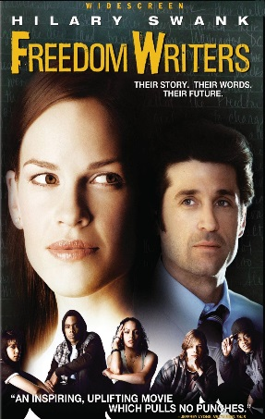
Freedom Writers was nominated for two awards , the film won them one.
2007Humanitas award in the Feature Film category
Resume
This film is about a gentle teacher named Erin Gruwell, she studied English and now want to be a teacher at a school that she likes. When Miss Gruwell went on the job interview,the director gave an immediate bias for the school was way too ghetto for such a gentle teacher but of course you do not say that about your own school. She gets classroom 203 a very worn and old room, but soon she finds out that the kids are not interested in a rich white teacher. Miss gruwell didn’t accepted the behavior of the kids though she decided to know a little more about these kids. Why are they such negative about everything. After a lot of talking and asking she finds out that every single child in here has there own stories. Such as gangs, homeless, drugs and abuse. She used Anne Frank as a example for what these kids are going through. For them the story of Anne Frank was a heart breaking. They stared to realize they all going trough the same thing and that they got to stand up for them self but just with words. She got so busy with here wonderful work that she forgot her partner Scott. He had work but he actually didn’t wanted to work there, for him seeing how his wife has the greatest job of the world became him to much so he left.
Miss Gruwell is just at that school and should give even only English to 1st / 2nd year, when the children hear that they are going crazy. They want their teacher back to the juniors. Where they need to go next year. Eva says: you I'm going to respect the classroom and i have respect for you. It must not want to exchange course with the head of the school to talk with the director all the teachers, but the English teacher for juniors and seniors. The headmistress Margaret also do not want that to happen, they think nothing changed with the childeren. The director sends them to the bord of the school. They talk and hear the decision. When she came back at school all the chilren werer waiting for her. Someone question "are you going back to the juniors" she says "no, no I'm not going with you along after the juniors, I go with you after the juniors and the seniors." .It is a celebration in the school as the children hear. They where on top off moon. At the end of this film Miss Gruwell has a good relationship with all the kids and their numbers are much better , the kids loved to go to school because they finaly got attention and and they know it only comes by miss Gruwell.
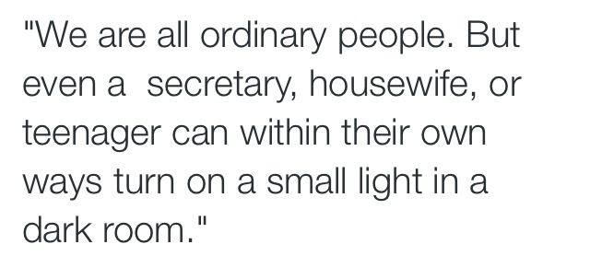
My opinion
Freedom Writers is not a bad film and has many beautiful scenes that you certainly deliver a lump in the throat. Like the scene they show about what they been trough. As example the scene were they show that Eva’s father was taken, i think they took the right actress. When i looked at the film as if it had happened to the actors themselves. It is a pity that the movie doing much reminiscent of his predecessor twelve years ago. This would allow many people forget that it is a true story and that these situations in schools now once common in the US for coming . The end of the film is a bit of a cliche and as a viewer you wonder if this is really gone as if it was made better for the public. Anyway, suckers for happy endings can safely this film, you do not walk out of the classroom with a heavily loaded feeling. That makes a difference. When i saw eva the first time i really tought she was a bitch i could relate to her, and they all made it look like a really hell in own home. I think they should remake this movie cause because it’s such a old movie and you really see that i think it would be a succses if make it a movie of nowadays. The little things like the clothes the actorss are wearing and how the schol looks like you’ll see it is a very old movie

