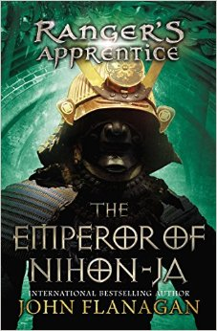Book report:

Book report:   
Stef de Haan 2Va  
09-03-2016

* Book: ‘Ranger’s apprentice, The Emperor of Nihon-Ja’
* Written by: John Flanagan
* Publisher: Random House, in 2010 in Australia  
  Genre: Adventure, fantasy

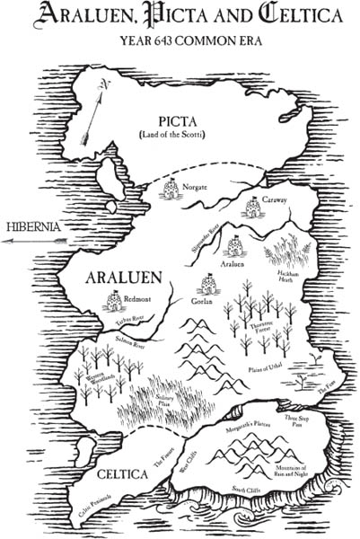**When and where?**The story takes place in Araluen and Nihon-Ja. Therefore the title ‘the emperor of Nihon-Ja’. These places are found in medieval Japan. The story takes place around the year 642-644.

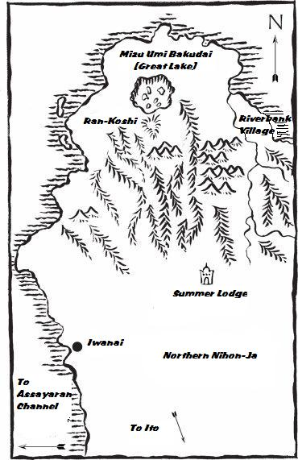

**Persons**

**Main:**

***Will:*** Has been Ranger for several years, having trained with legendary Halt. He is known for his loyalty, bravery and has proven himself in countless battles.

***Halt****:* Is a renowned member of the Ranger Corps. He is a superb archer and uses a massive longbow, his skills with the bow is uncanny, deadly accurate and devastatingly swift.  
***Horace***: Is a legendary knight of the Araluen Court, renowned throughout the Kingdom for his courage, strength and loyalty. Like Will and Alyss, he is an orphan, and grew up in the ward of Castle Redmont.  
 **Sub:**

***Emperor Shigeru:*** is kind and calm. He believes strongly in helping everyone in society.  
***George:*** Grew up with Will, Horace and Alyss in Castle Redmont. In contrast to the others, he trained as a scribe and attorney and he has a particular interest in the ways of the Nihon-Ja.  
***Alyss***: Is a former ward mate of Horace and Will. Her beauty, intelligence and calm nature make her perfect fit for her Diplomatic Service missions for the Kingdom. She is very fond Will. Having known him for years, but can’t help the jealous feeling of his friendship with Evanlyn.

**Other words**

***Shukin:*** The guard of the emperor Shigeru. ***Senshi:*** Samurai, special warriors, with sword skills. ***Kikori:*** Native inhabitants of the North of Nihon-Ja. ***The tortoise formation:*** Specific attack formation used in the medieval period.

Summary

***Horace*** is missing. Months have passed since he was sent on a military mission to the court of the Emperor of ***Nihon-Ja*** with his friend and former wardmate ***George*** but he has failed to return. Meanwhile, ***Halt, Will***, Selethen and Alyss are in ***Toscana*** watching demonstrations of new fighting techniques, to become more skilled. When Evanlyn arrives, telling Horace is missing, the Araluens and Selethen leave on a Skandianship to find Horace.  
 They find out Horace has become victim in Nihon-Jan politics. The arrogant Senshi sect, a class which believes that they are a superior race, has rebelled against the rightful Emperor Shigeru and Horace has chosen to stay and lend support to the deposed ruler.

Followed by the rebel leader and master swordsman Arisaka, Horace and ***Shigeru*** flee along with Shigeru's cousin and guard ***Shukin***. Their only hope is to find the legendary castle of ***Ran-Koshi***, which is mentioned in a legend and said to have impossibly high walls. The three lead their small entourage of 50 ***Senshi*** around the native villages recruiting Kikori, lumberjacks’ native to the area.

After recruiting, the men flee from Arisaka and his much larger army of Senshi. However, the Emperor's party is moving slower and slower. In an effort to save them more time, Shukin and nine other Senshi volunteer to stay back at a river and duel the enemy until they are killed. From a cliff, Shigeru watches as Arisaka kills his cousin and continues the pursuit. Shortly after, they come to a precipice crossed only by a rickety footbridge, and quickly cross. However, as the last men are crossing Arisaka's army arrives. Horace has a rope tied around his waist and goes back onto the bridge to defend it while the heavy ropes are being cut. When it falls, Horace is bashed against the cliff and drops his sword into the precipice. Shigeru later presents a gift to the knight, a perfect copy of his blade but forged with the strong Ni-hon Ja'n steel. With the enemy army stuck on the other side of the precipice, the party is free to carry on to Ran Koshi.

When they arrive, they discover that the legendary fortress is a valley between high cliffs, defended by a palisade at its narrow opening. The men set up camp and the ***Kikori*** start to renovate the fortress as more numbers join from the surrounding villages. After they arrive, the heavy snows of the Ni-han Ja'n Winter come in, giving the men time to prepare while Arisaka is further hindered. Come springtime, the Ran Koshi has been transformed into a full military fortress, but the all the Emperor has for an army are 50 Senshi and 200 untrained Kikori. Unknown to them, Evanlyn's party has arrived, and goes out in search of Horace. They are found by scouting Krikori, and they bring them to ‘Ran Koshi’. Horace welcomes his old friends, and tells them of his situation.

The problem reminds Will of the Toscan military demonstration, and he and Selethen begin training men to use ***the tortoise formation***. They form four units of 50 men, heavily trained formations of men armed with large wooden shields, short swords and javelins. Meanwhile, Alyss and Evanlyn embark on a journey across a large mountain lake to find a people from a myth called the Hanasu. When they arrive on the other side, they make contact and find that the Hanasu are large mountain people covered in thick, reddish fur and are intensely loyal to their lord. When hearing about Shigeru's situation, their lord says he would help, but their way is blocked by a forest haunted by a demon that has killed 17 Hanasu, and they will not enter it. Alyss and Evanlyn go out to kill it, and discover the demon is a giant snow tiger. After killing it, they bring it back and the Hanasu march for Ran Koshi.

When Spring comes, Arisaka's men come through the mountains and camp at the bottom of a nearby valley. However, they are now much larger due to reinforcements from the south. Shigeru, Horace, Halt, Will and Selethen know that they are heavily outnumbered, but they prepare for battle to confront Arisaka. They prepare their formations on the plain outside Ran Koshi, and kill hundreds of Arisaka's army. But just as they are about to engage again, another army arrives, carrying hundreds more to Arisaka's aid under the Lord Yamada. As the enemy arrives, the Hanasu arrive as well, with three thousand brutal warriors. Arisaka prepares to fight to the end, but Shigeru stops the battle, and says that he will give up his position as emperor if it will save hundreds of his people dying. Arisaka's army lays down their weapons and salutes Shigeru. But when Arisaka runs forward with hate, Will throws a ‘saxe’ knife at his neck, the knife killed the lord.

Because the battle is won, Shigeru returns to his position as Emperor to reorganize Ni-hon JA. Shigeru gives Horace a painting to remember him by, and they return to ***Araluen***. In the end, Horace and Evanlyn become engaged, and Will mentions to Alyss that they should do the same.

**My opinion**

I prefer the book, because it’s an exciting story. It’s an entertaining and addicting book. If you start reading you don’t want to stop. Now and then the book was difficult to understand because of all Japanese words like Krikori. Still you can read the story if you read the text around. If I had to give this book a mark, I’d give a 7.