Hugo Grotius
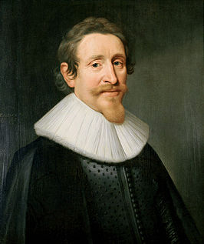

Table of contents

- Front page
- Table of contents
- Introduction
- How did Hugo’s childhood look like?
- What books did he write?
- What did he do in the republic?
- Why was he captured in Slot Loevestein?
- Conclusion + Main question
- Sources

Introduction
Most people know Hugo Grotius as the man from the book chest. And so did I. I’ve chosen Hugo Grotius because at primary school I learned something very funny. I learned that he escaped from prison in a book chest. For me it was just a nice story. But that’s all I know about him. But I’m sure that’s not everything you can tell about Hugo. In this way I can learn more about him.

Main-question:
-What makes Hugo important for the Golden Age in the republic?

Sub-questions:
-What did he do politically in the republic?
-What books did he write?
-How did his childhood look like?
-Why was he captured in Slot Loevestein?

How did Hugo’s childhood look like?

Hugo Grotius was born in Delft at the 10th of April 1583. He came from a very rich family, with many regents. He was a very smart boy. When he was only 8 he could write poetry. Not just poetry in Dutch, but even in Latin! So at a very young age he translated Latin and Greek books to Dutch. He was only 11 when he went to study at university. His teacher was the French philologist Josephus Justus Scaliger. In 1598 he was allowed to join an embassy to France, which was led by Johan van Barneveld. His purpose was to get support for the continuation from the insurrection against Spain. During this trip, the French king, Hendrik IV called Hugo le miracle de la Hollande And gave him a golden necklace. He was very impressed with the nicely dressed and fluent French speaking little guy of 16. Therefore offered the King Hugo Grotius to PhD programs at the University of Orléans. PhD programs comes from a Latin word promovere that means moving forward, promote or better. On May 5, 1598 he got his doctorate in civil law. He was only 16 years old when he graduated. In 1600 he moved to The Hague and that’s where he began his career as a lawyer. In 1607 he was in the same city judge-advocate of the Supreme Council of Holland, Zeeland and West Friesland. His most famous work is Inleidinge tot de Hollandse Rechtsgeleerdheid. In 1608 when he was 25, married Hugo Grotius with Maria van Reigersberch. They had three sons and a daughter.
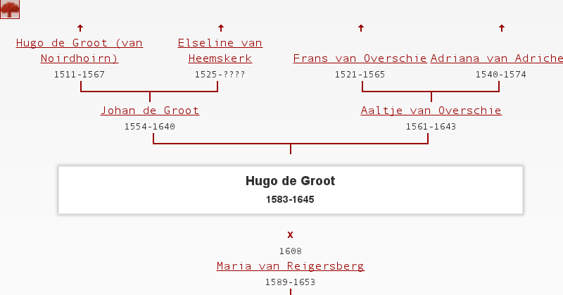Family-tree from Hugo
What books did he write?

Hugo Grotius also had written books. he had written 3 important books. One about war and peace, And an important book about rights at sea. And a book about Church polity. Maybe he had written more books but I couldn’t find it. The book about sea is called Mare Liberum. Mare Liberum is Latin for ‘free sea’. It was published in 1609 in Leiden by Elzevier. A long time later it seems to be a piece of the treatise ‘De Indis’. De Indis was written between 1604-1606, but never published. The script disappeared and they found it again after 4 years. In 1668 it finally was published but then it was called De iure praedae. The book about war and peace is called De iure belli ac pacis. It was published in 1625. In this book stands when a state is allowed to attack another state and in wich way. It’s originally written in latin. Ordinum Hollandiae ac Westfrisiae pietas (The Piety of the States of Holland and West-friesland) is also written by Hugo Grotius. It was written in the year 1613. It’s about church polity. It was the first book that he had published. A shorter name for Ordinum Hollandiae ac Westfrisiae pietas is Ordinum Pietas. It also gave commentary on the Five Articles of Remonstrance of 1610. That was the legacy of the the theological opinion from Jacobus Arminius. Jacobus Arminius died in the year 1609.
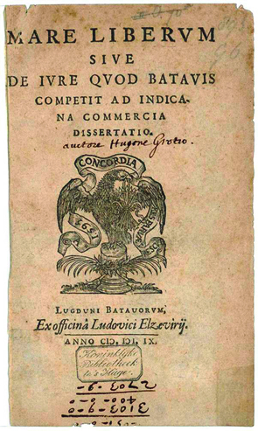 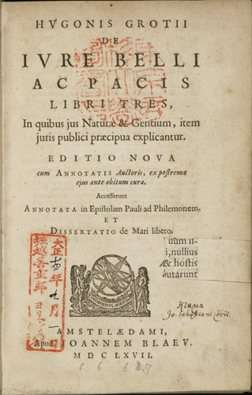 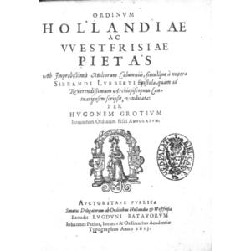 Mare Liberum De Iure Belli Ac Pacis Ordinum Hollandiae ac Westfrisiae pietas

What did he do for the republic (politically)?

Hugo Grotius was not only a good lawyer and a good thinker. He also became involved in the politics of the republic. He became advocate of The Hague in 1599, Advocate General of Holland, Zeeland and Friesland in 1609 and pensionary of Rotterdam in 1613. That’s not all. As you just read, Hugo also had written books. Also pamphlets about government and the law. One example is that he argued that Holland had an ideal government system and that other countries should have one like that. Hugo Grotius played a starring role in the Government of the Republic of the United provinces until 1619. He was a very important advisor to the Grand Pensionary Van Oldenbarnevelt. It was in the time of the Twelve year old file with Spain. The twelve years truce of Treves was a 12-year period of truce during the eighty years war (tachtigjarige-oorlog) in which a little or not at all was fighten in the republic with the Spaniards against the insurgents. The truce lasted from 1609 to 1621. In 1621 the hostilities were resumed. The creation of the Dutch West India Company also dates from that year. In that time there was also much argument between stadtholder Maurice and Oldenbarnevelt.
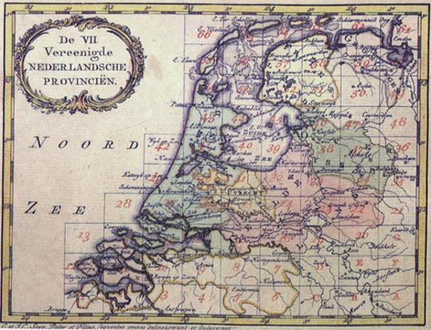
Map of the republic
Why was he captured in Slot Loevestein?

Now we are at the part I knew about. In 1618 Hugo Grotius was arrested, together with Oldenbarnevelt. He was imprisoned in Slot Loevestein. The reason for that was the next: Prince Maurice, who said he did not have much knowledge of theology saw in the religious wars a chance to put the peace party offside, that is, those who were for the conversion of the Twelve Years' Truce with Spain in a permanent peace treaty. The truce had been passed to him as commander in loss of great power and prestige and loss of foreign money. In August 1618 knew the prince through the issue of ‘waardgelders’ to settle the power struggle in his favor. Oldenbarnevelt and Grotius were captured on August 29, 1618. Gilles van Ledenberg committed suicide a few days later, Van Barneveld was sentenced to death and executed. A panel of 24 judges condemned the Remonstrant Grotius' to eternal prison nisse. Initially he was in The Hague held in custody, but he was taken on June 5th, 1619 to Loevestein, then a state prison, followed by his wife Mary and their maid Reigersberch Elselina of Houweningen. His wife Mary came with a solution. Hugo Grotius had to keep studying and writing so once per month he get a book chest filled with books. The guards first were very strict and watchful. Later on that reduced. So Mary told him to go into the book chest and escape. And that is what he did. On the 22th of march 1621 Hugo Grotius escaped from Slot Loevestein.
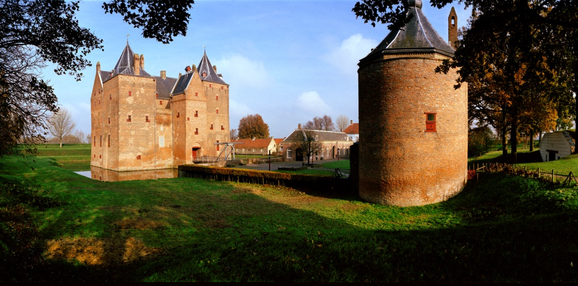
Slot Loevestein in Zaltbommel-Gelderland
Conclusion + Main question

So Let’s start with the conclusion. Hugo Grotius was a very smart boy. Smart? Let’s say ‘a miracle’! that’s how the French king called him. Hugo studied law in Leiden. He graduated in 1598. He had done a lot. He had written books and pamphlets. He was advocate. He was pensionary. He was captured in slot loevestein but he escaped with the help of his wife Mary. Therefore he was really important for the Golden Age. I don’t see Hugo Grotius as the ‘man from the bookchest’ anymore. I learned a lot about him!

Sources

Textbook
http://www.entoen.nu/hugodegroot
http://www.scholieren.com/biografie/19490
https://nl.wikipedia.org/wiki/Hugo_de_Groot_(rechtsgeleerde)
https://1213noahugodegroot.wordpress.com/1-de-tijd-van-hugo-de-groot/
https://nl.wikipedia.org/wiki/Mare_liberum
https://www.google.nl/search?q=google&espv=2&biw=1920&bih=955&source=lnms&tbm=isch&sa=X&ved=0ahUKEwi6wefGkq7LAhUH1BoKHdGgD0UQ_AUIBigB#tbm=isch&q=hugo+de+groot+stamboom
https://www.google.nl/search?q=google&espv=2&biw=1920&bih=955&source=lnms&tbm=isch&sa=X&ved=0ahUKEwi6wefGkq7LAhUH1BoKHdGgD0UQ_AUIBigB#tbm=isch&q=mare+liberum
https://www.google.nl/search?q=google&espv=2&biw=1920&bih=955&source=lnms&tbm=isch&sa=X&ved=0ahUKEwjd28OYvLjLAhXK1hoKHbVJBxAQ_AUIBigB#tbm=isch&q=De+iure+belli+ac+pacis
https://nl.wikipedia.org/wiki/De_iure_belli_ac_pacis
https://en.wikipedia.org/wiki/Ordinum_Hollandiae_ac_Westfrisiae_pietas
http://www.historischnieuwsblad.nl/nl/artikel/26012/hugo-de-groot-1583-1645.html

