Book report

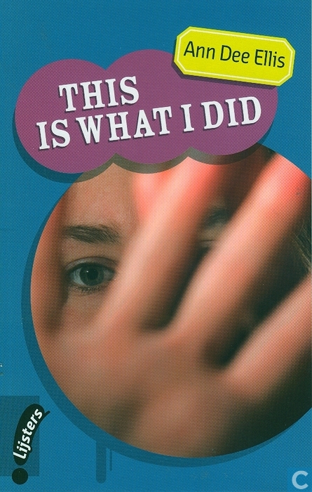
Facts:
- a. Title: This is what I did
b. Author: Ann Dee Ellis
c. Publisher: Noordhoff Uitgevers, Groningen/Houten
Lijsters; Young Blackbirds
d. ISBN number: 978 90 01 500634
e. Number of pages: 109 pages

- Where does the story take place?
The story take place in the city Judge. There are many flashbacks in the story, they take place in the city Mulholland.

- When does the story take place?
The story has a common thread, which take place in the present tense. The common thread goes back until two years.

- How is the story told?
The story is namely told in the first person. Logan is the I narrator in the story. The whole story goes about Logan.

- What is the story about? (State the theme of the story in a few sentences)
Logan lives in in a family with two little brothers and his both parents. The moved from Mulholland to Judge. The reason they moved is because of a terrible something that happened with Zyler. He is the best friend of Logan. Zyler and his girlfriend, Cami, where abused by the father of Zyler. His father was very aggressive. Logan saw secretly what happened with Zyler, Cami and his father and he hasn’t done anything about it.
In Ludge, Logan is being bullied a lot at school and at Scouts. After what happened with Zyler, Logan never got in contact with Zyler. Logan has only one friend in Ludge, her name is Laurel. They became best friends because they write a lot of small letters to each other in there school class. In these letters they wrote palindromes.
In the end, Logan went to a psychiatrist and he was never bullied again, he also kept contact with Zyler.

- Can you mention three ‘’things’’ the story is about? (List them in order of their importance to you)
- Logan is being bullied a lot at school and at Scouts.
- Zyler and his girlfriend, Cami, where abused by the father of Zyler. Logan saw secretly what happened with Zyler, Cami and his father and he hasn’t done anything about it.
- Logan and Laurel became best friends because they write al lot of small letters to each other with palindromes.

- Mention a problem the story points to, explores, or deals with.
- Logan is being bullied a lot at school and at Scouts.
- Zyler and his girlfriend, Cami, where abused by the father of Zyler. Logan saw secretly what happened with Zyler, Cami and his father and he hasn’t done anything about it.

- Is the problem solved or is it simply presented? (If it is solved explain how)
The problem is almost solved, Logan is no longer bullied at school and at Scouts. That is because of Logan went to a psychiatrist. You don’t know if the problem with Zyler and his father is solved, because there is nothing written about in this story.

- How would you handle the problem? In the same way or differently? (Explain your answer)
Logan didn’t want to talk about both situations with his parents. My choice would be to talk with my parents of someone who I trust.

- Write down the names of the most important characters in the book:
- Logan
- Zyler
- Laurel
- Luke, Bruce and Toby (the teasers at the new school of Logan, they are also with Logan at Scouts)

Which of these is the hero/heroine?
There is no hero, because nobody did something good.

- Which character(s) in this story did you especially like? What qualities appealed to you?
Laurel’s character, because she is the only person who is nicely to Logan.

- Which character(s) in this story did you especially dislike? What about them displeased or angered you?
Bruce’s character, because he like to bully Logan.

- Does any person in the story remind you of anyone you know, including yourself, in any way? (Please give at least on example)
I see myself a little bit in Laurel, because she is nicely to everyone.

- Select a passage that you particularly liked and explain your choice. Why was that part especially appealing to you? (A photocopy/photocopies of the selected passage may be added to book report to illustrate you choice)
The two last pages, number 108 and 109.
Page 108: Laurel is still friends with Logan even though what happened in the past.
Page 109: Logan writes an e-mail to Zyler.

- What feelings did this story arouse in you? What part(s) made you feel sad, worried, frightened, angry, envious, excited, surprised, or ………… (any other feeling)?
This story is very educational, because you learn not to bully someone. You learn also that you have to help someone who is in trouble.

- Did you find any humor in the story? (Describe the part(s) that made you smile or laugh)
No, there was no humor in this story.

- What are the incidents, scenes or moments in the story which you remember (or which strike you) most vividly? (Please mention at least two)
- The moment Logan saw that Zyler and his girlfriend, Cami, where abused by the father of Zyler.
- Logan is being bullied a lot by Bruce, Luke and Toby at school and at Scouts.

- What mental pictures did you get from this story that were especially vivid? (Please give a description)
When I read a book I always imagine the story in my mind.

- Does any event or occasion in the story remind you of any time in your own life? (Try to give at least on example)
In the first class of secondary school, there were many girls who gossip about me.

- Were there any parts in this story that you found especially difficult or boring? Why did/do you feel this way?
There is spoken about a play of Peter Pan during the story and that is totally not relevant.

- Is there anything you discovered or learnt from this story?
This story is very educational, because you learn not to bully someone. You learn also that you have to help someone who is in trouble.

- Are you left with any questions or thoughts about the story that you do not have an answer to?
Yes, you don’t know if and what Zyler will answer the e-mail from Logan.

- In a few sentences say why you did or did not enjoy reading this book.
I did enjoy reading this book, because it has a really happy ending. Logan is no longer bullied at school and at Scouts and he wrote an e-mail to Zyler.

