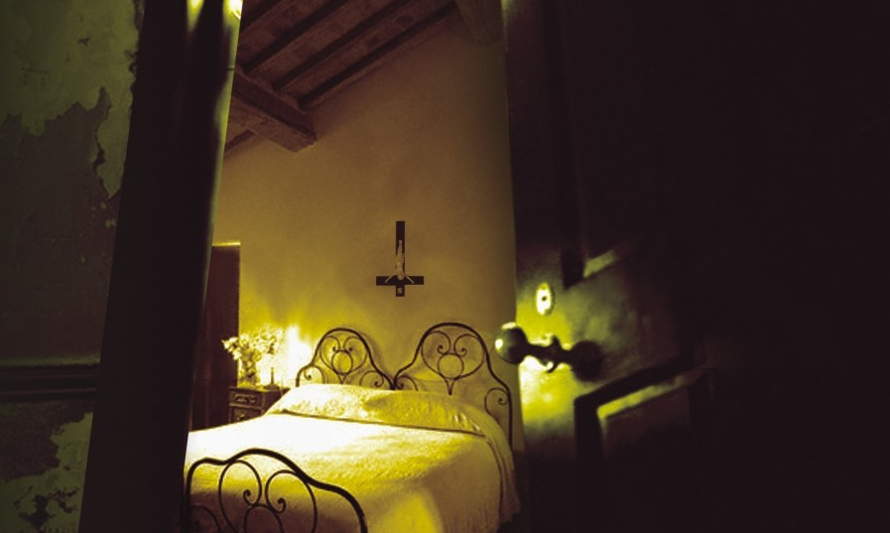
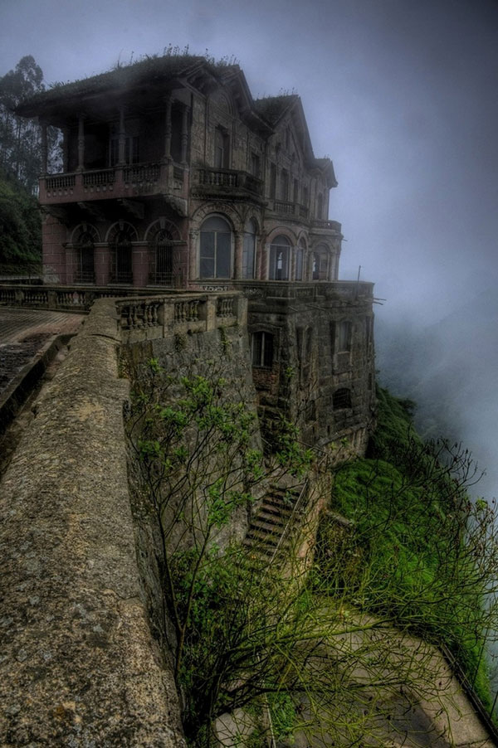
The twins Fay and Sophie were going on holiday to Scotland. They stayed six days in the hotel Spooky Bird. When they came the hotel looked old and abandoned. The family thought that it was a five stars hotel but it didn't look like that. "Is this the good address?"Asked daddy. "Yes, Come we have a look inside." Said Mom. When they entered there was one big dark room. 'Reception' was on a sign. On a long brown table with a lot of candles two keys existed. The dad of Fay and Sophie took the keys and went upstairs. Fay and Sophie had there own big room and there parents had another room. It was Friday 13 December and the room number of Fay and Sophie was 13. Fay found it really creepy but Sophie said it's only a number. The room was black with a big white double bed. The room had one big black corner that had a creepy window. The window made a lot of creepy crackling sound. The curtains were dark blue and waved in the wind. In the icy darkness the owls flew around and made that macabre sound. Every time when Fay and Sophie came in you could see one big shadow came out of the window, the shadow always repeated "I will come get you!" The twins were really afraid of that but they did not know what to do, they wanted to another hotel. "Maybe we can better go to bed" said Fay the next morning. When they woke up a little piece of paper was attached on the wall with the text;
The abandoned hotel

Give me your food, money and jewelry otherwise you will never have a lovely life. Your parents be killed, I am make your life a hell. Don't tell this to the FBI our police.

"So, what are we going to do?" Asked Sophie. "We have to go to another hotel and hide us" said Fay. That evening the twins and the parents went to another hotel. When Fay and Sophie came in there new room they saw a creepy big man with a green face. "Give everything what was on the paper otherwise, you will be killed with your parents. "Runnn! Now!" Said Sophie. But it was all to late he grabbed them and tied them. "Sorry, you can have all our stuff." "That is now too late girl, I am going to kill you and your parents." "No, please don't do that." That was the last word that Fay said. The man stabbed her dead with the big scary knife, the blood flowed from her body. When the twins were dead man stepped to the parents, he pulled their heads off and threw them on the street. He ran away with all the things, no one has ever seen him.

The end

