Paragraph 1
Because Asia is so different (Culture, natural zone , rich poor etc..)
it is hard to draw a line around Asia, so the continent is split in 6 regions.
Around the pacific ocean there is a region where there are many volcanoes.
This region is called the ring of fire.
The earth has tectonic plates that move a few centimeters a year. This plates can move: Past/Away/Towards each other, in other words: they collide.
The pacific plate collides with the Eurasian and Philippine plate.
When these plate collide the energy that opens can ‘cause a volcano eruption or earthquake.
The most hit parts from Asia are South Asia/East Asia/ South East Asia

Paragraph 2

You measure earthquakes on the scale of Richter
Hypocentre is the center of the earthquake
Epicentre Point directly above the hypocentre
Earthquake in Kashmir:
High risk on earthquake due the 3 tectonic plates (Eurasian and Indo-Australian)
Millions of people lost homes. Lived in tents. Thousands of dead people
Etc..

Paragraph 3

Deep in the earth it is very hot. This causes magma. When there’s too much pressure it goes out the earth through a volcano which is created by multiple earthquakes
Mount Merapi is an active volcano on Indonesia In 2006 six in almost erupted but it actually happened in 2010
Good points about volcanoes
- Good for soil (EVEN AFTER THOUSANDS OF YEARS)
- Can contain important minerals
- Tourists pay a lot of money to see it

Paragraph 4

A tsunami is a wave cause by a seaquake, It is only a few decimeters high but moves at a speed of 800-900 km/h and 100-400 kilometers long.
The front parts slows down but the back part catches up with the front part.
This creates a very high wall of water that comes to the coast with a lot of force(Speed)
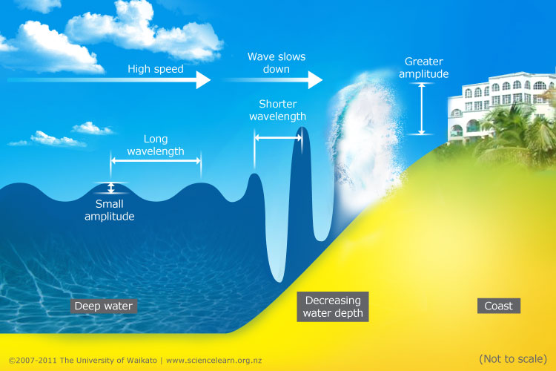

Organizations, People and governments give billions of euros(just money)
Only there’s a lot of criticism about how it gets spent. And the aid doesn’t arrive at the right place due corruptions

Paragraph 5

Philippines & Vietnam are often hit by hurricanes or like they say in Asia: typhoon/cyclone.
In 2006 typhoon Durian occurred this was a very destructive typhoon.
After is passed the Philippines it moved to Vietnam. Most of the deaths were by landslides.(Falling ground due over rain fall) There was reported that 180mm had fallen down.
There are 3 characteristics:
- Wind speed. (On the scale of Saffir Simpson)
- Heavy rain and floods.
- Causes high waves in the sea (Most deaths by this)
How devastating such hurricane can be depends how great the level of development

