What were factors in the development of the following welfare systems and what are its most important characteristics? France, Germany, Sweden, Britain.
France:
France went through 3 stages: it was a monarchy, after that there was a revolution and even later Catholicism occurred. In 1850 the Catholic government and the post-revolutionary government shared some same ideas and they decided to cooperate in one government who would organise a welfare state for France. These two organisations wanted to strengthen the national feeling and therefore create France as a family. Therefore, people had to give something to the government to get something back → everything to help the family.
France as a welfare stated is considered a bit static, but in practice, it is loose, because of the flexible central organisation.

The features of the French welfare state:
- Pension system (the employer and employee both contribute to a retirement fund)
- Family insurance system (families receive money for children until they are 16, unless they are still on school. For disabled people the state keeps giving money through taxes)
- Education system (the government supplies materials to maintain a high level of education)
- Unemployment insurance (there are different rules for people who can still work and people who cannot work. The people who can work receive 35% of their income they had before when they were still working)

Germany:
After the second world war, the two political parties (Christian Democratic-led and Social Democratic party) wanted to have a welfare state, also in Germany. Germany was governed socially. Instead of getting national minimum standards for all of its citizens, the social state consisted of a wide range or work-oriented social insurance schemes that contained strong elements of compulsory self-help. The purpose of this type of system was to provide the working people security and therefore protecting their status in their work.

The German government had two main goals to achieve this welfare state:
- Security for all its citizens
- predictability in economic development outcomes
To be able to achieve this goals, the Labour party and Capital party had to make a compromise together. They agreed to compromise in limiting the movement of capital across boarders nationally, to create institutions/frameworks to work out differences between Labour and Capital in order to prevent a breakdown in their relationship and they agreed to Institutional Self-Regulation. This means that people (head of an organisation) could make their own rules without the government interfering. Also, the government highly invested in education, to minimalize the amount of uneducated workers. Therefore, the wages could be high, and the government could give the ones who were disabled, or old money through taxes.

There are four features to the German Welfare Model:
- the Social solidarity insurance model where different funds support one another (cross-subsidisations)
- economic governance intended to reduce labour costs, provide for a high-skills labour force, and absorb surplus workers (early retirement, longer vacations, shorter work weeks)
- a low-skilled workforce in occupations Germans are reluctant to pursue (usually serviced by migrant workers)
- under-developed social assistance schemes for those who fall through the cracks of the social insurance model

Sweden:
The welfare state in Sweden was an idea of the Swedish Social Democratic Party (SDP). This party was founded in 1889. This party was formed by industrial workers, and it was against the violence in Russia. Therefore, the country wanted to be a democracy. The SDP aimed at building a system that would provide workers with health insurance, old-age pensions, protection from unemployment, and other social benefits financed by taxes on workers and employers. At first they only aimed at the workers, because they had more rights, but later on they also focussed on everybody in Sweden, so also the people who did not have the chance to get education, or the people who are disabled. The businesses in Sweden belong to the private owners, so the government has almost nothing to say about the businesses in its land. However, from 1938, the government set some standard wages for the workers in the businesses, so that the income between citizens would be divided more equally.

The Swedish welfare state succeeded for two reasons:
- the economy grew fast in Sweden
- Sweden was not engaged in the Second World War, and therefore did not have the recovery like the other European countries

The features of the Swedish welfare state are:
- The right of health care
- Family services
- Old-age pensions
- Any other social benefits regardless of income

Britain:
Britain became a welfare state officially when it was recovering from the Second World War. This was a result after the Labour party won the election in 1945. This party was introducing a welfare state. The National Insurance Act was signed in 1946, and in 1948 the National Health System was introduced. In the United Kingdom, the basic idea of the British Welfare State has been articulated as the desire to care for all people resident in the United Kingdom "from the cradle to the grave". The social feeling was that it was better to give something away from your own wealth to maintain a wealthy state in general. This is because people think they are happier when nobody in their surrounding suffers from illness, poverty or hunger. The welfare state had success because it was supported by this idea.

The features of the welfare state of Britain:
- Unemployment benefit
- Sickness benefit
- Old-age pensions
- Widow pensions

By comparing the social system across countries, analyse how the following important social benefits are provided in the above country cases: >>> health care, unemployment, old age pension, family (or child) assistance. Please identify whether the benefits are subject to means testing, based on contributions and/or provided as service by the government, etc.
France:
Health care:
All residents are entitled to publicly financed health care. The state finances coverage for residents not eligible for coverage by the general public health insurance scheme (0.4% of the population). The state also finances health services for illegal residents.

Unemployment:
France has a total yearly cost of 28,737 euro for an average unemployed person. However, compared to the average salary cost in France (34,219 euro), the unemployment cost represents 84% of the salary cost. So France is an average country compared to the other European countries.

Old age pension:
The French pension system is fragmented, consisting of nearly 200 separate pay-as-you-go schemes for different groups of workers. The largest of these is the general scheme, which covers private sector workers and accounts for 60 percent of national pension expenditures. France also has a minimum pension (EUR 599 per month) with a declining number of recipients, due to the expansion of earnings-related schemes. The French pension system’s wage replacement rates are relatively high, with the average benefit equal to about 80 percent of average net wages. Those who claim a
full pension must wait till age 67, rather than 65.

Germany:
Health care:
Health insurance is mandatory in Germany for all citizens, either in the social or in the private health insurance scheme, depending on previous insurance and/or job status. All employed citizens earning less than €4,050 per month or €48,600 per year are covered by a mandatory public health insurance scheme. Their dependents (non-earning spouses and children) are covered free of charge. An exception are the people who earn more than €48,600 per month. They can choose to have private health instead of public health.

Unemployment:
In absolute terms, the cost of unemployment in Germany holds an average position in
relation to the other countries (25,550 euro). However, compared to the average salary
cost in Germany (28,472 euro), the unemployment cost represents 90% of the salary
cost, which places Germany in the first position in terms of relative costs of
unemployment.

Old age pension:
Germany’s pension system relies on a pension points system (OECD 2009). Under the point system, in a particular year each worker’s earnings are related to the average wage. A worker with average earnings is credited with one pension point per year, while a worker with a lower wage receives a proportionate fraction of a point, and one with a higher wage receives a proportionate boost. Because the point system results in benefits that are proportionate to wages, it does not allow
for the sort of redistribution to low-income workers that occurs in the U.S. benefit formula. Given the lower average wages of women, the point system disadvantages them as a group relative to a redistributive formula.
Sweden:
Health care:
Coverage is universal. All residents are entitled to publicly financed health care.

Unemployment:
Sweden has a total cost of unemployment with a total of 26,905 euro. However, compared to the average salary cost in Sweden (35,908 euro), the unemployment cost represents 75% of the salary cost, which places Sweden in one of the lowest positions in terms of relative costs of unemployment (after Britain).

Old age pension:
For a parent to receive a pension, he or she must satisfy what the Swedish scheme refers to as the earned income requirement: employment for at least five years with annual earnings exceeding a threshold. Pension credit for childcare is not counted unless the five-year work requirement is met.

Britain:
Health care:
Coverage is universal. All those “ordinarily resident” in England are entitled to health care that is largely free at the point of use.

Unemployment:
In absolute terms, the cost of unemployment in the United Kingdom holds the last
position in relation to the other countries (18,008 euro). This is also the case when
comparing the average salary cost in the United Kingdom (30,510 euro) to the
unemployment cost, which represents 59% of the salary cost.

Old age pension:
There are two types of pensions: one ‘normal’ pension for the people with an average income (Basic State Pension), and a pension for the people with a higher income (State Second Pension).

Overview of family (or child) assistance per country: (http://europa.eu/epic/studies-reports/docs/rr-554-dg-employment-childcare-brief-v-0-16-final.pdf)

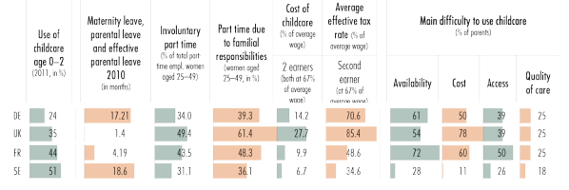

What would you say are the biggest problems facing insurance types (contribution based/pay as you go) welfare systems and what are the biggest shortcomings of a Beveridge* type/service system and the Dutch system.
*William Beveridge/Lord Beveridge is an important British social reformer

The biggest problems of insurances in the welfare systems:
Many people are still poor or and not insured. This is because they do not have the money in their family to have the insurance. For example hobo’s still do not receive the amount of money they deserve. Also, there are people who get money from the government but are still working, without the knowledge of the government. Therefore, they get a double income, one from their illegal job and one from the government. This is unfair for the people who really do not have a job. Therefore, the government is unable to decide whether to give a family more or less than another family who are unemployed for the same reasons. This weakness shows that there is a lack of security in the government. The pay-as-you-go system is well-organised, but can have some disadvantages. When you lose your job for example, this might have a negative effect on your pension. You did not have the chance to build up a pension by the years you are working, but you receive it while stopping with working. When you stop earlier than your retirement, you will not receive the pension.

In 1944 William Beveridge joined the liberal party and his goal was to create a welfare state. He referred to ‘Five Great Evils’ in society, want, disease, ignorance, squalor and idleness, all of which could be eliminated under his policy. His ideas do and do not correspond with the society of Europe. It does because there is a welfare state indeed who takes care of all these Great Evils. Therefore taxes are introduced and people pay for other people’s wealth. However, there are still people who live way above the normal living standards (bank owners for example). They earned this money unfairly and therefore the society is still in want.
Also, there are several diseases in Europe which cannot be treated, unless the person pays an enormous amount of money to the hospital. This is because there is not a medicine yet which is funded by the government. This shows that the rich people are more likely to live healthy than the ones who cannot pay for their own health, when they get a rare disease.

When comparing all of the following cases (France, Germany, Sweden, Britain, Italy, Greece and Spain), how would you group and classify these systems. In short, which ones have similar characteristics and belong together, how many different groups would you establish and which criteria would you use to make your classification? Note that you do not have to describe each system in detail here but you do need to justify why you assign a particular country to a particular group or category.
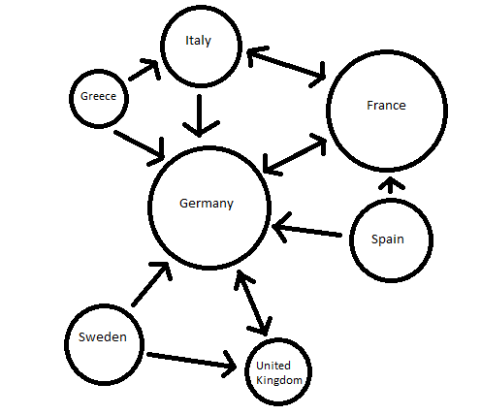
I categorised the countries by relations and trade-relations. It is clear that Germany is the centre of Europe. Every country is pointing towards Germany. A pointing arrow towards a country means that the country puts lots of effort in that country (based on numbers from the trade between the countries), sometimes, this is equal from both sides.
A division can be made between a group of Sweden, the United Kingdom and Germany, and Greece, Italy, France, Spain (and Germany). This is because all the countries have something to do with Germany. However, the countries connected to Germany do not cooperate with other countries. For example the United Kingdom has not much to do with Greece for example. Therefore, this would be the division of the countries according to the trade of the countries with each other.

