The Roman Empire: From Village to Empire

rome
From about 500 B.C. until 500 A.D. the Roman Empire was one of the strongest empires. A lot of things the Romans did in their time attributed to the success and long upholding of the Roman Empire. They had a new way of governing its citizens and they also had a very solid army. They had a lot of innovations that made governing easier and better, and encouraged recreation. But the most important reason for Roman success was that Romans wanted to achieve something called Pax Romana (Roman Peace) throughout the whole of their empire.
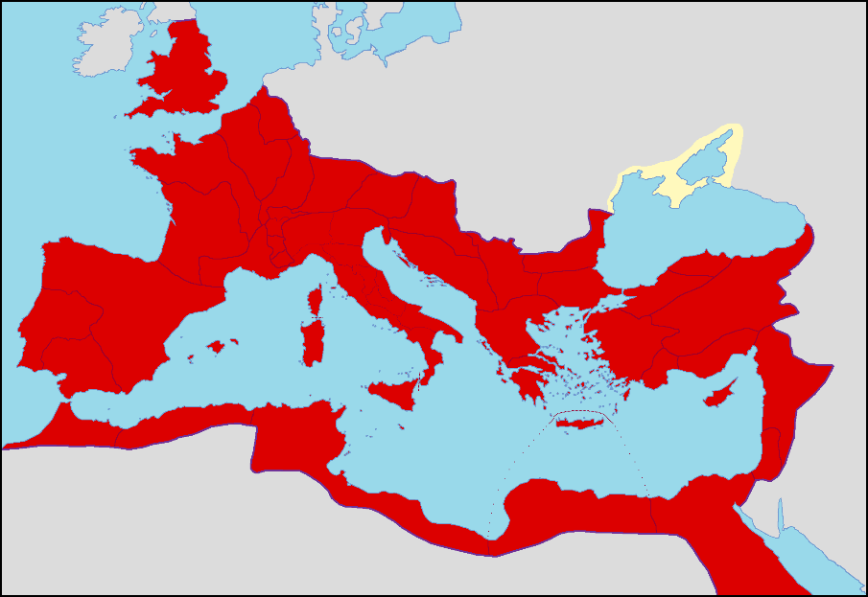
The Roman Empire in 54 A.D.

We all know the Greeks’ way of governing, often people think the Romans did it in the same way, but that’s a lie. The Romans’ way of governing is actually the complete opposite of the Greeks’. Rome was sparsely populated, it needed more people to live there, and to be in the military. So instead of denying the rights of citizenship to outsiders, like the Greeks did, the Romans gave right to citizenship to its surrounding alliances. By doing this Rome built up much of its immense power. It slowly started to expand in Italy. Because these people were citizens they could enjoy all the benefits of being Roman, except for voting and holding office. But they did have to pay taxes and could be called for military duties. Giving right to citizenship to foreigners helped strengthen Rome by giving it more money to build and expand, more manpower, and more citizens.

governing
Apart from the foreign citizenship, there was another reason why the Romans were so successful, the government. Because of the way they ran their government, sometimes referred to as "the Roman senate and the people’’. The government was divided into two groups, the ‘aristocracy’, or wealthy landowners, and the ‘common people’, the merchants, artisans, and landless urban dwellers. Rich or poor, this type of government helped to give an equal opportunity for everyone to have a voice in the government. They did this so the common people, even though they didn’t really have a say in what was law, were still able to vote on officials. As well as that, the government consisted of the senate and the consul. The senate had mostly people of the aristocracy in it. The people in the consul were voted by the people every year. The senate couldn't pass laws but could give strong and important advice to the consul, which did pass the laws. This kept a fair balance between the two groups and also allows the common people to vote for the people that will rule.

military
The military was another key factor in the success of the Roman Empire due to the size of their armies. The Romans started off slowly by conquering surrounding cities. Sometimes they made an alliance with a surrounding city. This got them more men to fight, more resources and more power overall. After time past, the army became one of the strongest aspects of Rome.
One way the Romans got so many men to join the army was by telling them about the gloryful lives they would live and the recognition they would get. If men joined the army they could go through the "course of Honor’’ and climb the ladder step-by-step to become a political leader. Men also wanted to achieve two things; ‘Dignitus’, (reputation), and ‘Gloria‘ (glory). Furthermore, the Romans gave out rewards for soldiers which had done something heroic. It’s told that, if a man did something heroic, he was honored by praises from the generals, given gifts from the leaders or from someone they have helped. These kinds of rewards encouraged soldiers to work hard. With hard-working soldiers, Rome's military massively grew in numbers, which then helped the Empire to grow. But only giving rewards wouldn’t help, there needed to be a balance. The Romans found that balance by punishing misbehaving soldiers severely. For example, if a soldier tried to flee his army post to go home, he could be killed without trial. There were just as many punishments as there were rewards.

innovation
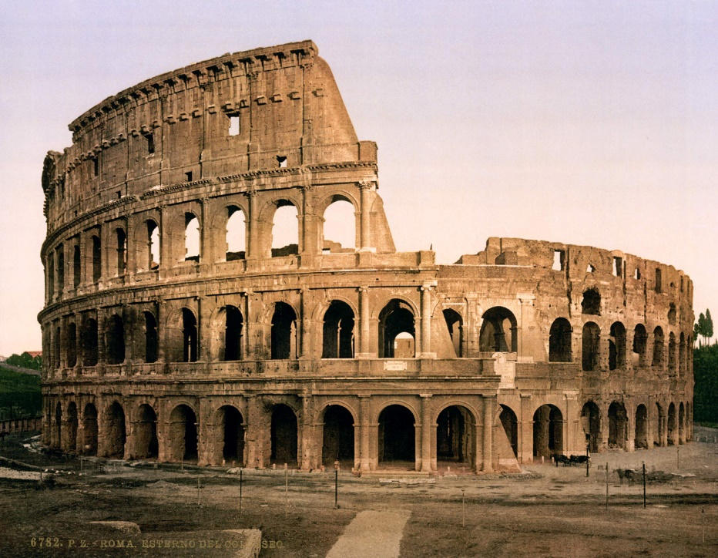
The Romans were also very innovative. They had many inventions which helped them to maintain such a large empire, but also to meet the needs and demands of the citizens. The most important and most famous thing the Romans built were roads. Roads made it much easier to send men to other cities to keep peace and it encouraged many people to travel to different places in the empire at the same time.
The famous Colosseum in Rome, Italy. Built in 70 A.C., still standing
Romans also enjoyed entertainment and the government was keen on keeping its citizens happy. Therefore they created huge arenas which were mainly used for gladiator games, and sometimes for other types of entertainment. Another great architectural achievement were the Roman aqueducts. Not only was it important because of the revolutionary architecture but also because it was a new, efficient way to bring water directly into the city from far away.
Even today, in the twenty-first century we are still talking about the Roman inventions. Even with our technology and experience, building buildings the way the Romans did would be very hard. If there is one thing Roman people had an eye for, it was detail.

today
Nowadays we still enjoy the accomplishments of the Romans. Going sightseeing in Rome to look at cathedrals and the Colosseum is highly popular. Rome, the centre of the old Roman Empire, has over 900 churches and a lot of those churches were built during the Empire’s upholding.
Also think of movies, we all know ‘Gladiator’, starring Russell Crowe, about a Roman general wrongly being sentenced to death, and coming back strong as a gladiator in Rome
Without the Roman Empire all these things and more simply wouldn’t have existed.

julius caesar
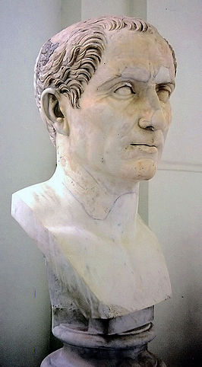
Gaius Julius Caesar, better-known as just Julius Caesar was a Roman general, politician and writer. He was born in approximately 100 B.C. and was one of the most powerful and influential men of his time. Caesar is best-known for his variety in his life. He has had almost every influential position in the Roman Empire, including consul, general of the army and high priest. He suggested many laws, most of which actually approved by the Senate. He also reorganized the army and improved the way provinces were ran. People trusted his judgement, and took him very seriously. Caesar was murdered brutally in 44 B.C. by members of the Senate which didn’t agree with his ideas. He got stabbed 23 times. After his death, in order to honor Caesar, the Romans even named a month after him, July. Caesar is often seen as the first emperor, he actually wasn’t an emperor. What he did was, was an important man in the building-process of the Roman Empire. Julius Caesar

augustus
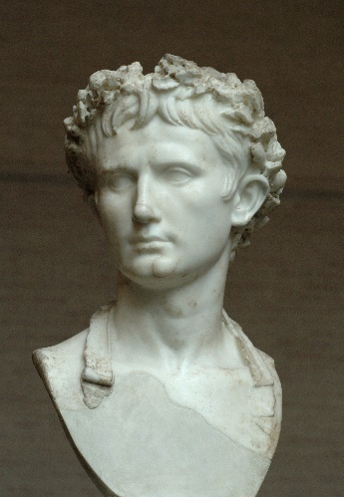
During the existing of the Roman Empire, many important leaders lived, and they contributed a lot to the success of the Empire. Augustus, the first emperor, was one of these great leaders, and therefore well-known. His main goal was to restore the republic to a good state again and help in establishing "Pax Romana’’. Augustus also was important because he helped Rome to grow by his ideas about trading by the sea. Also under his reign, lots of roads were built. He stated, "I made the sea peaceful and freed it of pirates ‘’(lecture notes). He also helped bring peace and protection to Rome and its surrounding counties that were under Roman rule like Spain and Gallic using these ideas.
When Augustus got more power he started to expand to other countries and spread the Roman culture, Roman traditions and law. This sometimes happened by force and sometimes through peace. Augustus also invested lots of money and time into making the city of Rome an eye catcher. He ordered to have the aqueducts restored, to have many buildings restored and created new forums and theatres. All this input from Augustus made it possible for the empire to expand and achieve success.
Augustus, wearing the Civic crown
Even now Augustus is remembered as important. Think of the eight month in our year, August. It was named after emperor Augustus, who lived roughly 2000 years ago.

nero
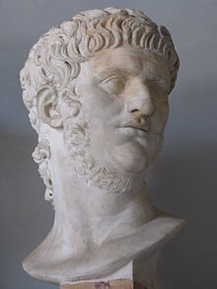
Another famous, somewhat controversial emperor, was Nero. Nero was the fifth emperor of the Roman Empire and lived from 37 A.D. until 68 A.D.. He became emperor in 54 A.D. because he was heir to the throne of his uncle, Claudius. Although Nero’s reign only lasted for 13 years, he did a lot we still remember today. Most of his attention went out to diplomacy, improving trade and making culture important in the Empire. He ordered theatres built and approved promotion of athletic games. But Nero wasn’t all good, he was known for his multiple executions as well. In particular the one of his mother and stepbrother.
Emperor Nero
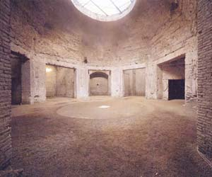
The thing Nero is remembered for the most is the Domus Aurea, which means house of gold. In 64 A.D. almost the whole of the city of Rome was destroyed in a fire, the Great Fire of Rome. Many people blamed Nero for the fire, saying he consciously started it to burn down enough ground for his house. This house of his, Domus Aurea was decorated richly with all kinds of paintings, flowers and more.

Domus Aurea

the decline and fall of rome
What caused the Roman Empire to fall? Why did such a powerful Empire lose its power? Well, Rome was the center of the world, the place what everything was about. It was not built in one day, so it couldn’t be destroyed in one day.
The most significant and important reason was the steep decline of the Roman economy. The government had a lot of debts to pay, and therefore had to tax citizens heavily. At this time, the Empire was massive, worldwide. So defending it, cost an awful lot of money.
Rome didn’t fall in a day, it went to a gradual decline of many years full of mistakes. Mistakes which could have been prevented. But after rulers’ reigns past, not all as smart as each other, mistakes were made. Rome ‘officially’ fell in 476 A.D., but actually could have lived on, for many more years.

