Essay: A great man
Name person: Christiaan Huygens
Subject: History
Name:
Class:
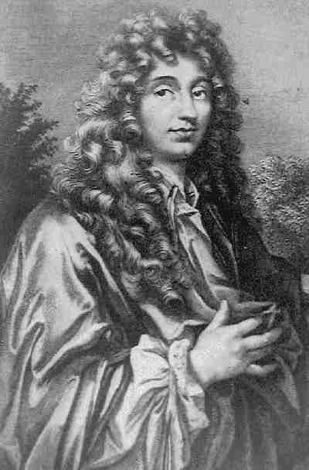

Content
- Introduction. Page 3

- The main events of his life. Page 4

- How people thought of Christiaan Huygens. Page 4

- How people think of Christiaan Huygens. Page 4

- Why Christiaan Huygens is a great man. Page 5

- The most important reason why he is a great man. Page 5

- Conclusion. Page 5

- List of my used sources Page 5

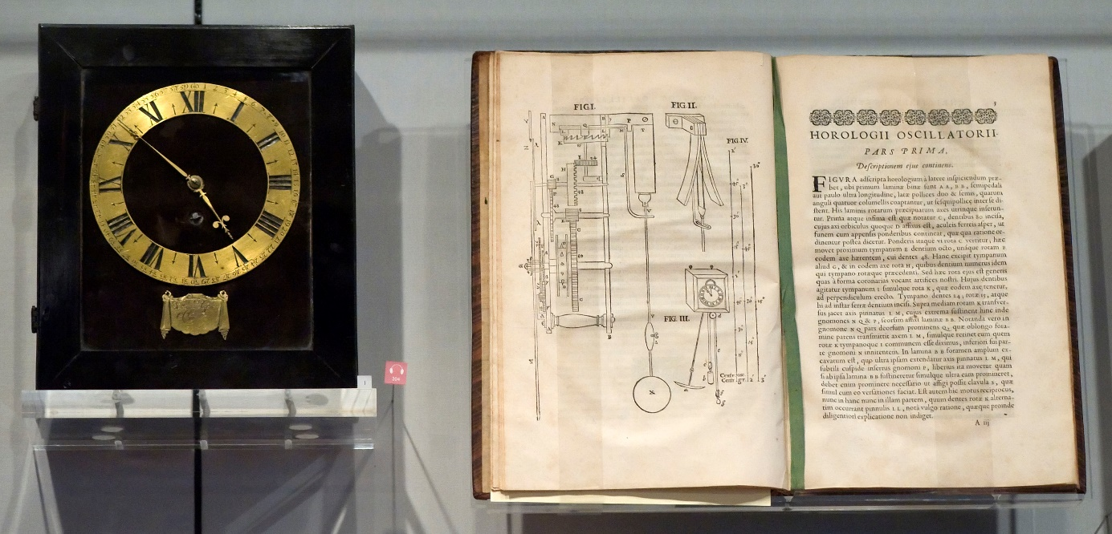

Introduction

- Motivation: why did I chose this particular person?
- I chose Christiaan Huygens because I think he is a very interesting person and I wanted to know more about him.

- About the essay: What am I going to tell?
- As I told in the content, I am going to write about Christiaan Huygens. I’ll tell about the main events of his life, how people thought about him, and how people think about him. I’ll also tell why he is a great man and the most important reason for this. I will end this essay with a conclusion.

- Who is Christiaan Huygens?
- Christiaan Huygens was born in 1629. Christiaan was interested in science and experiments from an early age. He studied law and math at university. He was the son of a diplomat who was also interested in mathematical thinking. Huygens and his brother made a telescope through which Huygens found the first moon of Saturn, Titan in 1655. In 1656 he worked out the shape of the ring of Saturn. He invented the first clock worked by a pendulum in 1656. Huygens also worked on mathematical ideas. He was the first person which worked through the mathematical theory of probability. He was asked to join the Royal Society. He spread his ideas by discussions in societies likes this, by publishing them.

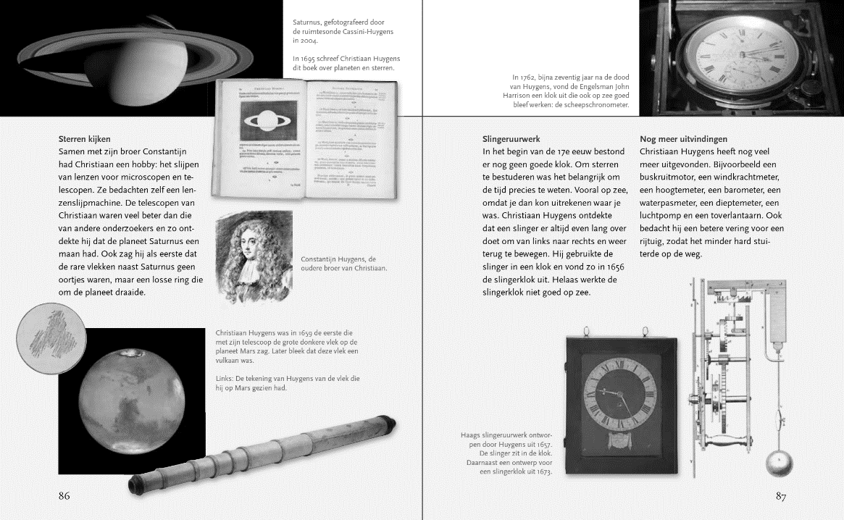

The main events of his life.
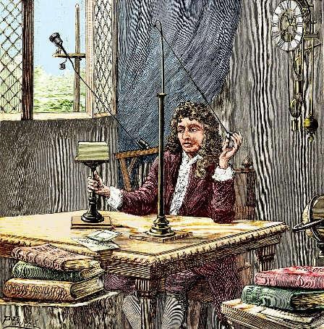
The main events of his life are that Christiaan lived and studied in England and France. In 1666 he became the first director of the France scientific academy. This name shows how important the work of Huygens was and how valuable his ideas were for science. He was also asked to join the Royal Society. From 18681 until his death he lived in his family house Hofwijck in Voorburg and in The Hague.

How people thought of Christiaan Huygens.
People in his time thought him to be the leading figure when we talk about mathematics. A friend of Huygens father wrote to him: If he continues this way, he will one day be even greater than Archimedes. (A famous Greek thinker). They didn’t liked it that he couldn’t admit that he was wrong sometimes and that’s why they kicked him out the scientific academy later. But later he came on the banknote of 25 gulden. Scientists were jealous on him because he discovered the answers to questions which they thought about for months/years.

How people think of Christiaan Huygens.
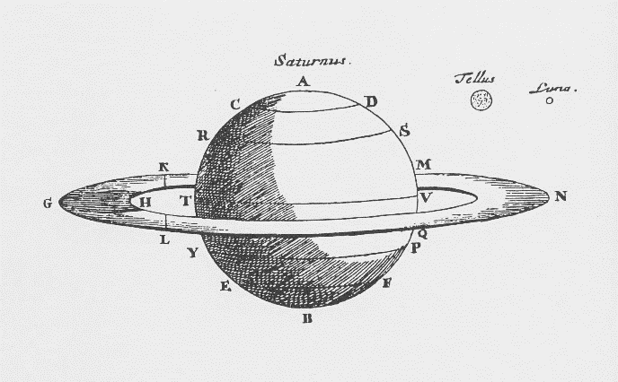
People in our time think he was a very smart person. Huygens is very important for the Dutch Science history in the Golden Age. He discovered all kind of things which are proved to be true. He even thought that there is life on other planets, this is not proved yet but scientist thinks he’s right again. We have learned a lot of things from the theories of Huygens and we still use his inventions. Because of him we know a lot more about the universe and mathematics.

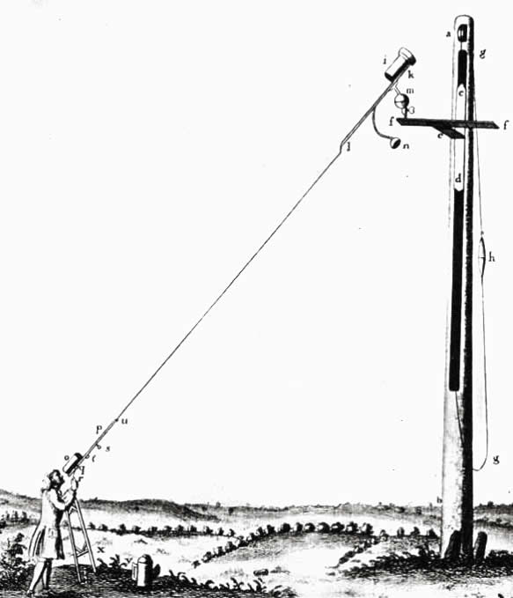
Why Christiaan Huygens is a great man.
There are many reasons for calling him a great man, because Christiaan invented a lot of things which are still useful right now. He discovered Saturn’s rings. People thought that the rings were kind of ears but he discovered that it was a thin flat ring around the planet. He also discovered the telescope and the glass were you could see 50x bigger with. With this telescope they found area details of the planet Mars. But the longer the telescope the better you could see, so people made very long telescopes until they broke because of the weight in the middle. Huygens had again a solution for this, he designed a telescope without a tube. He was just that smart that he found answers to everything he once examined.

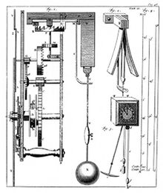
The most important reason why he is a great man.
The most important of those reasons is that he invented the pendulum. In that time was timing on sea very important. That wasn’t invented yet so Huygens started to think about that problem. He invented a pendulum. In 1656 his pendulum became publical. And in 1673 he wrote a book "Horologium Oscillatorium" published in Paris, it discussed the mathematics surrounding pendulum motion and the law of centrifugal force for uniform circular motion. This invention made measuring much easier, and we still use the same formula for clocks. Scientist learned a lot from the discoveries of Huygens.

Conclusion
In conclusion Christiaan Huygens was one of the most important scientist of the 17th century. He invented a lot and with most of his inventions he helped himself and other scientist to discover new inventions. When we look at the inventions of the Huygens, then we see that there is almost no discovery in the 17th century of science which is not discovered by him.

List of my used sources
In my essay I used the following sources.
-Scholieren -Entoen.nu –Wikipedia -Het klokhuis –Digging deeper, Jane and Paul Shuter, 2008.

