New York
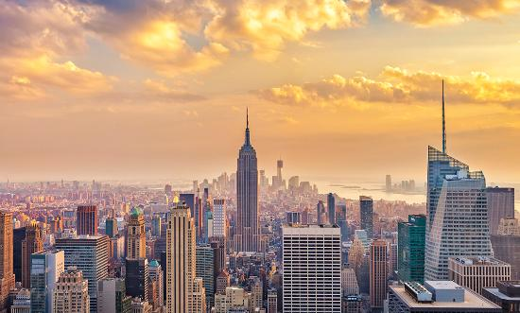
Name : Tom Groenendijk
Class : K3C
POG Werkstuk Engels

Table of contents
Page : Content :
1 Frontpage
2 Table of contents
3 Introduction
4 C1 History
5 C2 City Information
6 C3 Terrorist attack on 9/11
7 C4 Monuments
8 C5 New York Yankees
9 C6 Videogames in New York
10 Sources

Introduction
I’m doing my project about New York, one of the biggest cities of America and the whole world. I’ve never been there but i just really want to go there because i see so much good things about new york in movies and series. It was not that hard to find information about it because its one of the biggest cities and there is a lot of information about it on the internet. I also have seen a lot of pictures on internet from New York in the dark and that looks so beautiful!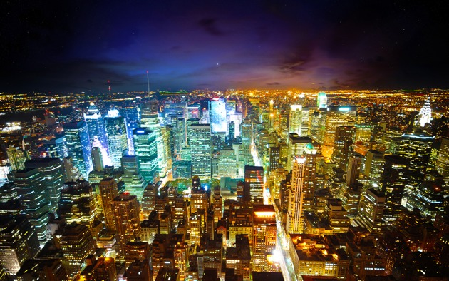

Chapter 1 : History
The History
New York was found nearly 500 years ago, by Giovanni da Verrazano, before that, Indians owned it. In 1614 Adriaen Block made a name for it, called the area New Netherlands. In 1625 the West-Indian Company found New Amsterdam. In 1664 the English men got the Wall streets wall and called the island New York to the brother of Karel II. The pact of Paris gave the English in 1763 government over 13 American colonies. There was a war from 1770 until 1783 about the independence ( Freedom ) of New York. In 1783 the pact of Paris made an end to the war. Women get their rights to vote in 1920. Wall Street crashed in 1929, which gave a lot of unemployment. The construction of the Chrysler building, the highest building of the world, was started in 1930. The Empire State Building’s construction, then the highest building in the world, was started in 1931.The building of the World Trade Centre was started in 1973 it was the biggest building until New York until 11 september 2001. John Lennon (member of the beatles) was killed in front of the Dakota hotel in 1980. The New York stock exchange crashed in 1987. David Dinkins, the first Afro-American mayor of New York is appointed in 1990. A terrorist bomb damages the World Trade Centre in 1993. The population of New York has grown from 80.000 up to 3 million people between 1800 and 1900. The population grew on and from 1900 until now it has grown from 3 million up to 9 million. The city has developed itself through the years to be the centre of America.
Post - Wereldoorlog 2 : 1946 - 1977
Veterans who came back out of WW2 and immigrants from europe gave a big economical afterwar and this brought the big devolepments of the big districts in the east of Queens. In 1951 the VS traded there first Headquarters in Flushing Meadows Park. ( Queens )

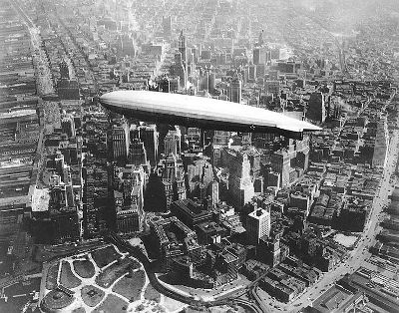

Chapter 2 : City Information
New York is one of the oldest and biggest cities of North America. Its located at the Hudson River. The city has about 9 million people. this is almost as much as in Belgium. The city has 5 parts : The Bronx, Queens, Brooklyn, Manhattan and Staten Island. The City has a surface area of 782 km2, New York has 10,300 km street, 1050 km subway, 10585 ha park 200 skyscrapers. There are a lot different nationalities in New York. Some races are in specific parts. The Most famous are Harlem ( Black People ), China Town ( Chinese People ), Little Italy ( Italian People ) And Spanish Harlem ( Puerto Ricans ).
Here is a little summary about the New York demography
Jurisdiction |  | Population | Land area
Borough | County | 1 July 2013  Estimates | square  miles | square  km
Manhattan | New York | 1,626,159 | 23 | 59
The Bronx | Bronx | 1,418,733 | 42 | 109
Brooklyn | Kings | 2,592,149 | 71 | 183
Queens | Queens | 2,296,175 | 109 | 283
Staten Island | Richmond | 472,621 | 58 | 151
City of New York |  | 8,405,837 | 303 | 786
State of New York |  | 19,651,127 | 47,214 | 122,284

Chapter 3 : Terrorist attack ( 9/11 )
The attack on 11 September 2001, the American people call it nine eleven ( 911 )
Earlier that day there already were a few terrorist attacks. The terrorist group Al Qaida hijacked 4 big passenger planes and used it to attack the Twin Towers of the World Trade Centre. The boss of Al Qaida was responsible for the attack called Osama Bin Laden who is now dead only since 2011 when he was killed by the Navy Seals at his heavily protected home. 1 Other plane crashed into the Pentagon and the last plane crashed into the ground near Shanks Ville in Pennsylvania all 4 planes flew inside of the roster. 2 planes were owned by American Airlines and 2 by United Airlines. The attacks were done by 19 members of the terrorist group Al Qaida. These attacks were and are seen as one of the most biggest attacks of all time. Almost 3000 people out of 90 different countries died. There are still 24 missing people but its assumed that they are dead.
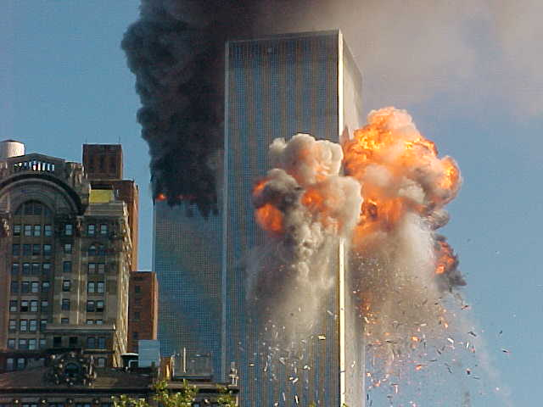

Chapter 4 : Monuments
Monuments and buildings in New York
There are a few important monuments that you can find in New York. 1 of it is the Empire State Building. This building is 375 Meters high and has 102 stories. There also is a big building called Chrysler Building this building is 319 Meters high. The most important monument in New York is a statue with a crown on her head and a torch in her hand. It’s called the Statue of Liberty it stands on Liberty Island and has been built on 1876, as a symbol of the freedom. The Statue is a big attraction for the people who go there on vacation even for the people who live there. You can even go into the statue and look trough the windows in the crown.
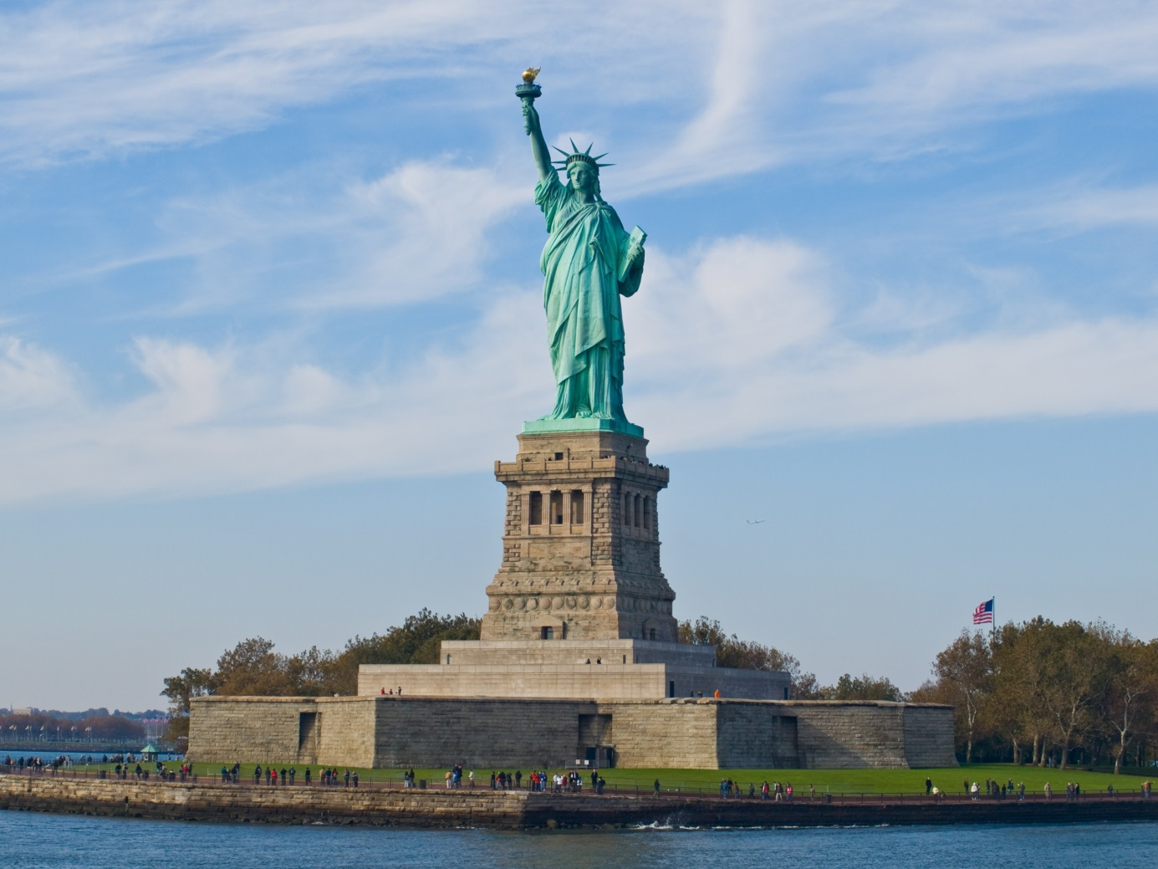

Chapter 5 : New York Yankees
The Yankees the most popular sports club out of New York, Out of the Bronx They play in the eastern division of the American League. There Home stadium is called the Yankee Stadium. There Biggest enemy’s are called the Boston Red Sox.
The New York Yankees Are since 1920 one of the most famous and most successful clubs in the American Sports. The Yankees were founded in 1901 in Baltimore. They played with the name Baltimore Orioles in that time. Now The current Baltimore team plays with that name.
In the beginning of 1903 Frank Farrel and Bill Devery bought the club and then they moved to Manhattan. Until 1912 the team was called New York Highlanders. Because the highlanders ended up in the American League a lot of people the team NY Americans but the press used the word Yankees or Yanks to keep more space. The Team moved from stadium in 1913 when at that time the San Francisco Giants Played. From the moment they moved into that stadium they call themselves New York Yankees.
On 18 April 1923 the new stadium in Bronx was opened. 70.400 people saw the first match in the new stadium, Babe Ruth made his first homerun there. The Yankees won the World Series, The highest title in the American Baseball. Since that moment they have already won 27 times, the last one was in 2009. They have the most wins of all the American clubs.
The team of the New York Yankees out of 1927 is still being looked at by baseball experts as one of the most strongest teams out of all time. In that season the won 110 times and lost 44 times.
In 1929 the Yankees were the first team which had numbers on their backs. The first win of the World Series after they had their back numbers was in 1932. Joe McCarthy was the manager, and with him the real wins came. And it began with 2 wins of the World Series, 1932 – 1946 In that period with Joe as manager they won 7 out of the 8 World Series Finals.
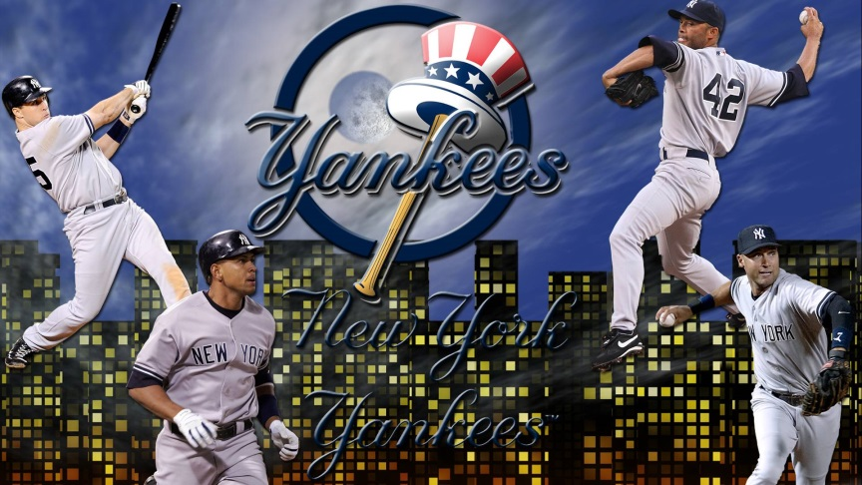
Chapter 6 : Videogames in New York
Because New York is such a big and beautiful city a lot videogames have the map of New York, For example GTA 4, Metal Gear Solid 2, Crisis 2 and Modern Warfare 3. Those are just a few examples. There are a lot more games with the map of New York but that’s that list is to big.
Because i have played GTA 4 I know a little bit what I would expect when I go to New York because of those videogames. Its just really cool because the map on GTA 4 is almost the same as in real life, so If I would play GTA 4 for a long time and I would go to New York I could just know the way everywhere. I would love if GTA 5 was in New York because its way more fun and the quality of the games are just a lot better then when GTA 4 came out I hope that GTA 6 Is in New York!
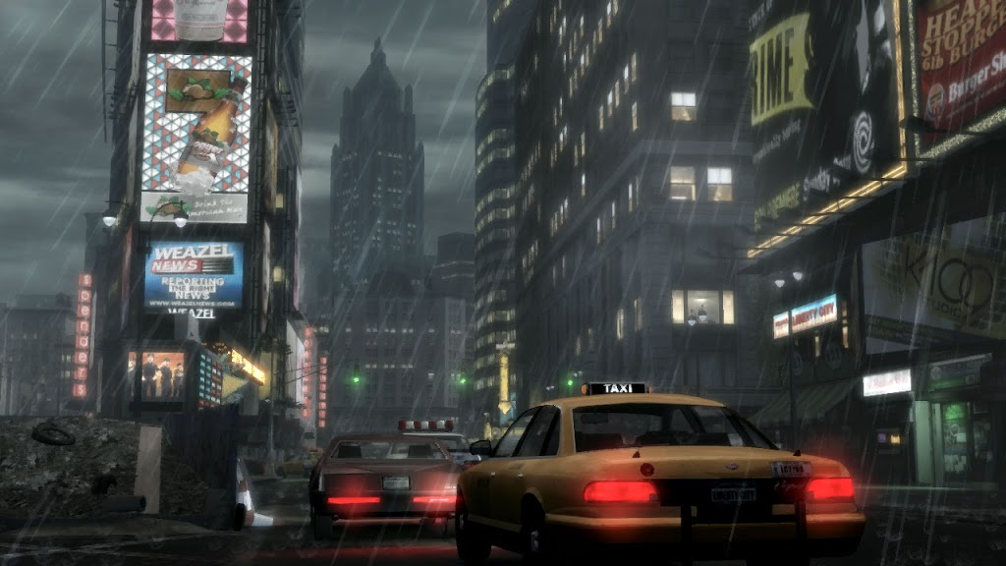

Sources
These are sources I used to get my information.
Wikipedia
http://nl.wikipedia.org/wiki/New_York_City
http://en.wikipedia.org/wiki/List_of_video_games_set_in_New_York_City
Google
https://www.google.nl/
Google Translate
https://translate.google.nl/

Scholieren
http://www.scholieren.com/praktische-opdracht/73375

