Soldier dog
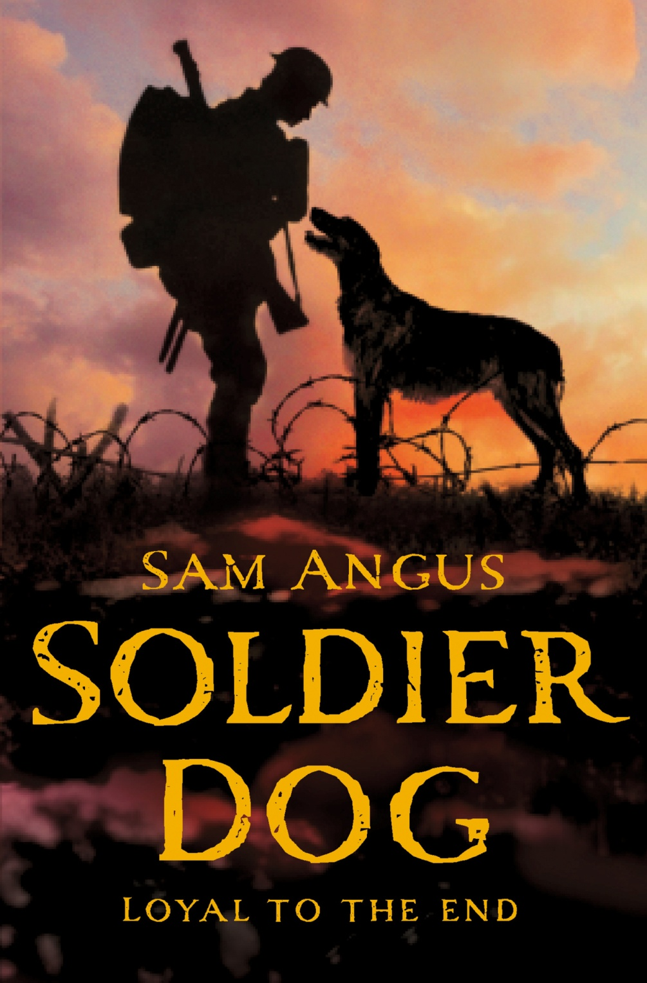

Name: Coen Smeelen
Class: 4

Information

Title: Soldier dog
Author: Sam Angus
Publisher: Macmillan Children’s Books
Genre: Scary, WO II, Dogs
Number of pages: 288
Date of publication: ?

About the plot
Peacefully living together, Stanley, Da and Rocket live in the time of WO I. Tom, Stanley’s older brother, had to join the army to fight against Germany in order to protect France. And a few weeks after that, Rocket suddenly disappeared. When Stanley found Rocket back, it was pregnant and immediately brought four puppies on earth. 1 for Tom 1 for Stanley and the rest for Da. The one for Tom was a special one. Stanley named him Soldier. When Da came in and saw the puppies he gave them away because they were half breeds. Stanley had hidden Soldier behind his coat so he could hold at least 1 of them. When Da found out, he became furious and said he would drown Soldier. Stanley saw Soldier laying lifeless in the pool. Stanley was so furious that he could never forgive Da for drowning Soldier and ran away to join the army. He was only fourteen so he may not join the army yet but if he dressed himself up as an adult he looked like 17 and could join the army. When he joined the army he would search for Tom and stay with him, far away from Da. He was good with dogs so he became part of the royal engineers. The engineers were short of men that know about animals. When he arrived in France, he saw they needed men for the messenger dog service so Stanley went to a signaling school before he went to the messenger dog school. When he finally came there, he was allowed to choose a dog. He chose a dog and named it Bones. Bones was a big and strong dog. A long period passed, because he had to train Bones. When Stanley finally did that he was send to the battlefield in order to support the troops by sending Bones with a message from the front line to the second line to give them some more information about what’s going on there. When Bones had to run to the frontline and back with a message, he came back shredded by the barb wire. Bones was so heavily injured that they couldn’t help him anymore, so he died. Meanwhile he got some letters from Tom, who came home because his leg was broken. He said Stanley had to come home as fast as he could. Now Stanley felt like he had been let down by both Tom and Da. He didn’t want to go home anymore. He wanted to stay here forever, so he took a new dog to train. In de beginning, the dog was very scared of everyone but Stanley gave him a chance and trained him well. He named the dog Pistol. Pistol was a very fast and light dog, which whatever happened, stuck to Stanley’s side. Stanley was send to the battlefield again. A couple of weeks passed and he had to send Pistol to the frontline again in order to protect Tom, who was there looking for Stanley and now trapped inside a little shelter, surrounded by the enemy. Pistol made it to the frontline, but when he tried to come back he got shot in his legs. Stanley desperately tried to safe him and sought shelter in a hole. What Stanley didn’t know was that the hole was full of poisonous water. Together they waited there until rescue came. But when rescue came, they only took Stanley and left Pistol suffer in the hole. When Stanley was healing in the hospital, he finally got a message from Da had been missing for over a year looking for his son and Soldier. He said that he didn’t drown Soldier at all and that Soldier was now a messenger dog in France. Messenger dog number 2176. That turned out to be his dog, Pistol, which was still suffering in the hole for over two weeks. When rescue came to safe Pistol (Soldier) too, he was still waiting for Stanley. When Stanley heard that he forgave Da and they all went home together, Stanley, Tom, Da and Soldier.
Main character
Stanley
Stanley is a 14 year old boy. He doesn’t talk often. He only talks when it’s about something very important. He is also a very brave boy because he ran away from Da, joined the army and fought for his life in France. Stanley does also know allot of animals. Especially dogs.

My favorite character:
Maybe it’s obvious, maybe it’s because he’s the main character and I know more about him than the others, but Stanley is my favorite character because he risked his own life to safe his dog Soldier. That’s one thing only a soldier and a dog that have such a strong bond, they would risk their lives for each other.

My opinion
I think this is a great book to read. It shows you how the fight on the battlefield was, how the war caused family breakups and it shows you how strong the bond between each other was when it was going about being alive or dead.

My recommendation
I first thought, wow this is a long book to read. And in the beginning there were some words I didn’t understand. So I put it away. A few days after that I thought, oh why not, and I began to read it further. Once I came further in the story I understood it and the rest was easy to read. That was the moment I began to enjoy the book. Once I had finished it, I was amazed by the story. If you don’t like to read and haven’t got much time, then maybe it isn’t a good option for you, but if you like to have a good story, then I would surely recommend this book.

