Geography; Chapter 1, Paragraph 1 summary.

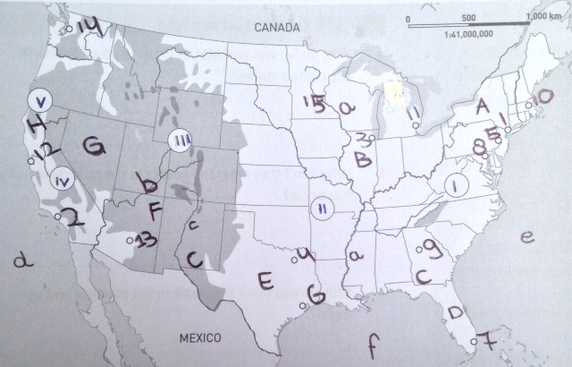1 New York

2 Los Angeles

3 Chicago

4 Dallas

5 Philadelphia

6 Houston

7 Miami

8 Washington

9 Atlanta

10 Boston

11 Detroit

12 San Francisco

13 Phoenix

14 Seattle

15 Minneapolis/St. Paul

A New York I Appalachians a Mississippi

B Illinois II Ozark Plateau b Colorado

C Georgia III Rocky Mountains c Rio Grande

D Florida IV Sierra Nevada d Pacific Ocean

E Texas V Coastal Ranges e Atlantic Ocean

F Arizona f Gulf of Mexico

G Nevada

H California

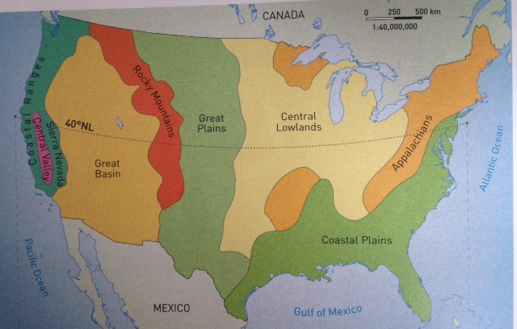

**Course book:** America was discovered in 1492. At that time it was an empty continent with very little man-made landscape. Immigrants built houses and started to farm there. Making an area fit to live in and developing it is called **colonization**.

European countries had problems with hunger, poverty and unemployment. Wars were being fought and not every country had freedom of neither religion nor expression. This is the main reason why the Europeans massively immigrated to the United States. The most people settled on the east coast first. Some travelled to the west. The shifting border between area inhabited by the Europeans and ‘the Wild West’ is called the **frontier**.

If you travel in a straight line from New York to San Francisco, you go through all the landscapes shown in the picture above. You’ll see the landscape changing as you travel. Though nowadays, however, there’s much more man-made, or cultivated landscape.

Two very important mountain regions stretching from north to south are very important; those are the Appalachians in the east and the Rocky Mountains in the west.

― The Appalachians is an **old mountain range**: its peaks have been rounded by **erosion** over millions of years. Therefore it’s also a **low mountain range** about 500-1500 meters high.

― The Rocky Mountains is a **young mountain range** with sharp peaks that are mostly higher than 4000 meters and covered in **perpetual snow**. So it is a high mountain range.

The extensive Interior Plains lie between the ‘Rockies’ in the west and the Appalachians. This is a large-scaled agricultural area that is mostly flat. The eastern part is lower than 500 meters (**coastal plain**). A lot of maize is grown in this region; they often call it the Corn Belt.

Further to the west, the landscape is drier and gradually increases in altitude; the Great Plains. It’s a **plateau** (higher than 500 meters) which has natural vegetation of prairie grasses (steppe). Crops can only be grown with irrigation water pumped out of the ground. Farmers mostly grow wheat, so they called it the Wheat Belt. This is also a region of **extensive livestock farming**. There are just a small number of animals roaming the enormous grassy plains per hectare.

On the west side of the Rocky Mountains is the Great Basin, an area of plateaus that are about 1500 meters height. It is extremely dry there. The landscape is characterized by bare rocks, dry grasses and cacti. There is more rain closer to the coast, but the Central Valley lies in the **rain shadow** of the surrounding mountains. Farmers grow citrus fruits such as oranges and grapefruits, rice and vegetables with the help of irrigation.

**Geoguide**: **Relief** ― the geographical name for height differences in a landscape

There are four main types of relief:

**High mountain ranges**: most of the peaks are higher than 1500 meters.

**Low mountain ranges**: most of the peaks are between 500-1500 meters.

**Hills**: most of the peaks are between 200 and 500 meters.

**Lowland**: lower than 200 meters.

A region with very little or no relief is called a plain. One lower than 500 meters is called a coastal plain and one that is higher than 500 meters is called a plateau.