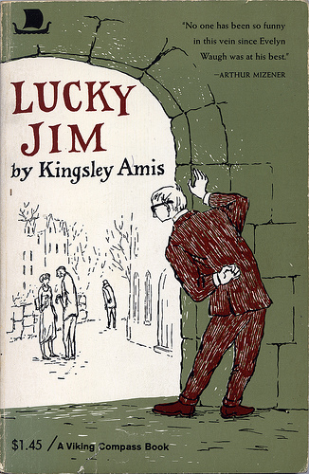
Ali Kumas
A4B

Title: Lucky Jim
Writer: Kingsley Amis
Publisher: ?
Year of publication: 1954
My book published in: 1980

Summary
Jim Dixon works as a lecturer at the history department of a provincial university. Although Jim despises his supervisor, Professor Welch, he tries to keep on good terms with him, to ensure the continuation of his job. Jim succeeds in making a fool of himself by accidentally knocking down the chair on which the Registrar was about to sit down, and criticizing a book written at Welch's suggestion. Jim feels responsible for his colleague Margaret Peel, who has attempted suicide after being deserted by her boyfriend Catchpole.
Jim is asked by Professor Welch to prepare a lecture on 'Merrie England' for the College open week at the end of the term. Besides that Welch urges Jim to get an article on Medieval Shipbuilding published. Jim gets the article accepted by a new journal, but its editor is a cheat and publishes the article under his own name in another journal. The special subject Jim plans to teach is not a success either. Only one student intends to take the course.
Jim and Margaret are invited to a cultural weekend at the Welches' country house. They meet the Professor's son Bertrand, a painter, and his girlfriend Christine. Although attracted by Christine, Jim is soon bored by the party and gets drunk at the local pub. He is invited by Margaret, who seems to want to make love, but who then indignantly sends him away. He falls asleep, burning holes in the blankets. Christine helps him to cover up.
Jim discovers Bertrand's only reason for his relationship with Christine is to get close to her uncle, the millionaire Julius Gore-Urguhart and that he is having an affair with Carol Goldsmith. At a ball Jim leaves with Christine and they talk for some time. Jim keeps his knowledge of Bertrand's affair to himself. Both Bertrand and Margaret are angry at Jim for leaving the party with Christine. Jim still has tea with Christine, which leads to a ridiculous fight between Bertrand and himself.
Jim's career comes to an end when his lecture on 'Merrie England' turns into a catastrophe. Due to stage-fright, fatigue and liquor, Jim collapses on the platform, just after giving an embarrassing impersonation of Professor Welch and the University Board. Fortunately for Jim Gore-Urquhart offers him the well-paid job Bertrand was after. Jim meets Catchpole and learns that Margaret's suicide attempt was fake. Jim then loses his feelings of responsibility for her. Christine learns about the affair Bertrand and Carol were having and decides to start a relationship with Jim.
Bron: http://www.scholieren.com/boekverslag/49607

Type of work
It’s a psychological novel. It goes about the live from Jim. He was unlucky, but then he was lucky, because he get all of things, what he wants. First a girl, money, a job… it goes about him, how he changes.

Theme
The story goes about Jim, who tries to find his place in the world. So het get all of things what he want. He is afraid to do something wrong, so I think that the theme is to find your place in the world.

Main Characters
Jim Dixon: He teaches history at a university, he's specialized in the middle-ages. The story goes about him. First he had a normal life, but then, he will be the luckiest man, with a good job and a nice girlfriend. First he had a lot of problems, but now not more. Dixon tries to get pretty girls in his history class, but that doesn't work. Dixon things he isn't good enough to work at the university especially when his lecture is going wrong. He has something with Margaret, but he find her ugly and she isn't so nice as Christine, but Christine has something with Bertrand, so he don't know what he must do now.

Christine Callaghan: She is the niece of Mr Gore-Urquhart and she is a very beautiful girl. Dixon loves Christine, but she had something with Bertrand. She things that she loves Bertrand and all the things he's doing to her, she sees them as a thing you have to handle with.

Bertrand Welch: He is the son of Professor Welch and he is a painter. He dates Christine because he wants the job that Dixon later gets. Christine doesn't know this and Bertrand his a lot of other girlfriends. He says to Dixon that he has to go away of Christine and when he doesn't do that they are going to fight.

Margaret Peels: She is the girlfriend of Jim. She is ugly and use a lot of make-up. She is the other woman in the life from Jim, but he doesn’t want her, because she is ugly.

Context of the story
It’s a psychological novel. It goes about the live from Jim. He was unlucky, but then he was lucky, because he get all of things, what he wants. First a girl, money, a job… it goes about him, how he changes. It’s also historical.

My opinion
I found the book very difficult to read, maybe this book was not for me. Actually, it was only in the begin difficult, eventually it became easier. Sometimes it was very boring, because the story in too many details were explained. And some things were just not well explained again. Allowing you not understand at. And if it's too long, it was just boring again. If you understand it's still a good book, but when you first read the summary and then the book, you think very differently about the book. I had expected something completely different. It took too long before I was out. I should have another book to read, so I did not like the book. It is also a historical story, what makes it so boring. In the beginning of the story I did not even know who was who.

