**Enlarging**

PR/QP/QR = k

Area = k2

Volume = k3

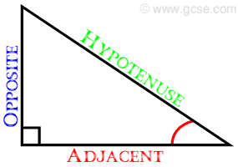

**Area of a triangle**

Area = base x height : 2

**Area of a parallelogram**

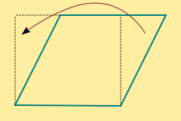Area = base x height

**Area of a circle**

Area = π x radius x radius

**Circumference of a circle**

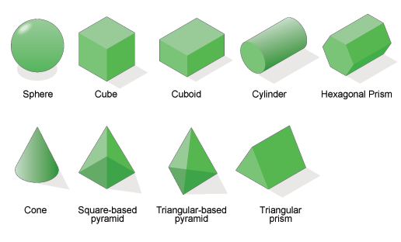Circumference = π x diameter

**Volume of a cuboid/prism/cylinder**

Volume = base area x height



**Volume of a pyramid/cone**

Volume = $\frac{1}{3}$ x base area x height



**Volume of a sphere**

Volume = x π x r3

**Area of a sphere**

Area = 4 x π x r2