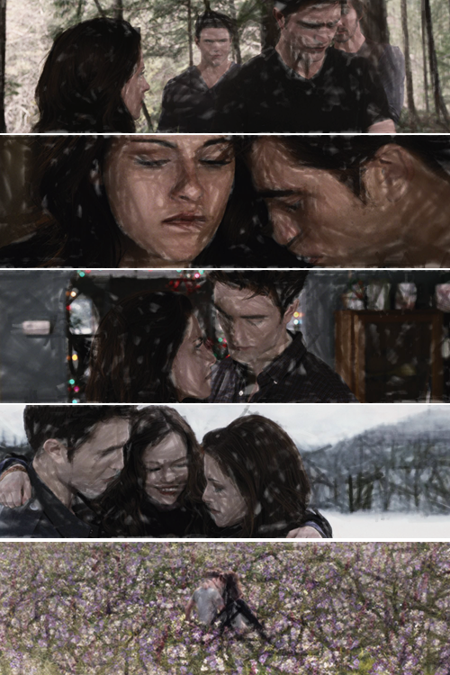
Twilight

Riëlle van Bommel
Engels
Mvr. Dijkstra
05.03.2013

Contents

Information
About The Book ……………………………….. 3

Characters ……………………………………….. 4

Summary …………………………………………. 5

Personal Opinion ……………………………… 6

Information
About The Book

- Title
The title of the book is Twilight

- Author
The author of Twilight Stephenie Meyer. She is the author of the whole Twilight-saga and two other books called: Hell on Earth and The Host. Stephenie Meyer is 38 years old and has sold more than 50 million books in less than 5 years.

- Genre
The genre of the book is thriller and detective.

- Setting
Twilight is set in Forks (Washington) where Bella has moved to. At first she lived in Phoenix (Arizona), but Bella thought her mother was quite unhappy because Phil, her mother’s boyfriend, travels a lot and her mother couldn’t go along otherwise Bella would be alone. Bella didn’t want her mother to be unhappy so she moved to Forks to her father’s.

- Perspective
Twilight is written from Bella’s point of view. It feels like there’s a movie playing in your head. The story is told in a chronological order, but there is a flashback: at the part where Jacob tells the legend about the “cold ones”. There are no flash-forward, but there are some predictions.

The Twilight-saga consists of three more books: New Moon, Eclipse and Breaking Dawn.
Characters

- Bella Swan
is the main character and the whole story is written from her point of view. She is an ordinary, very clumsy girl, also lacking in confidence and she has a great sense of humour. She is an observant and remembers everything which is strange in her eyes. She is seventeen and lives in Forks with her father Charlie. Bella is going to school.

- Edward Cullen
is an extraordinary boy. He is a vampire, also known as one of the “cold ones”, but he doesn’t want to harm humans. That’s why swore not to drink humans blood and hunts animals instead. Edward was made a vampire at the end of World War I. He’s also very handsome and is described as god-like. He’s adopted by the Cullen family. Edward is also going to school.

- Jacob Black
is a fifteen year-old boy who knows Bella for a long time. They have been friends since their childhood. Jacob told Bella the legend about the “cold ones” they’re not welcome on Indian-land because he thinks that vampires are not to be trusted. Jacob is both a Indian and a werewolf. He likes to work with cars.

- The Cullen Family
has adopted Edward and all the other ‘Cullen-kids’. The other members of the family are Carlisle Cullen: the head and “father figure” and the man who made Edward a vampire;
Esme Cullen: the wife of Carlisle. She is passionate and loving;
Rosalie Cullen: the most beautiful vampire and the only Cullen who dislikes Bella;
Emmet Cullen: the most intimidating. Rosalie and Emmet are married;
Alice Cullen: playful and caring. She has the closest relationship with Bella aside from Edward;
and Jasper Cullen: older than most of the Cullen members and is the partner of Alice.
Summary

When seventeen year-old Bella Swan leaves sunny Arizona to live with her father in the small Forks she doesn’t expect to like it. After all, she has made excuses not to go there. If living in Forks, where it’s constant raining, wasn’t bad enough she will have to make new friends and settle down into a new school.
Bella made soon some new friends at school. But when she sees a boy called Edward Cullen, sitting with his brothers and sisters, she’s instantly obsessed with him. Edward is attractive, almost inhumanly beautiful, but also an outsider too. Although Edward and his family have lived in Forks for two years, they have never been accepted by the people who live in Forks.

At first Edward is aloof, sometimes it seems like he can’t be in the same room as her. But eventually they have an unlikely friendship. Even when Bella falls hopelessly and irrevocably in love with Edward, she still can’t work out what makes him so different.

On a trip to the beach, Bella is told of the local legend about the “cold ones”, a group of blood drinkers who have sworn not to go hunting humans but are still not welcome on Indian-land because vampires are not to be trusted. Realising that Edward is a vampire changes nothing for Bella. She knows that she still loves him even if he’s not human.

Edward and his whole family are vampires. Edward was made a vampire when he was seventeen years-old, that was at the end of World War I.
Edward’s love for Bella is both a delight and a torment. A delight because she is the first person he has loved since he was made a vampire. A torment because although he has sworn not to drink human blood and only hunts animals the craving for human blood never truly leaves him and the scent of Bella stirs his hunger for blood…
Personal Opinion

I’ve heard Twilight was described as “a vampire story for people who don’t like vampire stories” and I think I would agree with that. I was never in love with vampires until Twilight came out. I didn’t know it was possible, but Stephenie Meyer changed the stereotypical blood-sucking vampire into a beautiful god-like creature.

Twilight is the story of Edward’s and Bella’s romance. Forget any vampire romance you have read before, Twilight is so unique it is almost its own genre. It is simply and beautifully written. The descriptions of Forks let you feel like you can almost smell the damp air and hear the rain falling on the roof.

Even Bella herself is a well written and realistic character: Shy and lacking in confidence and her sarcastic inner voice just tells it all.

The story is told in first person, so the reader only know what Bella knows and making Edward and his family a mystery that is slowly unravelled throughout the story. Even by the end of the book I want to read more of the Cullen family…

.

