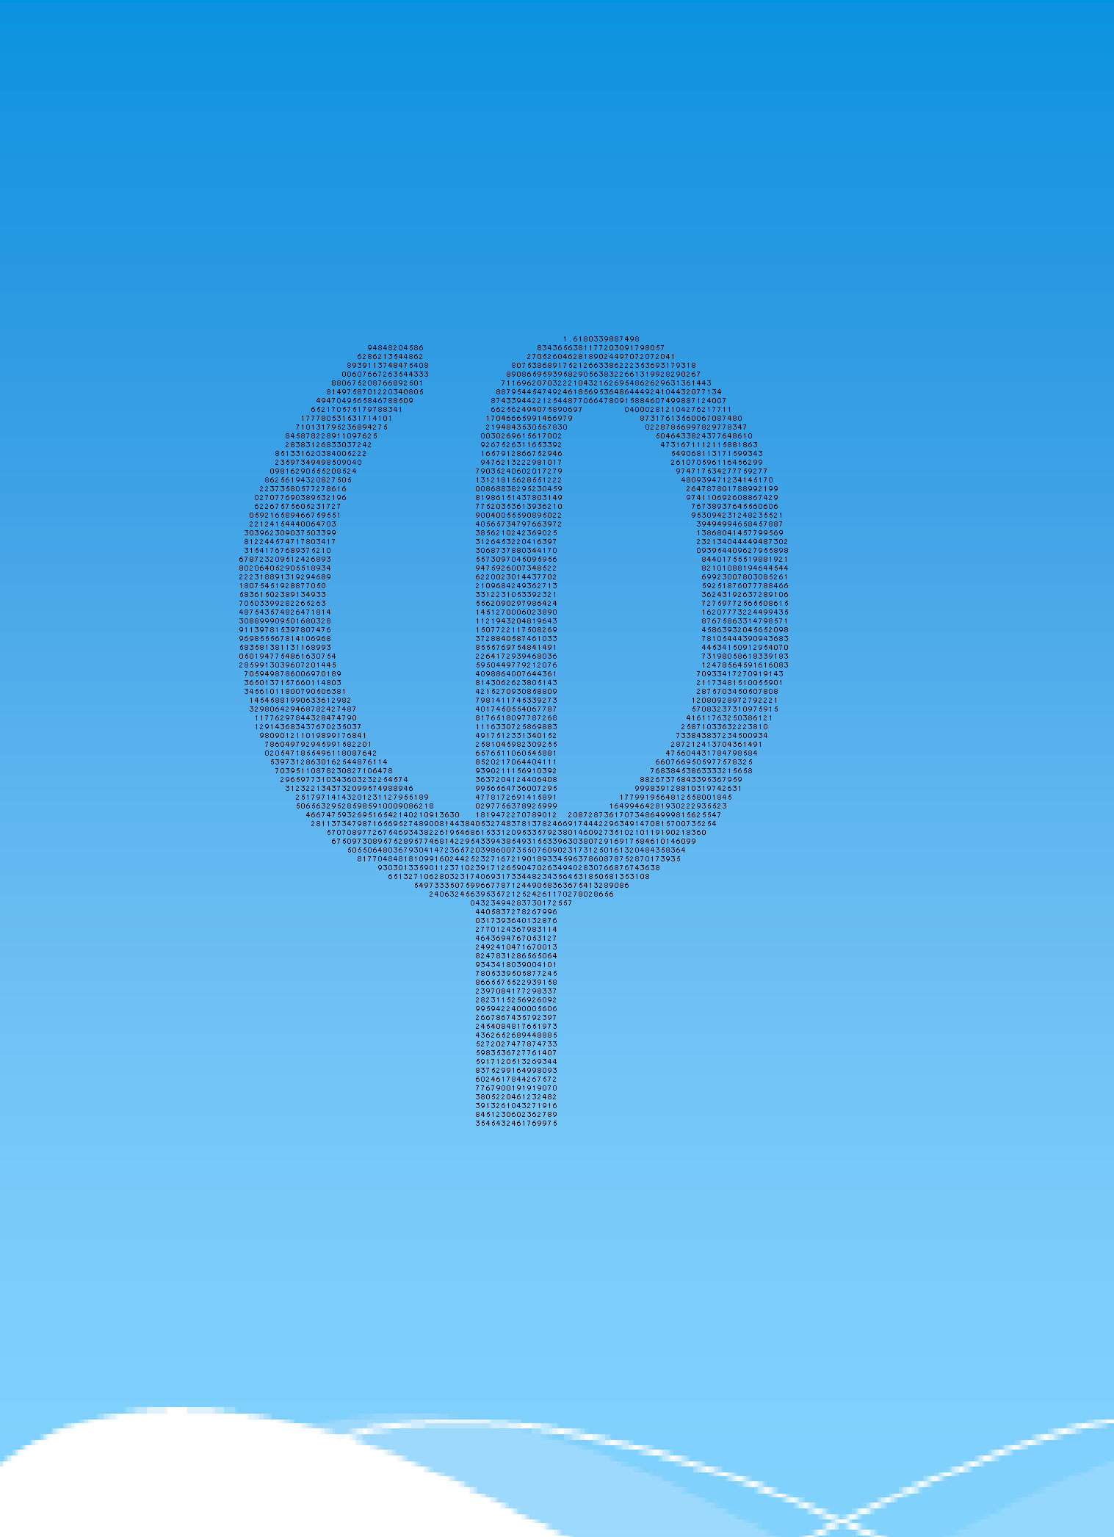The Golden Ratio and Fibonacci Numbers:

Their relation and practical uses

Jeffrey Bottse

January - 2011

With special thanks to Mr. Nagtegaal

**Contents**

1. **Introduction**  Pg. 3
2. **The Golden Ratio**
   1. *What is the Golden Ratio*
      1. Numbers Pg. 4
      2. How can a Golden Ratio be made Pg. 5
      3. Pentagram and reasoning Pg. 6
      4. Classic Construction Pg. 8
   2. *What are the properties of the Golden Ratio*
      1. Formula and Conjugate root Pg. 9
      2. The Golden Spiral, Rectangle and Triangle Pg. 10
      3. The continued fraction Pg. 13
      4. The Golden Angle Pg. 14
3. **The Fibonacci numbers**
   1. *What are the Fibonacci numbers*
      1. Sequences Pg. 16
      2. Origin and Formula Pg. 17
      3. The Rabbit problem Pg. 18
      4. Direct formula Pg. 19
   2. *What are the properties of the Fibonacci numbers*
      1. Fibonacci Spiral Pg. 21
      2. The Triangle of Pascal Pg. 22
      3. Lucas Numbers and Tribonacci numbers Pg. 24
4. **What is the relation between the Golden Ratio and the Fibonacci numbers?**
   1. Direct formula of the Fibonacci numbers Pg. 26
   2. Ratio and Limit Pg. 26
   3. Continued Fraction Pg. 30
5. **Where can we find the Golden Ratio and Fibonacci numbers in practice?**
   1. Architecture Pg. 31
   2. Nature Pg. 34
   3. The Ideal Human Pg. 37
   4. Art and Music Pg. 39
6. **Conclusion** Pg. 44
7. **Evaluation** Pg. 44
8. **Sources** Pg. 45
9. **Log** Pg. 47
10. **Introduction**

This is my research paper about the Golden Ratio and the Fibonacci Numbers. My goal is to describe and explain the relation between the Golden Ratio and the Fibonacci numbers and where those can be found in practice. This actually is my main question. I intend to explain it in a general way and talk about it in my presentation in such a way that my fellow students can understand everything I am talking about. I have chosen this subject because of its difficulty, it is a big challenge for me to obtain information and explain it in my own words. The golden ratio itself is fascinating: in practice, and especially in nature, it occurs in so many different ways of which I was not even aware of their existence. What about the Fibonacci numbers? First I thought of them as just a sequence that is just getting bigger, but now I can see a lot of qualities it has, and I will explain them in this paper. As you will read this, I hope I can inform you about the Golden Ratio, the Fibonacci Numbers, their relations and their practical uses. As seen in the contents, the following sub questions will be given an answer to:

-What is the Golden ratio?

-What are the properties of the Golden Ratio?

-What are the Fibonacci Numbers?

-What are the properties of the Fibonacci numbers?

These sub questions will lead to my main question, which is the following:

-What is the relation between the Golden Ratio and The Fibonacci numbers and where can we find the Golden Ratio and Fibonacci numbers in practice?

After I have dealt with these questions I will write a brief conclusion about these questions and give a brief evaluation about the whole project.

1. **The Golden Ratio**
   1. *What is the Golden Ratio*
      1. **Numbers**

The golden ratio represent the best ratio 2 numbers can have. A ratio means A divided B (A:B) is for example 12:3 shortened as 4:1. This means that A is 4 times bigger than B.

Numbers

To understand this subject, a bit will now be explained about numbers: Our numeral system is divided in different categories. :

**Natural Numbers(N):**   
Natural Numbers are counting numbers from 1,2,3,4,5,...  
N = {1,2,3,4,5,…}

**Integers (Z):**

* Whole Numbers together with negative numbers.
* Integers are set containing the positive numbers, 1, 2, 3, 4, ...., and negative numbers,…....-3, -2, -1, together with zero.
* Zero is neither positive nor negative, but both.
* In other words, Integers are defined as a set of whole numbers and their opposites.
* Z = {..., -3, -2, -1, 0, 1, 2, 3,...}

**Rational Numbers (Q):**

* All numbers of the form a/b , where a and b are integers (but b cannot be zero)
* Rational numbers include fractions and decimal numbers:  
  \* Proper Fraction: Numbers smaller than 1 for example: 1/2 or 3/4 or 0.75  
  \* Improper Fraction: Numbers greater than 1 for example: 5/2 or 2.5  
  \* Mixed Fraction: 2 and 1/2 = 5/2 or 2.5
* Integers: 6/3 or (=2)
* Powers and square roots may be rational numbers if their standard form is a rational number.
* In rational numbers the denominator cannot be zero

**Irrational Numbers (Q1 ):**

* Cannot be expressed as a ratio of integers.
* The order of decimals in irrational numbers never repeats, they decimals are random
* They have infinite decimals

*Example:* 2, 3, 7, 8   
square root of 2 = 2 = 1. 41421356......Irrational (no repeating or terminating decimals)

pi =  = 3.14159265....... Irrational (no repeating or terminating decimals)

**Real Numbers (R):**

* Real Numbers are every number, irrational or rational.
* Any number that you can find on the number line.
* It is a number required to label any point on the number line; or it is a number that names the distance of any point from 0.
* ***R = Q + Q1***
* Natural Numbers are Whole Numbers that are Integers, which are Rational Numbers, which are Real Numbers.
* Irrational Numbers are Real Numbers, but not all Real Numbers are Irrational Numbers.



The main subject of this paper is an irrational number called Phi:

This ratio has been of interest to mathematicians, physicists, philosophers, architects, artists and even musicians since antiquity. Synonyms of the golden ratio are the golden mean, the golden section, the divine proportion, or the mean of Phidias. For more information about Phidias, see page 32. The non-exact value of this number ((1+√5)/2) is 1.61803… and can be found using different ways which will be explained later in chapter 2.a.ii to chapter 2.b.iv. We can see that it is an irrational number, as its decimals never terminate or contain a repeating order. The letter used to describe this term is the capital letter Φ or small letter φ. In this paper, φ is used but occasionally, in some formulas, φ is used, which is the same Greek letter but written in a different font. This is the first letter of Phidias whose name came to be associated with the concept of the golden ratio.

* + 1. **How can a Golden Ratio be made**

There are several ways to construct a golden ratio. But first we need to know how it was found.

The ratio itself represents this: Imagine, you have a rope or a stick of 1 meter (A), and you cut it in two pieces. If you divide it in a piece of 60 cm (B) and a piece of 40 cm (C) you get a ratio of 2:3

The two new pieces both have a ratio with the original piece: for the bigger piece it is

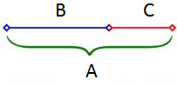60:100 or 1:1.667

If the rope or stick of 1 meter is divided in pieces of 65cm (B) and 35 cm (C) the ratio between them is: 35:65 or 1:1,857. The bigger piece has the following ratio to the original piece: 65:100 or 1:1.538

In the first situation, 1.667 is bigger than 1.5 and in the second situation, 1.538 is smaller than 1.857.

This means that there must be a perfect division somewhere in between these 2 mentioned ratios where A/B = B/C

* + 1. 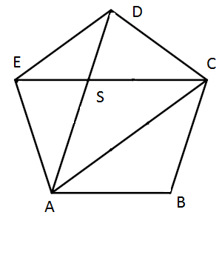**Pentagram and reasoning**

The golden ratio can be derived using a pentagram:

We see 3 different lengths: short (DS), bigger (AS), and biggest (AD or AC).

What we want to find out are the ratios of for example DS:AS or AB:AD

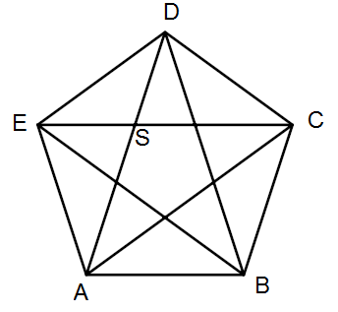As ABCDE is a regular pentagon, all 5 whole outer angles are equal. They are 540° together, as it is a regular polygon, so they all are 540°/5=108°. Because of a pentagons symmetry triangle EDC is an isosceles triangle, which means that angle CED is equal to angle ECD. They are both (180°-108°)/2=36°. As triangle ADE is the same as triangle EDC, angle AEB = angle CED which was 36°. As the whole of angle E is 108°, it leaves 108°-36°-36°=36° for the angle in between: angle BEC. Angle ASE=180°-36°-36°=72° and this angle is equal to angle ECB which is 36°+36°=72°. This means that there are F-angles and AD is parallel to BC. Using this construction, we can also conclude that AB is parallel to EC, AE to BD, ED to AC and DC to BE. Also triangle ACS is a bigger version of triangle DES because angle ASC=angle ESD because they are opposite angles and they are both isosceles triangles.

Triangle ACS ~ Triangle DES🡪 DS:AS=DE:AC (1)

In parallelogram ABCS are EC-AB and AS-BC parallel🡪 BC=AS and DE=BC🡪DE=AS (2)

Because of the symmetry AC=AD (3)

Substitute the equation 2 and 3 in 1 and we get the following:

DS:AS=AS:AD=AB:AD

This means that SHORT:BIGGER(1) = BIGGER(1):BIGGEST

This is the main quality of the golden ratio

This means that there is a perfect division where A/B = B/C

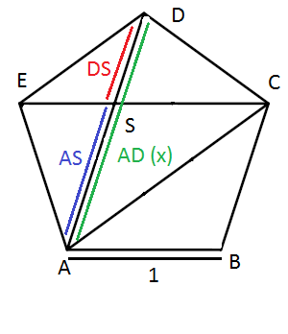By using these equations, we can find the exact values of the lengths.

Imagine AB=1 (=BC=CD=DE=EA) = AS

We want to find the length of the diagonal AD to get the value of our ratio, so imagine diagonal (AD) = x

The ratio becomes: (x-1):1=1:x🡪 (x-1)×x=1🡪x2-x-1=o

**Quadratic formula**

The quadratic formula is a formula used to find unknown values in quadratic functions. If the standard formula is , then you can find the x by filling in the quadratic formula:



By using the quadratic formula we find

for X1(Bigger/Short) 🡪  ≈ 

And for X2(Short/Bigger) 🡪  ≈ -0.61803

x is the length of a line and that cannot be negative🡪x=1/2 $×$ (1+√5)≈1.61803.

This number is called φ

1 + \frac{b}{a} = 1 + \frac{1}{\varphi}. \frac{a+b}{a} = \frac{a}{b} = \varphi\,.We cannot only find this by using the pentagon and the quadratic formula. We can also do it by simple reasoning and then the quadratic formula. The property of a golden ratio is this: Here φ is still an unknown number, as it has not been proved yet and a and b are our lengths where a is the longest and b the shortest. If we now convert the fraction on the lefthand side we can make a quadratic equation again by multiplying all factors by our still unknown number φ: \varphi + 1 = \varphi^2, which we can put into the standard quadratic equation mode as: {\varphi}^2 - \varphi - 1 = 0.

Now we find the solutions and we find our  ≈  and  ≈ -0.61803 again. Of course we focus on the positive one which defines φ. The other solution is not an option because it is not possible to have a negative length.

* + 1. **Classical Construction**

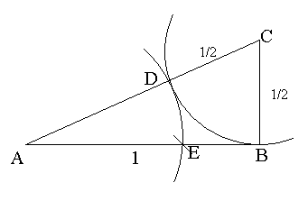In the time of the ancient Greek, no calculators or measuring tools were developed yet. So if they had to produce a ratio or regular polygon, they had to do this by means of a construction. So how could they construct the golden ratio? A classical construction is a drawing where only a pair of compasses and a ruler are used. The ruler does not contain any numbers; therefore it is basically a tool to draw a straight line. This is the way the ancient Greek made these drawings and that’s why this is called classic. In these drawings only straight lines and arcs are used.

This is the way to create a golden ratio using the classical construction:

-Draw a line AB (this length is 1)

-Draw BC perpendicular to AB with length ½ AB

-Draw arc: Center is C, radius is BC. (½ AB)

-Intersect this arc with AC, the point of intersection is called D.

So DC is ½ and AD = √(12 + ½ 2) – ½ = √(5/4)- ½ = ½√5-½ ≈ 0.61803 =Φ

-Draw arc: Center is A, radius is AD

-Intersect this arc with AB, the point of intersection is called E

In this image: AB: AE = AE:EB, which is the golden ratio.

It is 1: ≈0.61803 = 1.61803 = φ

* 1. *What are the properties of the Golden Ratio*
     1. **Formula and Conjugate root**

As we have just seen the golden ratio is an irrational number:  and this number is approximately 1.61803.

If we now look for the negative root of the quadratic equation we find 1-φ≈ -0.61803. The absolute value, which means the number is the same but negative terms become positive, ≈ 0.61803 and is the same as b/a, smallest/bigger. This is called the golden ratio conjugate and for this number we use the capital Phi: Φ. Now in formulas: \Phi = {1 \over \varphi} = {1 \over 1.61803\,39887\ldots} = 0.61803\,39887\ldots\,

And to do this exact we get:

$$\frac{\text{1}}{\text{φ}}\text{=}\frac{\text{1}}{\frac{\text{1}}{\text{2}}\text{+}\frac{\text{1}}{\text{2}}\sqrt{\text{5}}}×\frac{\frac{1}{2}-\frac{1}{2}\sqrt{5}}{\frac{1}{2}-\frac{1}{2}\sqrt{5}}=\frac{\frac{1}{2}-\frac{1}{2}\sqrt{5}}{\frac{1}{4}-\frac{5}{4}}=\frac{\frac{1}{2}-\frac{1}{2}\sqrt{5}}{-1}=-\frac{1}{2}+\frac{1}{2}\sqrt{5}=Φ$$

Because of its special quality we can express Φ as

\Phi = \varphi -1 = 1.61803\,39887\ldots -1 = 0.61803\,39887\ldots \,.

This shows an important and unique property of the golden ratio. It is the only one among positive numbers for which is true:

{1 \over \varphi} = \varphi - 1\,

for φ

{1 \over \Phi} = \Phi + 1\,.

and for Φ

* + 1. **The Golden Spiral, Rectangle and Triangle**

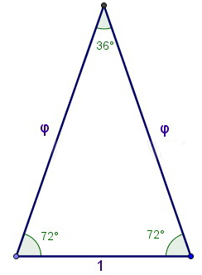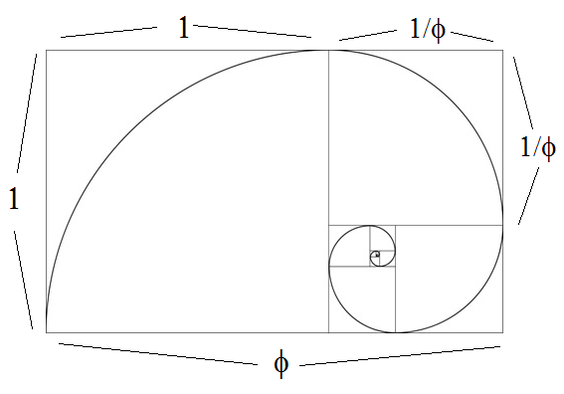Using the golden ratio, a golden rectangle can be made. This golden rectangle has sides which represent the golden ratio. This rectangle has a special feature: If we remove the largest square that is possible out of the golden rectangle, a new golden rectangle will be the remaining area. This one has the same proportions as the previous one but is 1/φ times smaller and 90° turned clockwise. This process can be done infinite times, and in the corners of each square new points are created. Connecting these infinite points will result in a golden spiral, which is a unique logarithmic spiral. This is just one of its main properties. The midpoint of the first arc is the bottom rights corner of its square inside the golden rectangle. The next midpoint is the bottom left corner of the newly generated square. The next midpoint is the left top corner, and the one after that is the right top corner. After this one (the 4th arc) the midpoint sequence repeats itself.

This golden rectangle returns in nature, and in architecture, and will be explained in chapter 5.

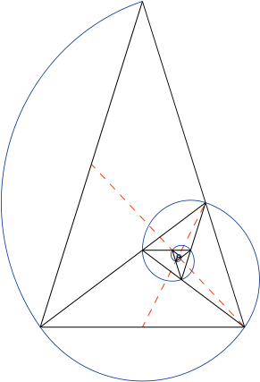A golden triangle, also known as the sublime triangle, is an isosceles triangle in which the two longer sides have equal lengths and in which the ratio of this length to that of the third, smaller side is the golden ratio.

This triangle has equal sides A and short side B.

The two longer sides have length φ and the short one has length 1: This means the triangle is based on the golden ratio.

Also the top angle is consine-1 of (φ/2) is it is side A/ (1/2B), which is π/5=36°

One of the qualities of a triangle is that the sum of the angles is 180° together, so 180-32=144° for both bottom angles.

As this one is an isosceles triangle, both bottom angles are equal in value, and therefore are 144/2=72° each.

Another thing that makes the golden triangle unique is the fact that it is the only triangle to have its three angles in 2:2:1 ratio.

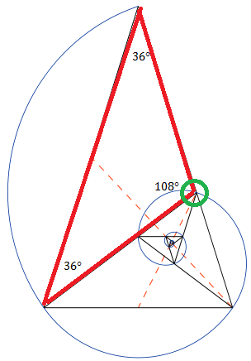From the golden triangle we can also generate a logarithmic spiral.

By bisecting the two base angles, new points on this spiral are constructed, and this point creates a new golden triangle together with the two old base points. This bisection progress can be continued infinitely, and therefore an infinite number of golden triangles are created. This spiral is shown on the right.

As for the midpoints, these are the middle angels (108°) of the isosceles triangles. Each new midpoint is the middle of the whole triangle minus the biggest golden triangle that can be taken from it:

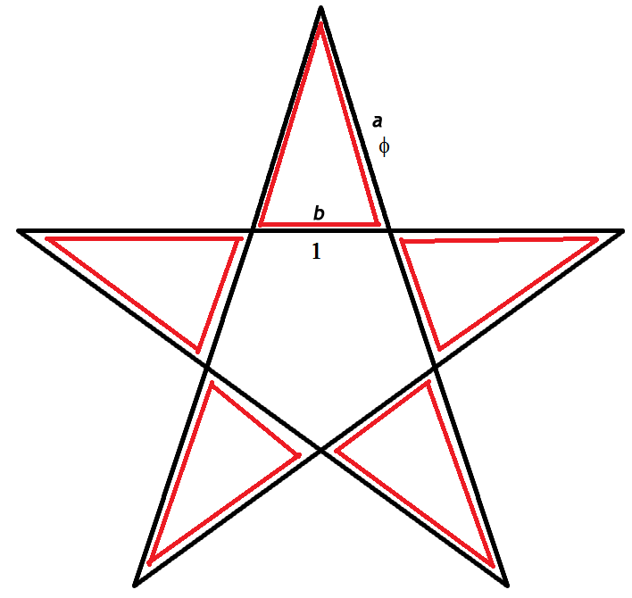

The golden triangle also exists in a pentagram; every outer triangle is a golden triangle. The inner area of the pentagram excluding the golden triangles is a pentagon, with the same qualities but it is φ+1 times smaller. This process can also be done infinitely.

As the golden triangle is isosceles, this triangle at the top (with isosceles side a and opposite side b) can be extended to obtain the whole pentagram except for the original sized golden triangles on the left and right.

As we have seen before in the golden rectangle and triangle, a golden spiral exists. This golden spiral is a logarithmic spiral, which is a spiral that often occurs in nature and its growth is determined by a logarithm. Its growth factor (b) is in this case φ, the golden ratio. It gets wider by the factor of φ for each quarter of a circle it makes. A golden spiral is a logarithmic spiral whose growth factor (b) is related to φ, the golden ratio. Filling in the quarter circles of the golden rectangle generates this golden spiral, as we can see on the right:

To find the length of the golden spiral we do the following things:

First we need to find a formula to find the length of the arcs.

The first arc is ¼ \* 2πr, where r is the radius and for the first arc is 1.

This will gives us ½ πr. For the second arc, the radius is 1/φ and for the third arc it is 1/φ2. We can therefore find a pattern in these lengths: ½ π\*(1/φn-1) if we choose our n to be in the first golden rectangle of φ by one. In this way we can find a few lengths of arcs:

|  |  |
| --- | --- |
| 1 | ½ π(1/φ1-1)= ½ π≈1,5707 |
| 2 | ½ π(1/φ2-1) ≈0.9798 |
| 3 | ½ π(1/φ3-1) ≈0.5999 |
| 4 | ½ π(1/φ4-1) ≈0.3708 |
| 5 | ½ π(1/φ5-1)≈0.2292 |

Now we want to find the length from n=1 to n= $∞$. To estimate, it will be around 3.7+0.25(=4.05) which are the added up value (n=1 to n=5) and the part I estimated of n=6 and bigger. With the formula of the length of the arcs we can find a formula for the sum of the lengths of the arcs:

Now we need to let our sum run from n=1 to n= $∞$

$$\sum_{n=1}^{∞}{\frac{1}{2}π×φ^{-1}}=\frac{1}{2}π\frac{1-{\left(\frac{1}{φ}\right)}^{∞}}{1-\frac{1}{φ}}→\frac{1}{2}π\frac{1}{1-\frac{1}{φ}}=\frac{1}{2}π\frac{φ}{φ-1}=\frac{1}{2}π\frac{\frac{1}{2}+\frac{1}{2}\sqrt{5}}{\frac{1}{2}+\frac{1}{2}\sqrt{5}-1}=\frac{1}{2}π\frac{\frac{1}{2}+\frac{1}{2}\sqrt{5}}{-\frac{1}{2}+\frac{1}{2}\sqrt{5}}=\frac{1}{2}π\frac{1+\sqrt{5}}{-1+\sqrt{5}}×\frac{1+\sqrt{5}}{1+\sqrt{5}}=\frac{1}{2}π\frac{1+2\sqrt{5}+5}{-1+5}=\frac{1}{2}π\frac{6+2\sqrt{5}}{4}=\frac{1}{2}π×\left(1\frac{1}{2}+\frac{1}{2}\sqrt{5}\right)=(\frac{3}{4}+\frac{1}{4}\sqrt{5})π≈4.1123$$

The golden spiral is a logaritmic spiral. A logatihmic spiral is a curve that can be found in nature and has a special notation. This notations is called the polar coordinate system. This is a two-dimensional coordinate system, in which every new point is determined by a distance from the starting point (a fixed point), and has an angle in a fixed direction. In polar coordniates, the curve will be the following: $\left(\begin{matrix}x= & r\cos{t} \\ y= & rsin t\end{matrix}\right)$ In this formula $r={ae}^{bϑ}$, in which a and b are random positive constants, e is the base number of al natural logarithms, $ϑ$ is the angle and r is the value that is put before the sine or consine function in the parametric. iii) **The continued fraction**

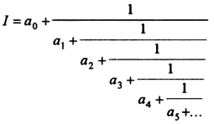All irrational numbers I can be written in terms of an infinite number of integers, a0,a1,a2.. in the form:

This kind of fraction is called a continued fraction: it’s infinite. It can also be expressed as: 

Where does this come from? In chapter 2,a,iii the quadratic formula is used to find the unknown value of the golden ratio: x2-x-1=o

Rewriting this gives us: x(x+1)=1

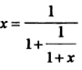Dividing by (1+x) gives: 

If the x on the right-hand side of the equation is replaced by gives us:

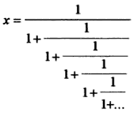

This can be done infinite times to give us:

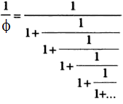

Since the answer to this equation is 1/φ, it becomes:

And as the inverse of the golden ratio is related to φ by the simple relation: {1 \over \varphi} = \varphi - 1\,,

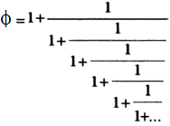

Then we can write the continued fraction also as:

**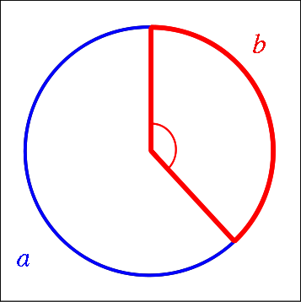iv) The Golden Angle**

There are several ways in which the golden ratio expresses itself. We have seen it in a rectangle, a triangle and a pentagon, but it is also present in a circle. If looking at the angles, there is also a perfect division where

arc a : arc b = arc a+b (circumference) : arc a

This ratio can be created. It looks like this:

By means of algebra, c will stand for the circumference, a will be the length of the bigger arc and b the length of the smaller arc🡪c=a+b

The ratio therefore will be: 

How can we than find the angle?

The exact value of the golden ratio therefore is derived using the formula of the circumference. As the radius of the circle is 1, the circumference will be 2πr=2\*π\*1=2π radians (or 360°). We can find the answer in degrees or radians:

360\left(1 - \frac{1}{\varphi}\right) = 360(2 - \varphi) = \frac{360}{\varphi^2} = 180(3 - \sqrt{5})\text{ degrees}≈137.51°

or

 2\pi \left( 1 - \frac{1}{\varphi}\right) = 2\pi(2 - \varphi) = \frac{2\pi}{\varphi^2} = \pi(3 - \sqrt{5})\text{ radians},≈2.399963 radians

Another way to find these values is the following: Now f will be the ratio of bigger arc b to the whole circumference c. Then it seems that:

 f = \frac{b}{c} = \frac{b}{b+a} = \frac{1}{1+\varphi}. but we can fill in this formula: {1+\varphi} = \varphi^2,

 f = \frac{1}{\varphi^2} So we can shorten it to this formula: ≈0,381966 (which is 1-Φ) and it also means

that φ2 times the golden angle can fit in one circle.

The golden angle *g* can therefore be approximated in degrees, by simply multiplying by 360, as:

g \approx 360 \times 0.381966 \approx 137.51^\circ,\, and of course it can also be approximated in radians as:

 g \approx 2\pi \times 0.381966 \approx 2.399963. \,

This “Golden Angle” will come back in chapter 5, in example sunflowers and pinecones.

1. **The Fibonacci numbers**
   1. *What are the Fibonacci numbers*
      1. **Sequences**

The Fibonacci numbers is numeral sequence. A numeral sequence is an ordered list of objects (numbers). It contains terms and the number of terms, which is called the *length* of the sequence is mostly infinite. Unlike a set, which is just a collection of terms, order matters, and exactly the same terms can appear multiple times at different positions in the sequence. A sequence is therefore a discrete function, and gives a discrete graph. To understand the Fibonacci numbers (the Fibonacci sequence), a few examples of sequences will be given. There are two sorts of sequences: The arithmetic progression and the geometric progression. There are two different ways of describing these sequences: A recursion and a direct formula.

A recursion is a method of defining [functions](http://en.wikipedia.org/wiki/Function_%28mathematics%29) in which the function being defined is applied within its own definition; specifically it is defining an infinite statement using finite components. It is a formula in which the next term can be derived from the previous term. In order to get this working, one of the terms has to be present and mostly it is the first one.

A direct formula is a method of describing a sequence is a way that the value of the term can be found by filling in the term in this formula.

First the arithmetic progression: This is a sequence of numbers such that the difference of any two terms of the sequence is constant. A simple recursion is for example U(n+1)=U(n)+7, where U(1)=2.

The U(n) means the value of the nth term.

This gives the following terms:

|  |  |
| --- | --- |
| U(1) | 2 |
| U(2) | 9 |
| U(3) | 16 |
| U(4) | 23 |
| U(5) | 30 |

The direct formula can be derived and gives: U(n)=7n+2, because 7 is the **difference** every new term acquires and 2 is the **starting number**.

Than the geometric progression: This is a sequence of numbers where each term after the first is found by multiplying the previous one by a fixed number called the common ratio. A simple recursion is for example U(n+1)=U(n)\*3, where U(1)=6

This gives the following terms:

|  |  |
| --- | --- |
| U(1) | 6 |
| U(2) | 18 |
| U(3) | 54 |
| U(4) | 162 |
| U(5) | 486 |

The direct formula can be derived and gives: U(n)=2\*(3n), because 3 is **the common ratio** and 2 is the **starting number.**

* + 1. **Origin and Formula**

The man who discovered this Fibonacci sequence was a man called Leonardo of Pisa, who was known as Fibonacci (which is a contraction of filius Bonacci, "son of Bonaccio"). Fibonacci has written several mathematical books, but his most famous one was Liber Abaci, which was written in the year 1202. This book introduced the Fibonacci sequence to Western European mathematics, although it has been said that the sequence may have been previously described in Indian mathematics, where mathematicians were ahead of European mathematicians by means of discoveries. When Fibonacci was alive, the printing press was not invented yet, so the book could only be copied by hand. But in his days, mathematics was not very appreciated: people underestimated its importance. But nowadays the importance is determined. Because there weren’t that many copies and some of them got lost, we are lucky to have some of them and therefore know about the Fibonacci Numbers.

The Fibonacci sequence is a special sequence: it’s not an arithmetic progression or geometric progression. It’s an addictive sequence. Here the recursion will be given, and in chapter 3b, the direct formula will be derived.

The recursion formula of the Fibonacci numbers is the following:

Fn=F(n-1)+F(n-2) with F0=0 and F1=1 as starting numbers. Starting numbers can also be named seed values. Because of Fibonacci’s importance in mathematics, the U, which is usually used to describe a recursion or direct formula, is replaced by the letter F.

This means that every new value can be calculated by adding the two previous. This leads to a very special integer sequence with a lot of qualities, which will later be explained.

The first 10 terms and values are these:

|  |  |  |  |  |  |  |  |  |  |
| --- | --- | --- | --- | --- | --- | --- | --- | --- | --- |
| F(0) | F(1) | F(2) | F(3) | F(4) | F(5) | F(6) | F(7) | F(8) | F(9) |
| 0 | 1 | 1 | 2 | 3 | 5 | 8 | 13 | 21 | 34 |

According to the numbers, the sequence can be extended indefinitely by applying the recursion relation. It may also be extended to negative values of the index, (n), by applying a recursion relation based on the one given above, which will lead to these numbers:

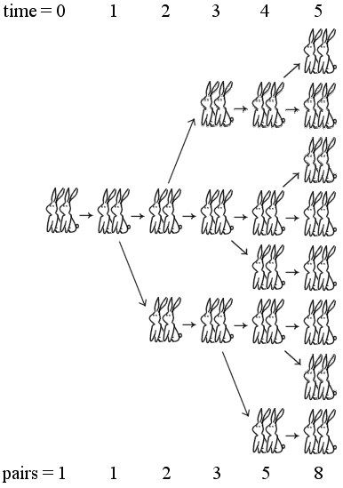… 34, -21, 13, -8, 5, -3, 2, -1, 1,0, 1, 1, 2, 3, 5, 8 …

* + 1. **The Rabbit problem**

To give us an explanation of the Fibonacci numbers, Fibonacci considers the growth of an idealized (biologically unrealistic) [rabbit](http://en.wikipedia.org/wiki/Rabbit) population, assuming that: a newly-born pair of rabbits, one male, one female, are put in a field; rabbits are able to mate at the age of one month so that at the end of its second month a female can produce another pair of rabbits; rabbits never die and a mating pair always produces one new pair (one male, one female) every month from the second month on till infinity. The puzzle that Fibonacci posed was: how many pairs will there be in one year? Here we can find the Fibonacci numbers.

* 1st month: First rabbit couple mate, but still only one pair
* 2nd month: Female produces new pair, which brings the total to 2
* 3rd month: 1st couple produces new pair, in total now 3 pairs are present
* 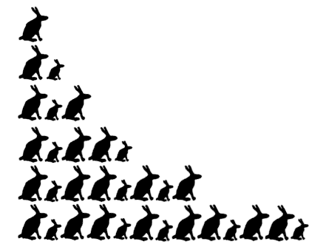4th month: Original pair produces new pair and the second pair also produces a new pair, this adds up to 5 pairs.

So we can generalize this situation now: at the end of the nth month, we add the newly produced rabbits in the nth month to the existing rabbits, and together they make up the corresponding nth Fibonacci number.

In the picture the rabbits who are qualified to mate (at least one month old) are the bigger couples, while the smaller ones are the newly born couples who are not ready to mate yet:

* + 1. **Direct formula**

As the Fibonacci numbers have a recursion formula, they are also supposed to have a direct formula. This direct formula contains the golden ratio, which will be explained in chapter 4.

 which can be written as

33bc3626759045d4727c34ed4b13240f

In this formula you can fill in every natural number: \ n=0,1,\dots.

Now for the proof we subsitute the following: A := \frac{1+\sqrt{5}}{2}  = φ and  a := \frac{1-\sqrt{5}}{2} = Φ

From this we can make this formula:

f_n\ :=\ \frac{1}{\sqrt{5}}\cdot(A^n - a^n)

How can we proof the direct formula?

$$F_{\left(n+2\right)}=\frac{1}{\sqrt{5}}\left(A^{n+2}-a^{n+2}\right)=\frac{1}{\sqrt{5}}(\left(A^{n+1}+A^{n}\right)-\left(a^{n+1}+a^{n}\right))=\frac{1}{\sqrt{5}}\left(A^{n+1}-a^{n+1}\right)+\frac{1}{\sqrt{5}}\left(A^{n}-a^{n}\right)=F_{n+1}+F_{n}$$

But we can only make this formula using these properties:

* f_0 = 0\     and     \ f_1 = 1
* A^2 = A+1\     hence     \ A^{n+2} = A^{n+1}+A^n
* a^2 = a+1\     hence     a^{n+2} = a^{n+1}+a^n\ 
* f_{n+2}\ =\ f_{n+1}+f_n

This can be applied to every \ n=0,1,\dots.

Thus \ f_n = F_n  for every natural number: \ n=0,1,\dots, and the formula is proved.

Furthermore, we have the following qualities of the golden ratio:

* A\cdot a = -1\ 
* A > 1\ 
* -1 < a < 0\ 
* \frac{1}{2}\ >\ \left|\frac{1}{\sqrt{5}}\cdot a^n\right|\quad\rightarrow\quad 0

From these qualities and the formula on the previous page, it follows that:

F_n\   is the nearest integer to  \frac{1}{\sqrt{5}}\cdot \left(\frac{1+\sqrt{5}}{2}\right)^n

for every \ n=0,1,\dots

It is vital in this formula that there is no round-off error in the calculation, and if n is very large and a precise integer value of F(n) is required then the value of φ, which is used for the calculation, must have a sufficient number of significant digits. In this formula, the second term in F(n) above is eliminated, so this formula arises:

$F_{(n)}=\frac{φ^{n}}{\sqrt{5}}$, which is only usable for very large n numbers.

b) *What are the properties of the Fibonacci numbers*

* 1. **Fibonacci Spiral**

Using the Fibonacci numbers to make rectangle gives us the following:

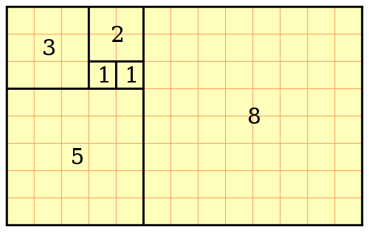

Here we can see that the new square added is the next Fibonacci number and has the same length as the length or width of the 2 previous numbers: 1+1=2, 2+1=3, 3+2=5, 3+5=8

Therefore the new rectangle length is F(n+1), n being the amount of squares. This gives 3+2= lentgh 5, 3+5=length 8, 5+8=length 13.

The Fibonacci spiral looks like a logarithmic spiral, but its mathematically spoken not one, because it has no direct formula which can be derived. Despite this it looks very much like the golden spiral. But every quarter turn a Fibonacci spiral does not get wider by φ, like the golden ratio, nevertheless the ratios of consecutive terms in the Fibonacci sequence swirls around φ, and eventually will become φ. This will determine the shape of both spirals, but the smaller the spiral gets, the less overlap there will be. Also this spiral starts at the square of 1 by 1, whereas the golden spiral gets infinite small.

The spiral itself is a series of connected quarter-circles drawn inside a rectangle of squares with Fibonacci numbers for lengths. This is illustrated below.

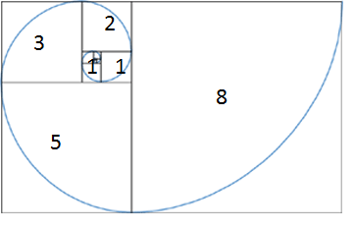

A lot of people think the Fibonacci spiral or the golden spiral corresponds with a nautulus spiral. A nautulus a shell with its chambers in the form of a spiral. This is a common mistake. In chapter 5 more information will be given.

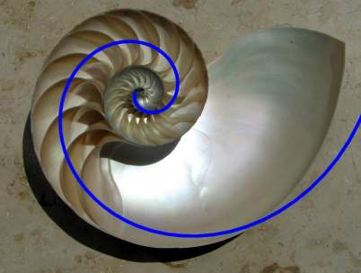

* 1. **The Triangle of Pascal**

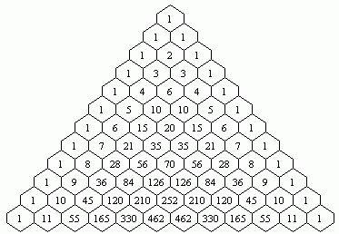In mathematical sciences, Pascal's triangle is a triangular array, which consists of the binomial coefficients. This means that from both the left and right side new numbers are added to expand the triangle. It also means that the row is only as low as its own index. It is named after the French mathematician Blaise Pascal, and this name is used in much of the Western world, although other mathematicians studied it centuries before him in Greece, India, Persia, China, and Italy.

In Pascal’s triangle, the rows categorized in an organized way starting with the first row n = 0 at the top. The entries in each row are numbered from the left beginning with k = 0. We can simply produce a way to describe this: On row 0, write only the number 1. Then, to construct the elements of following rows, add the top left number with the top right number to find the new value. In every new row a one on the right and on the left is added. If either the number to the right or left is not present, substitute a zero in its place, to remain consequently. The first number in the first row is 0 + 1 = 1, whereas the 1 and 4 in the fourth row are added to produce the number 5 in the fifth row. Therefore every new number is the sum of its direct precursors.

This triangle is used for the calculation of for example probabilities of for example flipping

coins and finding terms because every row is a 2n term (powers of 2): Row 1 is 20=1, row 2 is 21=2, row 3 is 22=4 etcetera.

It can also be used in a binominal expansion **(a+b)n** for example (a+b)3 = **1**a3 + **3**a2b + **3**ab2 + **1**b3. This example corresponds with the 4th row in the triangle.

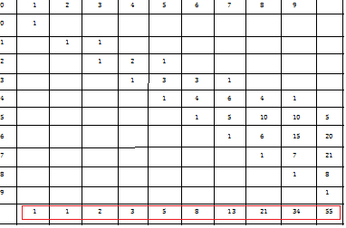Now you might think: What does this have to do with the Fibonacci numbers? Well Pascal himself did not know his triangle contained the Fibonacci numbers. If Pascals Triangle is slightly twisted to the side, the Fibonacci numbers can be written of the diagonals:

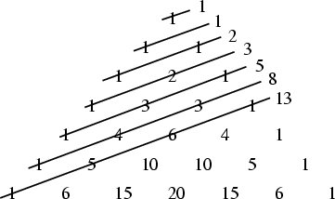

Pascals triangle can also be used to explain the rabbit problem. As this problem requires the Fibonacci numbers.

f_{n+2}\ =\ f_{n+1}+f_nHow do we find the Fibonacci numbers in the triangle of pascal? Well to answer this question we have to look at the qualities of the fibonacci numbers again:

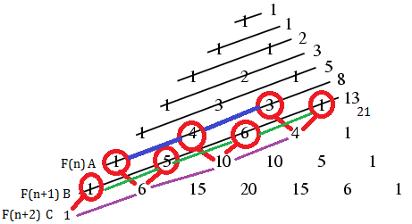

We can find this qualitiy of the Fibonacci numbers in the semi-diagonal rows (no real diagonals). Adding up row A and row B gives us row C, which proves the theorem. We can also do this proces with adding up row B and C which will give us row D. This shows us that in general Row(A)+Row(A+1)=Row(A+2)

* 1. **Lucas Numbers and Tribonacci Numbers**

The Fibonacci numbers represent a sequence of Fn=F(n-1)+Fn-2) with F0=0 and F1=1 as starting numbers. But this sequence can also have other starting numbers,. In the late 19th century Edouard Lucas, who was a French mathematician, considered two other starting numbers, which were also small, and were the next smallest after 0 and 1. These were F0=2 and F1=1. This will generate this row: 2,1,3,4,7,11,18,29,47,76,123….

As proved before with the Fibonacci sequence, these sequences can be extendet to the negative side as well: … 7,-4,3,-1,2,1,3,4,7…

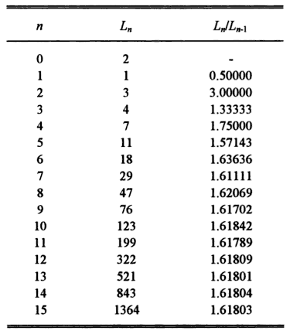

As we can see in this table, the Lucas numbers (often written as L(n)) have the same ratio as the Fibonacci sequence; they both include the golden ratio as limit. As a matter of fact, starting with any seed values A1=x and A2=y the limit An+1/An will always be φ.

The direct formula of the lucas numbers is the following:

6551ea7f2fd39df664fd3f90073dea5a

We can see that just like the fibonacci numbers, the direct formula is related to φ

The lucas numbers are closely related to the fibonacci numbers as we can see in for example these formulas : abc75842bf32b32947dfd60e6869a696 and 49b951ee97aa810da6e3762008618577

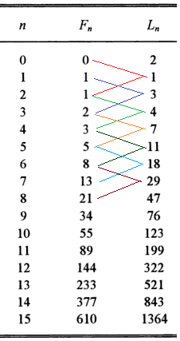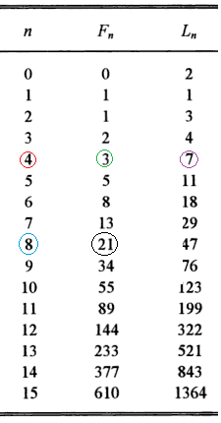 can be found by looking at the table on the left. For every n, its corresponding Lucas number has the same value as its previous and succeeding Fibonacci numbers added up. $F_{2n}=L_{n}×F_{n}$ can be found by looking at the table on the right: As n is our red number, 2n is our blue number and F2n is the black circled number. Fn will than be the green number and Ln the purple number. This can be applied for every n.

**The Tribonacci numbers**

As the formula of the Fibonacci numbers was f_{n+2}\ =\ f_{n+1}+f_n we can also make a formula which is $T_{n+3}=T_{n}+T_{n+1}+T_{n+2}$. This means that the next number of the sequence is found by adding up the three previous terms. In this we need three seed values, and logically we use the seed values T1=1, T2=1 and T3=2 Here we can find a cubic equation of $x^{3}-x^{2}-x-1=0$ we can find two imaginary answers including the imaginary number I, and we get one real root, which is: , which unexactly is about 1.839287. This numbers is like the number φ we have proved in chapter 2.a.iii, using the quadratic formula.

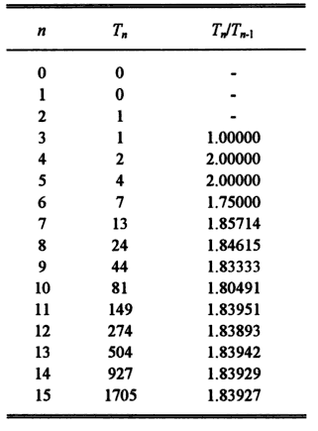As for this reason we can also conduct a tetranacci sequence (adding up the four previous terms), a pentanacci, hexanacci and heptanacci sequence, but they are not interesting enough for researchers, as they don’t have the qualities the Lucas numbers and Fibonacci numbers have.

1. **What is the relation between the Golden Ratio and the Fibonacci numbers**
   1. **Direct formula of the Fibonacci numbers**

As seen in chapter 3 the following direct formula of the Fibonacci numbers can be found:

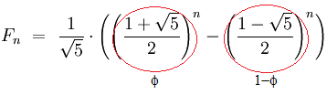 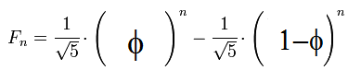



Also F_n\   is the nearest integer to  \frac{1}{\sqrt{5}}\cdot \left(\frac{1+\sqrt{5}}{2}\right)^n

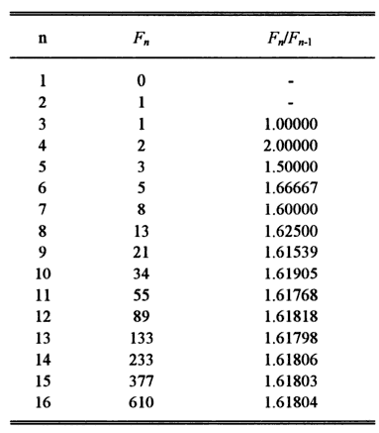which actually is: = 

* 1. **Limit**

When looking at the Fibonacci numbers, they can also be divided among each other. This gives us a ratio which eventually becomes a fixed number. In the table on the right the number gets more and more to about 1.618003, the value of φ.

We can see in the graph below that the sequence of F(n)/F(n-1) is altering around φ: Every new ratio comes closer to φ and is higher or lower than φ.

Starting from n=3, we get 1/1=1.000 2/1=2.000 3/2=1.500 5/3=1.667 8/5=1.600 etcetera.

We can see that the first value is lower than φ and the second value is higher than φ whereas the next value is lower again and the one after that higher.

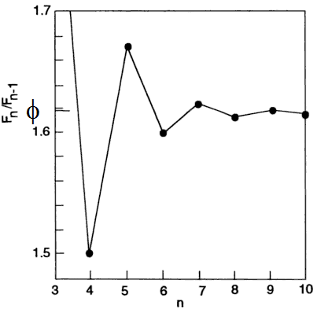This concludes into a converging sequence: The values of the ratio get to a fixed number, and this number is φ.

Now we want to find the limit of F(n)/F(n-1). To find this we can use the direct formula of the Fibonacci numbers:



If we now let our n (number) become infinite, so that we can find the limit. By deviding our F(n)/F(n-1).

Now we let our n become infinite so that:

$$\lim_{n→∞}{\frac{\frac{1}{\sqrt{5}}×{\left(\frac{1+\sqrt{5}}{2}\right)}^{n+1}-\frac{1}{\sqrt{5}}×{\left(\frac{1-\sqrt{5}}{2}\right)}^{n+1}}{\frac{1}{\sqrt{5}}×{\left(\frac{1+\sqrt{5}}{2}\right)}^{n}-\frac{1}{\sqrt{5}}×{\left(\frac{1-\sqrt{5}}{2}\right)}^{n}}}$$

Now we divide all factors by the highest power of n which is ${\left(\frac{1+\sqrt{5}}{2}\right)}^{n+1}$

$$\lim_{n→∞}{ \frac{\frac{\frac{1}{\sqrt{5}}×{\left(\frac{1+\sqrt{5}}{2}\right)}^{n+1}}{{\left(\frac{1+\sqrt{5}}{2}\right)}^{n+1}}-\frac{\frac{1}{\sqrt{5}}×{\left(\frac{1-\sqrt{5}}{2}\right)}^{n+1}}{{\left(\frac{1+\sqrt{5}}{2}\right)}^{n+1}}}{\frac{\frac{1}{\sqrt{5}}×{\left(\frac{1+\sqrt{5}}{2}\right)}^{n}}{{\left(\frac{1+\sqrt{5}}{2}\right)}^{n+1}}-\frac{\frac{1}{\sqrt{5}}×{\left(\frac{1-\sqrt{5}}{2}\right)}^{n}}{{\left(\frac{1+\sqrt{5}}{2}\right)}^{n+1}}}}$$

Now we have got to work this out and find a value. First we divide by $\sqrt{5}$:

$$\lim_{n→∞}{\frac{1-\frac{{\left(\frac{1-\sqrt{5}}{2}\right)}^{n+1}}{{\left(\frac{1+\sqrt{5}}{2}\right)}^{n+1}}}{\frac{{\left(\frac{1+\sqrt{5}}{2}\right)}^{n}}{{\left(\frac{1+\sqrt{5}}{2}\right)}^{n+1}}-\frac{{\left(\frac{1-\sqrt{5}}{2}\right)}^{n}}{{\left(\frac{1+\sqrt{5}}{2}\right)}^{n+1}}}}$$

Than we replace the numbers by $φ$:

$$\lim_{n→∞}{ \frac{1-\frac{{\left(1-φ\right)}^{n+1}}{{\left(φ\right)}^{n+1}}}{\frac{{\left(φ\right)}^{n}}{{\left(φ\right)}^{n+1}}-\frac{{\left(1-φ\right)}^{n}}{{\left(φ\right)}^{n+1}}}}$$

Now we simplify the fractions on the right:

$$\lim_{n→∞}{ \frac{1 - {\left(\frac{1-φ}{φ}\right)}^{n+1}}{\frac{{\left(φ\right)}^{n}}{{\left(φ\right)}^{n+1}}-({\frac{1-φ}{\left(φ\right)})}^{n}×\frac{1}{φ}}}$$

Now we simplify the fraction on the left bottom:

$$\lim_{n→∞}{ \frac{1 - {\left(\frac{1}{φ}-1\right)}^{n+1}}{φ^{-1}-({\frac{1}{φ}-1)}^{n}×\frac{1}{φ}}}$$

As $\left|\frac{1}{φ}-1\right|<1$, we can find our limit of : 🡪

We can also use our qualities of the golden ratio and the Fibonacci numbers to find this in a more simple way. Using: A := \frac{1+\sqrt{5}}{2}  = φ and  a := \frac{1-\sqrt{5}}{2} = Φ and we can find this:

$$\frac{F_{\left(n+1\right)}}{F_{\left(n\right)}}= \frac{\frac{1}{\sqrt{5}}\left(A^{n+1}\right)-\frac{1}{\sqrt{5}}(a^{n+1)}}{\frac{1}{\sqrt{5 }}\left(A^{n}\right)-\frac{1}{\sqrt{5}}\left(a^{n}\right)}= \frac{\left(A^{n+1}\right)-(a^{n+1)}}{\left(A^{n}\right)-\left(a^{n}\right)}= \frac{A-\frac{a^{n+1}}{A^{n}}}{1-\frac{a^{n}}{A^{n}} }→\frac{A}{1}=A$$

Therefore the limit of n🡪infinity is φ. Explanation: If really huge numbers of n are filled in, for example n=101000, the formula will be: F(101000+1)/F(101000)= φ

 ≈1.61803, which is also the limit of the Lucas numbers

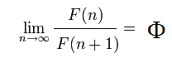The other way around can be done by exactly the same calculation and gives us:

≈0.61803



The Tribonacci numbers have a different ratio; they also get to a fixed number but not the golden ratio, which every adding sequence with two seed values gets to. It gets to 1.839286…, which we can see in the table:

c) **Continued Fraction**

Rewriting the golden ratio in the Fibonacci sequence using the information that G(n+1)=Gn+G(n-1) gives: or, when moving the numerator to the denominator it becomes:

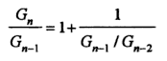 and if we fill in Gn/G(n-1) instead of G(n+1)/Gn, it gives:

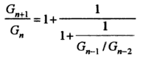

If now G(n+1)/Gn is filled in, it gets close to a continued fraction:

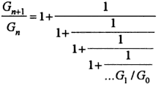

And if we do this infinite times we get the continued fraction:

But since G0=0, and we cannot divide by 0, we use G2/G1 , which will lead to 1/1 instead of G1/G0 ­­which should be 1/0, but is not possible.

1. **Where can we find the Golden Ratio and Fibonacci numbers in practice?**
   1. **Architecture**

The golden ratio is used for geometrical and mathematical purposes. We can also find the golden ratio in our lives. It is present in architecture, art, music and nature, including human beings. To start we can find it in architecture. As the golden ratio is so perfect or divine as the Romans called it, and it is omnipresent in nature, why not honor it?

Phidias, or Pheidias, who lived from about 490 B.C. to 430 B.C., is probably the first sculptor who used the golden ratio on purpose in his works. That is why we nowadays use the symbol φ, which was the first letter of his name, to indicate the golden ratio.

Phidias made a lot of sculptures in which the golden ratio was present, mostly of gods such as Athena and Zeus. This is why the Greek people thought he was the only one who knew what the gods looked like, as he uses a divine proportion. His statue of Athena Parthenos was 9 meters high and was located inside the Parthenon. He also made a huge statue of Zeus, which was about 13 meters high and is seen as one of the 7 ancient world wonders. Unfortunately, this statue was ruined.

The Egyptian pyramids in Gizeh contain the golden ratio. If we look at the cross-cut of the Great Pyramid, we can find a golden ratio. If we set the base length as 2, half the base length will be 1. The height is 1,272 times of half of the base of the triangle (1). This number is the square root of φ. The hypotenuse of the right-angled triangle we conducted is φ. Here the theorem of Pythagoras is used. This is the formula in which A2+B2=C2 in a right angled triangle. In this case, A= $\sqrt{φ}$, B=1 and C= φ. The angle of C(Phi) and B(1) in this triangle is 51,42°:

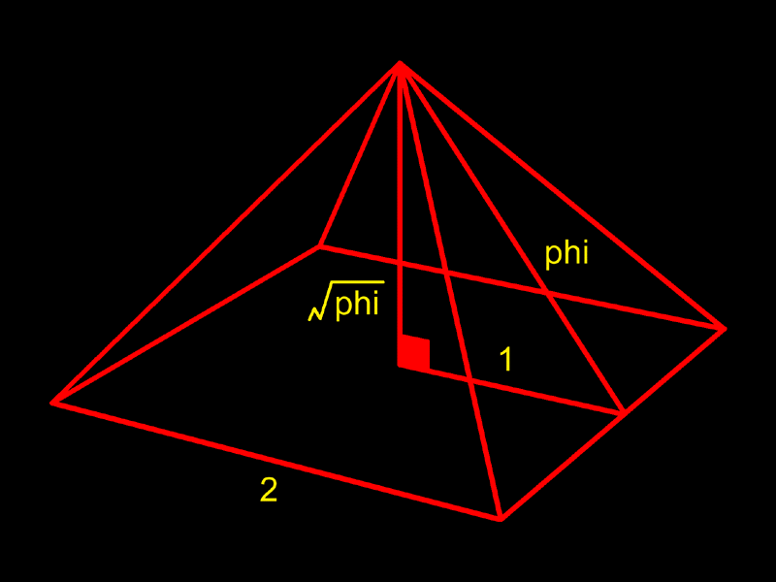

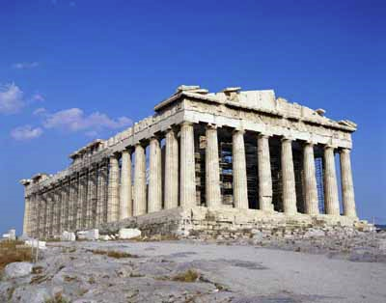

The golden ratio can also be found in the Parthenon itself. The Parthenon is a Greek temple which was made to honor the Greek goddess Athena Parthenos.

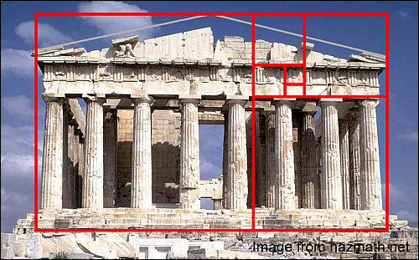It was built on the Acropolis, which is the holy Greek mount in Athens and form it the hole city of Athens can be seen. If we look carefully at this building we can find the golden ratio here in the front side: 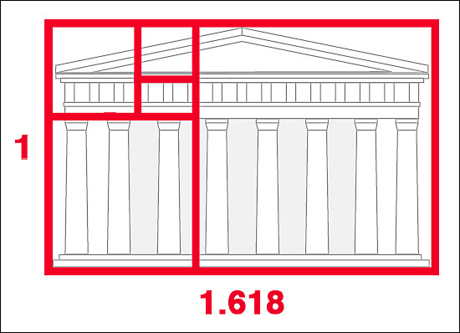

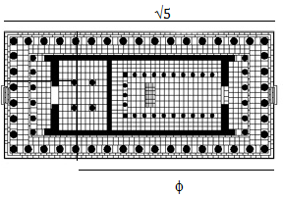In this picture a golden retcangle is produced over the Parthenon. We can now see that this building was made using the golden ratio: The timpanon, which is the triangle-shaped top, is placed in a golden rectangle again. The whole building is built in symmetry and according to recent calculations the the building hase a square-root-5-base, which is a rectangle where the longer side is $\sqrt{5}$ times the shorter side:

The elevation on the front side is build as a golden rectangle, but because of the fact that a small part of the temple is missing, these are just approximations.

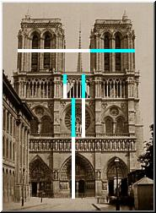As the medieval and renaissance builders cared about the rebirth of classic ideas and ideals, more buildings were made using the golden ratio. In for example the Notre Dame, the golden ratio is also present:

We can see it by means of the height, and the two towers, which together form a golden ratio, as 1 tower + the part in beteewn the towers is φ times as big as the other tower, and the whole part is φ times bigger than 1 tower + the part in between.

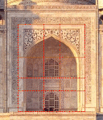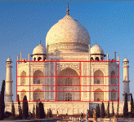In other buildings the golden ratio is also present, for example in the Taj Mahal:

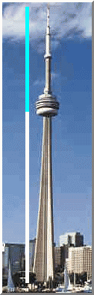

And a more modern building, The CN tower in Toronto, which was the tallest tower and freestanding structure in the world until the 2 towers in Malaysia were built. It has a total lenth of 553,33 meters and the height of the observation deck is 342 meters. 342+553,33=877.33

877.33/553.33=553.33/342≈1.61803=φ so it contains the golden ratio

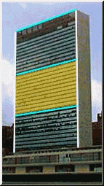As this is the divine proportion it is present in a lot of buildings. In for example the Pentagon in the U.S.A., the golden ratio is honoured by designing this building in the form of a pentagon, which has a lot of golden ratios in it.

Other modern buildings also use the golden ratio, for example the United Nations building on the left:

But also simple apartment buildings and schools; they are all built with measurements of the golden ratio.

* 1. **Nature**

We can find the golden ratio and Fibonacci numbers in nature. If we look at the golden angle, which was about 137.5° and if we look at sunflowers, we can find a certain regular pattern in the seeds.

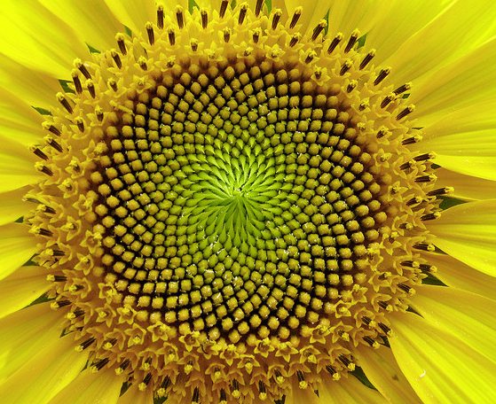

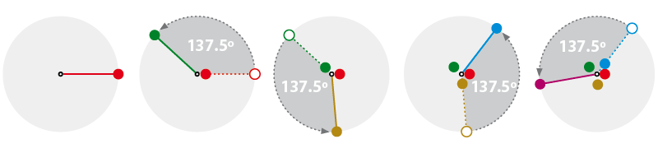If we start at one point (the red seed), and we go counterclockwise by 137.5° we get the next seed (the green one). If we add another 137.5° from the green point, seed 2, we get to seed 3 (the yellow one). Doing this again gives us the blue and later on the purple seed.

Continuing this and making all point the same colors gives us the following pattern:

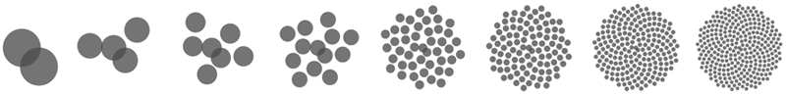

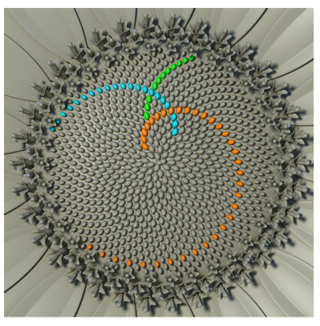If we now take a closer look at the last seed progression of the last picture, on the right we can see 3 different lengths of patterns. If we use the orange one to fill the sunflower we get 21 spirals:

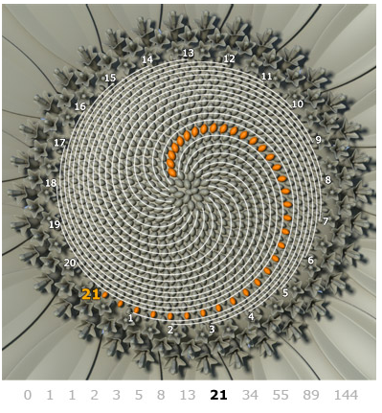

If we use the blue pattern we get 34 spirals and if we use the green spiral we get 55 spirals. We can see that the counterclockwise blue one is the opposite of the clockwise orange one and the clockwise green one:

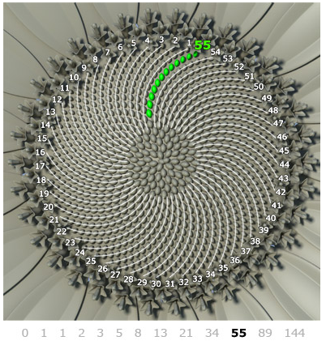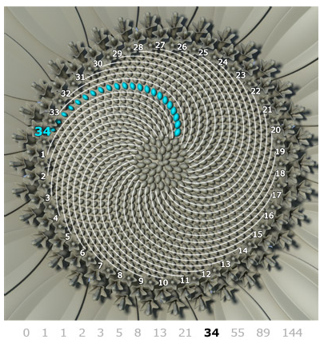The conclusion we can draw is that the seeds of the sunflowers are organized in a regular way. The golden angle (137.5°) is used for that and the Fibonacci numbers: 21, 34 and 55 are 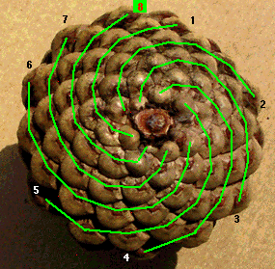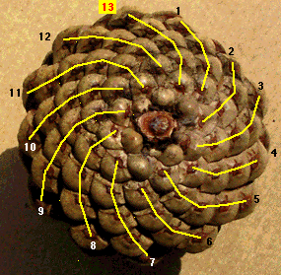succeeding Fibonacci numbers. Every new spiral number is turning the other way around. In for example the pinecone, the green spirals move clockwise whereas the yellow spirals, which are the next spirals according to the Fibonacci sequence, move counterclockwise. So in pinecones we can also find this process of seeds begin produced in 137.5°. They also have Fibonacci numbers as the total amount of spirals.

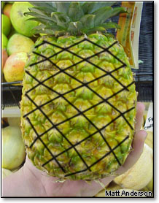These spirals in the pinecones and sunflowers are called fibonacci spirals, but don’t confuse them with the mathematical Fibonacci spirals, which was the spiral when the corners of squares inside a golden rectangle are connected. These spirals are an example of optimal natural spacing, which means to put as many seeds in limited space.

We can also find these spirals in for example pineapples, cactusneedles, razzberries, strawberries and rozes.

Also of many flowers, the average number of leafs is a Fibonacci number. For example:

3 Lilies 5 Buttercups, Roses 8 Delphinium 13 Marigolds 21 Black-eyed susans 34 Pyrethrum 55/89 Daisies.

The way this happens is because of optimal natural spacing.

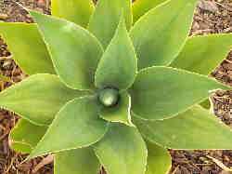

Natural spacing is a progress where the next leaf or seed is groing by the most efficient way. This is when they are created using the golden angle: Every new leaf or seed is directed to the most open space.

As we have seen on page 34, when started at leaf 1, leaf 2 gets to the largest space, and leaf 3 gets to the newly created largest space available.

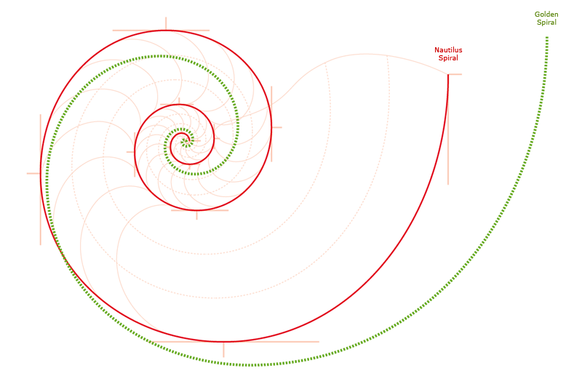In this way, almost no space is left out when completing layers, so this is a very effective way to grow and therefore is present I a lot of plants.

Then, a lot of people belief the that Fibonacci spiral or the golden spiral corresponds with a nautulus spiral. A nautulus a shell with its chambers in the form of a spiral. This is a common mistake.

The nautulus shell does contain the golden ratio, in another way however: The volume of consecutive chambers expands by the factor of the golden ratio.

* 1. **The Ideal Human Being**

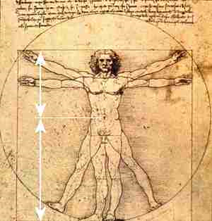The golden ratio is also present in the human body, in the ideal human body. This started with Leonardo da Vinci, who said that man is the measure of all things. As the ideal body has ideal proportions, this is when the golden ratio comes and takes a look.

At first he found out that the entire length of the body compared to the feet until the navel should be the golden ratio for the ideal man: If we take the length of feet to navel as 1, the length of top to toe is 1,618, which together form the golden ratio.

There are more ideal proportions in the human body, for example the distance between the fingertips and the elbow compared to the distance between the wrist and the elbow.

Also the length from shoulders to the top of the head compared to the whole head. Another example is the distance between the navel and the knee, to the distance between the knee and the foot.

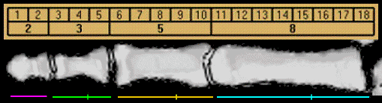Not only in those big body segments can the golden ratio be found, but also in smaller body part such as the fingers:

The parts of the finger are part of the Fibonacci numbers. The next phalanx is the added up value of the two previous ones: 3+5=8 for example. Therefore their relationship is that they are in a golden ratio.

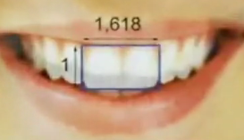

The golden ratio is also present in the ideal teeth; in for example the total width of the two upper front teeth compared to their height is a golden rectangle. The width of the first tooth from the second tooth compared to only the first tooth also contains a golden ratio:

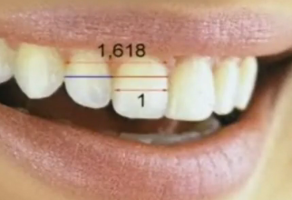In the face the golden ratio is also present, the ideal face has the measurements of a golden rectangle: The height compared to the width of the face:



And for example the width of the mouth compared to the width of the nose.

All these golden ratios in the human body represent the ideal body.

* 1. **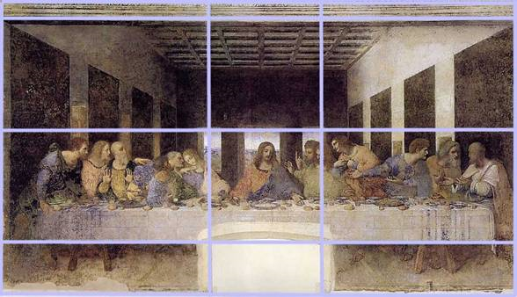Art and Music**

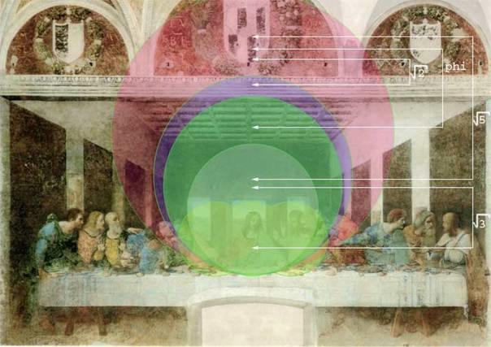As the golden ratio has been seen as a divine proportion, artists wanted to honor this by creating paintings and sculptures containing the golden ratio. They used the classical construction to create a golden rectangle (as in chapter 2.a.iv.). By this composition a lot of paintings were made by for example Leonardo da Vinci. He made the famous The Last Supper:

As Christ is there the midpoint, we can interpret that he is holding a circle. If we try to construct the circle we need to know where the top is, and the top could be in several places. If we do this, all logical tops give us irrational numbers including the golden ratio:

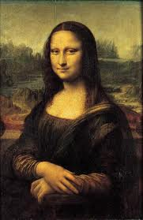This can be a coincidence, but if we do some research we can see that Da Vinci put them there on purpose. Leonardo put a lot of interest in mathematics and mysteries, and the painting in combination with the circles represent the hidden worlds Jesus is holding in is hands: The keys of the proportional world that Leonardo has always been fascinated by.

Da Vinci’s other major famous work is the Mona Lisa. In this beautiful painting a lot of mathematical elements make up a perfect painting.

In this painting, the girl Mona Lisa, has the perfect face, it contains a golden ratio and a golden rectangle. Another weird thing is that she didn’t actually had the name Mona Lisa, but she had the name Lisa Gherardini. As Mona was the word for my lady, it was used as title, and so the name Mona Lisa was born.

According to researchers, only 2 equally sized circles can be constructed in the head of Mona Lisa. The line that is constructed by connecting the two intersections is under a 32° angle from the horizon. This line also cuts the right pupil exactly in half.

Adding a perpendicular line which is extended until it gets to the bisectors of the 2 intersection points of the 2 circles, gives a kite.

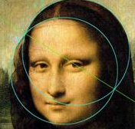These divisions on the right represent irrational numbers: C/D=√3 and G/H=φ.

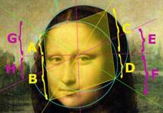Going further on we can make a new circle and if we connect this with lower of the 2 first circles we can make a Vesica Piscis. This is a geometric figure and contains the major irrational numbers. This is also a sign of duality. It contains √2, √3, √5, φ and π (the circumference of the circles). This comes back clearly in Mona Lisa’s head. This is a sign, according to researchers, that she could be an hermaphrodite, which is a person with both male and female reproductive organs.

Now we could think this is all way to far-fetched, but Leonardo Da Vinci was one of the smartest people ever and combined a lot of different fields such as art, music, architecture, science and mathematics. The proof of this is that Leonardo Da Vinci discovered this Vesica Piscis himself.

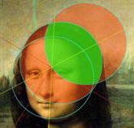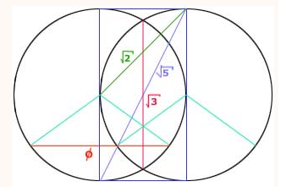

In this mathematical wonder, two circles are placed so that one overlaps the other in an ideal way. By ideal we mean with the smallest irrational numbers. From the bottom and top points of both circles a rectangle can be made. Its diagonal is exactly $5$. If we now divide this rectangle into two equal squares the diagonal of one of these squares will give us the next irrational number: √2. Connecting the two points of intersection of the two circles gives us a line of length √3. Another irrational number is π, which is the circumference of each circle. At last we can even find φ. We do this by going to the midpoint of the longer side of the rectangle and from there make a 108° angle; the length of the chord created by this angle.

Leonardo Da Vinci also made the Vitruvius.

This is the representation of the ideal human being. He put the man in a circle and constructed an ideal square with the exact same area. This is a very difficult process and will not be mentioned furthermore.

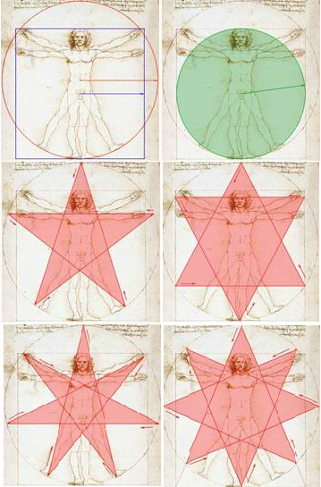Da Vinci uses the septogram to find the height of the two higher arms. The angles of the septogram in the circle are 51,42°, which is exactly the same as in the Egyptian Pyramids.

From the hexagram the middle feet were produced and from the pentagram the lower arms.

Not only Leonardo Da Vinci used the golden ratio and Fibonacci numbers in his works, Rapheal for example used it in The Crucifixion: 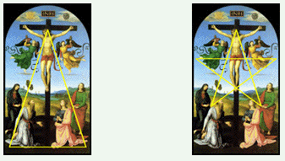

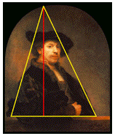The golden triangle in this painting can be used to discover the pentagram.

Also the Dutch artist Rembrent used it in his self-portret: The triangle is formed from his edges. If a line perpendicular to the base is dropped from the top of the triangle, it cuts the base into a golden ratio.

In music, the golden ratio stands for a certain harmony. If we look at the ancient Indians and Chinese, they used music for traditional ceremonies. Still, when music got evolved and got more complex, the religious text or melody was always the basis. Music was very organized: Confucius thought that music reveals character by the six different emotions: Sadness, satisfaction, happiness, anger, devotion and love. In this way, he said, was good music in harmony with the world. Using this harmony it can even restore peace in the physical world and can make sure that cheating and misleading was no longer possible.

Our original music system comes from the ancient Greeks. We can see that music was an important part in their lives. However, we have no idea how that music sounded like because music couldn’t be recorded yet and we only have a few written fragments left. The Greeks started writing music notes into a notation. Then Pythagoras, which we mostly know for has famous theorem: A2+B2=C2, discovered the basis of the nowadays called key and the relation between pitch and the length of a string.

Then Plato believed, just like Confucius, that music had an ethical component. He wanted it to be controlled, and in his book the Laws, he has even forbidden music that was inharmonic and would lead to chaos among the people.

Well Pythagoras invented the key accidentally by using anvils. When the farrier touched the anvil, certain tones were generated that were in harmony with the size of the hammer. He then discovered that mathematical ratios have influence on different vibrations, and so he was the first one to discover the relation between music and mathematics. If we produce a tone on a snare of for example 250 Herz (250 vibrations per second), a snare that is exact the length of the first snare, or the first snare that is pressed in in the middle, produces a tone of the double vibrations per second: 500 Herz.

So the difference between these tones conducts the range of the key. The key we know is called an octave, which is the Latin word for 8, and has 7 different tones we call A, B, C, D, E, F and G. They 8th note is on the next octave. Every note has a certain frequency, which is the amount of vibrations per second. After experimenting with the snares he found out that the perfect harmonic tones were an octave, a fourth and a fifth. An octave is from A to A, a fourth is from A to D and a fifth is from A to E.

And there we have our golden ratio. A perfect a vibrates in 432 Herz and a perfect E vibrates in 161,803 Herz which is the exact golden number φ, but only with a different place for the comma.

We can even see that each perfect note is a Fibonacci ratio away from its key note:

|  |  |  |  |  |  |  |  |
| --- | --- | --- | --- | --- | --- | --- | --- |
| Fibonacci Ratio | Calculated Frequency | Tempered Frequency | Note in Scale | Musical Relationship | When A=432 | Octave below | Octave above |
| 1/1 | 440 | 440.00 | A | Root | 432 | 216 | 864 |
| 2/1 | 880 | 880.00 | A | Octave | 864 | 432 | 1728 |
| 2/3 | 293.33 | 293.66 | D | Fourth | 288 | 144 | 576 |
| 2/5 | 176 | 174.62 | F | Aug Fifth | 172.8 | 86.4 | 345.6 |
| 3/2 | 660 | 659.26 | E | Fifth | 648 | 324 | 1296 |
| 3/5 | 264 | 261.63 | C | Minor Third | 259.2 | 129.6 | 518.4 |
| 3/8 | 165 | 164.82 | E | Fifth | 161,8 (Phi) | 81 | 324 |
| 5/2 | 1,100.00 | 1,108.72 | C# | Third | 1080 | 540 | 2160 |
| 5/3 | 733.33 | 740.00 | F# | Sixth | 720 | 360 | 1440 |
| 5/8 | 275 | 277.18 | C# | Third | 270 | 135 | 540 |
| 8/3 | 1,173.33 | 1,174.64 | D | Fourth | 1152 | 576 | 2304 |
| 8/5 | 704 | 698.46 | F | Aug. Fifth | 691.2 | 345.6 | 1382.4 |

(from <http://goldennumber.net/music.htm>)

1. **Conclusion**

The golden ratio and the Fibonacci numbers are special mathematical issues. They are said to be the basis of all natural things. Mathematical they could be explained and a lot of uses can be found such as the golden angle, golden spiral and Fibonacci spiral. Their complexity can be expanded infinite and hopefully enough of it has been explained in the paper. The irrationality of the golden ratio is also something that should be mentioned: It is the most perfect division and has infinite decimals. The Fibonacci numbers have infinite terms and contain a lot of special numbers and prime numbers such as 2, 3 and 5. The relation between these two major mathematical things is that the golden ratio number, φ, is the limit of divided consecutive Fibonacci numbers. To find a Fibonacci value directly using its nth term is possibly by using φ. In nature itself they are omnipresent, for example in the seeding progression of pinecones and sunflowers. To honor this divine proportion, architects immortalized it by using it to construct their buildings such as the Great Pyramid in Gizeh, the Parthenon and even the recently build CN tower. As discovered by Leonardo Da Vinci the ideal human has ideal proportions and therefore has its body parts in form of the golden ratio. I don’t know if you have noticed but the blue bar at the top of each page also represents a golden ratio: The whole width of the page is 21.1 cm (A+B), the remaining white bar is 13.04 cm (A) and the blue bar is 8.06 cm (B).

1. **Evaluation**

I have learned a lot from this work: of course a lot of mathematical uses and what they exactly are, but also the practical uses in nature. Now, when I’m walking in the park and I find a pinecone, I count the number of clockwise and counterclockwise spirals, and yes: They are Fibonacci numbers (mostly 13 and 21 or 8 and 13). Not only have I learned from the mathematical and practical progression, I have also learned how to do a large scale project, how to finish before the deadline (by making my own earlier deadlines), to obtain information and get to know everything about a subject. As I really liked this subject, I did not look at this project as obligatory, but more like a hobby, and therefore I have already put the 80 obligatory hours in it, while I still have the presentation to make and to do. And so, if I now look back at this project, I am completely satisfied. 8) **Sources**

**Books:**

Hemenway, Priya, DE GEHEIMDE CODE, Librero Kerkdriel, NL 2010

Kruijtzer, Godfried, RUIMTE EN GETAL: HET PLASTISCHE GETAL EN HET GULDEN SNEDE GETAL, Architecture & Natura Amsterdam, NL 1998

Kleijne, Wim & Konings, Ton, DE GULDEN SNEDE, Epsilon Uitgaven Utrecht, NL 2000

Dunlap, Richard A., THE GOLDEN RATIO AND FIBONACCI NUMBERS, World Scientific Danvers, USA 2008

**Webpages:**

<http://en.wikipedia.org/wiki/Golden_ratio>

<http://en.wikipedia.org/wiki/Fibonacci_number>

<http://en.wikipedia.org/wiki/Pascal%27s_triangle>

<http://en.wikipedia.org/wiki/Golden_rectangle>

<http://en.wikipedia.org/wiki/Golden_ratio>

<http://en.wikipedia.org/wiki/Logarithmic_spiral>

<http://en.wikipedia.org/wiki/Polar_equation>

<http://en.wikipedia.org/wiki/Golden_angle>

<http://en.wikipedia.org/wiki/Golden_triangle_%28mathematics%29>

<http://goldennumber.net/architecture.htm>

<http://www.jimloy.com/algebra/fibo.htm>

<http://www.sriyantraresearch.com/Article/GoldenRatio/golden%20ratio%20triangles.html>

<http://books.google.nl/books?id=Pq2AekTsF6oC&printsec=frontcover#v=onepage&q&f=false>

<http://www.soulsofdistortion.nl/dutch/SODA_chapter5.html>

<http://www.wordiq.com/definition/Tribonacci_number>

<http://www.kwiznet.com/p/takeQuiz.php?ChapterID=2377&CurriculumID=40>

<http://www.shallowsky.com/blog/science/fibonautilus.html>

<http://www.etereaestudios.com/docs_html/nbyn_htm/about_index.htm>

<http://hynesva.com/blogs/character_and_excellence/archive/2009/11/15/the-golden-ratio-a-wonder-of-god-s-creation.aspx>

<http://members.chello.nl/~jlmbar/Uitleg/spiralen.htm>

<http://www.mathsisfun.com/numbers/nature-golden-ratio-fibonacci.html>

<http://milan.milanovic.org/math/english/body/>

<http://www.youtube.com/watch?v=085KSyQVb-U>

<http://www.archeologie-nieuws.nl/onbegrensd.asp?id=8>

<http://goldennumber.net/music.htm>

<http://jwilson.coe.uga.edu/EMT668/EMAT6680.2000/Obara/Emat6690/Golden%20Ratio/golden.html>

<http://goldennumber.net/hand.htm>

<http://library.thinkquest.org/27890/theSeries6.html>

<http://www.valdostamuseum.org/hamsmith/Gpyr.html>

9) **Log**

|  |  |  |
| --- | --- | --- |
| **Date** | **Activity** | **Time** |
| **07 09 2010** | Preparation | 2 h |
| **09 09 2010** | Preparation | 2 h |
| **10 09 2010** | Preparation | 2 h |
| **11 09 2010** | Research Plan + Preparation | 3 h |
| **12 09 2010** | Research Plan + Time Plan | 1 h |
| **14 09 2010** | Evaluation Research plan with teacher | 20 min |
| **15 09 2010** | The Golden Ratio | 3 h |
| **03 10 2010** | Chapters 2a+2b | 2 h |
| **10 10 2010** | Chapters 2a+2b | 2 h |
| **17 10 2010** | Chapters 2a+2b | 2 h |
| **24 10 2010** | Chapters 3a+3b | 3 h |
| **07 11 2010** | Chapters 3a+3b | 3 h |
| **14 11 2010** | Chapters 3a+3b | 2 h |
| **21 11 2010** | Chapters 3a+3b+4 | 2 h |
| **28 11 2010** | Chapter 4 | 3 h |
| **04 12 2010** | Chapter 4 | 3 h |
| **05 12 2010** | Chapter 4 | 3 h |
| **06 12 2010** | Evaluation with teacher | 20 min |
| **08 12 2010** | Chapter 1-4 | 3 h |

|  |  |  |
| --- | --- | --- |
| **Date** | **Activity** | **Time** |
| **09 12 2010** | Chapter 1-4 | 2 h |
| **13 12 2010** | Evaluation with teacher + Chapter 1-4 | 20 min + 1h and 40 min |
| **15 12 2010** | Chapter 1-4 | 2 h |
| **16 12 2010** | Chapter 1-4 | 1 h |
| **19 12 2010** | Chapter 1-4 | 2h and 30 min |
| **20 12 2010** | Evaluation with teacher | 20 min |
| **28 12 2010** | Chapter 5 | 4 h |
| **29 12 2010** | Chapter 5 | 4 h |
| **31 12 2010** | Chapter 5 | 3,5 h |
| **01 01 2011** | Chapter 5 | 3 h |
| **02 01 2011** | Chapter 1-9 | 3 h |
| **03 01 2011** | Lay-out | 3 h |
| **06 01 2011** | Lay-out | 3 h |
| **07 01 2011** | Lay-out | 1h |
| **09 01 2011** | Grammar-check | 4h |
| **18 01 2011** | Evaluation with teacher | 20 min |
| **20 01 2011** | Improvements | 1h |
| **21 01 2011** | Improvements | 2h |
| **22 01 2011** | Improvements | 1h and 40 min |
|  | Total: | 85 hours |