**Isaac Newton**

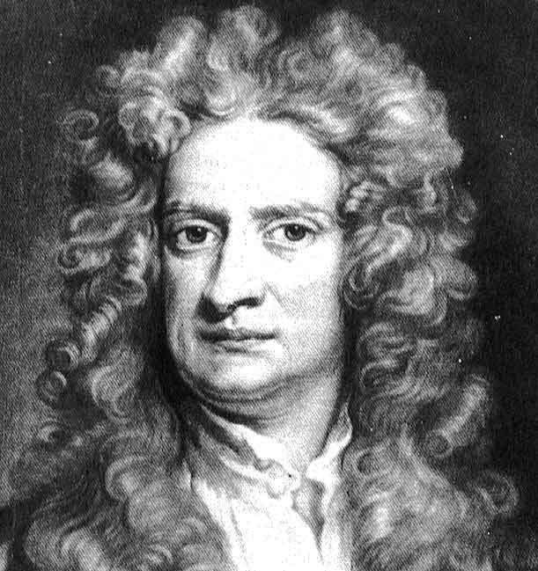

In this short paper I will tell you something about Isaac Newton. First I will give a short description about his life. Furthermore, I will tell you something about his discoveries and his main idea. Finely I conclude with his achievements.

Isaac newton was born in Woolsthorpe in England on the 25th of december in 1642. He grew up with his uncle because his mother left him and his father died before he was born. He went to a local grammar school. For a long time he was expected to manage his mother’s property when he would grow up. But he wanted to do something different, that interested him. In 1661, after he left the grammar school he went to Trinity College, at the university of Cambridge. And he got his bachelor of arts certificate in 1665.

While England fought with Holland, in 1666, Isaac Newton made three of his biggest discoveries. He proved that his theory that white light is a mixture of all the colors, which when split apart by a prism, form a band of color which is called a spectrum, is true. He also developed a binomial theorem, which is a quick way of expanding a binomial expression that is very large. He also worked out a way for calculating the steepness of a curve at a particular point. But his most important discovery was the invention of gravity. The reason why in space the planets, moons and comets stay in their place, and that objects are attracted to the earth, this theory, however, it wasn't published till 20 years later.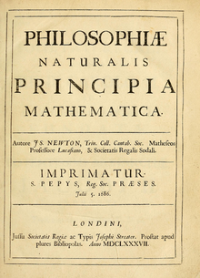

In 1669, Isaac Newton became a mathematics professor at Trinity College. In January 1672, Newton was voted in to the Royal Society, which is a organization with scientists.

After that, he showed them a paper with his discoveries on itBecause of this, he and Robert Hooke became competitive together. This rivalry would continue in the 1670's, when Newton continued to work out the mathematics of gravity, when Newton finally published his work, Hooke felt like it had been stolen from him. However, Newton's work was written in a three-volume book, were all his inventions were in. It was called the Philosophiae Naturalis Principia Mathematica, which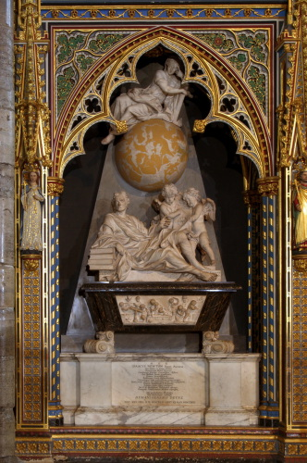 is Mathematical Principles of Natural Philosophy in English. Althought the theory had many negative comments at first, the scientists would eventually embrace this theory, and these theories dominated physics until the 20th century.

Principia made Newton an English celebrity. He was elected to the Parliament in 1691, and after surviving a nervous breakdown in 1693, he was elected warden of the mint in 1696, and three years later the master of the mint. He was elected to be president of the Royal Society in 1703, after the death of Robert Hooke, and he was knighted in 1705. As he became more famous, he worked to upgrade his own reputation, bringing the scientific society under his control and carrying on a fight with the German Leibniz over the issue of who had invented calculus first. Newton was never married, and he dedicated his later years to explain the meaning of scripture, and he put a mighty effort to understand the relationship between biblical prophecy and history. He died on the 20th March, 1727, and was buried in Westminster Abbey.