

Contents:
(short)introduction ……………………………………………….. 2
Summary ……………………………………………….. 3
Wordlist ……………………………………………….. 4
Drawing ……………………………………………….. 5

---------------------------------------------------------------------------------

Introduction:
This is my bookreport about the novel David Copperfield by
Charles Dickens. The book is the shortened version of the story
David Copperfield. I did not appreciate the book because it was
a shortened version and the writer put to much information
in this short version. That made it quite difficult to understand
the storyline. I reread it a couple of times just to get the punch
line. If I had to read the book again I would probably choose the
full version.

Summary:
The book starts of with David and his mother. His father died
before he was born. The story takes place In the victorian era.
They lived together in a big mansion. After a few years Davids
mother got in a relationship with Mr Murdstone. Davids mother
sent him on a vacation to the coast. When David came back his
mother and Mr Murdstone were secretly married. After the
marriage the relation between David and Mr Murdstone took
a turn for the worse. It resulted in that David was sent away to
boarding school in London.
---------------------------------------------------------------------------------
He did not enjoy his stay in London because he was
severely punished by his teacher. In the beginning he also got
bullied by the kids at boarding school. After a while things got
better and David even got a friend at school named Steeforth.
Unfortunately at that time his mother passed away, so he had to
go home. Mr Murdstone told him that he was not allowed to
go back to boarding school and that David needed to get a job.
---------------------------------------------------------------------------------
David got a job in a restaurant and he hated it. His job did not
last very long because his boss was sent away to prison. Because
he did not have any money and no place to live, he went to his
aunt and asked for help. His aunt gave him a place to live.
---------------------------------------------------------------------------------
After a few years David went to law school. During his study
he stayed at Mr Wickfield and his daughter Agnes. After his
studies he moved to London where he met Dora. They fell in
love and got married, but after a few years Dora passed away.
He was very sad about Dora passing away, so he decided to go
back to Mr Wickfield. He reconnects with Agnes and they fall in
love and they get married. This is where the story ends.

---------------------------------------------------------------------------------

Wordlist:
sentence | Dutch translation
They were traveling by carriage. | koets
They got in the coach together. | koets
He was deceived by a thief. | misleiden
I think Agnes is very humble. | bescheiden
I got a shilling from Mr Murdstone. | britse stuiver
Managing a restaurant is very hard. | onderhouden
He has a huge scar across his face | Litteken
He jumped across a small ditch. | greppel
That man owes me money. | Tegoed hebben
The clerk was not friendly. | klerk
He could not afford his servant. | bediende
He grabed the rope tightly. | Touw
He was not a real gentleman. | Heer
Mr Mell was cruel to the kids. | Wreed
The lady ha a lot of complaints. | Klachten
The man had a really old donkey. | Ezel
sentence | Dutch translation
The lawyer could not do much about it. | Advocaat
He rubbed his hands together. | Wreef
Is he in trouble again? | problemen
They were having a conversation . | Conversatie

---------------------------------------------------------------------------------

Drawing:

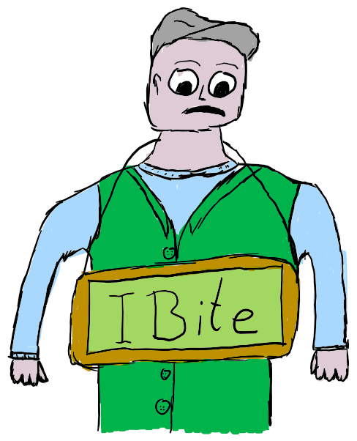
I have drawn David on his first day of boardingschool. He had
to wear a sign that sayed “I bite”. He had to do that because
he bit Mr Murdstone in a fight. Mr Murdstone told the
teacher that David needed to get punished extra hard.
I chose this scene because it has made a great impression
on me. I think it may well be the best scene in
the book. I think it is utterly rediculous that sombody
gets a double punishment for something that
happend at home, especially in front of a
classroom. A young boy should never be punished
like that. I think it is a form of child abuse. I don’t

get the fact that somebody would do this to a child.

