**Harry Potter: Mythical creatures**

 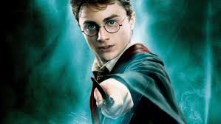  
                           
**Made by: Dante Chiappino 5H1**

**Index**

**Cover sheet:** page 1  
 **Index:** page 2

**Introduction:** page 3

**Background Jk Rowling and Harry Potter:** page 4 and 5  
 **Research method:** page 6

**Subquestions:** Which characters/creatures are based on mythological creatures? pages 7-16  
 Which storylines are similar to myths? 17-25

**Conclusion:** page 26

**Introduction**

My profile assignment is about: Harry Potter: Mythical creatures.

Because Harry Potter has a great book series and we love to do our profile assignment about it. And the creatures are amazing aswell.  
 It wasn´t easy to find a subject to do our profile assignment about but we found it eventually and Harry Potter is a fun subject to do our profile assignment about.

We are curious on where Jk Rowling got her inspiration for the creatures in Harry Potter, from the mythology or the bible or neither of them?

So my main question is: **How much did Jk Rowling borrow from mythology?**

And my subquestions are:   
 1) Which characters/creatures are based on mythological creatures?  
 2) Which storylines are similar to myths?

**Background Jk Rowling and Harry   
   
 Potter**

Joanne Rowling (brought into the world July 31st, 1965), who passes by the nom de plume J.K. Rowling, is an English writer and screenwriter best known for her seven-book Harry Potter kids&apos; book arrangement. On December 26th, 2001, J.K. Rowling wedded anesthetist Dr. Neil Murray at the couple&apos;s home in Scotland. They have two kids together, David (conceived in 2003) and Mackenzie (conceived in 2005). Rowling has one youngster, Jessica (brought into the world 1993), from her past marriage.

J.K. Rowling was living in Edinburgh, Scotland, and attempting to get by as a single parent before her first book, Harry Potter and the Alchemist&apos;s Stone, was distributed. The kids&apos; dream novel turned into a universal hit and Rowling turned into a global abstract sensation in 1999 when the initial three portions of Harry Potter assumed control super three openings of The New York Times blockbuster list in the wake of making comparative progress in her local Joined Kingdom.

The arrangement has sold in excess of 450 million duplicates and was adjusted into a blockbuster film establishment. Rowling distributed the novel The Easygoing Opportunity in 2012, trailed by the wrongdoing novel Cuckoo Calling under the nom de plume Robert Galbraith in 2013. In 2016, she discharged a play, Harry Potter and the Reviled Youngster, and a motion picture, Fabulous Brutes and Where to Discover Them.

As indicated by The Sunday Times 2017 Rich Rundown, J.K. Rowling&apos;s total assets is £650 million (about $850 million) — making her wealthier than even Ruler Elizabeth II. Forbes put her riches at $650 million of every 2017, in extensive part because of the 450 million duplicates of Harry Potter sold to-date and the ensuing motion picture establishment that has netted $7.7 billion. (Her value would&apos;ve been more in Forbes on the off chance that it were not for the $150 million she has given to different philanthropies.) In the primary portion of 2017, Rowling brought home an expected $95 million gratitude to her new play, Harry Potter and the Reviled Youngster, and motion picture, Phenomenal Brutes and Where to Discover Them.

Harry Potter is a progression of imagination books composed by English writer J.K. Rowling The books annal the lives of a youthful wizard Harry Potter, and his companions Hermoine Granger and Ron Weasley, every one of whom are understudies at Hogwarts School of Black magic and Wizardry. The primary story circular segment concerns Harry&apos;s battle against Master Voldemort, a dim wizard who expects to end up interminable, topple the wizard overseeing body known as the Service of Enchantment, and oppress all wizards and Muggles (non-otherworldly individuals).

Since the arrival of the main novel, Harry Potter and the Savant&apos;s Stone, on 26th June 1997, the books have discovered enormous ubiquity, basic praise, and business achievement around the world. They have pulled in a wide grown-up gathering of people just as more youthful perusers, and are frequently viewed as foundations of present day youthful grown-up writing. The arrangement has additionally had a lot of analysis, including worry about the undeniably dull tone as the arrangement advanced, just as the regularly abhorrent and realistic savagery it portrays. As of February 2018, the books have sold in excess of 500 million duplicates around the world, making them the smash hit book arrangement ever, and have been converted into eighty dialects. The last four books continuously set records as the quickest moving books ever, with the last portion moving about eleven million duplicates in the Unified States inside twenty-four hours of its discharge.

The arrangement was initially distributed in Ensh by two noteworthy distributers, Bloomsbury in the Assembled Kingdom and Educational Press in the Unified States. A play, Harry Potter and the Reviled Kid, in view of a story co-composed by Rowling, debuted in London on 30 July 2016 at the Castle Theater, and its content was distributed by Nearly nothing, Dark colored. The first seven books were adjusted into an eight-section film arrangement by Warner Brothers. Pictures, which is the third most noteworthy netting film arrangement ever as of February 2018. In 2016, the all out estimation of the Harry Potter establishment was evaluated at $25 billion, making Harry Potter one of the most noteworthy earning media establishments ever.

A progression of numerous classes, including dream, dramatization, transitioning, and the English school story (which incorporates components of puzzle, spine chiller, experience, frightfulness, and sentiment), the universe of Harry Potter investigates various subjects and incorporates numerous social implications and references. As per Rowling, the fundamental subject is passing. Other real subjects in the arrangement incorporate preference, debasement, and franticness.

The achievement of the books and movies has permitted the Harry Potter establishment to grow, with various subordinate works, a voyaging display that debuted in Chicago in 2009, a studio visit in London that opened in 2012, a computerized stage on which J.K. Rowling refreshes the arrangement with new data and knowledge, and a pentalogy of turn off movies debuting in November 2016 with Phenomenal Brutes and Where to Discover Them, among numerous different improvements.

**Research method**To find out the answers on my subquestions I will take a couple creatures from the Harry Potter books and describe them and search on the Internet if they are indeed based on mythology.

**Which characters/creatures are based**

**on mythology creatures?**

**Ghoul:** A Ghoul is a terrible animal that looks like a disgusting, buck-toothed beast. They will in general live in the storage rooms or outbuildings of wizards and witches. They are moderately innocuous animals and are simply observed as aggravations due to the commotion they make. They are generally stupid, and live off of bugs and other family unit bothers. At most, they will moan and toss objects.

A Fiend Team exists at the Service of Enchantment, under the Office for the Guideline and Control of Supernatural Animals. The Team is utilized to expel undesirable fiends from houses that have gone in to Muggle possession. There is an assortment of fiend, called the Chameleon Devil.

The upper room in the Weasley family&apos;s home, The Tunnel, is additionally home to a devil who incidentally hits against the funnels, when it feels the house is excessively peaceful. In 1997, Ron&apos;s family transfigured their Fiend to look progressively like Ron. The thought was to make the fiend look like Ron to supplant him when he, Harry and Hermione set off to discover the Horcruxes on the off chance that any Service laborers were suspicious of Ron not going to class. The Demon had an infectious look to him so when the Service laborers went to The Tunnel to check, the family said that he had a very infectious ailment called Spattergroit.

There was a "lethal old fiend" in a can in 12 Grimmauld Spot, which was experienced by Ron, Harry, Hermione, and Tonks when they were cleaning the house in 1995.

Demons are educated about at Hogwarts School of Black magic and Wizardry in Fiend Studies classes. The subject is instructed in a classroom off the Serpentine Passageway. In the 1988– 1989 school year, fiends were educated in a fifth year Guard Against the Dim Expressions class by Patricia Rakepick  
   
 **If you compare this creature to the Arabic mythology.** The ghūl is said to stay in burial grounds and other uninhabited spots. A male devil is alluded to as ghūl while the female is called ghulah. A source distinguished the Arabic fiend as a female animal who is here and there called Mother Demon (umm ghūla) or a social term, for example, Auntie Ghoul. She is depicted in numerous stories tricking hapless characters, who are typically men, into her home where she can eat them.

Some express that a devil is a desert-abiding, shapeshifting evil spirit that can expect the pretense of a creature, particularly a hyena. It baits unwary individuals into the desert squanders or relinquished spots to kill and eat up them. The animal additionally preys on youthful kids, drinks blood, takes coins, and eats the dead, then appearing as the individual most as of late eaten. One of the accounts distinguished a fiend named Ghul-I-Beaban, an especially massive character accepted to possess the wild of Afghanistan and Iran.

It was not until Antoine Galland deciphered One Thousand and One Evenings into French that the western thought of fiend was brought into European culture.  
 **Dragon:** Dragons are monster winged, fire-breathing reptilian Animals. Broadly viewed as frightening yet spectacular, they can be discovered everywhere throughout the world and are much of the time alluded to in Asian and medieval European old stories.

Ready to fly and inhale fire through their noses and mouths, they are a standout amongst the most perilous and hardest to disguise animals in the wizarding scene. The Service of Enchantment groups them as XXXXX, known wizard executioners that are difficult to prepare or tame. In spite of how hazardous they are, there are individuals who are prepared to work with them, called mythical beast managers, or dragonologists. A wizard who exchanges and moves winged serpent eggs (which is an illicit action) is alluded to as a mythical beast merchant.

**If you compare this creature to different mythology.** A Dragon is a vast, snake like amazing animal that shows up in the fables of numerous societies around the globe. Convictions about mythical serpents shift definitely by locale, however monsters in western societies since the High Medieval times have regularly been delineated as winged, horned, four-legged, and fit for breathing flame. Monsters in eastern societies are generally portrayed as wingless, four-legged, serpentine animals with better than expected insight.

The most punctual bore witness to mythical beasts take after monster snakes. Mythical beast like animals are first portrayed in the legends of the antiquated Close East and show up in old Mesopotamian craftsmanship and writing. Tales about tempest divine beings killing mammoth snakes happen all through almost all Indo-European and Close Eastern folklores. Well known prototypical mythical beasts incorporate the mušḫuššu of antiquated Mesopotamia, Apep in Egyptian folklore, Vṛtra in the Rigveda, the Leviathan in the Jewish Book of scriptures, Python, Ladon, Wyvern, and the Lernaean Hydra in Greek folklore, Jörmungandr, Níðhöggr, and Fafnir in Norse folklore, and the winged serpent from Beowulf.

The prominent western picture of a monster as winged, four-legged, and equipped for breathing flame is a creation of the High Medieval times dependent on a conflation of prior mythical beasts from various customs. In western societies, winged serpents are depicted as beasts to be restrained or survive, more often than not by holy people or culture saints, as in the well known legend of Holy person George and the Monster. They are frequently said to have covetous cravings and to live in caverns, where they crowd treasure. These winged serpents show up much of the time in western dream writing, including The Hobbit by J. R. R. Tolkien, the Harry Potter arrangement by J. K. Rowling, and A Tune of Ice and Flame by George R. R. Martin.

"Dragon" has additionally come to be connected to the Chinese lung, which are related with favorable luck and are thought to have control over downpour. Mythical serpents and their relationship with downpour are the wellspring of the Chinese traditions of monster moving and winged serpent vessel dashing. Numerous East Asian divinities and mythical beings have monsters as their own mounts or sidekicks.  
   
   
   
   
 **Gnome:** A Gnome, or greenhouse little person, is an enchanted animal ordinarily known to invade the greenery enclosures of wizarding family units. The right taxonomical name for elves is, purportedly, Gernumbli gardensi, or now and then alluded to as Gernumblies. They are found all through Europe and North America. A dwarf in the Muggle world is a lifeless statue that resembles a little Dad Christmas.  
   
 **If you compare this creature to Latin mythology.** The word originates from Renaissance Latin gnomus, which initially shows up in the Ex Libro de Nymphis, Sylvanis, Pygmaeis, Salamandris et Gigantibus, and so on by Paracelsus, distributed after death in Nysa in 1566 (and again in the Johannes Huser release of 1589– 1591 from a signature by Paracelsus). The term might be a unique development of Paracelsus, perhaps getting the term from Latin gēnomos. For this situation, the oversight of the ē is, as the Oxford English Word reference (OED) calls it, a botch. Paracelsus utilizes Gnomi as an equivalent word of Pygmæi and orders them as earth elementals. He depicts them as two traverses high, hesitant to communicate with people, and ready to travel through strong earth as effectively as people travel through air. The chthonic, or earth-abiding, soul has points of reference in various old and medieval legends, frequently guarding mines and valuable underground fortunes, strikingly in the Germanic smaller people and the Greek Chalybes, Telchines or Dactyls.  
   
 **Chimaera:** A Chimaera is a sort of half breed creature and a fierce enchanted animal that started from Greece. As a result of their savagery, Delusions are named XXXXX (perilous), and their eggs are delegated Class A Non-Tradeable Materials. There is just a single record of a wizard executing a Fabrication yet the wizard kicked the bucket after that from weariness.  
   
 **If you compare this to Greek mythology.** The Chimaera, as per essayists, was a flame breathing half and half animal of Lycia in Asia Minor, made out of the pieces of more than one creature. It is generally portrayed as a lion, with the leader of a goat emerging from its back, and a tail that may finish with a snake&apos;s head, and was one of the posterity of Typhon and Echidna and a kin of such beasts as Cerberus and the Lernaean Hydra.

The expression "figment" has come to portray any legendary or anecdotal creature with parts taken from different creatures, or to depict anything made out of exceptionally divergent parts, or saw as fiercely inventive, improbable, or astonishing.

Seeing a Figment was a sign for calamity.  
   
   
   
   
   
 **Hinkypunk:** The Hinkypunk is a creature with one leg that looks like blue, grey or white smoke. It likes to distract travelers from their path at night. They are like Imps that trick magical people and non-magical people.  
   
 **If you compare this to mythology.** A Hinkypunk, (will-o&apos;- wisp or ignis fatuus) (articulated [ˈfa.tu.us]; Medieval Latin for "trick&apos;s flame") is a climatic phantom light observed by voyagers during the evening, particularly over lowlands, bogs or swamps. The wonder is known in English people conviction, English mythology and quite a bit of European old stories by an assortment of names, including jack-o&apos;- light, monk&apos;s lamp, hinkypunk and diversion light, and is said to misdirect explorers by looking like a flashing light or lantern. In writing, will-o&apos;- the-wisp once in a while have an allegorical importance, for example portraying an expectation or objective that drives one on however is difficult to reach, or something one finds vile and confounding.

Will-o&apos;- the-wisp show up in people stories and conventional legends of various nations and societies; prominent will-o&apos;- the-wisp incorporate St. Louis Light in Saskatchewan, Marfa lights of Texas, the Naga fireballs on the Mekong in Thailand, and the Hessdalen light in Norway. While urban legends, folkore, and superstition commonly characteristic will-o&apos;- the-wisps to phantoms, pixies, or essential spirits, present day science frequently clarifies them as normal wonders, for example, bioluminescence or chemiluminescence, brought about by the oxidation of phosphine (PH3), diphosphane (P2H4), and methane (CH4) delivered by natural rot.

**Fawkes:** Fawkes is a highly intelligent and Albus Dumbledore his pet, animal companion and defender. We don´t know how long Fawkes has been in Albus Dumbledore his service. He has been loyal to Dumbledore for many years now, prior to the Headmaster´s death. Fawkes was very important in helping Harry Potter defeat Salazar Slytherin´s basilisk. Fawkes&apos; tears, that contain recuperating properties, spared Harry&apos;s life after his arm was punctured by the basilisk&apos;s tooth. Fawkes went to Dumbledore&apos;s guide in fightning Master Voldemort amid the Clash of the Bureau of Secrets. After Dumbledore&apos;s demise, Fawkes sang his Mourn over the grounds of Hogwarts School of Black magic and Wizardry and afterward left, gone forever.

Fawkes&apos; tail quills were the centers of two twin wands which were held by Master Voldemort and Harry Potter.

**If you compare this creature to Greek Mythology.** A phoenix is an extensive flying creature that consistently recovers or is generally conceived once more.

Related with the Sun, a phoenix acquires new life by emerging from the slag of its ancestor. As per a few sources, the phoenix passes on in a show of flares and ignition, in spite of the fact that there are different sources that guarantee that the incredible winged animal kicks the bucket and essentially decays before being conceived again. There are distinctive conventions concerning the life expectancy of the phoenix, however by most records the phoenix lived for a long time before rebirth. Herodotus, Lucan, Pliny the Senior, Pope Forgiving I, Lactantius, Ovid, and Isidore of Seville are among the individuals who have added to the retelling and transmission of the phoenix theme.

In antiquated Greece and Rome, the phoenix was related with Phoenicia, (present day Lebanon), a human advancement well known for its creation of purple color from conch shells.

In the authentic record, the phoenix "could symbolize restoration by and large just as the sun, time, the Domain, metempsychosis, sanctification, revival, life in the radiant Heaven, Christ, Mary, virginity, the extraordinary man, and certain parts of Christian life"

 **Griffin:** The Griffin started in Greece. It has the front legs, the tail of a lion, wings and head of a giant eagle, and the body, and hind legs. The Griffin eats a lot of raw meat, that is his main diet. Grffins are knows as angry creatures, however despite this, experienced Wizards have been able to befriend them. Wizards often use Griffins as guards of treasure, like Sphinxes.  
   
 **If you compare this creature to Greek mythology.** The griffin, griffon, or gryphon (Greek: γρύφων, grýphōn, or γρύπων, grýpōn, early structure γρύψ, grýps; Latin: gryphus) is an incredible animal with the body, tail, and back legs of a lion; the head and wings of a bird; and some of the time a falcon&apos;s claws as its front feet. Since the lion was customarily viewed as the lord of the monsters and the hawk the ruler of flying creatures by the Medieval times the griffin was believed to be a particularly amazing and lofty animal. Since established artifact, Griffins were known for guarding treasure and extremely valuable possessions.

In Greek and Roman writings, griffins and Arimaspians were related with gold stores of Focal Asia. Without a doubt, as Pliny the Senior expressed, "griffins were said to lay eggs in tunnels on the ground and these homes contained gold nuggets.

In medieval heraldry, the Griffin turned into a Christian image of celestial power and a watchman of the divine.  
   
 **The Basilisk:** The Basilisk is a huge serpent, they are also called the King of Serpents. The Dark Wizards invented this creature. Herpo the Foul was the first one to create a Basilisk. He hatched a chicken egg beneath a toad, which resulted in the creature known as a Basilisk. Creating a Basilisk was banned in Medieval a long time ago. The way to hide that you are creating a Basilisk is really simple, you just remove the egg from the toad. The Department for Regulation and Control of Magical Creatures came to check very often but they didn´t find anything because of the simple hide trick. If you look a Basilisk directly in the eyes, you will die. However if you indirectly make contact with a Basilisk it will only petrify you. It is also the mortal enemy of spiders because spiders can intuitively sense them and flee away whenever they do. The Basilisk is classed as an XXXXX creature by the Ministry of Magic Classification because of it´s immense powers.  
   
 **If you compare this creature to Greek mythology.** In European bestiaries and legends, a basilisk (/ˈbæsɪlɪsk/or/ˈbæzɪlɪsk/, from the Greek βασιλίσκος basilískos, "small ruler"; Latin regulus) is an amazing reptile rumored to be a snake lord, which was half and half from a chicken and a snake, who can cause passing with a solitary look. As indicated by the Naturalis Historia of Pliny the Senior, the basilisk of Cyrene is a little snake, "being A goliath creature", that is so venomous, it leaves a wide trail of dangerous venom afterward, and its look is similarly deadly. Its shortcoming is the smell of the weasel, which, as per Pliny, was tossed into the basilisk&apos;s opening, unmistakable in light of the fact that a portion of the encompassing bushes and grass had been burned by its essence. It is conceivable that the legend of the basilisk and its relationship with the weasel in Europe was motivated by records of specific types of Asiatic snakes, (for example, the lord cobra) and their normal predator, the mongoose.   
   
 **Kappa:** The Kappa is a water demon from Japan that likes to feed on blood from humans. They are known for suffocating humans that invade their shallow ponds.  
 You can protect yourself from a Kappa by throwing a cucumber with a persons name in it. If it works the water in the Kappa will spill out and that will weaken the Kappa.  
 The Kappa lives in shallow waters mainly in Japan. The Kappa looks like a scale-covered monkey with webbed hands and a water-filled depression atop its head.  
   
 **If you compare this creature to Japanese mythology.** A kappa (河童 , stream youngster), otherwise called kawatarō (川太郎 , "waterway kid"), komahiki (駒引 , horse-puller), kawatora (川虎 , stream tiger) or suiko (水虎 , water-tiger) is a land and/or water capable yōkai evil presence or devil found in customary Japanese mythology. They are ordinarily portrayed as green, human-like creatures with webbed hands and feet and a turtle-like carapace on their backs. A melancholy on its head, called its "dish" (sara), holds water, and if this is harmed or its fluid is spilled, the kappa is seriously debilitated.

The kappa are known to support cucumbers and love to take part in sumo wrestling. They are frequently blamed for striking people in water and evacuating a legendary organ called the shirikodama from their unfortunate casualty&apos;s butt.   
   
 **Imp:** The Imp is a magical creature that can only be found in Britain and Ireland.  
 Imps are sort of the same height as a Pixie between six and eight inches, but that is where the physical similarities end. An Imp can’t fly and he doesn’t has bright colours like the Pixie does. An Imps eats a lot of insects, that is his main diet. They also like to throw stuff at anybody that wishes to harm them at that moment, they get a sence of delight from it. Imp breed there eggs like a Pixie but their young hatch is fully formed. An Imp is not dangerous but be dispatched rather easily by anyone.  
   
 **If you compare this creature to German mythology.** An Imp is a fanciful being like a pixie or evil spirit, much of the time depicted in old stories and superstition. The word may maybe get from the term ympe, used to mean a youthful united tree.

Imps are frequently portrayed as insidious more than genuinely undermining, and as lesser creatures as opposed to increasingly vital powerful creatures. The specialists of the villain are here and there depicted as imps. They are typically depicted as vivacious and having little stature.

 **Kelpie:** A Kelpie is a creature that can shapeshift into any form it wants. They usually choose to take the shape of a horse with a bulrush mane. They trick travelers in to thinking that they are a horse.  
   
 **If you compare this creature to Scottish mythology.** The mythology Kelpie is generally depicted as an amazing and excellent dark pony occupying the profound pools of waterways and surges of Scotland, going after any people it encounters. One of the water-kelpie&apos;s basic recognizing attributes is that its hooves are switched when contrasted with those of an ordinary steed, a characteristic likewise shared by the nykur of Iceland. An Aberdeenshire variety depicts the kelpie as a steed with a mane of serpents, while the inhabitant equine soul of the Stream Spey was white and could lure exploited people onto its back by singing.Douglas Harper, student of history and author of the Online Historical underpinnings Lexicon, characterizes kelpie as "the Marsh name of an evil presence in the state of a horse". It is the most well-known water soul in Scottish mythology, yet the name is credited to a few distinct structures in stories recorded all through the country. The late nineteenth century saw the beginning of an enthusiasm for deciphering legends, yet the recorders were conflicting in spelling and as often as possible anglicized words, which could bring about varying names for a similar soul.  
 **Fire-breathing chicken**: A flame breathing chicken was appropriated by Weave of the Service of Enchantment, as the animal was viewed as a tremendous infringement on the Prohibition on Exploratory Rearing. The chicken was kept inside a vast cardboard box, whose airholes would every now and again light up because of the flying creature&apos;s red hot breaths. The crate was likely captivated to keep it from bursting into flames. Weave took the animal to the Office for the Guideline and Control of Enchanted Animals.  
   
 **If you compare this to Japanese mythology.** It is said to live in the mountains of Iyo Territory (today Ehime Prefecture). As per the depiction on the delineation, it takes after a substantial chicken and inhales apparition fire from its mouth. It is depicted as having a splendid red cockscomb and spits a similarly splendid shaded flame. The flame is a virus fire, a shine, and it doesn&apos;t burn. It more often than not lives in the bamboo forests of mountain breaks however once in a while emerges in human towns late during the evening. At the point when the Basan folds its wings, a creepy stirring ("basa") sound can be heard. Probably, if a human hears the sound and looks outside, the flying creature&apos;s structure will all of a sudden evaporate.

 **All creatures I described above are in mythology, so JK Rowling copied them.**

**Demiguise:** The Demiguise is a serene, herbivorous animal that can make itself undetectable and tell the future which makes it exceptionally difficult to get. It is found in the Far East, yet just wizards and witches prepared in their catch can even observe them. It looks like a combination of a sloth and a primate with extensive, bruised eyes and long, sleek hair.  
   
 **Erumpent:** The Erumpent was a huge magical African beast. It looks like a rhinoceros with a roundish body. It was a powerful creature, with a thick tail. They were treated with great causion and also respect, since they were rated as XXXX. The Erumpent does not attack unless it is provoked. The horn can penetrate skin and metal and the horn also has a deadly fluid that causes whatever it is injected into to explode. But there are also scenario’s where it did not explode in the case of Wilfred Elphick.

**Golden Snidget:** The Golden Snidget is a small golden bird with wings that can fully rotate. The Snidget is fat, round, covered in feathers and he has a long thin beak.  
  It has red eyes and the purpose of the wings that can rotate is that the Snidget can move in any direction with remarkable agility and speed. Also the bird is very fragile and is an endangered species. A human´s grip can kill them.   
    
   
   
 **Graphorn:** The Graphorn is a very dangerous and aggresive creature native to the mountains of Europe. He is large and hump-backed, with grayish-purple skin, two golden horns and he walked on large four-thumbed feet. The Graphorn could repell most spells and his mouth was made of tentacle-like appendages. He used that so he could grap food and put it in his mouth.   
    
    
 **Three-headed dogs:** Three-headed dogs are very rare creatures to see and find. We don´t know if each head serves a different purpose. Their greatest weakness is the inability to stop from falling asleep to the sound of music.   
    
   
 **Double-ended Newt:** They are magical creatures that wizards keep as pets.  
  They are two newts sharing the same body. Double-ended Newts swim a lot around and they eat a lot of algae, that is the main food they eat. You can purchase a Double-ended Newt from the Magical Menagerie, at Diagon Alley.  
   
 **Doxy:** A Doxy, aka the Biting Fairy, is a small creature like the Fairy. The Doxy gets sometimes mistaken for a Fairy. The Doxy has coarse black hair and has extra arms and legs. The Doxy has shiny beetle-like wings and a double row of sharp venomous teeth. When a wizards or witch gets bitten, they should take an antidote immediately.  
  A Doxy burries his eggs underground and a Doxy Queen can lay up to five-hundred at once. The eggs from a Doxy usually hatch in two to three weeks.**Augurey:** The Augurey, otherwise known as the Irish Phoenix, is a flimsy and sad looking fowl, fairly like a little starved vulture in appearance, with greenish dark plumes and a sharp bill. Its eating routine comprises of creepy crawlies, pixies and flies, which it chases for in the substantial downpour. Strongly bashful, the Augurey lives in a tear-molded home in thistle and thorns. It is local to Extraordinary England and Ireland, but on the other hand is found in Northern Europe. It was for quite some time trusted that the sorrowful cry of the Augurey predicted demise, and wizards would make a huge effort to maintain a strategic distance from Augurey homes. Augurey plumes repulse ink, making them pointless as Plume feathers. Be that as it may, the mysterious Plume of Acknowledgment that records imminent understudies for Hogwarts School of Black magic and Wizardry in the Book of Induction was accepted to originate from an Augurey.

When it was found out that Augureys could foresee the happening to rain, they were utilized as climate forecasters. Be that as it may, the ceaseless groaning from them amid the winter months was hard to shoulder.  
   
 **Acromantula:**An Acromantula is a mammoth arachnid, local to the rainforests of Southeast Asia, especially Borneo where it occupies thick wildernesses. Acromantulas are accepted to be a wizard-reproduced animal groups, intended to protect residences or fortune stores, and were first made before the Prohibition on Test Rearing in 1965. These monster insects with a desire for human tissue were first seen in 1794.

Acromantula&apos;s have eight bruised eyes, their eyes are white on the off chance that they are visually impaired. They likewise have thick dark hair, with legs that can be up to fifteen feet.

 **Alizor of Westacottus:** The Alizor of Westacottus was a supernatural animal with a portly body, long, spindly appendages, vast feet, extensive, round ears and a since a long time ago, pointed nose.

This animal was shrouded in The Beast Book of Beasts, and was along these lines incorporated into the third-year Care of Mystical Animals educational programs at Hogwarts School of Black magic and Wizardry under Teacher Rubeus Hagrid.

**Ashwinder:** The Ashwinder is a snake that is made from the remaining parts of any supernatural flame that is permitted to consume unchecked. As it is a serpentine animal, the Ashwinder might just be vulnerable to Parseltongue enchantment.

**Crup:** A Crup was a wizard-reared pooch. It truly resembles a Jack Russell Terrier, then again, actually a crup had a forked tail. They were plainly wizard-reared canines since they were amazingly faithful to wizards, and savage toward Muggles. Crups were incredible foragers, eating everything from elves to old tires. A gathering of crups is known as a "pack". Crup little dogs are known as cruppies. Crup proprietors were required by English wizarding law to evacuate the forked tail of the creature when it was six to about two months old, utilizing an easy Disjoining Appeal, on the off chance that they were seen by Muggles. A permit from the Division for the Guideline andControl of Mysterious Animals likewise must be acquired, and the proprietor needed to breeze through a test to demonstrate that they could control the creature in Muggle-occupied zones.

**The other creatures I described above are not from any mythology, so JK Rowling did not copy them.**

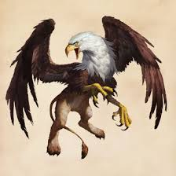  
  
 This is a Griffin from the Greek Mythology.  
 

 

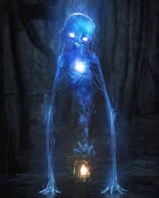  
  
 This is a Hinkypunk from the English mythology.  
   
   
 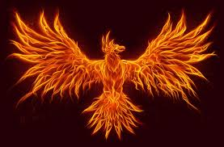  
 This is a Phoenix from the Greek mythology.  
  
  
**Which storylines are similar to myths?  
   
      Harry Potter and the Philosopher’s stone  
   
   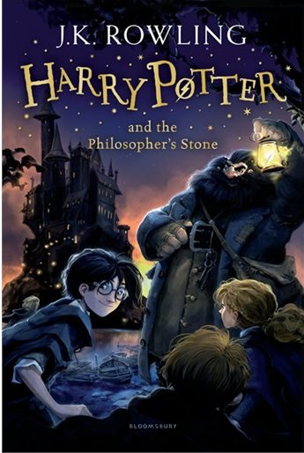**

**The Dursleys adopt Harry:**Shocking families are available all through our best-adored society stories. Regrettably, the Dursleys keep up this with zeal.

Harry&apos;s life at Privet Drive is a great deal like the narrative of Cinderella. Our poor hero is compelled to do every one of the tasks in old rummage garments for his evil auntie, while Dudley acts like two appalling sisters folded into one. Much like Soot, Harry is liberated from his predicament with a little enchanted mediation. He never had a pixie adoptive parent, yet his wizard back up parent was a lot cooler. Additionally he might not have an entirely dress but rather he got some pleasant dress robes later on.  
   
 **Fluffy was purchased:** There&apos;s a motivation behind why Fluffy was purchased from a &apos;Greek chappie&apos; Hagrid met down the bar — he could in all likelihood be founded on Cerberus, the three-headed pooch from Greek mythology. Cerberus was named by Hades to monitor the black market, much the same as Dumbledore utilized Soft to watch the trapdoor at Hogwarts. Like Cushioned, Cerberus additionally had a weakness for music, which enabled the legend Orpheus to slip past the first dog from damnation subsequent to playing him a tune.

The most famous picture of Cerberus may be only your normal three-headed pooch, yet Fleecy may have looked very changed without a doubt. The artist Hesiod guaranteed Cerberus had an astounding 50 heads (the psyche boggles), while different delineations incorporate a snake&apos;s tail, a mane of snakes and the hooks of a lion. Well that is a pooch no one but Hagrid could love.

**The Mirror of Erised is introduced:** There are numerous accounts in which mirrors show something beyond a reflection. The Snow Queen highlighted a mirror that contorted reality, ignoring all the great and enhancing the awful and the revolting. The courageous woman from Beauty and the Beast was given a charmed mirror by her captor. Most broadly, the underhanded ruler from Snow White utilized hers for a spot of day by day approval, however she wasn&apos;t constantly enthusiastic about the outcome. Fanatically checking the Reflection of Erised is likewise not prescribed.

Now and again a reflection can be supernatural enough, as Narcissus would affirm (and if that name sounds well-known, you&apos;re likely reasoning of Mrs Malfoy). As indicated by the legend, Narcissus saw his face reflected in a lake and fell profoundly enamored with himself. Besotted by his own excellence, he in the end squandered away at the water&apos;s edge… similarly as Dumbledore cautioned that &apos;men have squandered away&apos; before Erised. We don&apos;t know whether that was an analogy.  
  **The chessmen are introduced:** To reach the Philosopher&apos;s Stone, Harry and companions are compelled to play their way over a mammoth chessboard… and as we probably are aware, wizard chess isn&apos;t a drop in the bucket. The chessmen, transfigured to life by Educator McGonagall, savagely obliterate any pieces that are caught. That is the exact opposite thing you need to observe while you&apos;re remaining in for one of the pieces!

Chess has been depicted as an incredible round of life and demise in different stories as well. Numerous movies portray the round of rationale played with the Harvester of souls – the allegory being that chess speaks to the complexities of life. Jan Kochanowski&apos;s 1500s ballad Chess portrays a match between two men contrasted with a fight, and even anthropomorphises the pieces, much the same as how the chess is fiercely played in Harry&apos;s reality.  
   
 **The Philosopher Stone needs to be found:** This though idea didn&apos;t spring from no place. The Philosopher&apos;s Stone is unbelievable in Western speculative chemistry. Much the same as the one covered up in Hogwarts, the genuine stone should transform base metals into gold and silver. At it´s most exceptional stage, the stone should turn dark red. Whatever the goal, the mission to find the Philosopher&apos;s Stone prompted logical leaps forward in science, metallurgy and pharmacology.

The stone&apos;s maker, Nicolas Flamel, was a genuine memorable figure. Flamel professed to have obtained a baffling book that, when deciphered, would open the insider facts of speculative chemistry and made it his labor of love to make the Thinker&apos;s Stone. Many trusted he had succeeded gratitude to his riches (a lot of which he gave to philanthropy) and the reality he delighted in an uncommonly long life expectancy for somebody conceived in fourteenth century France. He might not have endure hundreds of years like his Harry Potter partner, yet he did live into his late eighties. A ready maturity even by the present benchmarks.

                              
                      

Harry Potter and the Chamber of Secrets  
   
 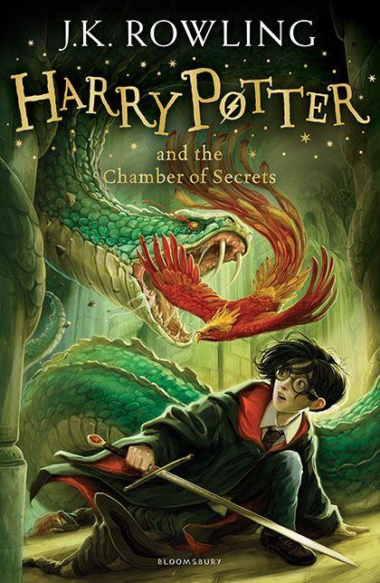  
 

 

 **Albus Dumbledore helps Harry:** The way that Dumbledore is an old and ground-breaking wizard with a long white facial hair is sufficient to convey the correlation with Merlin. Be that as it may, there are different perspectives too. For instance, them two are the coaches and instructors of legends, helping young fellows find their predeterminations. Both additionally have an association with prediction.

**The Dursleys adopt Harry:**Shocking families are available all through our best-adored society stories. Regrettably, the Dursleys keep up this with zeal.

Harry&apos;s life at Privet Drive is a great deal like the narrative of Cinderella. Our poor hero is compelled to do every one of the tasks in old rummage garments for his evil auntie, while Dudley acts like two appalling sisters folded into one. Much like Soot, Harry is liberated from his predicament with a little enchanted mediation. He never had a pixie adoptive parent, yet his wizard back up parent was a lot cooler. Additionally he might not have an entirely dress but rather he got some pleasant dress robeslater on.

**Neville Longbottom becomes more confident:** Neville doesn&apos;t begin to such an extent. In any case, neither did King Arthur! Not withstanding them two being from incredible ancestries, Neville with his Auror guardians and Arthur being sovereignty, the two men were viewed as powerless when they were youngsters. Besides, them two were likewise abused by relatives due to this apparent shortcoming. Nonetheless, both them at that point grow up to wind up solid pioneers and officers of men, with Arthur driving Camelot and Neville assuming responsibility for Dumbledore&apos;s Military. Gracious, and after that there&apos;s the way that they both end up battling with well known supernatural swords.

  **Ron is brave in any situation:** Sir Gawaine is an outstandingly bold and steadfast knight, and when his court is looked with threat, he&apos;s the person who volunteers to confront it. Ron additionally happens to be bold and steadfast and consents to go on a risky journey. In any case&apos;s, intriguing that them two waver while on these missions. Sir Gawaine lies about getting an enchanted relic with the expectation that it will spare his life and Ron flees. However, notwithstanding these slips in strength, them two apologize, with Gawaine admitting reality and Ron returning. At last, them two can return home triumphant with their slip-ups excused for their general great character.

   
   
 

   
                           
 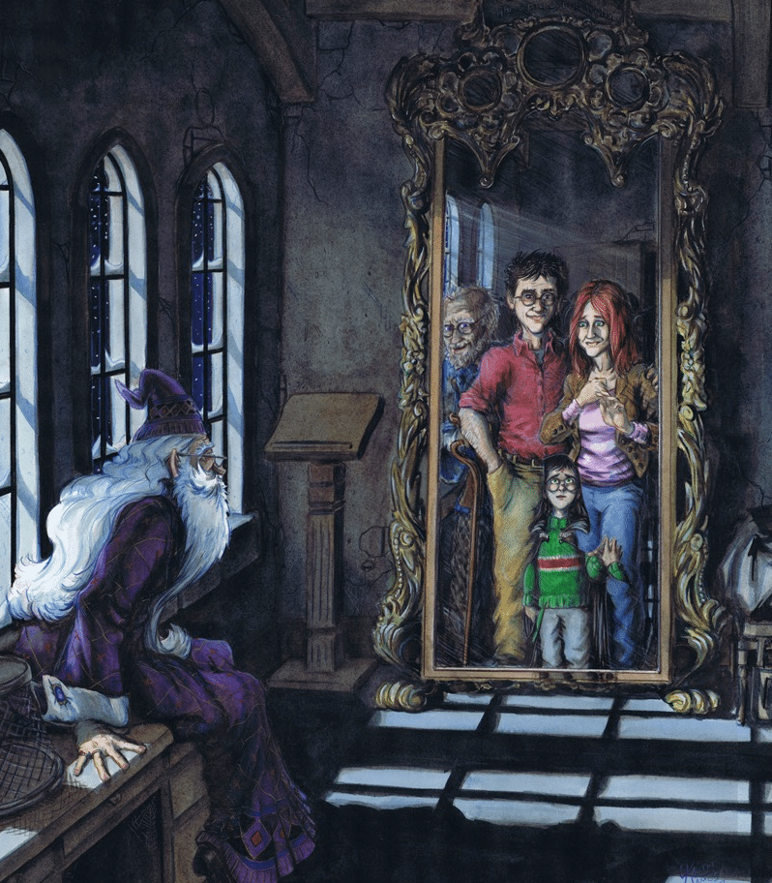  
   
                      
                        This is the Mirror of Erised.  
                   
                 
  
  
  Harry Potter and the Prisoner of Azkaban

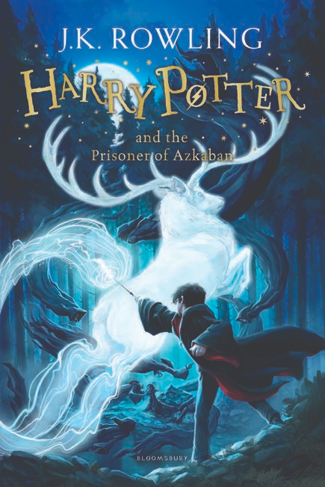  
   
   
   
   
   
   
 

   
   
   
   
 **Ron is brave in any situation:** Sir Gawaine is an outstandingly bold and steadfast knight, and when his court is looked with threat, he is the person who volunteers to confront it. Ron additionally happens to be bold and steadfast and consents to go on a risky journey. In any case&apos;s, intriguing that them two waver while on these missions. Sir Gawaine lies about getting an enchanted relic with the expectation that it will spare his life and Ron flees. However, notwithstanding these slips in strength, them two apologize, with Gawaine admitting reality and Ron returning. At last, them two can return home triumphant with their slip-ups excused for their general great character.  
   
 **Hermione is the brightest witch of her age:** There is the undeniable association of insight here, with Hermione being the brightest witch of her age and Athena being the Greek goddess of astuteness. Be that as it may, there&apos;s additionally the association of them two being the guider of saints. Hermione regularly goes about as Harry&apos;s counsel all through the arrangement, and Athena oftentimes controls saints, for example, Odysseus and Perseus in Greek mythology. The Perseus fantasy makes an especially well-suited correlation, since in it Athena gives Perseus a mirror-brilliant shield to battle Medusa, a beast who transforms individuals into stone when they take a gander at her. This can without much of a stretch be connected to Hermione and her mirror in the second book, which cautions Harry and Ron that they&apos;ll be confronting the Basilisk, another animal known for its fatal look.

**Remus Lupin teaches Harry how to defend himself against Dementors:** In Roman mythology, Romulus and Remus are twin siblings, whose story advises the occasions that prompted the establishing of the city of Rome and the Roman Kingdom by Romulus. The executing of Remus by his sibling, and different stories from their story, have roused specialists all through the ages. Since antiquated occasions, the picture of the twins being suckled by a she-wolf has been an image of the city of Rome and the Roman individuals. Despite the fact that the story happens before the establishing of Rome around 750 BC, the most punctual known composed record of the fantasy is from the late third century BC. Conceivable authentic reason for the story, just as whether the twins&apos; fantasy was a unique piece of Roman legend or a later improvement, is a subject of progressing banter. Romulus must be Harry in this case. Harry and Remus may not be twin siblings but Remus in the book is one of the creators of the Marauder&apos;s Map and in the mythology he also founded Rome as I mentioned in the beginning.  
   
 **You can see that a lot of scenes and events are from mythlogy and that JK Rowling copied them.**

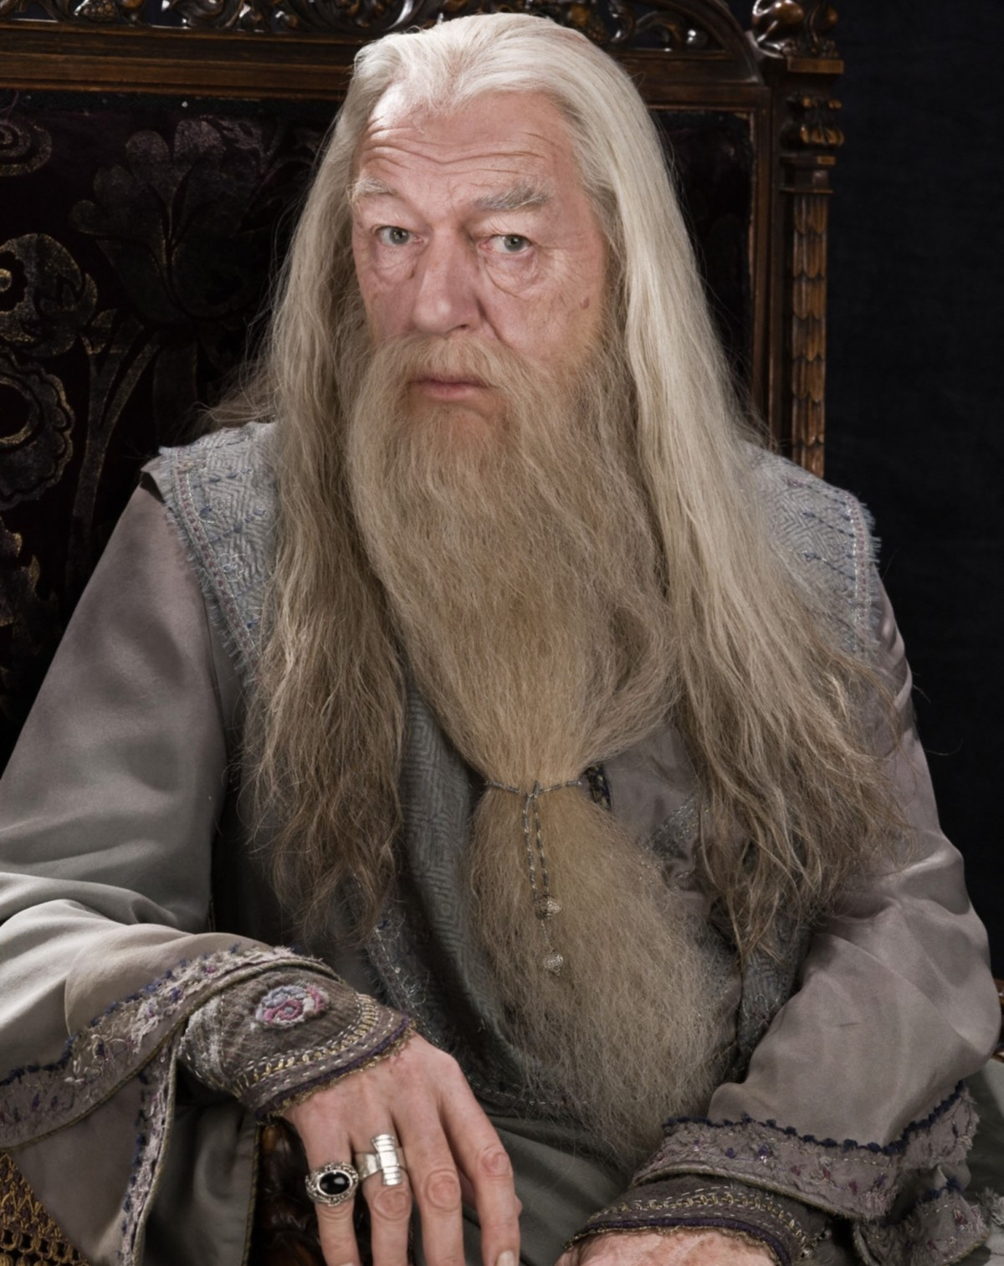

This is the wizard Albus Dumbledore that is an important character in every Harry Potter book.  
   
   
   
                                            **Conclusion**

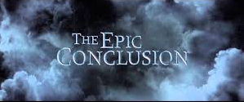

All in all on the off chance that the trailers and the books are anything to pass by, we definitely realize where to discover incredible mammoths: Eddie Redmayne has a bag brimming with them in 1926 New York. Be that as it may, where did they originated from, the mythical serpents, unicorns and hippogriffs of the Harry Potter universe? Beasts and legendary monsters play out a job in JK Rowling&apos;s work which rises above that of world-building: they include emblematic and mental profundity, just as advising us that we are visiting an otherworldly spot. Rowling is both an innovator and documenter of fantastical creatures, populating her universe with a blend of what one may term &apos;exemplary beasts&apos; (trolls, centaurs, mer-individuals) and legends staples, nearby her very own developments. A portion of these gathered beasts are boundlessly preferred known over others: grindylows and boggarts, for instance, have sources in Celtic and English legends, however they are not really commonly recognized names. These generally minor animals frequently have a not exactly fantastical backstory: grindylows live in shallow water and compromise to get at youngsters with their green, reed-like arms. It isn&apos;t hard to see here both a clarification for the presence of the grindylow – it imparts numerous qualities to water plants, which are normally portable and along these lines have their own disturbing appearance – and a clarification for why such stories may flourish – as a notice from guardians to their kids to avoid a potential peril, regardless of whether the hazard was bound to originate from suffocating than a malignant water sprite.  
  
 **Based on my research I can say that 50% of the creatures are definitely copied from mythology and the other 50% of the creatures are not copied.**