**After reading**

**Chapter 1**

1. Complete the table.

|  |  |  |
| --- | --- | --- |
|  | Alex | Lake |
| A. do not have imagination |  |  |
| B. does not have the air in the form |  |  |
| C. is nervous |  |  |
| D. is in a bad mood |  |  |
| E. always takes the train Pout ALLET office |  |  |
| F. took an unusually today Taxi |  |  |
| G. has just used the bike to office |  |  |
| H. always arrives late to office |  |  |
| I. always arrives on time at the office |  |  |

1. Technical issues ?

|  |  |  |
| --- | --- | --- |
|  | true | false |
| A. The bike of Alex dos not start. |  |  |
| B. Its electronic agenda does not lighten. |  |  |
| C. His watch does not indicate the correct time. |  |  |
| D. The lift of the building does not work. |  |  |

1. What thinks Alex about Nina?

* She does not understand.
* That she is too maternal.
* That it irritates him.
* That she is very kind.
* That she should not take vacations.

**Chapter 2**

1. Answer the following questions.
2. What are the advantages of the TGV?
3. Cite a disadvantage of the TGV for Alex?
4. What are the disadvantages of Hotel Logeco?
5. Why are Alex and Jacky lodging there?

**Chapter 3**

1. True or false.

|  |  |  |
| --- | --- | --- |
|  | true | false |
| A. The stars are filmed by 100 cameras. |  |  |
| B. The security of the festival is ensured by video surveillance cameras. |  |  |
| C. Jacky finds information about Hotel Majectic in the program of the festival. |  |  |
| D. Jacky is as seductive as Philippe Frisson. |  |  |

1. True or false.

|  |  |  |
| --- | --- | --- |
|  | true | false |
| A. Eva calls her bodyguard. |  |  |
| B. Jacky tried to wake Eva Trogen before photographing her. |  |  |
| C. Eva Trogen does not immediately identify Alex and Jacky. |  |  |
| D. Jacky takes for himself Jean-Claude Van Dammes |  |  |
| E. Jacky is in love with Eva Trogen. |  |  |
| F. Alex intervenes effectively with Terminator. |  |  |

**Chapter 4**

1. Say now what you know   
   Eva **knew** working Trogen and Philippe Frisson. Use phrases like "she looks ...", "it seems" when needed.

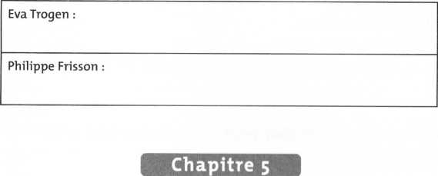

**Chapter 5**

1. Answer the following questions.
2. What thinks Jacky of the attitude of the woman who follows them in the car?
3. What is the real reason for his attitude?
4. Why can not Alex laugh?

**Chapter 6**

1. Answer the following questions.
2. Is Alex rather sporty or rather lazy?
3. What is the particularity of the beaches where they jog that morning?
4. Why is Alex so authoritative when he speaks to the curious, near the boat arrived on the beach?

Chapter 7

10. In your opinion, Dulac is aware of the murder because:

1. He asks someone to watch Alex and Jacky.
2. It can observe the beach from Brussels thanks to video surveillance cameras.
3. He is an accomplice in crime.
4. Other journalists gave the information immediately.

11. Find a shock title for the next edition of *L’Avis.*

Chapter 8

12. According to Philippe Frisson ...

|  |  |  |  |
| --- | --- | --- | --- |
| AT | the mannequins | 1 | are difficult |
| B | thee dentists | 2 | Appreciates his/her work |
| C | The other comedian | 3 | balance |
| D | All the roles at the cinema | 4 | lie |
| E | its successes and its failures | 5 | do not speak |

13- The interview of Philippe Frisson gives you details about his character. Complete your first impression of his character as in chapter 4. Distinguish his personality on one side and his professional background on the other.

Chapter 9

14. Who are we talking about?

|  |  |
| --- | --- |
| Alex | 1 |
| Santino | 2 |
| Rod Book | 3 |

|  |  |
| --- | --- |
| A | Has a talent of actor |
| B | Has bad character |
| C | Has an eccentric look |
| D | Is attentive to pretty women |
| E | Is attentive to the menus |
| F | Is a cinema/movie actor |
| G | Is a bit psychologist |
| H | Is a little bit depressive |