Danny, the champion of the world.

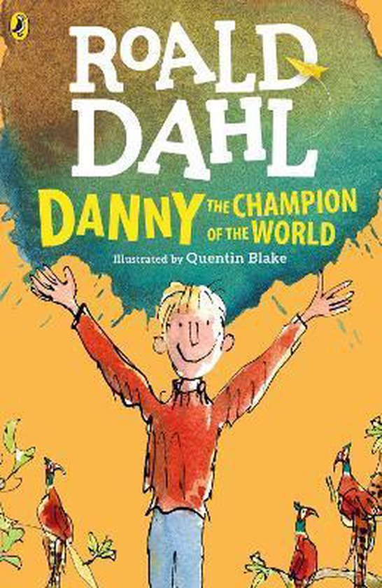

Explain the title of the book.
Danny had to go through a lot of things that also meant that he had to be strong and help his father as much as he can.
That's why the title is also that he's a champion of the world, that’s why.

Who wrote the book?

It was written by: Roald Dahl.

Where does the story take place?
The story takes place at Danny's father's gas station, and the caravan next door.
Also at Mr. Hazel's forest, and more other places by the country lands.

Who are the main characters?
Danny, Danny is a boy who grew up without a mother and only with his father and he is 9 years old.
He does his very best to help his father at the workshop and with other things he is there for his father and protects him.
He went to school from the age of 7 but never liked it, all he wanted to do is help his father in the workshop.
And he is not afraid at all, he can drive a car, he is smart and can get by without his father and take care of himself.

Danny's father, Danny's father is a good man he is always there for his son and let him help whenever he wants.
He is not afraid and involves his son in everything, even letting him drive a car at a very young age.
He is a single father who is not afraid of anything.
He really likes poaching pheasants, he likes that very much.
He is also not afraid at all and is always there for his son when he needs it.

What is the situation in the first chapter?
It is the introduction to the book.
It's about the gas station and car workshop.
About what it looks like and how it is used.
It is also about the boy's childhood and that his mother was no longer alive
It is also about his father, what his characteristics are and what he is willing to do for his son.

What is the story about? Tell about the plot.
Danny is a nine year old boy. He lives in a caravan with his father. His mother passed away when Danny was four months old. The caravan has a fuel station and a car garage. Danny's dad repairs cars and Danny would like to become the same and take over everything
When Danny is seven years old, he has to go to school from his father. Danny is not really happy about this because he likes to repair cars just like his father.
Danny's father goes poaching pheasants one evening. If he's more than four hours late, Danny goes looking for him. He takes the car that is in the garage at the moment and goes to Hazel's forest. Danny's father has fallen into a trap and Danny pulls him out with a rope.
Danny is beaten in class when he talks to another boy. Danny's father is very angry with the teacher and can hardly contain his anger.
Danny's father is very angry with Mr. Hazel for dropping him into a trap.
That's why Danny and his father come up with a plan to get him back
When that plan is carried out, they take the 120 pheasants they had poached with them.
Mr. Hazel found out about this and he called the police and sent them to the gas station.
Once there, Mr. Hazel and Danny's father came to an agreement.
They chase the pheasants back to Mister Hazel's forest
All the pheasants flew away from the gas station but the sleeping pill hadn't worn off yet so they stayed on the ground for a while
Instead of the pheasants going to the forest, they sit on Mr. Hazel's car.
That's why Mr. Hazel drives away really fast, so the pheasants all fly up and the sedative had worn off so all the pheasants were free.
As Danny wanted.
What did you think of the book? Explain .
I think it was a good book, it was well put together and the main characters were really in the role in the book.
Sometimes they could have indicated the time lag between different events.
But otherwise I thought it was a good book.

Was it easy or difficult to read? Explain.
It was a good read, a good book for 1st/2nd graders.
Because there are many words that people already know.
Sometimes you don't know a couple, but that's not a bad thing either.
I could also learn a lot from it.
Learned a lot of new words too.
But it was more on the easy side.

Would you recommend the book to your classmates? Why? Why not?
Ik raad het mijn klasgenoten wel aan want het is een prima boek.
Ook goed te gebruiken voor een boekverslag of gewoon in je vrije tijd te lezen

EINDE

