**PWS**

**How to Recognize a Psychopath**

**Maud van Kempen**

N&G, Engels

# **Acknowledgements**

I will to start with my motivation for this research. I am very interested in psychology since a few years and I am planning to study criminal psychology, making the subject psychopaths an easy choice. After watching the show about Jeffrey Dahmer and reading the book called ‘*surrounded by psychopaths*’ by Thomas Erikson, the question I kept thinking about was ‘How can people be like this?’. For this reason, I decided to write a research paper on this. As this paper will include various different research studies, I would like to thank all the scientists, authors and other people who worked on these research studies. All the used studies will be included in the resource list at the bottom of this paper.

# **Table of contents**

**Acknowledgements** 2

**Table of contents** 3

**Introduction** 5

**Hypothesis** 6

**What is the definition of a psychopath?** 7

**Chapter 1: Behaviour** 8

**1.1** 8

**1.2**  8

**1.3** 8

**1.4** 8

**1.5**  8

**1.6** 9

**1.7** 9

**Chapter 2; Medical Research** 10

**Chapter 3: Inheritance** 11

**3.1 Environmental factors** 11

**3.2 Internal factors** 11

**Chapter 4: DISC-system** 13

**Chapter 5: My own research** 15

**2.1 Hypothesis** 15

**2.2 Questionnaire** 15

**2.3 Scoring chart** 15

**2.4 Results** 16

**Conclusion** 17

**References** 18

**Appendix** 21

# **Introduction**

Adolf Hitler

Ted Bundy

Richard Ramirez

Winston Churchill

John F. Kennedy

Bill Clinton

What do all these men have in common, you may ask. They are all diagnosed psychopaths. Some names on this list may not be a surprise, in contrast to others. Autor Kevin Dutton wrote a book called *The good psychopaths guide to success.* He wrote this book about what makes a psychopath good in what he does, and how thinking like a psychopath can help more in life.In this book he used a personality test called PPI-R (Psychopathic Personality Inventory-Revised) , developed by S. Lilienfeld and B. Andrews, to evaluate character traits in different people. The result of his study? Multiple American presidents score highly on this test. This shows that not all psychopaths are serial killers. Everybody has their own personality. Some personalities are easier to understand than others, but there is one group of people with what seems a lack of personality. This is considered psychopathy. Psychopaths seem like they don’t have feelings. However, most psychopaths seem likable and are often popular. This seems like it could not be true, but it is. Psychopaths have the ability to mirror the personality of people around them. They use this ‘fake’ personality to get what they want and it this process they will not hesitate to hurt others. A psychopath may seem nice on the outside, but appearances are deceiving. (Erikson, 2020)

This research paper is focused on recognizing psychopaths. Recognizing psychopaths is important, as they will not hesitate to hurt people in order to get what they want. To prevent you being hurt, this research paper will tackle four different subjects in psychopathy. The reason I chose to research these four subjects is that I think these four criteria are considerably the most important criteria. At the end, I will answer the main question *how can you recognize a psychopath?*

The first chapter is about the behavioural aspects. This chapter is focused on recognizing and dealing with psychopathic behaviour. At the end of this chapter, I will answer the question *how can you recognize a psychopath based on their behaviour?*

The second chapter is about medical research. This chapter is focused on how to recognize a psychopath based on medical research,

The third chapter is about inheritance. This chapter includes several research studies performed by different scientists. At the end of this chapter, I will answer the question *is it possible to decrease the severity of psychopathy if diagnosed at birth?*

The fourth chapter is about the DISC-system. There will be an explanation about the DISC-system and how to use it to recognize psychopaths. At the end of this chapter, I will answer the question *how can the DISC-system be used in recognizing psychopaths?*

The fifth chapter includes my own research to show that the percentage of people with psychopathic traits is relatively high. This research is a questionnaire based on the psychopathy checklist by Robert Hare. This research is used to estimate the total amount of students with psychopathic traits.

As mentioned earlier, psychopaths do not hesitate to hurt others. That is exactly the reason why it is important to recognize a psychopath.

# **Hypothesis**

I expect that recognizing psychopaths is possible evaluating different personality traits. If a person shows specific divergent personality traits, such as lack of remorse, I believe it is possible to recognize a psychopath. There have been several studies, showing that most psychopaths often show a variety psychopathic personality traits.

# 

# **What is the definition of a psychopath?**

*A psychopath is a person affected by a chronic mental disorder with abnormal or violent social behaviour*

*-Oxford languages*

Even though Jeffrey Dahmer was a well-known serial killer, a neuroscientist claims he was not a psychopath (Shaheen, 2022) There are several forms of psychopaths, some more dangerous than others. Some people are clearly psychopaths, but some, who you would expect to be psychopaths, are not. This also means that some people who you might expect to be ‘normal’ could turn out to be a psychopath. The term psychopath is commonly used, but it is not a medical diagnosis. The term is mostly used to describe people with antisocial personality disorder (ASPD). According to The Diagnostic and Statistical Manual of Mental Disorders, ASPD is one of four cluster B personality disorders. (Lindberg, 2022) Cluster B disorders are a collection of personality disorders that effect how people behave. (*What are Cluster B personality disorders?*, 2021) The four cluster B personality disorders are ASPD, Borderline Personality Disorder (BPD), Histrionic Personality Disorder (HPD) and Narcissistic Personality Disorder (NPD). According to the DSM-5, a comprehensive classification and diagnostic tool for mental disorders, to receive a diagnosis of ASPD, a person must show 3 or more signs of the following criteria:

* Failure to conform to social norms concerning lawful behaviours, such as performing acts that are grounds for arrest;
* deceitfulness, repeated lying, use of aliases, or conning others for pleasure or personal profit;
* impulsivity or failure to plan;
* irritability and aggressiveness, often with physical fights or assaults;
* reckless disregard for the safety of self or others;
* consistent irresponsibility, failure to sustain consistent work behaviour, or honour monetary obligations;
* lack of remorse, being indifferent to or rationalizing having hurt, mistreated, or stolen from another person.

In the upcoming chapter *Behaviour* I will elaborate further on these criteria.

Psychopathy is astonishingly common as mental disorders go. It is twice as common as schizophrenia, anorexia, bipolar disorder, and paranoia, and roughly as common as bulimia, panic disorder, obsessive-compulsive personality disorder, and narcissism. Indeed, the only mental disorders significantly more common than psychopathy are those related to drug and alcohol abuse or dependence, depression and post-traumatic stress disorder (Kiehl, 2011).

# **Chapter 1: Behaviour**

In this chapter I will describe the different forms of psychopathic behaviour, how to recognize them and how to deal with them. As listed in the introduction, some forms of this behaviour are impulsivity, narcissism and antisocial behaviour. In this chapter, the most common types of psychopathic behaviour will be listed. As discussed on the previous page, I will elaborate further on the criteria described by DSM-5. At the end of this chapter, I will answer the question: *How can you recognize a psychopath based on their behaviour?*

## **1.1 Failure to conform to social norms concerning lawful behaviours, such as performing acts that are grounds for arrest**

One of the most famous examples of a psychopath is Ted Bundy. Bundy murdered at least 30 women in a 5-year time period. When he was on trial he received a mental health check executed by Hervey Cleckley, who diagnosed Bundy as a psychopath. (Plercy, n.d.). The reason why I took ted Bundy as an example for this criteria sign, is because Bundy committed multiple crimes that are a ground for arrest. The best current estimate is that just less than 1% of all noninstitutionalized males age 18 and over are psychopaths. This translates to approximately 1,150,000 adult males who would meet the criteria for psychopathy in the United States today. And of the approximately 6,720,000 adult males that are in prison, jail, parole, or probation, 16%, or 1,075,000, are psychopaths. Thus, approximately 93% of adult male psychopaths in the United States are in prison, jail, parole, or probation. (Kiehl, 2011) As this research shows, most psychopaths have committed an act which is ground for arrest and therefore fulfil this criteria. Out of all criteria, this might be the most recognizable one. After all, recognizing a crime is not that hard. The tricky part about this is that not all serial killers or crime committers are psychopaths. So how do you distinguish the difference between the two? The difference between them is in most cases the motive for the committed act. Most psychopaths commit a crime because of their other psychopathic characteristics. Think of personality traits like aggressiveness, impulsivity and lack of remorse (Porter et all, 2018) It is incorrect to call any criminal a ‘psychopath’; formally, only those scoring high on a particular assessment, such as the Psychopathy Checklist (PCL; Hare 1991), can be so diagnosed as a psychopath. (Adshead et all, 2012)

## **1.2 Deceitfulness, repeated lying, use of aliases, or conning others for pleasure or personal profit**

Everyone tells a lie sometimes, but without the intention of repeatedly lying and hurting others. This makes you different from a psychopath. The latter will not hesitate to lie to get what they want.   
Compared with typical individuals or individuals with other forms of psychopathology, those with high levels of psychopathic traits take longer to recognise emotional facial expressions, particularly those indexing distress in other people.   
Other paradigms have documented blunted empathy towards others, reduced startle responses to negative stimuli and a relative immunity to punishment. Remarkably, however, individuals with psychopathy are perfectly adept in understanding other people’s thoughts, in contrast to individuals with autism spectrum disorders. This may help explain why individuals with psychopathy are often so good at manipulating other people — they understand what others are thinking, but do not resonate with the distress their actions will inflict on others. (Viding et all, 2014)

## **1.3 Impulsivity or failure to plan**

Psychopaths often have an poor impulse control compared to non-psychopathic people. Non-psychopathic people often think before they act and have some sense of self control. Non-psychopathic people recognize that their intended actions will have consequences for others and hold that into account. A psychopath is the complete opposite of all these things. They can act rationally sometimes, but they often lack any real self-control and restraint on their behaviour. They just do things, either because they feel like it, or to get something they want right away, without taking into account how their behaviour might affect others. (*Psychopaths in life,* 2019) Summarised, psychopaths often search the quickest way of getting what they want, not caring about the consequences for other people. This can result in robberies, injuries, rape and sometimes even murder, simply because they cannot resist the urge.

## **1.4 Irritability and aggressiveness, often with physical fights or assaults**

As earlier done research show, most psychopaths in general are more aggressive than non-psychopathic people. As mentioned in point 1.1, approximately 93% of adult male psychopaths in the United States are in prison, jail, parole, or probation. (Kiehl, 2011) Another research has indicated that within one year of release from prison psychopaths are 4–6 times more likely to commit another violent crime than non-psychopaths (Hemphill et all, 2011). All forms of aggression can be divided in 2 categories; reactive or proactive aggression. According to N.A. Anderson and K.A Kiehl, impulsive (reactive) aggressionis characterized as an emotional response to some immediate provocation or frustration. In contrast, premeditated (proactive) aggression results from more complex motivating factors and is largely characterized by predatory actions serving some instrumental purpose. In other words, psychopaths can show aggression as a result of impulsivity or emotional distress, or aggression that has been planned out for longer and has a more complex background.

## **1.5 Reckless disregard for the safety of self or others**

This criterion is a mix of the criteria before. As mentioned in 1.3, psychopaths often have little to no self-control, resulting in them doing everything imaginable to get what they want, regardless of the consequences for others. This includes hurting other people. Their impulsivity can also be a danger to themselves. A research done by L. Campbell and A. Beech showed that individuals who scored higher on psychopathic traits were more likely to self-harm. This shows that psychopaths are not only a danger to the safety of others, but also to themselves.

## **1.6 Consistent irresponsibility, failure to sustain consistent work behaviour, or honour monetary obligations**

In the book *surrounded by psychopaths*, Erikson tells a story about a man who got caught for embezzling almost one hundred thousand dollars from his job before he got reported to the police. It took two years before he got reported, and in those years he caused a lot of chaos. He got two women pregnant, sent 2 members of the staff home on sick leave because of rumours he spread. The reason it took 2 years before he got reported was because no one suspected him. He was irresponsible for his actions. This story is a perfect example of irresponsibility. Psychopath rather let other people take the consequences for their actions, resulting in false obligations. They also cannot sustain consistent work behaviour, because they are more prone to boredom. A normal office job is not in it for them, simply because they miss the thrill of excitement.

## **1.7 Lack of remorse, being indifferent to or rationalizing having hurt, mistreated, or stolen from another person**

*"Guilt doesn't solve anything, really. It hurts you. I guess I am in the enviable position of not having to deal with guilt.".*

*-Ted Bundy*

This statement shows that even after committing multiple crimes, Bundy felt remorse, but did not feel guilt. Research has shown that psychopaths are not deficient in all components of empathy. In fact, a number of studies have demonstrated that only the affective component is implicated in psychopathy, while the level of cognitive functioning remains relatively normal Simply put, psychopaths realize, recognize, and fully comprehend the distress their victims are feeling. They simply, though, do not feel it themselves. (Perry, 2014). In other words, it is wrong to say psychopaths do not know remorse, they simply cannot feel it themselves. They are not unfamiliar with the concept of remorse, they simply do not care about it.

Now the answer to the question *how to recognize a psychopath based on their behaviour?* If you recognize multiple of the described traits, the odds of you dealing with a psychopath are relatively high. Some traits are easier recognisable than others, but keep in mind that psychopaths are good in faking their personality. In some cases, their true personality will shine through and that is when you will recognize these traits, so pay attention.

# **Chapter 2; Medical Research**

Differences between normal people and psychopaths can not only be found in behaviour, but also in the brain. K.A Kiehl and N.E Anderson wrote a research paper in which they included a study about the brain of a psychopath compared to the ‘normal’ brain. This paper is called *The psychopath magnetized: insights of brain imaging.* The information below is derived from this research.

The brain is made out of multiple complex parts, and most of them are similar in the normal brain and the psychopathic brain. There are 3 parts, however, that differ from the normal brain. These parts are in the amygdala, the prefrontal cortex and the extended paralimbic structures.

Amygdala

The amygdala is a part of the brain that plays a part in skills like learning and the recognition of emotional information. In recent studies, psychopathic brains showed less activation in the amygdala when viewing pictures depicting moral violations and fearful faces: suggesting these things simply affect a psychopathic brain less. The greater the level of psychopathy, as measured on the Hare Psychopathic Checklist, the less activation seen in the amygdala. (Tracy, 2021)

Prefrontal cortex

The prefrontal cortex is a part of the brain important in monitoring behaviour, estimating consequences and incorporate emotional learning in making future decisions. This would mean that their emotions do not affect future decisions and that they may underestimate the consequences of their actions. A section of the prefrontal cortex, the orbitofrontal cortex, shows reduced grey matter in volume and thickness. Again, the more severe the psychopathy, the greater this deficiency seems to be. The activation in this region during specific tasks mirrors this finding as when psychopaths decide to cooperate, they show less activation here and when they observe an opponent being punished, this area activates more than in the normal brain. This correlates with antisocial behaviour and impulsivity traits. (Tracy, 2021)

Extended paralimbic structures

The limbic system is the part of the brain involved in behavioural and emotional responses. The extended paralimbic structures are the regions outside of the limbic system, involved in emotion processing, goal setting, motivation and self-control. In the extended paralimbic structures, reductions in grey matter have been found. These reductions have been linked to impairments in episodic memory and self-referential experiences, meaning that psychopaths view their own memories differently than others do. (Tracy, 2021)

# **Chapter 3: Inheritance**

# To set the right expectations, there is no such thing as being born a psychopath. However, it is possible to be born with a higher chance for developing psychopathy because of various genetic factors. Psychopathy is not just one gene, it is a combination of hundreds or even thousands of genes. Some children are born with these genes, they will have a higher chance of developing into a psychopath.

# Even though there are no psychopathic genes, there are some factors that have been linked to increase the chance of psychopathy. These factors can be split in environmental and internal factors.

## **3.1 Environmental factors**

# Environmental factors will only increase the severity of the symptoms by a little bit. It is important to remember that a risk factor is not the same as a cause. For example, lack of a safe environment during childhood can be considered a risk factor, But, many children with psychopathy have none of these risk factors and did experience warm and responsive parenting. Similarly, most children with these risk factors will not develop psychopathy. (PsychopathyIs, 2023)

Research shows that maternal smoking, drug use, stress and anxiety during pregnancy can increase the risk to develop behavioural problems later. After birth, obstetric complications, malnutrition, exposure to heavy metals, parental psychopathology, deviant peer groups, poverty, low socioeconomic status, and exposure to community violence confer an increased risk for antisocial behaviour and callous-unemotional traits among youth (Junewicz and Billick, 2021)

In other words, a variety of environmental factors including lifestyle, parents and violence give an increase in the risk of developing psychopathy.

## **3.2 Internal factors**

There have been several research studies about the role of the monoamine oxidase enzyme (MAO-A), the catechol-O-methyltransferase enzyme (COMT), and the sodium-dependent serotonin and dopamine transporter genes in antisocial behaviour. According to Ficks and Waldman (2014) polymorphisms (discontinuous genetic variations) of the MOA-A and the serotonin transporter are associated with aggression and antisocial behaviour in youth. Various genes affect dopamine neurotransmission, which has been associated with externalizing behaviours. As all of the enzymes above are genes, there is a possibility to inherit genes associated with a higher chance of psychopathy.

It is important to remember that the presence of these genes does not necessarily mean that one is a psychopath, they solely increase the risk of developing psychopathy. Saying that the gene definitely has a role in psychopathy is too complex, so this chapter is based on assumptions on earlier done studies.

The answer the question *Is it possible to decrease the severity of psychopathy if diagnosed at birth?* is not as simple as previously thought. Since the presence of the internal and environmental factors does not necessarily mean psychopathy, there is no such thing as preventing psychopathy. However, some of the environmental factors can be changed or prevented. This would decrease the risk of one becoming a psychopath. The internal factors cannot be changed. However, if the genes are detected at birth, limiting the exposure to the mentioned environmental factors would decrease the risk.

# **Chapter 4: DISC-system**

The DISC-system is a system founded by psychologist William Moulton Marston. The DISC-theory is a model used to describe human behaviour, based on four personality traits.

* Dominance
* Influence
* Stability
* Compliance

As seen above, all four personality traits have been given a colour. This makes it easier for people to identify themselves. A person can be a mix of multiple colours, but in general two colours will dominate. (Erikson, 2020)

Dominance

The dominance category is related to control, power and assertiveness. The people who score high in this category are often confident, outspoken, assertive and decisive. (Herrity, 2023)

Influence

The influence category is related to social situations and communication. The people who score high in this category are often skilled at influencing or persuading others and tend to be optimistic, open, enthusiastic, trusting and energetic. (Herrity, 2023)

Stability

The stability category is related to patience, persistence and thoughtfulness. The people who score high in this category place emphasis on cooperation, sincerity and dependability and tend to have calm and deliberate dispositions. (Herrity, 2023)

Compliance

The compliance category is related to structure and organization. The people who score high in this category place emphasis on quality and accuracy to enjoy their independence and be detail-oriented.

As you would classify yourself in these four categories, you will probably notice you have traits from all four colours. That is how most people will feel.

As mentioned earlier in the introduction, psychopaths seem like they do not have a personality of their own. They would not fit in one of these four categories. As Thomas Erikson describes in his book *surrounded by psychopaths,* psychopaths do not have a ‘colour’ of their own. He asks the question *If a person doesn’t have a personality of their own, but simply mirrors whomever is in front of them, who is that person? They are not Red or Yellow, and definitely not Green or Blue. Are they all the colours? A fifth colour?* He answers this question with *none of these.* The problem with this is that psychopaths are really good at hiding that they do not have a personality of their own. They simply mirror the personality of the people they are talking to. As Erikson says in his book, psychopaths take advantage of the DISC-system.

To answer the question *how can the DISC-system be used in recognizing psychopaths?* You have to pay close attention to someone’s personality. Does it seem like they are copying your personality one day and have a complete different personality the other day? If yes, try to watch out for the other personality traits mentioned in chapter one. This is not an official way to declare someone a psychopath, but it can help in preventing becoming a psychopaths victim. The DISC-system is not an official diagnosis, it is only a tool to help you in recognizing psychopaths.

# **Chapter 5: My own research**

For my own research I decided to make a questionnaire based on the psychopathic checklist by Robert Hare. In the book *surrounded by psychopaths* it says that the checklist is not meant to be used for medical research, so I only used it to estimate the total amount of students with psychopathic tendencies. This checklist is made into a google forms questionnaire. On the presentation day I also handed out 20 printed copies.

## **2.1 Hypothesis**

I expect this research to show that the total percentage of students with psychopathic traits is above 10%. I expect the range of this research to be around 30 students, this would mean that at least 3 students have some psychopathic traits.

## **2.2 Questionnaire**

In the questionnaire, the following questions were asked.

1. How often are you bored?
2. Do you often use your own charm to get what you want?
3. Have you ever been diagnosed with a personality disorder? (If yes, which one?)
4. Do you often put yourself above other people?
5. Are you quickly frustrated?
6. Do you use lies often?
7. How much do you care about other people’s mental wellbeing?
8. Do you often feel guilty?
9. Do you often profit from other people’s benefits?
10. What is the estimated time of your usual romantic relationships?
11. Did you cause much trouble when you were younger?
12. Do you often think about your plans in the future?
13. Do you have impulsive thoughts?
14. Did you ever get punished for something? (Think about rule breaking)
15. Do you take responsibility for your actions?
16. How often do you use alcohol and/or drugs?

## **2.3 Scoring chart**

All previous questions had either 2 or 3 answers, each rewarded 0,1 or 2 points. In the original questionnaire by Robert Hare there are 20 questions. The highest possible score was 40 points. In my research I asked 16 questions, with a total score of 30 points. This leads to the following scoring chart. Every score between 1-10 is the common population. Every score between 10-15 has some psychopathic traits. Every score above 15 has multiple psychopathic traits and has a high chance of qualifying as a psychopath.

The scoring chart for the answers is as following;

|  |  |  |  |
| --- | --- | --- | --- |
| Question | 2 points | 1 point | 0 points |
| 1 | Regularly | Sometimes | Never |
| 2 | Regularly | Sometimes | Never |
| 3 | Yes | x | No |
| 4 | Regularly | Sometimes | Never |
| 5 | Regularly | Sometimes | Never |
| 6 | Regularly | Sometimes | Never |
| 7 | Never | Sometimes | Regularly |
| 8 | Never | Sometimes | Regularly |
| 9 | Regularly | Sometimes | Never |
| 10 | Short | x | Long/None |
| 11 | Yes | x | No |
| 12 | Never | Sometimes | Regularly |
| 13 | Yes | Yes, but don’t execute them | No |
| 14 | x | Yes | No |
| 15 | x | No | Yes |
| 16 | Regularly | Sometimes | Never |

## **2.4 Results**

To come to a results, I added the total score for each individual. There was a total of 32 answers on the google forms questionnaire. On the presentation day, all 20 printed copies were filled out. I incorporated all results in two different diagrams.

As seen in the results, the total amount of people who scored 10 or higher was much more in the printed copies. The printed copies gave the result that 60% of the people (12 individuals) had psychopathic traits. The online forms gave the result that 25% of the people (8 individuals) had psychopathic traits. However, both results show that my hypothesis was correct.

# **Conclusion**

In this research paper, there was one overarching question. This question was *How to recognize a psychopath?* To answer this question, I described 4 different methods to come to a conclusion. Chapter one shows that psychopaths can be recognized focusing on different personality traits. Chapter two shows that they can also be recognized by medical research and brain scans. Chapter three shows different internal and external factors that could increase the risk of becoming a psychopath. Chapter four described the DISC-system and how it can be used in recognizing a psychopath.

In conclusion, recognizing a psychopath is possible using different criteria. If you were to talk with one, you could recognize the personality traits or the lack of a personality according to the DISC-system. If you were to medically research a psychopath, the brain scan would show a difference compared to a ‘normal’ brain. The inheritance factor only plays a small role, so this factor does help you in recognizing a psychopath. It simply increases the chances if combined with any of the other factors.

This research is relatively small compared to others, so some subjects are not extensive. The 80 hours I spend on this research were solely focussed on the five chapters mentioned in this research paper. This limited various other questions. If I would have had the time to further research various subject, I would take more interest in the differences between men and women. I would also spend more time to research the various characteristics.

# **References**

Anderson, N. E., & Kiehl, K. A. (2011, December 15). *The psychopath magnetized: insights from brain imaging*.

Campbell, L., & Beech, A. (n.d.). *View of Is there a link between psychopathy and self-harm?        | International Journal of Risk and Recovery*. <https://mulpress.mcmaster.ca/ijrr/article/view/3475/3606>

*Doctor discovers he’s a psychopath*. (n.d.). [Video]. CNN Health. <https://edition.cnn.com/videos/health/2014/02/22/sgmd-doctor-psychopath.cnn>

*Encyclopedia of Mental Health* (2nd ed.). (2016). <https://doi.org/10.1016/b978-0-12-397045-9.00212-3>

Erikson, T. (2020). *Surrounded by Psychopaths*.

Ficks, C. A., & Waldman, I. D. (2014). Candidate Genes for Aggression and Antisocial Behavior: A Meta-analysis of association studies of the 5HTTLPR and MAOA-UVNTR. *Behavior Genetics*, *44*(5), 427–444. <https://doi.org/10.1007/s10519-014-9661-y>

Garofalo, C., Neumann, C. S., & Velotti, P. (2020). Psychopathy and Aggression: The role of Emotion Dysregulation. *Journal of Interpersonal Violence*, *36*(23–24), NP12640–NP12664. <https://doi.org/10.1177/0886260519900946>

Gray, N. S., Weidacker, K., & Snowden, R. J. (2019). Psychopathy and impulsivity: The relationship of psychopathy to different aspects of UPPS-P impulsivity. *Psychiatry Research*, *272*, 474–482. <https://doi.org/10.1016/j.psychres.2018.12.155>

Hare, R. (n.d.). *Hare Psychopathy Checklist (Original) (PCL-22)*. Psychology Tools. <https://psychology-tools.com/test/pcl-22>

Hemphill, J. F., Hare, R. D., & Wong, S. C. P. (1998). Psychopathy and recidivism: A review. *Legal and Criminological Psychology*, *3*(1), 139–170. <https://doi.org/10.1111/j.2044-8333.1998.tb00355.x>

Herrity, J. (2023, March 11). *The 4 DISC Personality Types*. indeed.com. <https://www.indeed.com/career-advice/career-development/disc-personality-types>

Hunter, P. (2010, September 11). *The psycho gene*. Pubmed Central. <https://www.ncbi.nlm.nih.gov/pmc/articles/PMC2933872/>

Junewicz, A., & Billick, S. B. (2021b). Preempting the development of antisocial behavior and psychopathic traits. *Journal of the American Academy of Psychiatry and the Law*, *49*(1), 66–76. <https://doi.org/10.29158/jaapl.200060-20>

Kiehl, K. A. (2011, January 1). *THE CRIMINAL PSYCHOPATH: HISTORY, NEUROSCIENCE, TREATMENT, AND ECONOMICS*. PubMed Central (PMC). <https://www.ncbi.nlm.nih.gov/pmc/articles/PMC4059069/>

Kim, E. Y., Xu, C., Bubeleva, K. V., & Neumann, C. S. (2023). Psychopathy. In *Elsevier eBooks* (pp. 884–893). <https://doi.org/10.1016/b978-0-323-91497-0.00243-5>

Lee, S. (2022, October 9). Ted Bundy had a very dull last meal and refused to eat any of it. *UNILAD*. <https://www.unilad.com/news/ted-bundy-dull-last-meal-20221009#:~:text=And%20despite%20his%20awful%20crimes,&apos;t%20solve%20anything%2C%20really>.

Lindberg, S. (2022, June 1). *What is a psychopath?* Healthline. <https://www.healthline.com/health/psychopath>

Morin, A. M. (2022, November 7). *What is a psychopath?* Verywell Mind. <https://www.verywellmind.com/what-is-a-psychopath-5025217>

Perry, J. M. (2014, October 24). *Failures of empathy: The killer with no remorse (Psychopathy) – Emotion, Brain, & Behavior Laboratory*. <https://sites.tufts.edu/emotiononthebrain/2014/10/24/failures-of-empathy-the-killer-with-no-remorse-psychopathy/>

Plercy, L. (n.d.). *A&S psychology researcher unravels serial killer Ted Bundy’s mental health | University of Kentucky College of Arts & Sciences*. <https://psychology.as.uky.edu/psychology-researcher-unravels-serial-killer-ted-bundys-mental-health>

Psychopaths &amp; Poor Impulse Control (With examples) - Psychopaths in life. (2019, September 2). *Psychopaths in Life*. <https://psychopathsinlife.com/psychopaths-poor-impulse-control/>

PsychopathyIs. (2023, November 13). *What causes psychopathy | Psychopathy is*. Psychopathy Is. <https://psychopathyis.org/what-causes-psychopathy/#:~:text=Genetic%20Risk%20Factors,child&apos;s%20chance%20of%20developing%20psychopathy>.

Shaheen, M. (2022, October 26). Neuroscientist claims Jeffrey Dahmer was NOT a psychopath. *Mail Online*. <https://www.dailymail.co.uk/health/article-11358689/Neuroscientist-claims-Jeffrey-Dahmer-NOT-psychopath.html>

Tracy, N. (2021, December 17). *The Psychopathic Brain: Is It Different from a Normal Brain? | HealthyPlace*. <https://www.healthyplace.com/personality-disorders/psychopath/the-psychopathic-brain-is-it-different-from-a-normal-brain>

Viding, E., McCrory, E., & Seara-Cardoso, A. (2014). *Psychopathy* (24th ed.).

*What are cluster B personality disorders?* (2021, November 27). Webmd.com. <https://www.webmd.com/mental-health/what-are-cluster-b-personality-disorders#:~:text=Cluster%20B%20disorders%20are%20a,less%20attention%20than%20other%20people>.

# **Appendix**

The following results are the results of each question in my own research.

Question 1 :

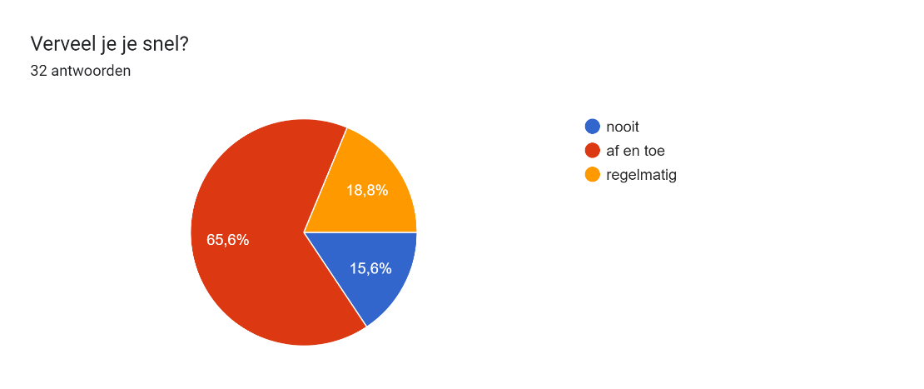

Question 2 :

Diagram met antwoorden op het Formulier. Titel van de vraag: Ben je ooit gediagnostiseerd met een persoonlijkheidsstoornis?
(Zo ja, welke). Aantal antwoorden: 23 antwoorden.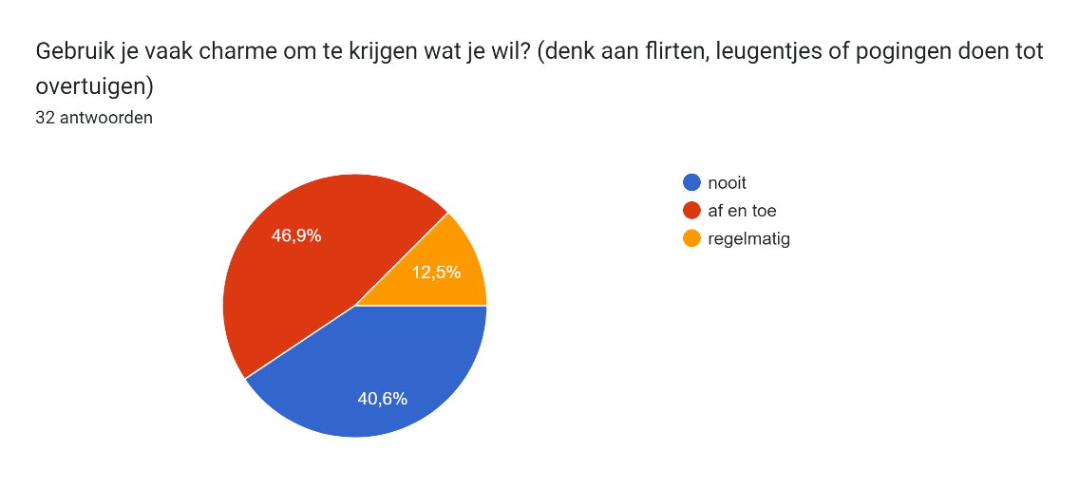

Question 3 :

Question 4 :

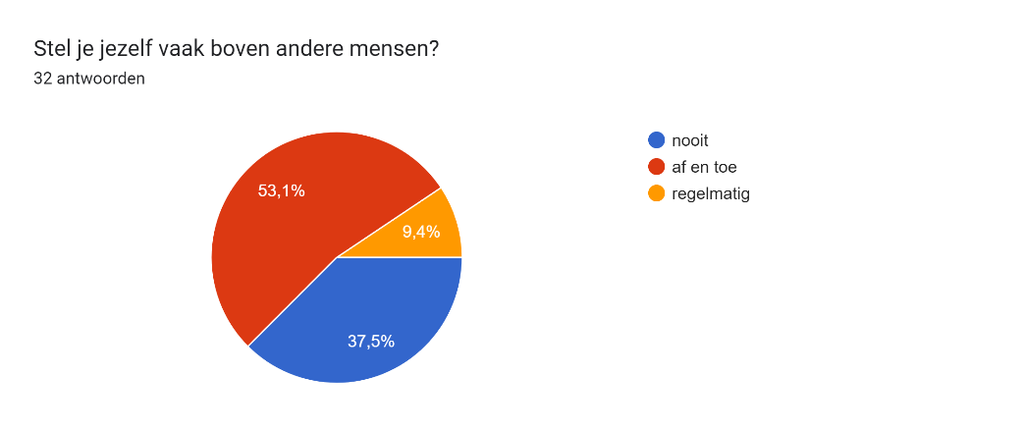

Question 5 :

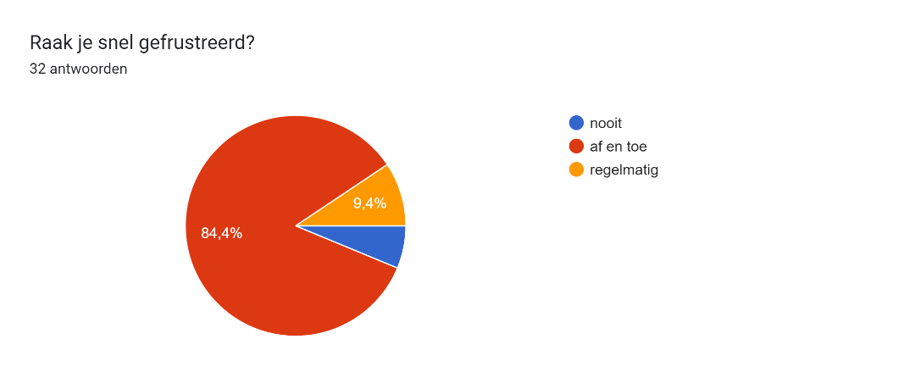

Question 6 :

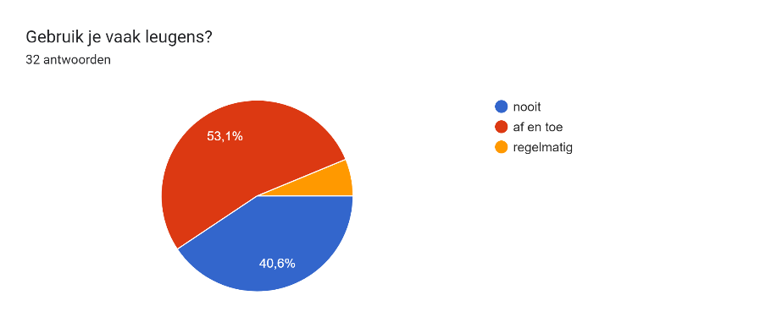

Question 7 :

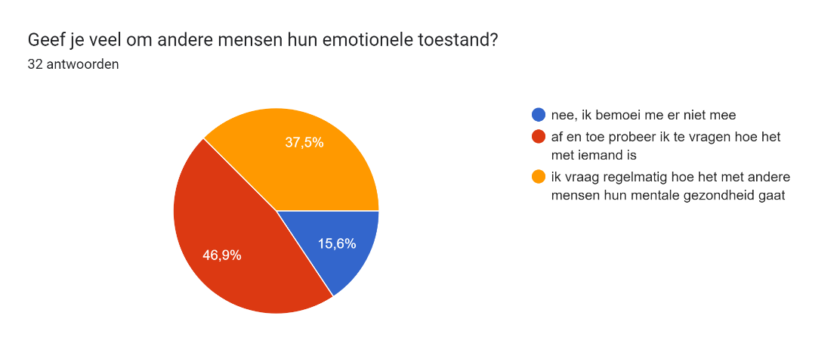

Question 8 :

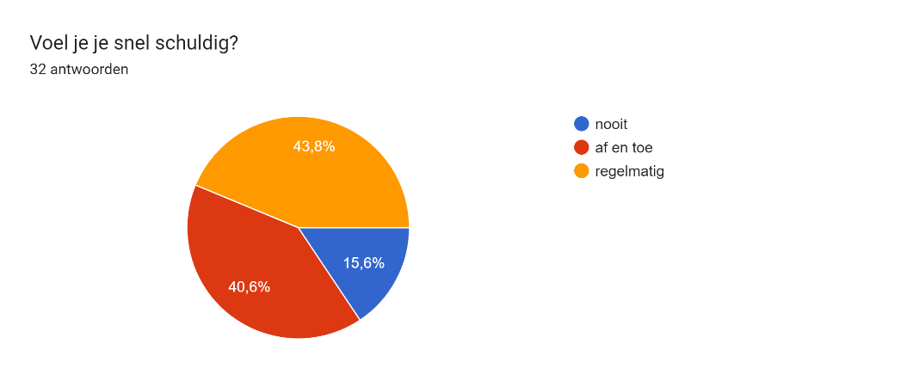

Question 9 :

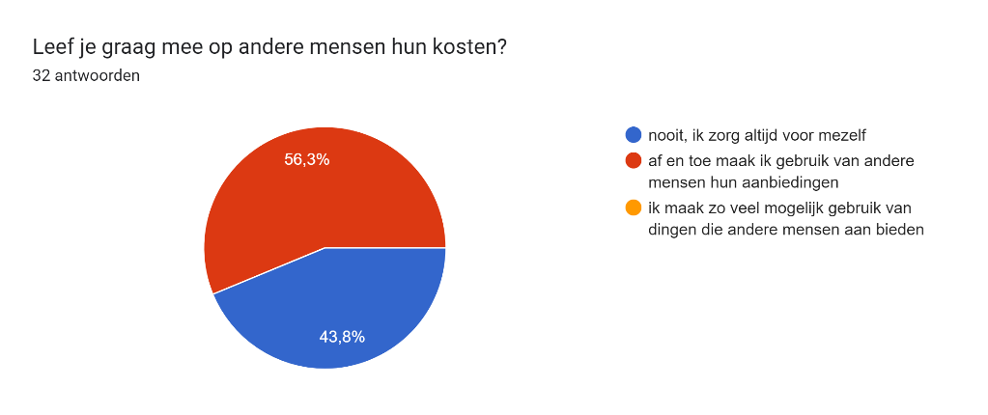

Question 10 :

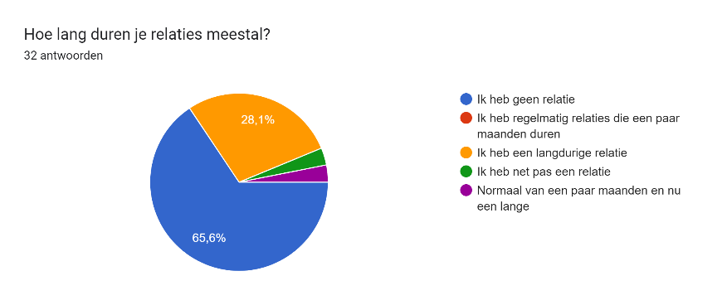

Question 11 :

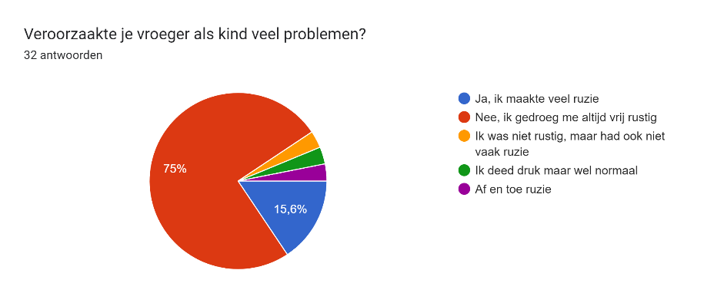

Question 12 :

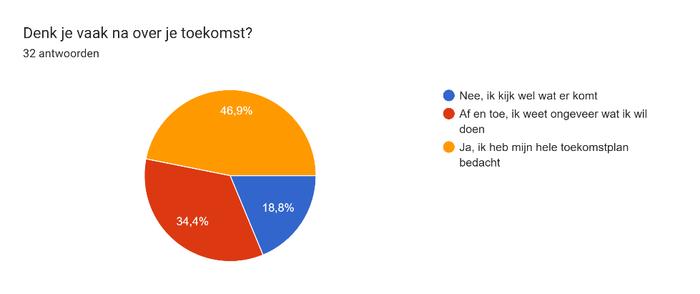

Question 13 :

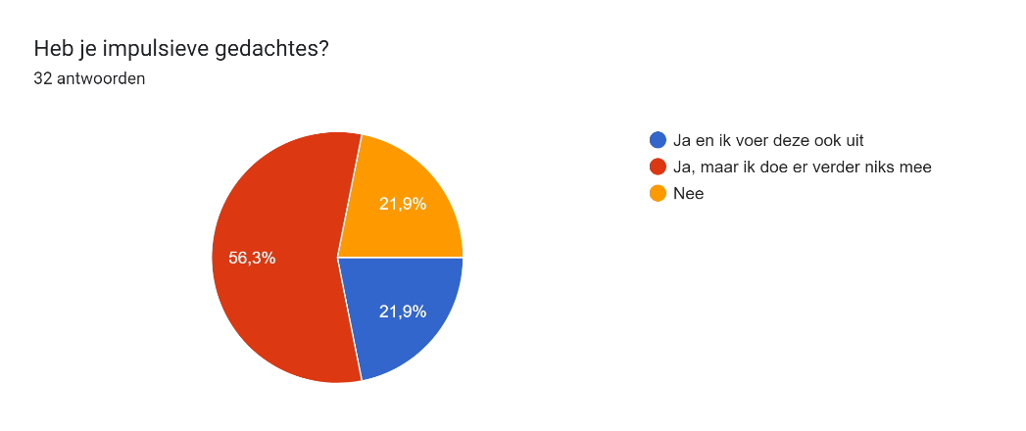

Question 14 :

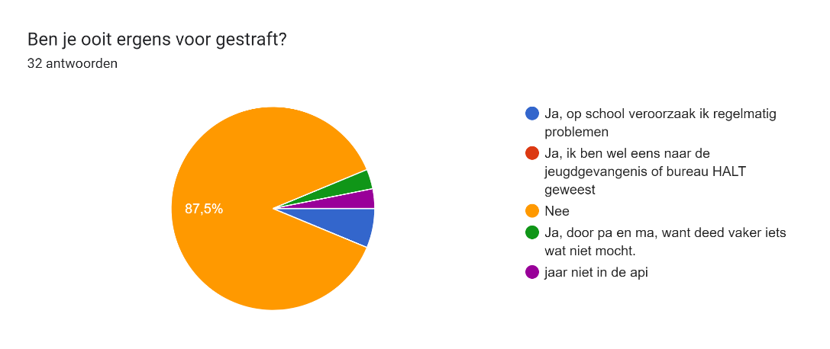

Question 15 :

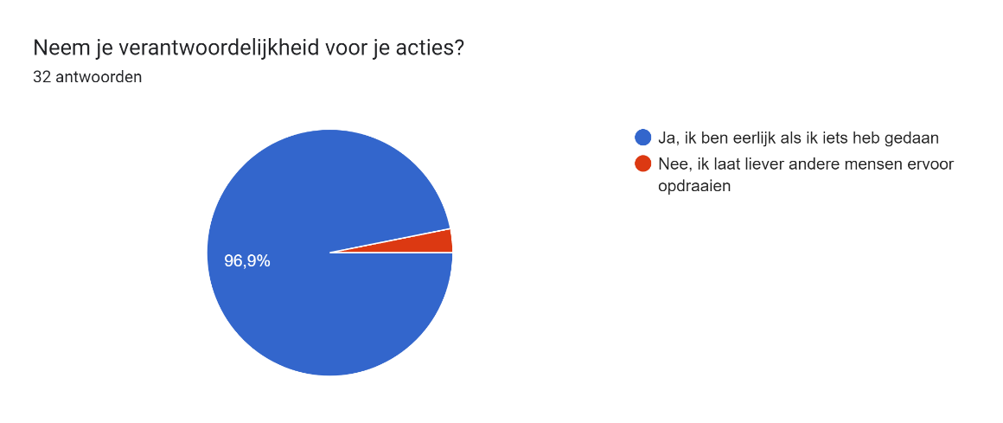

Question 16 :

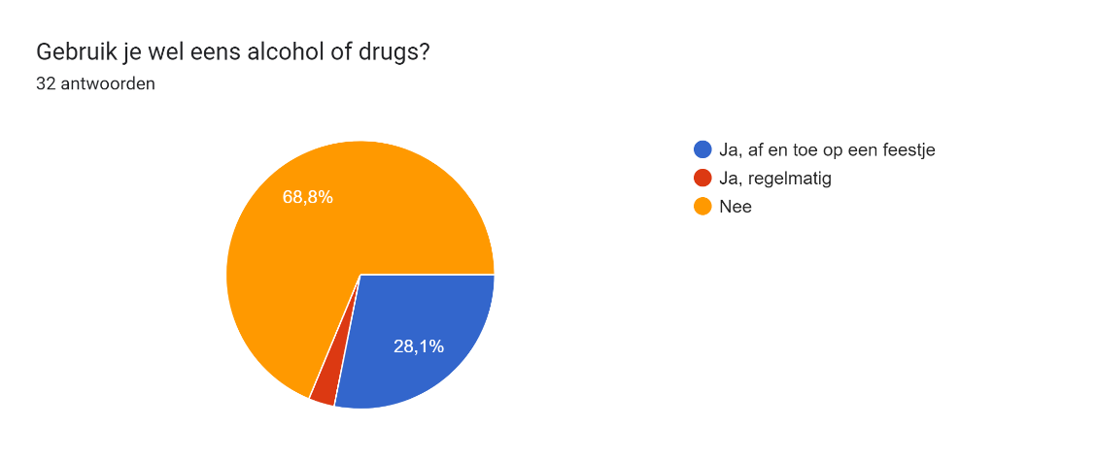

Since question 3 had matching answers, this question is not relevant to the results.