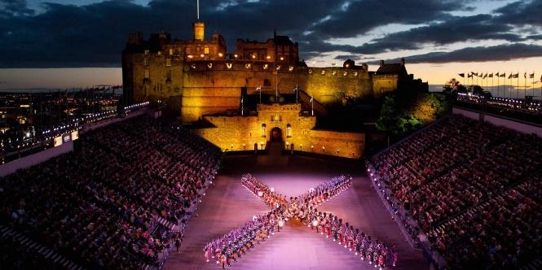
Royal Edinburgh Military Tattoo
- First edition: 1950
- Edinburgh Castle
- Musicians, pipers, drummers, singers and dancers
- A tattoo is a military performance of music or display of armed forces in general (wikipedia)

Hogmanay (New Year's Eve) & New Year
The Scots celebrate Hogmanay with a lot of big events. Hogmanay is Scottish for the last day of the year.

The highland games
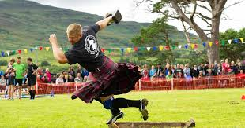
The highland games have been a part of Scotland’s culture for hundreds of years and are just as popular today as they’ve ever been. Every Highland games event has a unique character and traditions and many are held in stunning locations. You can enjoy a sporting spectacle of champions, with dancing, music and more. You have a lot of traditional sports like Caber toss, shot putt, weight for height, tug o’ war and also Highland dancing. It’s a one-day event that includes all these sports but also family fun, best-dressed pet competitions and parades. They ask everybody if they want to join the competition. There are so many options, perfect for a day with your family.
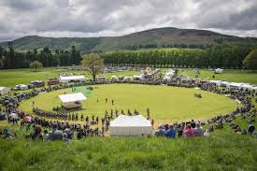

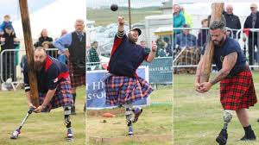
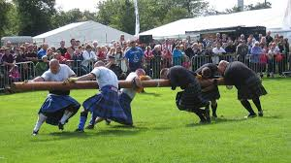

Geography

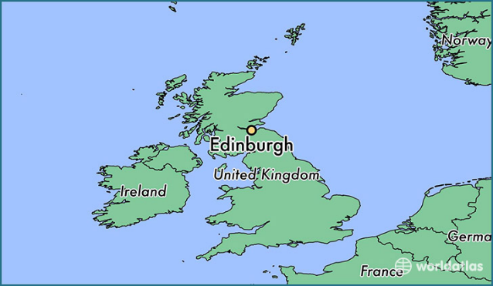
Scotland in general
Scotland is a part of the UK, it is the northern part of the Island Great Britain. Scotland is surrounded by the Atlantic Ocean (north and west), the North Sea (northeast) and the Irish sea (south). Scotland's capital is Edinburgh.
Ben Nevis
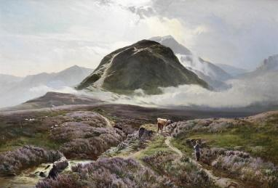
With its 1345 meter, Ben Nevis is the highest mountain in the United Kingdom. It’s situated in the north west Highlands. It can mean 'mountain with its head in the clouds' and 'venomous mountain' in Gaelic. Ben Nevis used to be a massive active volcano.

Northern lights
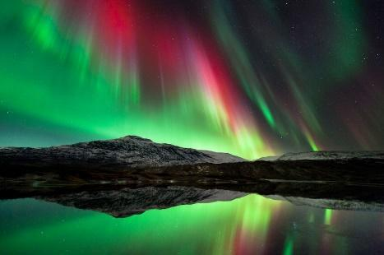
Also known as The Aurora Borealis. The Aurora Borealis is named after Aurora, the Roman goddess of dawn and Boreas, the Greek name for the north wind. The northern lights are caused by charged particles (geladen deeltjes) accelerated into the Earth's upper atmosphere. Thanks to sunlight, we can see this extraordinary spectacle.

Loch Lomond
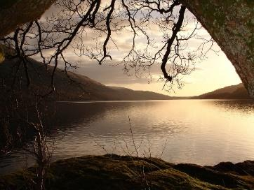
Loch Lomond is the largest lake in Scotland and the largest body of freshwater in Great Britain. Loch Lomond is about 37 kilometers long and 8 kilometers wide, with a surface area of 71 km.

Giant’s Causeway
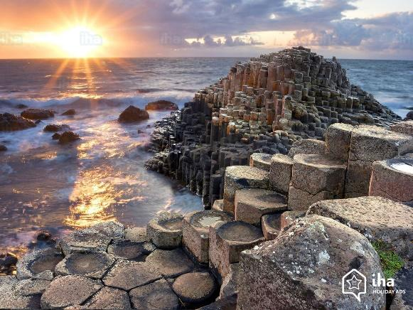
The Giant’s Causeway is a rock formation that consists of 40.000 columns. It starts in Northern-Ireland and it ends in Scotland. 60 million years ago, it was just chalk beds. As a consequence of volcanic activity, molten basalt formed a lava plateau. This plateau broke, resulting in cracks spreading down, leaving pillarlike structures as the mass cooled down. There is also a legend to explain this rock formation. The legend says that there was an Irish giant called Fionn mac Cumhail. He was challenged to fight the Scottish giant, Benandonner. Of course, he accepted the challenge, so he built the causeway so the two giants could meet. When Fionn saw his opponent, who was much bigger then he was, he fled back to Ireland. He asked his wife to disguise him as a baby. Benandonner then saw the baby and he thought that, if the baby was this big, it’s father must be huge. So he went back to Scotland, but not before he destroyed the causeway so the giants could never meet again.
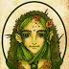
Ghillie Dhu
He is a male fairy who lives deep within Scottish forests, particularly in birch trees. He lives alone and camouflages himself from humans, using leaves and moss for clothing. The Ghillie Dhu, or the ‘dark-haired lad’ in Gaelic, gets very angry if adults’ trespass upon his forest and he severely punishes those who interfere with his precious leafy home. But the Ghillie Dhu is also known for his kindness but only towards younger explorers of his forest

Odd Scottish traditions

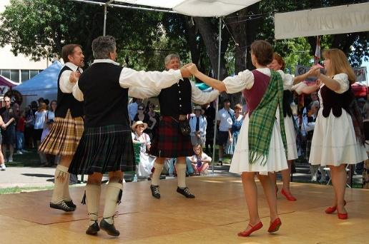
The Lang Reel dance
The Lang Reel is a traditional dance which happens in the fishing communities of Scotland. The dance, with the inhabitants and the wedding party, begins from the harbour and continue through the village, with each couple leaving the dance when they pass their home, until the bride and groom leave and have the last dance.

Sports
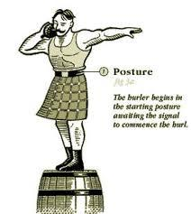
Haggis Hurling
A professional sport, where a portion of haggis is thrown as far as possible, whilst the athlete stands atop a barrel of whisky. The haggis skin must remain intact and be fit for consumption.

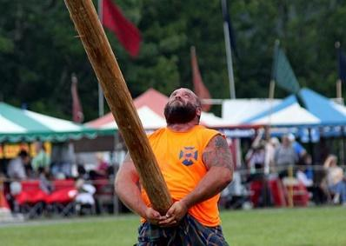
Caber toss
The competitors of Caber toss have to toss a 6m-long log (caber) of 68kg as far as they can. The athletes have to balance the log in their hands and perform a run-up before tossing it away in a ’12 o’clock angle away from themselves.

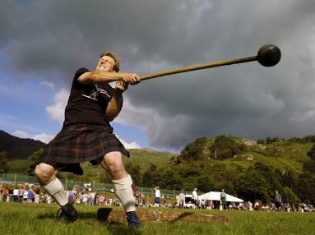
Hammer throw
Also an Olympic Event, although the hammer in the Highland Games differs from the one used in the Olympics. It consists of a metal ball connected to a wooden handle. The athletes swing it over their heads, twist 180° and launch it as far as they can.

Stone put
It’s the same as shot put (=kogelstoten), but instead of throwing an iron ball, the athletes throw a stone picked from a nearby river.

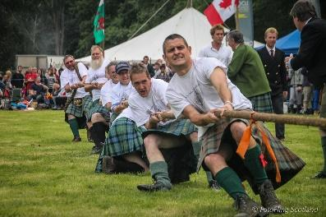
Tug o’war
Two teams of 15 players are pitted against each other and in order to win they need to pull their opponents forward by six feet using the rope in a best two out of three.
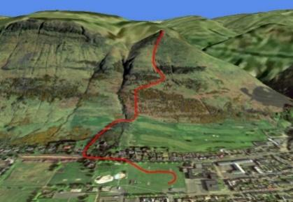
Hill race
Hill races see runners trying to get to the top of a local hill as quickly as possible, any way they choose.

Weight for height
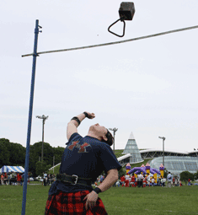
Much like high jumping the crossbar in weight for height is raised after every successful time the athlete gets over the crossbar, but unlike high jumping the athlete has thrown a 24kg weight over the bar with one hand, from a standing position.

Highland Games

The highland games are a continuation of the traditional clan games of the Highlands. The Games are held every year from the end of May to mid-September. The Highland Games are held all throughout Scotland, moving during the year. You can enjoy watching the sports championships or old Scottish traditions in use.

Traditions
Highland Dancing
In this competitive dance, the solo dancers and groups hope to dazzle the crowds with their fancy footwork. Dancing in traditional dress and on traditional Scottish music. It’s one of the few sports were men and women are on equal footing, both do the same dances and there is no discrimination according to gender.

Kilts
Kilts are still a key symbol of Scottish culture and also feature heavily in the Highland Games. It is stated in the rulebook that those taking part in open heavy events must wear kilts while competing.

Clan gathering
The Highland Games are also an opportunity for different clans to meet. You will often see the different clans wearing their own pattern of tartan (the rectangular and square patterns you find on kilts) on their kilts.

Food and drinks
Porridge is a sort of breakfast cereal dish that consist of grain, water, milk, sugar, honey, fruit and syrup. It’s served hot and is used in a lot of cultures. It’s a very healthy dish and is mainly used in prison.

Haggis is national Scottish meal that is boiled in a bag traditionally made from the animal’s stomach. The meat in this meal are sheep heart-lungs and liver. This meal was first seen in 15th century

Scotch whisky is first seen in 1945. There is mat and grain whisky, it is made off wheat and rye and is often sold illegally.
Scotch whisky = Whisky distilled in Scotland, especially from malted barley

Scottish ale is a strong beer with a red/black colour. After WO I it became popular in Europe and now it’s also made by Belgian/Dutch brewers.

Famous Scots

Macbeth
Macbeth is one of the most iconic characters ever created by Shakespeare. Only few people realize that Macbeth was a real man as well, a king of Scotland who led a life in the 11th century filled with as much murder, drama and treachery as the hero of Shakespeare's play.

William Wallace
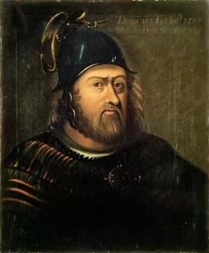
William Wallace (1270) is hailed by many as the greatest Scotsman. He was to become the leader of the Scottish resistance against the English occupation at the beginning of the Scottish Wars of Independence. One of his most famous battles was when he defeated the English army at the Battle of Stirling Bridge, but he was eventually betrayed and executed in London.
On 23 August 1305, William Wallace was transported from the hall to the Tower of London, stripped until he was naked and was dragged through the city hanging on to a horse to the Elms at Smithfield. He was hanged, but released while he was still alive, emasculated, eviscerated and his bowels burned before him, beheaded, then cut into four parts. His head was dipped in tar and placed on a pike on top of London Bridge.
Across Scotland, you'll find many memorials and statues made in his image, as well as monuments erected to commemorate the battles of the Wars of Independence.
The movie ‘Braveheart’ starring Mel Gibson as William Wallace tells the tale of Wallace’s life however, there are many historical mistakes.

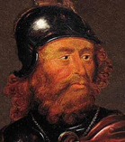
Robert The Bruce:
Robert the Broce was born in 1274 and was a powerful ruler. Through his father, Robert had family ties with the former Scottish royal family.
Robert was named 'guardian of Scotland'. Robert led the Scottish army and defeated the much larger British army in the Battle of Bannockburn (1314). He secured Scotland's independence with this..

Mary Queen of Scots
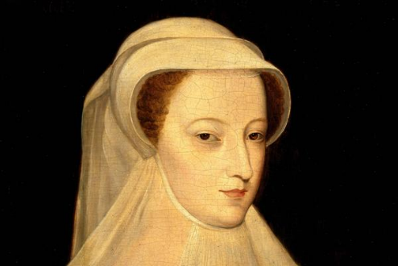
Mary Queen of Scots is a very strange woman. Historians know plenty about what she did and where she went during her short life, but they don’t know good who she really was: most think she was a cruel martyr who killed a lot of people for her political ambition.

.

